MATH9102: Fundamentals of Data Analysis –
Describing Your Dataset
Deirdre Lawless
Email:◦ deirdre.lawless@tudublin.ie
5 ECTS
100% Continuous Assessment

Week 1 – Fund DA Concepts- The Process – Intro to R

Welcome

- Comment
  - Was previously known as Prob and Statistical Inference but not interested as mch in mathematical cmputatin of the statistics

What is the module About?

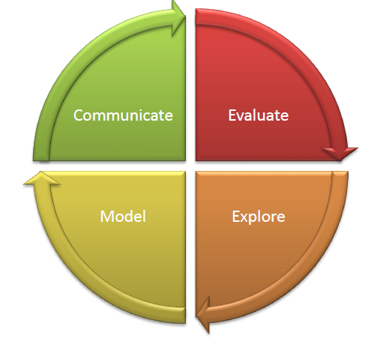

- Equip learners with core principles and tools to analyse complex data
- Critically evaluate data quality and suitability
- Use numerical, graphical, and computational techniques
- Build and evaluate predictive models to uncover patterns and trends
- Present clear, evidence-based insights

- Comment
- Eventually build small scale predictive models
- Use linear logistic regressin to do those
- Very concise structured way
- So max amount of knowledge with minimum amount of words…
- Use templates to express words… not how mcuh you write
- You have to capture it succinctly
- Might end up with statistical report about 200 words btu captures a lot fo detail..

How will I learn?

Interactive
Hands-on R lectorials (lecture + programming demo +practice)
Real-world data Assessment used during through authentic examplesproject work

- Comment
  - Lectorial
  - Talk > demo > practice a bti . do ti all over again ….alk we do a bti
  - Using R
  - Quarto markdown for publicatins – nce outputs and html styling to make it look fancy
  - Using real world data (may be smaller versions but real)
  - A few synthetic – juta s easier ti illustrate whatever we want to illustrate
  - For assessment we pick data

How class sessions will run
BEAK
Present a
bit
Demo a
bit
Practice a
bit
Break

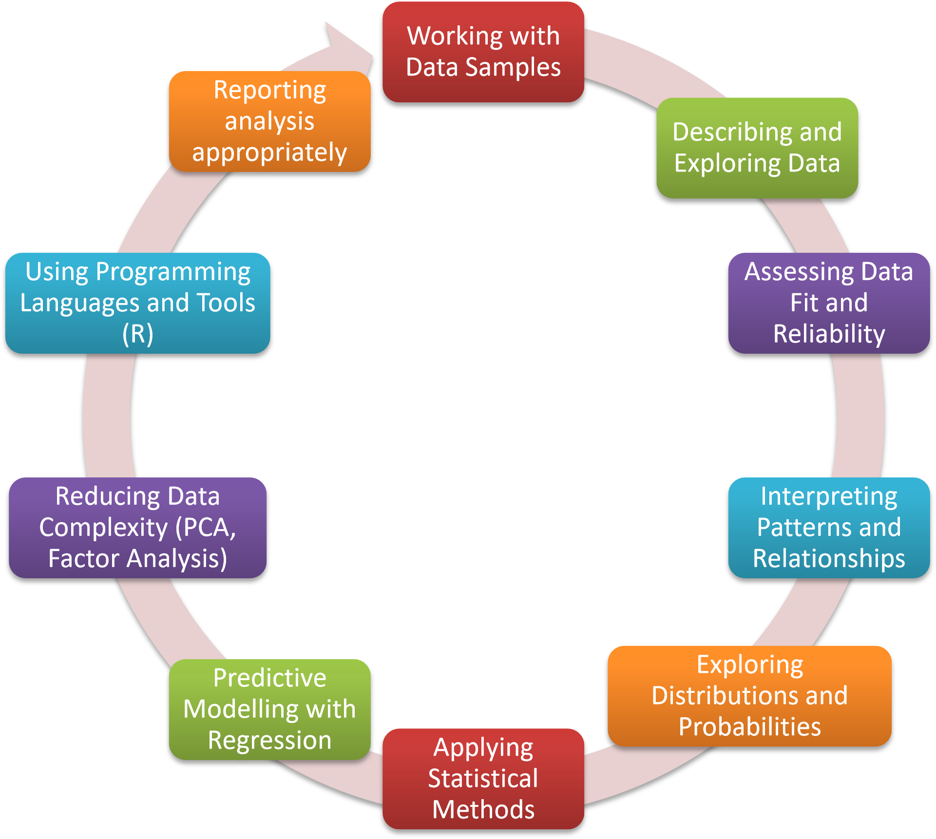

- Assess the suitability of datasets for use in data science workflows and justify methodological choices based on these assessments.
- Select and apply appropriate methods for exploring data and identifying meaningful patterns or relationships.
- Comment
  - Look at suitabl of data
  - Look at patterns – require us to understand different distributions – does it fit one profile or another >>
    - Want most accurate representation of data usig those tests
    - Liner and logistic
    - Ddata will have a lot of variables
      - Doesn’t work when put 20 variables into mode
    - So reduce them down and just have uderlyign variable as a proxy
    - Doing all that using R

Module Learning Outcomes

- Module 1 - Critically evaluate fundamental data analysis concepts.
- Module 2 - Apply advanced numerical and graphical techniques to explore and summarize datasets.
- Module 3 - Assess the suitability of datasets for use in data science workflows and justify methodological choices based on these assessments.
- Modue 4 - Select and apply appropriate methods for exploring data and identifying meaningful patterns or relationships.
- Module 5 - Inerpret and synthesize analytical outcomes to extract meaningful insights and support evidence-informed decision-making.
- Module 6 - Design, implement, and critically assess models for predicting outcomes based on data patterns.
- Module 7 - Apply and evaluate data reduction techniques to enhance interpretability and modelling performance.
- Module 8 - Communicate insights clearly and effectively through wellstructured reports that demonstrate analytical depth, clarity of interpretation, and actionable recommendations.
- Module 9 - Demonstrate proficiency in using appropriate programming tools and languages to develop, implement, and communicate end-to-end data science workflows, including data preparation, analysis, modelling, and results presentation.

Locating Module Material

While waiting for Brightspace to be setup, material can be located at this link:https://tinyurl.com/FundDA-2025



- Within Brightspace module:
  - ◦ Material for Lectures/Labs
    - ◦ Organised by week number
    - ◦ Lecture notes (pdf) (generally available in advance of class)
    - ◦ Lab exercise and solutions (solutions to exercises will be published after the classes are completed) ◦ Generally, will be available in advance of classes
  - ◦ Please Note:
  - ◦ Presentations used during class sessions are intended to be a supplement to attending class not a replacement
- ◦ Continuous Assessment
  - ◦ Links to specs, submission boxes, rubrics etc
- ◦ Datasets Used
  - ◦ Useful Resources
- While waiting for Brightspace to be setup, material can be located at this link: https://tinyurl.com/FundDA-2025

Practical Component



- R and R studio will be used during the classes
- Getting started with R and RStudio > https:..education.rstudio.com/learn/beginner

GitHub

- GetyourselfsetupwithaGitHubStudentDeveloperPack-https://education.github.com/pack
  - Lotsoffreetools
  - Lotsoffreeresources
  - ExtratimeforusingCodespacesforfree

Code Provided to Support Learning
    - This is a module in how to conduct a data analysis
      - ◦ We will be using R as a tool
    - This is not a module in how to use R
      - ◦ That should be covered in Working with Data
    - This is not a module about visualisation
    - Fancy graphs are covered in Data Visualisation

  - You will learn how to:
    - ◦ Design an analysis
    - ◦ Describe your data (using appropriate visuals)
    - ◦ Conduct relevant statistical tests
    - ◦ Build simple predictive models
    - ◦ Evaluate the findings in the context of your analysis
    - ◦ Express your findings appropriately
  - You will be provided with R code snippets which implement some of the above

Datasets
- A range of datasets will be used throughout the module to illustrate concepts
- You will be provided with these datasets or details of where to find and download them as needed

Some Books

- Peter Bruce,Peter C. Bruce,Andrew Bruce,Peter Gedeck. (2020), Practical Statistics for Data Scientists, 2nd. O'Reilly Media, p.0, [ISBN: 978-1492072942].
- https://datapot.vn/wp-content/uploads/2023/12/datapot.vn-Practical-Statistics-forData-Scientists.pdf?srsltid=AfmBOopXEOEs6uamO_ogfXsNiiAurw8LY3A_uVTQHVRL4hORSwvVTiC
- Hadley Wickham,Mine Çetinkaya-Rundel,Garrett Grolemund. (2023), R for Data Science, 2nd. O'Reilly Media, p.0, [ISBN: 978-1492097402].
- https://digitallibrary.tsu.ge/book/2019/september/books/R-for-DataScience.pdf
- Mike McGrath. (2023), R for Data Analysis in Easy Steps, 5th. In Easy Steps, p.0, [ISBN:
978-1840789980].
- Multiple copies in the Grangegorman library (Park House)

Asessment / Assignments
- 100% continuous assessment

Phase ONE (40% of module marks):
- You will choose a dataset
- You will apply your learning from the module to construct an appropriate statistical description of selected concepts in this dataset and construct an appropriate report.
- There will be requirements w.r.t the types of statistical variable you should use.
- You will then conduct an initial statistical analysis of a selected concepts represented in this dataset and construct an appropriate report.
- There will be requirements w.r.t the types of statistical tests you should use.
- Put together a plan for phase TWO.
- You will be required to submit your report, your R code, your dataset.
- Comment
  - I don’t need you to do a lot of cleaning -can do that in WWD
  - But you need to be able to express and understanding of whats in it / what needed to eb fixed / why you did what ou did – how that impacts your analysis – mechanics of it something you can do in WWD
  - Test
- Discussed in Week 3
  - You choose dataset and complete assignment
  - Given list of datasets you could use
  - Just make sure ahs right number of numerical/interval/categorigal

Phase TWO (60% of module marks):
- What you will do…
- You will build, analyse and report on:
- Build A linear regression model (using the same dataset as phase one)
- Build A logistic regression model (using the same dataset as phase one)
- Build a second linear/logistic model and compare to the model previously built (using the same dataset as phase one)
- Dimension reduction – using a second dataset provided to you

How to succeed in the module

- Focus on learning the process of conducting a data analysis:
- ◦ What are you trying to discover or show?
    - ◦ Figure out a question you are trying to answer/theory you are trying to test
- ◦ What data do you need to collect?
- ◦ Once you have data, how do you describe the data you have?
    - ◦ You need to explain this to whoever will be the consumer of your work ◦ What analysis should you conduct?
    - ◦ You need to know the types of statistical tests and models you need and how to explain the outcomes to your consumer
- ◦ How do you interpret your analysis?
    - ◦ You need to know how to interpret the outcomes of the analysis and present these to your consumer
- ◦ How will you present your findings?

- Work steadily through the material
  - ◦ Keep up
  - ◦ Make use of the lab time allocated to work on CA
- Make your own notes
  - ◦ On the topics we cover in class
    - ◦ On how to use the software
    - ◦ Make comments in your scripts/output and save it somewhere
- Don’t be afraid to ask questions
  - ◦ Of me, of each other, on the web…
- Keep going…
- Keep notes yourself….

Contact

    - In person:
      - ◦ During class.
    - ◦ Email:◦ deirdre.lawless@tudublin.ie

Use of AI
- Fine to use
- But it will be puirest view of things but we are much more pragmatic / application based
  - If ask AI if dataset if normal it will suggest >>
  - Eg – deciding if normal or no
    - We understand nomal distri is – how close it is to a normal one – if within reasonable margin we can traeat as normal as long as we know what impact of that is
    - Ai will ask you to run a statistical test
      - Chapiro Wilkes
      - Or
      - Komanv – smirnof
      - And will tell you your data is not normal….

Probability v Statistics Vs Data Science

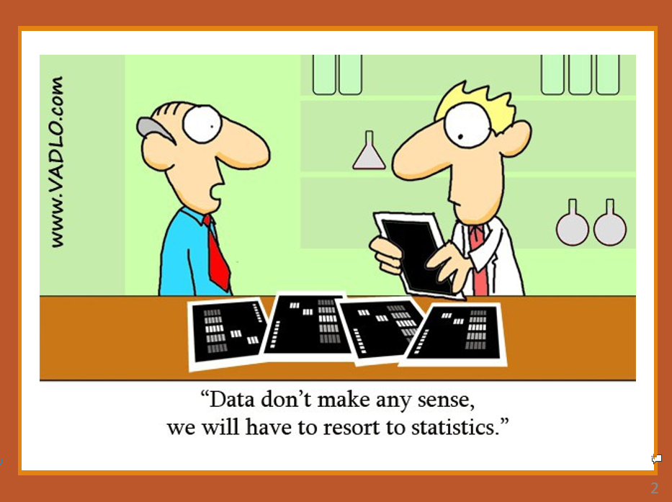

1 >>>

- A person goes to a casino and encounters their first dice game. A sixsided dice is used.

- If the person is a probabilist:
- ◦ They would think the dice is six sided
- ◦ If each side is equally likely to land face up, then the probability of
    - getting a particular face of the dice is
    - 1/6
- ◦ Using probability theory, they will be confident they can predict the likelihood that they will guess right
    - (or wrong)

- Comment
  - Giving data result for other to understand so use common metrics /approaches
  - If looking at data that is continuous data will do
    - measure of central tendency /
    - measure of variation
    - will give vsualisatio of that thay shows spread of data around central area

2 >>>>

person goes to a casino and encounters their first dice game. A six-sided dice is used. If the person is a statistician

- They would see the dice and think:
- The dice is six-sided. It could be that each side is equally likely to land face up.
- BUT – the dice might be loaded (some sides more

- They would:
- Observe rolls for a while and record outcomes.
- Compare observed frequencies with what would be
- expected if the dice were fair.
- Use statistical tests (e.g., chi-squared) to check whether results are consistent with fairness.
- Once they had enough evidence,they could confidently decide whether to accept or question the fairness assumption.
- If consistent, they rely on probability theory to make predictions.

The dice is six-sided. It could be that each side is

3 >>>>
- A person goes to a casino and encounters their first dice game. A six-sided dice is used. If the person is a data scientist :
- Instead of immediately assuming each face has a probability of 1/61/61/6, they will want to collect data.
- They might roll the dice 100 times, record the outcomes, and build a dataset.
- OR
- They may source a dataset recording the outcomes of other people rolling a dice 100 times.
- The data scientist will then apply some statistical testing.
- They may apply a statistical test (e.g. chi-squared test) to check whether the observed frequencies significantly deviate from the expected uniform distribution.
- If the p-value is large, they conclude the dice is fair (at least no evidence against fairness).
- If small, they suspect the dice is biased and might explore which face(s) occur more often.
- The data scientist will then try to build a model The probabilist assumes fairness, but the data scientist may model probabilities empirically:
- 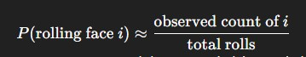

- Over many rolls, this estimate converges toward the true underlying probability distribution.

Summary
Probabilist | Theory-first. Works with mathematical models and assumptions about randomness. | Assumes the die is fair → each face has probability 1/61/61/6. Uses probability theory to compute chances of winning/losing.
Statistician | Inference and validation. Designs experiments, collects data, and applies formal methods to test if the probabilist’s assumptions hold. | Rolls the die many times, uses a chi squared test to check if outcomes deviate from fairness. Reports whether data provides evidence for or against bias.
Data Scientist / Data Analyst | Data-first, applied, and exploratory. Gathers large datasets, explores patterns, builds predictive models, and communicates insights. Explore over time.. | Collects thousands of dice rolls, visualises frequency distributions, estimates probabilities empirically, simulates casino outcomes, and advises on betting strategies if bias is found.

- Comment
  - Observe over time and express a factor with data
  - Describe howe collected the data/ model / interpretation
  - What is the factor – person / time of day // bias of the dice?
  - Data first - eploratry

The relationship

- Probability provides the framework → what the model of fairness looks like. Statistics provides the bridge → testing whether reality (data) aligns with the framework.
- Data Science/Analysis provides the application → exploring data at scale, finding patterns, and generating actionable insights.
- Together, they form a theory–inference–application pipeline: Theory (probability) Inference (statistics) Application (data science/analysis)

What is Data Science
What is  Data  Science? | The science of extracting knowledge and insights from data by combining statistics with computing, machine learning, and domain expertise

What is Data Analysis
What is  Data  Analysis? | The process of inspecting, cleaning, and modelling data, using statistical methods to discover useful information and support decision-making.

What can Statistics Do?

- Make data more manageable6, 1, 8, 3, 5, 4, 9
- What can statistics do?
- •We can calculatean average(5.147…)
- •We can state the range (1 to9)
- •We can create a visualizationof it
- Provide us with evidence from the data that allows us to draw conclusions from the data
- Group of numbers #1: 6, 1, 8, 3, 5, 4, 9
  - Average is 5.14
- Group of numbers #2: 8, 3, 4, 2, 7, 1, 4
  - Average is 4.25
- Allows us to compare groups of data
- Allows us to do this objectively and quantitatively

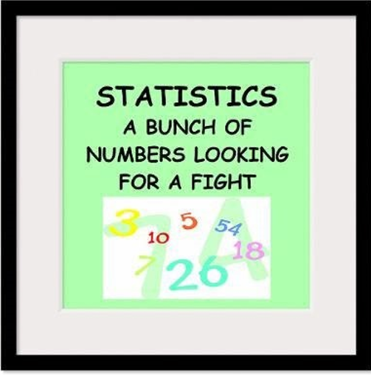

Example

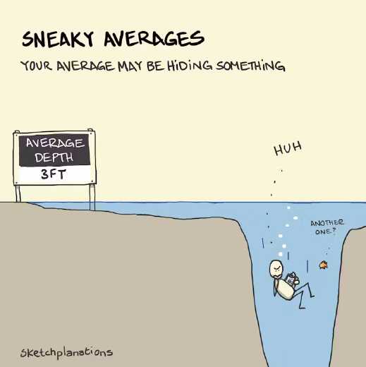

- Averages summarise data into a single value, making complex information easier to compare.
- But while they simplify, they also hide variation — and sometimes what’s really going on.
- Suppose you run a delivery service and have a mean delivery time of one day;
- it could be that most deliveries are actually a few hours, while just a few have people waiting for a week.

- A figure of mean incomes might mask the fact that most people have low salaries, while a few are millionaires.
- Sometimes a different measure of central tendency, like the median, can provide a clearer picture.

- But you also need other statistics to give you the full picture – variance, std deviation, range etc.
- You need to "Spend time with your data."
- Sometimes it's the only way to know what's happening for sure.

Meian > better than mean > also need variation

The Process (Source Andy Field)
- Process we are going to sue is from Andy field
  - Book - "Discovering Statistics Using SPSS"

- Initial Obsevation – Our Idea – something happening in real world

- ◦Observe the real world
- ◦Experience the real world
- ◦Read related research
- ◦……
- The Process

Conceptual Framework
  - Need a good conceptual framewoek as it affects what we do
  - System of:
    - concepts,
    - assumptions,
    - expectations,
    - beliefs, and
    - theories that supports and informs your research
  - A key part of your design
  - A conception or model of what is out there that you plan to study, and of what is going on with these things and why a tentative theory of the phenomena that you are investigating
  - going on with these things and whya tentative theory of the phenomena that you are investigating
  - Influences your design and in particular the data you need to collect/use

Conceptual Framework – Why is it important?
- Bernd Heinrich – ant colony story… data results were different…
- Spent a summer conducting detailed, systematic research on ant lions
  - ◦Small insects that trap ants in pits they have dug.
- When he conducted his analysis, he found his results were very different to other researchers…
  - ◦A good thing ? Was his research revolutionary?
- Repeated experiments following summer
  - Found that he and his team had misunderstood ant lion behaviour
  - ◦In particular the time frame involved
  - Missed specific behaviour that impacted the results
- “Even carefully collected results can be misleading if the underlying context of assumptions is wrong”
- Source: Maxwell, J. A. (2005). Conceptual framework: What do you think is going on? Qualitative research design: An interactive approach (3rd. ed., pp. 39-72

Generating and Testing Theories

Theory
  - ◦A hypothesized general principle or set of principles that explains known findings about a topic and from which new hypotheses can be generated.
  - ◦e.g. Computer Science attracts students with strong mathematical ability

Hypothesis
  - ◦A prediction from a theory.
  - ◦States an assumed relationship between concepts of interest.
    - ◦E.g. the number of people applying for an MSc in Computer Science will have basic mathematical ability greater than the general level in the population.
    - ◦We want to test our hypothesis/hypotheses to see if they hold in the world that we are modelling based on our observations/data.

Identify the variables – the things I want to collect

- From your theory and hypotheses, you will be able to identify the
- items that can be observed or changed or manipulated or calculated or simulated.
- Example:
- If we are interested in researching the impact part-time work has on students' study time, we might state a hypothesis:
- The number of hours a student spends working for their employer impacts the number of hours spent on working independent study
- What are the variables?
  - ◦Number of hours spent working
  - Number of hours spent independently studying
- A variable is anything that can take on a different quantity or quality
  - ◦It is anything that can vary.
  - Hair colour / age /
  - Any variable that could eb related to your hypothesis

Example Theory

- The use of stimulants positively impact PSI students’ level of alertness, mental and physical activation, or readiness to respond.
- ◦We have a theory that the combination of caffeine and sugar as stimulants can increase these levels.
  - ◦Caffeine, in particular, is known to block adenosine receptors in the brain, reducing feelings of fatigue and increasing alertness and concentration.
  - ◦We choose Coca Cola as a suitable stimulant.
  - ◦We decide on the dosage levels, timings etc.
etc.

Example Hypothesis: Consumption of Coca-Cola improves a PSI student’s ability to concentrate during lectures

- VARIABLE ONE
  - ◦ Coca-Cola consumption
  - ◦The proposed cause
  - ◦A predictor variable
  - Suggesting it can cause attention span to increase
  - ◦Could be a manipulated variable (in experiments)
  - (cause)
  - ◦Independent Variable (or a predictor)

- VARIABLE TWO
  - ◦A student’s ability to concentrate in the hypothesis above
  - ◦The proposed effect
  - ◦An outcome variable
  - ◦Just Measured - not manipulated or try to affect or change in any way(in experiments)
  - What you expect to change as a result of changes in independent variable
  - (effect)
  - ◦Dependent Variable (outcome

- Comment
  - Data is only as valid as the decisions we made about oru data, appropriate ways to measure etc
  - Always have to think about variables and what can eb stroed in them
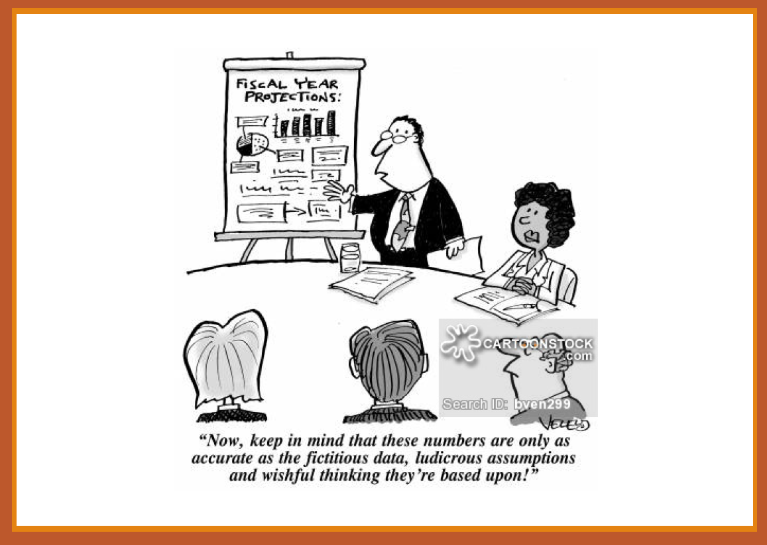

commentt

The Process

Collect the Data

- The information about different variables is referred to as data
- When the data relative to some specific variables is collected and organised, we refer to the collection as a dataset.
- Datasets are collected and organised around specific observations or instances in the world we are interested in.
- ◦E.g. we are interested in 40 students who are studying PSI in Dublin at MSc level, we collect their age, previous education level and their confidence level studying mathematics
- ◦The dataset would be made up of 40 observation or cases.
- ◦Each case should include a measurement for each of our values of interest.

Measure the Variables

- Once we have identified the variables we need, we need to decide their statistical type

6a ) Types of Variable (In Statistical Analysis)

- QUANTITATIVE
  - Involves measurement
    - ◦ Data in numerical form
    - ◦ bjective and results in unambiguous conclusions
    - ◦ 5.14 versus 4.25
    - ◦ 5% versus 50%
    - ◦ 1 hour versus 24 hours

- QUALITATIVE
  - Describes the nature of something
    - ◦ Often evaluative and ambiguous
    - ◦ “Good” versus “Bad”
    - ◦ Right” versus “Wrong”
    - ◦ “A Lot” versus “A Little”
    - ◦ May be numerical!! But makes no sense to do any arithmnetic with B,
      - you will see it happen in stat reports btu it is incorrect – shouldn’t do
      - e.g. 1 = Group 1, 2 = Group 2

6b) - Qualitative, or Attribute, or Categorical, Variable

- A variable that categorizes or describes an element of a population.
- Identifies basic differentiating characteristics of the population
- Note:

  - ◦ Category values can be numerical e.g., 1 for Urban and 2 for Rural, 1 for Blue Eyes, 2 for Brown Eyes

BUT

  - ◦ Arithmetic operations, such as addition and averaging, are not meaningful for data resulting from a qualitative variable.

6c) - Qualitative Datatype - Nominal

  - E.g. Country of Origin: 1=Ireland, 2=India, 3=China, 4=……..; Type of
  - residence: A=House, B=Apartment, C=Other
  - Categories should be
  - ◦ mutually exclusive
  - ◦ You must be able to assign every case in your dataset into one of the categories but only one category

  - AND
- ◦ collectively exhaustive
  - You have to have a category for every case in your dataset.

  - Example
- ◦ Suppose we are collecting data using a survey
- ◦ We want to collect information about respondents Religious Belief. We decide the categories.
  - We decide to have categories for Catholic, Protestant, Jewish, Muslim, Hindu and Other
  - What would we do if a respondent was an atheist?

6d( - Qualitative Datatype - Ordinal
Categorises but also introduces some order to the categories
- E.g.
- ◦
  - Ranking: 1st, 2nd, 3rd
  - Answer: Strongly Disagree, Disagree, Agree, Strongly Agree

- Suppose in our survey we want to collect information about respondents’ highest level of educational achievement.

- We decide to include the categories:
  - completed some primary level, completed primary level, completed some second level, completed second level, completed a primary degree, completed a post-graduate degree

- Here there is an inherent notion of order
  - Those who respond that they completed primary have less education that those that have completed a primary degree

Quantitative variable
- A variable that quantifies an element of a population.

Discrete
  - have values that can be counted
  - ◦Isolated points along a number line
  - ◦Usually counted
  - ◦Can only take certain values
  - ◦E.g. rolling a dice, #students attending class

Continuous
  - ◦takes on any value within a range, and the number of possible values within that range is infinite
  - Variable that can be any value in a given range
  - ◦Can be measured
  - ◦E.g. heights of students attending class, time spent concentrating in class

- Observations or measurements take on numerical values

- Note:
  - ◦Arithmetic operations such as addition and averaging, are meaningful for data resulting from a quantitative variable.

Levels of measurement – Interval Datatype

Interval
◦ Data can be ordered but there is meaning between the values of order
◦ Values are measure on a scale and the difference between the points on the scale are the interval

Key points
◦ There are equal intervals between the values
◦ The intervals are fixed and constant
◦ There is no true zero point
◦ Allows comparison between the data values
◦ While you can add and subtract interval data, you cannot meaningfully multiply or divide it.

Example:
◦ Temperature in Celsius or Fahrenheit.
◦ Zero degrees doesn’t mean the absence of temperature; it’s just another point on the scale.
- Example:
- ◦ Suppose I ask all the students in the class to tell me what time you usually wake in the morning (hours and minutes 24-hour clock format, nearest quarter hour)
  - ◦ The measurement type is interval:
  - ◦ The interval is 15 mins
  - ◦ The difference between 9:00 and 9:15 is the same as the difference between 18:00 and 18:15
  - ◦ But 0:00 is not a true zero - it is a valid time, it is not the absence of time.

Levels of measurement – Ratio Datatype
Ratio
- ◦ All the properties of interval
- ◦ Plus
  - ◦ Can take any value within a given range
  - ◦ But it is not restricted to fixed increments
  - ◦ It can be measured with increasing precision
  - ◦ Has a true zero
  - ◦ Represents the absence of the concept
  - Easier is easier to say twice as big…?
- ◦ You can find the ratio - it makes sense to say for example one value is twice as large as another

- Example:
  - ◦ Weight is an example of ratio data.
    - ◦ A weight of 0 kilograms means the absence of weight
    - ◦ And you can meaningfully say that 10 kg is twice as heavy as 5 kg.
- ◦ In a survey of students on how much they spend on buying lunch in the university café:
  - ◦This could be any value 7.01, 14.02, 10.56, 63.09
    - ◦ We can say 14.02 is twice as much as 7.01, 63.09 is 9 times as much as 7.01
  - ◦ But also, a student may spend 0 which is this case represents the absence of spending
    - Zero has a meaning….

From chatgpt

🧩 Summary
Concept | Applies To | Key Question | Example
Interval vs Ratio | Measurement scale | Does zero mean “none”? | Temperature (interval) vs Weight (ratio)
Discrete vs Continuous | Data structure | Can you count it, or can it take any value? | Number of pets (discrete) vs Height (continuous)

🧠 Summary Hierarchy
Level | Type | Has Order? | Equal Intervals? | True Zero? | Example
Nominal | Qualitative | ❌ | ❌ | ❌ | Eye color
Ordinal | Qualitative | ✅ | ❌ | ❌ | Satisfaction level
Interval | Quantitative | ✅ | ✅ | ❌ | Temperature (°C)
Ratio | Quantitative | ✅ | ✅ | ✅ | Weight, age, sleep time

💡 Examples Combining Both Concepts
Variable | Interval or Ratio | Discrete or Continuous | Explanation
Temperature (°C) | Interval | Continuous | Equal intervals, no true zero, measurable values
Height (cm) | Ratio | Continuous | True zero, measurable scale
Number of children | Ratio | Discrete | True zero, countable whole numbers
Age (years) | Ratio | Continuous (can also be treated as discrete if rounded) | True zero, measurable time
Sleep hours | Ratio | Continuous | True zero, measurable quantity

✅ In short:
- Interval/Ratio → how you measure (the scale)
- Discrete/Continuous → how values occur (the form)
---------

Key Note – Including every bit of data in a dataset
- You don’t need to have every possible value of a variable represented in your dataset

BUT

- It should be possible for that value to be included if it exists in the world you are modelling
  - Have to allow for the possibility for it to be included

Quiz
- Quiz - Types of Data – Quantitive/Qualitiive/Niminal/orinal/Interval/Ratio
  - https://www.med.soton.ac.uk/stats_eLearning/typesofdataquiz/index.html

Collect the data
- Once you’ve decided on our statistical types and we get our data
- You will not be going out collecting the data…
- Collect data that will provide evidence you can test to see if your idea is valid
- You can use data you have already collected – (secondary data) but you should not fish or dredge it to generate your hypothesis –
  - Worked with data for several years and see patterns – that’s a different thing, it is not fishing
  - fishing is where you deliberately go find a relationship and go I’m going to use that as my Hypothesis
    - i.e. find corelations >>> then hypothesise
  - Process
    - 1st > Hypothesise
    - 2nd > Test
- ◦Your theory and hypotheses should make sense in the real world

What data am I interested in/do I need?
- Data Analysis is usually carried out with a SAMPLE
- Population
  - ◦The entire set of individuals or objects of interest or the measurements obtained from all individuals or objects of interest
  - ◦The world you are interested in and trying to build a model of.
  - ◦Two kinds of populations:
  - ◦finite or infinite.
- Sample
  - ◦A portion, or part, of the population of interest

Population
- The entire set of individuals or objects of interest or the measurements obtained from all possible individuals or objects of interest
- The world you are interested in and trying to build a model of.
  - ◦E.g., All registered voters in Ireland.
- But the population is constantly changing.
  - ◦E.g. All registered voters in Ireland
  - ◦People are dying and being removed, turning 18 and being added
  - It is also usually incredibly large
  - ◦E.g. as of 2024 there are 3.4 million registered voters in Ireland.
- ◦If you want to collect information about every single one of them, how do you do it, how long would it take?
- So it is difficult to work with the full population

Sample
- A portion of your population.
- E.g., we may choose to work with a sample of 2000 registered voters in Ireland.
- But we need to decide which voters?
- What do we need the sample to achieve?
- ◦It will be a proxy for the population so it should be representative of that population
- ◦If Sample is not representative, it is biased

- Need to understand the nature of the population before collection/creating/choosing the sample
- Need the collection of the sample to provide the same opportunities for all possible values of a variables to appear as they would in the population.

Population v Sample
- ◦Example
  - survey
    - ◦You want to survey every customer who has purchased something from the company in the past calendar year
    - ◦That’s the population
    - ◦But could you logistically contact all of these customers? (Unlikely)
    - ◦And if you could, would they all respond? (Unlikely)
    - ◦In this case you would work with a sample.
  - ◦You need to make it representative.
  - ◦You are working for a retail company, and you want to conduct a customer satisfaction
  - comment
    - 20% response rate for survey is excellent
    - 10% - usual response rate

Population v Sample - 2

- ◦Example◦
- You are working for a retail company, and you want to conduct a customer satisfaction survey
- ◦You want to survey every customer who has purchased something from the company in the past calendar year ◦That’s the population

- ◦But could you logistically contact all of these customers? (Unlikely)◦And if you could, would they all respond? (Unlikely)

- ◦In this case you would work with a sample.
- ◦You need to make it representative.

Sample
- Factors influencing the accuracy of a sample’s ability to represent a population:
  - Size
  - Randomness

- Biased Sampling Method:
  - A sampling method that produces data which systematically differs from the population from which it is taken.
- Aim for a Simple Random Sample
  - A sample of n measurements from a population is a subset of the population selected in such a manner that every sample of size n from the population has an equal chance of being selected
  - Some things to note:
    - Researcher bias should not occur in the sample selection
    - May not always reflect the diversity of the population
    - We are always comparing it to random chance
    - Random chance should have opportunity to be the explanataion

Sample - 2

- In an ideal situation, the entire population should be studied but this is almost impossible.
- Majority of studies are performed on limited subjects drawn from the concerned population known as “sample population”.

- The data obtained is analysed and conclusions are drawn which are extrapolated to the population under study.
- Sample size - The number of cases n◦
  - E.g. n = 90

- Too small a sample
  - May not lead to conclusions that are valid for the population
  - May miss something
  - Maybe not happening in population just I this sample

- Too large a sample◦
  - Wasteful if a smaller sample would do
  - ◦May have ethical implications dependent on the type of experiment/observation being undertaken

- How do decide on sample size is something we will talk about
  - Generally get multiple samples

Data Collection:

What to Measure?

- Hypothesis:
  - Consumption of Coca-Cola improves a student’s ability to concentrate.

- •Variable One
  - •The proposed cause
  - •A predictor variable
  - •A manipulated variable (in experiments)
  - •Coca-Cola consumption in the hypothesis above
- •Variable Two
  - •The proposed effect
  - •An outcome variable
  - •Measured not manipulated (in experiments)
  - •A student’s ability to concentrate in the hypothesis above

Measurement Error
- Measurement Error
  - •(also referred to as observational error)
  - •The discrepancy between the actual value we’re trying to measure, and the number we use to represent that value.

- There are always random errors
  - •We need to expect them and handle them in our reporting

- Example:
  - ◦Suppose you are measuring the weight of 100 athletes
    - ◦The scale you use is 0.1 kg out
    - ◦ This is a systematic measurement error of 0.1kg
  - ◦However, ◦If our scale is accurate but our athletes all have different levels of hydration or are wearing different types of clothes
    - ◦Then we still have a measurement error – this is random
    - Need to take account when making any conclusions

Validity

- Whether an instrument measures what it set out to measure.
  - Is the weighing scales working properly

Content validity
◦
- Evidence that the content of a test corresponds to the content of the construct it was designed to cover

Ecological validity
◦
- Evidence that the results of a study, experiment or test can be applied, and allow inferences, to real-world conditions.
  - Can results be applied in real world

Reliability
Degree to which an indicator is a consistent measuring device

- The ability of the measure to produce the same results under the same conditions.

- Test –Retest Reliability

  - Will the scaled give the same weight if measuring tomorrow
  - calibration
- The ability of a measure to produce consistent results when the same entities are tested at two different points in time.

Confounding Variables
- Sometimes we are interested in establishing relationships/differences and then inferring cause and effect1

- This can be complicated by confounding variables
  - Variables which may or may not directly measured which has influence on other variables in the study

- Two variables are confounding when one cannot be distinguished from the effects of another

  - E.g. amount of petrol and time used to commute to work, it is likely that level of congestion will be a factor
  - Hybrid car in barttery mode – not fulyl modelling our problem
- We won’t actually be able to 100% demonstrate cause and effect – we will look at this issue later.

What could the confounding variables be for our Coca-Cola hypothesis?

- Hypothesis:
  - Consumption of Coca-Cola improves a student’s ability to concentrate.
    - Variable One
      - Coca-Cola consumption in
        - Confounding variables
          - Sugar and caffeine?
          - General health?
    - Variable Two
      - A student’s ability to concentrate
        - Confounding variable
          - Where studying?

The Process

Describing your data – Important Step
- Must describe before analyzing

- Need to include sufficient detail that your consumer can see what you are basing your analysis/conclusions on
- Understand anything that may constrain those analysis/conclusions

- You are trying to present information about a large body of data so that your consumer can understand it without having to view every individual case you have collected
    - Usually start with a picture and
    - Include some meaningful numbers to summarise and illustrate variability

Summarizing v Analyzing

Descriptive Statistics
  - Describing the population and the sample
  - Summarizing

Inferential Statistics
  - Inference from sample to population
  - Inference from statistic to parameter

Getting Started With Statistical Study
Need to decide the nature of the study and then decide what individuals or objects are of interest
- We must understand our population
  - ◦The data we need to collect
    - ◦Its structure and values, how it can be measured/represented
  - Sample
    - ◦Representativeness and size
  - ◦Be able to describe it simply
    - ◦Using the appropriate statistics for the variables of interest
  - ◦Be able to represent it visually
    - ◦Using the appropriate type of graph for variables of interest
- Then we will be able to analyse it appropriately
  - ◦Using the appropriate statistical tests to draw inference

- Comment

1st - Describe = describe the data simply

2nd - Visulise = represent it visually

3rd - Analyse = analyse it and infer about overall population

Misleading Statistics
REFERS TO THE MISUSE OF NUMERICAL DATA EITHER INTENTIONALLY OR BY ERROR

What do you think when you see this?
IMAGE:MANCHESTER EVENINGNEWS

- This does not disclose any information abou the survey from which it was derived:
- •
  - Whendentistsweresurveyed,theycouldchooseseveralbrands—notjustColgate.
- •
  - Sootherbrandscouldbejustas popularasColgate.
- •
  - Useofthisstatisticforadvertisingwas bannedbyAdvertisingstandardsinUK.
- Always check who was surveyed, what they were asked and how

Not Buying It IMage

RobertLangkjær-BainFirstpublished:29July 2020
https://doi.org/10.1111/1740-9713.01420

What’swrongwiththis?

https://www.amazon.com/LOreal-Paris-Youth-Texture-Perfector/dp/B00DG1B6V2?th=1

*Basedonconsumer self-assessments

What’s wrong with this?

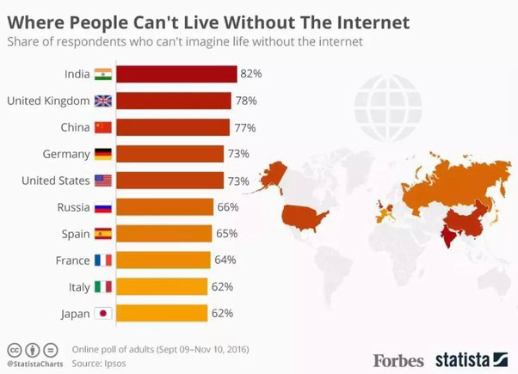

Whats wrong with this?

Source:FoxNews

Thescaleis0.5ontheyaxisbutthepointsare0.1
The8.6%onthefarrightishigherthanthe8.9%ontheleft

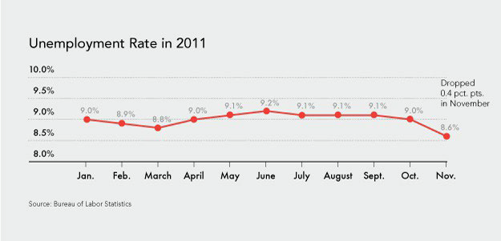

Correctedversion

Whatiswrongwiththis?

AttemptbyFoxNewstodemonstrateunder-representationofonesectionofpopulation atundergraduateeducationusingcategorisationsforethnicityfromUScensus.Whatiswrongwiththis?

In2015thiswasestimatedtobe55.7%white,14.2%black,22.3%Hispanic,and4.5%Asian orPacificIslander.

In201518-24yroldpopulationwasestimatedtobe55.7%white,14.2%black,22.3% Hispanic,and4.5%AsianorPacificIslander.
So now what can we conclude from the number spresented?

What about this?

- Addsupto485%
- Respondentscouldchoose morethanoneoption….
- Isthisthemostappropriate visualizationtouse?
- Doestheamountofthe ingredientshownreflectthe percentage?

- Comment
- Pie charts not a great way to represent statistics!!!

Meaningless, Unjustified Correlations or Inferences

Article - Meaningless Correlations –
  - Let's look at some correlations
  - https://www.tylervigen.com/spurious-correlations

Justify your Findings
- Look for source of data and context
- Be careful about using statistics to justify statements that may not hold in the real world( correlation does not mean causation)
- Examine the visuals (x, y axes, proportions, colours) Sample used
- Selective statistics-bias

Where can errors (or deceit) occur?
- Collection
  - While gathering the data
- Processing
  - When analyzing the data and its implications
- Presentation
  - When sharing your findings with others

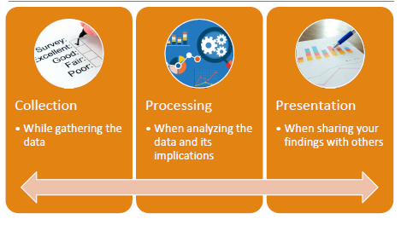

Common Mistakes
- Faulty Survey Design/Polling
  - Who, what, where, when and how?
- Insufficient Sample
- Flawed Correlation
  - Statistical correlation may be meaningless in the real world
- Misleading presentation of results
  - Particularly visualisation
- Selective Reporting
  - Focusing on only one particular time period/segment of population
- Data Fishing/Dredging
  - Trying to find relationships in data (not bad in itself) but with out a hypothesis (leads to bias)

Article - Reference – Statistical Inference enables bad Science Paper - A really useful paper
- Christopher Tong (2019) Statistical Inference Enables Bad Science; Statistical Thinking Enables Good Science, The AmericanStatistician,73:sup1,246261,DOI:10.1080/00031305.2018.1518264 >>
    - https://www.tandfonline.com/doi/full/10.1080/00031305.2018.1518264

Article - How many scientists fabricate and falsify research - Should we be worried?
- FanelliD. How many scientists fabricate and falsify research? A systematic review and meta-analysis of survey data. PLo S One. 2009;4(5):e5738.Published2009May29. doi:10.1371/journal.pone.0005738
- https://www.ncbi.nlm.nih.gov/pmc/articles/PMC2685008 /

- 2009 systematic review and meta-analysis found that 33.7% of scientists considered admitted to some form of questionable practice e.g.
  - Modifying results to improve outcomes
  - Subjective data interpretation
  - Withholding analytical details
  - Dropping observations because of gut feelings
  - If you look up this paper in Google Scholar and follow the citations of this paper (Cited by), you will find more recent studies that investigate this issue furthe

How do we avoid falling into these traps?

- Make sure you are asking the right question of the data
- And that you know what it is before you start
- No fishing!

Justify Approach and Questions - Most Important
- Make sure that you understand the conceptual framework of any research you use
  - To justify the question(s) you are investigating
  - To justify the approach you use
  - Or other work with which you compare your findings

At the end of the module, you will be able to
- Steps for a Statistical Analysis Project
  - Present the question you are interested in
    - In a way that makes sense to conduct a statistical analysis
  - Inspect and prepare the data you have
    - To support a valid and reliable statistical analysis
  - Describe the data you have
    - In a way that helps your audience understand any constraints the data may put on your analysis
  - Conduct a statistical analysis
    - Using appropriate statistical tests (for example, using R to execute the analysis)
  - Report on your statistical analysis
    - In a way that makes sense for your intended audience or consumer
  - Interpret the outcomes of your statistical analysis
    - Drawing appropriate and evidence-based conclusions
  - Report on the findings of your statistical analysis
    - In a way that makes sense for your consumer

Time for a break! -Next Step

- Getting started with R to help us describe our data

Time to get practicing - R

Install R and Your IDE

- Choose an IDE
  - R Studio
  - DataSpell
  - VSCode

Getting Started with R

- I will be using R and Rstudio during classes.
- Getting started with R and RStudio: https://education.rstudio.com/learn/beginner/

R

- R is a programming language
  - ◦“base” R
- ◦Comes with R out of the box, no extra packages.
- ◦Philosophy
  - ◦More “procedural” and function-based.
  - ◦Less opinionated than other languages: you can do the same task in many different ways.
- ◦Functions like mean(), sum(), lm(), plot().
  - lm() = linear model()
    - estimates the relationship between dependent variable (outcome) and one or more independent variables(predictors)
- ◦You manipulate data with vectors, matrices, lists, and data.frames.
- ◦You need to fully read and understand all the parameters and their values to understand what the code is doing

R – 2
- There are lots of different aspects of behaviour you will need to use.
- These are available as packages you can install as needed.
- Packages are collections of functions and datasets that add new features to R.
- Most R packages are available from CRAN, the official R repository – a network of servers (so-called mirrors) around the world.
- We will talk about how to install these packages in a later slide.

R-3
- R is a programming language
- ◦“tidyverse”
  - ◦A collection of add-on packages for working with different types of data.
- ◦There are separate functions for everything, which is perfect for code that relies on pipes
- ◦Pipes (|)
  - are operators that let you improve your code’s readability and restructure your code so that it is read from left to right instead of from the inside out
  - ◦Both ggplot2 and dplyr are part of the tidyverse, which are key data visualization and manipulation packages.

R Studio Interface
- The Environment pane
  - Where a list of the data you have imported and created can be found.
- The Files, Plots and Help pane
  - Where you can see a list of available files, will be able to view graphs that you produce, and can find help documents for different parts of R.
- The Console pane
  - Used for running code. This is where we’ll start with the first few examples.
- The Script pane
  - Used for writing code. This is where you’ll spend most of your time working

The Console pane (3)
- Used for running code. This is where we’ll start with the first few examples
- On startup this will show the R startup message and give you a prompt >
- You can type commands (code) directly into the Console and the results will be displayed below it or in the Viewer in the Files, Plots and Help pane (2)

- Or you can create scripts and execute them
- You will see the output in the Console and viewer
  - Or you can redirect your output to a file
- You can run a script line by line (hit CTRL + Enter or position the cursor on the line and hit run or )
OR
- Run the entire script (hit CTRL + Shift + Enter or select all the code and hit Run)

- You can install packages from the Console or within a script:
- install.packages("tidyverse")
- OR
  - in your IDE
    - R Studio Tools -> Install Packages
- In order to use the functions contained in the packages you need to load it
- library("tidyverse")

R Variables

- You can store data into variables using the <
  - operator
- E.g.
  - x < - 4
- You can see what is stored in the variable by inputting the variable name at the console
- Example:
‘’’{r}
income <- 100
taxes <- 20
net_income <- income - taxes
net_income
# You can use the variable/variables in functions e.g.
abs(income + taxes )
‘’’

Task 1 >
- Install the tidyverse package into your IDE (from the Console)
- Load the package (this will verify that it has successfully installed)

Task 2

- Try entering some commands at the console e.g.
‘’’{r}
1+1
2*7
sqrt(4)
‘’’

Working with Data
- We will usually want to work with sets of data
- We can create a single variable to handle a list of values of set of variables with values
- Vector
- Each item is an element. E.g.
age <- c(28, 48, 47, 71, 22, 80, 48, 30, 31)
# We can apply calculations to it
age * 12
# You can use it in functions e.g.:
min(age)
max(age)
sum(age)

- comment
  - c means it’s a separated list

Working with Data -2
- Usually we want to work with more than one variable
- In this case we use a dataframe
- We can use a second vector:
‘’’{r}
purchase <- c(20, 59, 2, 12, 22, 160, 34, 34, 29)
‘’’
- And combine it with age into a dataframe:

‘’’{r}
techsales <- data.frame(age, purchase)
‘’’

- If you enter techsales into the Console you should see each element in age displayed beside the equivalent element in purchase

Task 3

- Try out some of the tidyverse functions
‘’’{r}
# Example: Filtering rows in a data fame
filtered_data <- filter(techsales, age > 40)
filtered_data
#View all the data
view( techsales)
‘’’

‘’’{r}
# Create a categorical description using mutate
# add a new column, do mutation and put it into a new category
If > 100 put it in expensive
If between 20 and 100 reasonable
If < 20 = cheap
#%>% operator, known as the pipe operator, is used in the tidyverse
df_categorized <- techsales %>% mutate(
purchase_category = case_when(
purchase > 100 ~ "Expensive",
purchase <= 100 & purchase >= 20 ~ "Reasonable",
TRUE ~ "Cheap"
)
)
df_categorized
‘’’
- Comment
- Pipe operator = %>%
- The pipe operator (%>%) comes from the magrittr package (and is included automatically when you load the tidyverse).
- It’s used to chain together commands — sending the output of one function as the input to the next function.
- Think of it as saying “and then…”

‘’’

Getting Started

- Download the script MATH9102W1.R
- Put this somewhere you can find it and open it in your chosen editor
- We will review it section by section

SECTION ONE: INSTALL AND LOAD THE PACKAGES

Getting Started Interrogating the Dataset

SECTION TWO : SETUP THE DATAFRAME

SECTION THREE : LOOK AT THE DATA

Descriptive Statistics

USED TO SUMMARIZE OR DESCRIBE DATA FROM SAMPLES AND POPULATIONS

Measure of Central Tendency
- A descriptive statistic for quantitative data.
- A single number to serve as a representative value around which all the numbers in the set tend to cluster.

- Mode
  - ◦the value that occurs most frequently for a variable in a set of data
- Median
  - ◦the value in the middle; half of the values for a variable are larger than the median and half of the values are smaller than the median
  - ◦the middle value of a sequence of all the values in a distribution arranged from lowest to highest.
- Mean:
  - ◦the arithmetic average of a group of values; the sum of the values divided by the number of values.

Which do you use? Mean, Mode, Median?
Does it make a difference?

Mean, Mode, Median
- Sample Neighbourhood
- One Hollywood Star making 4,465,000 annually
- Five Professionals making 150,000
- One person earning 35, 000
- 20 people earning 10,000
  - MEDIAN =10,000
  - MODE=10,000
  - MEAN = 201,852

Measures of Dispersion
- Measure of Central Tendency needs to be considered in relation to the variability within the dataset.

- Measures of Dispersion are descriptive statistics that describe how similar a set of values are to each other (or the range of values)
  - The more similar the values are to each other, the lower the measure of dispersion will be
  - The less similar the values are to each other, the higher the measure of dispersion will be
  - In general, the more spread out a distribution is, the larger the measure of dispersion will be

- Comment –
  - Never just include mean/median/mode
  - Always include with our Measure of Central Tendency a Measure of Dispersion
  - Always go together – need appropriate measure
    - Mean + SD
    - Median + IQR
    - Mode + range

3 Measures of Dispersion - Range / IQR / SD(Variance)
There are three main measures of dispersion:
- The range
  - The difference between the largest value for a variable in a dataset and the smallest value
- The Interquartile Range (IQR)
  - Defined as the difference of the first and third quartiles divided by two
    - Order the data from least to greatest, Find the median
    - Calculate the median of both the lower and upper half of the data
    - The IQR is the difference between the upper and lower medians
- Variance/Standard Deviation
  - Concerned with how different values for a variable are from the mean

Variance

- Variance:
  - concerned with deviations from the mean (X-μ)

- Variance + Mean
- Use variance to get to standard deviation
- Variance – averge amount value is dispersed from mean
- First subtract the mean from each of the values gives use a deviate or a deviation value - how far a given value is from the typical, or average, value
- Then square the result
  - If we just added up the differences from the mean the negatives would cancel the positives
  - If we used absolute values we wouldn’t get an accurate measure of spread
  - Squaring is the best option
  - Variance is defined as the average of the deviations from the mean squared:

- ()NXorsΣ−=222μσ

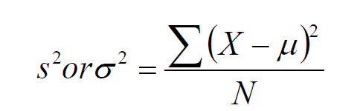

- N here is the degrees of freedom =the number of independent pieces of information on which the estimate is based

Standard Deviation

  - Standard Deviation:
    - the most useful and the most popular measure of dispersion.
  - Concept was first introduced by Karl Pearson in 1893.
  - Standard deviation = the square root of the Variance
  - Use Greek symbol sigma σ
  - The larger the value the more spread out around the mean the data is, smaller means less spread.
  - Allows us to see how spread out on average individual cases are from the mean

Standard Deviation - Example

- This is helpful in comparing samples.

- For example:
- Programme X and Programme Y have the same mean test value for Probability and Statistics
  - Same number of students in each data set
  - Dataset is well formed and representative (similar for both programmes)
- Does this mean that students on both programmes performed equally well?

Standard Deviation

- If the mean for Programme X is 60 and the standard deviation is 1.6
- then
  - if normal
  - 68% of the values in the dataset will lie between 58.4 and 61.6
    - MEAN-1SD(60-1.6=58.4) andMEAN+1SD(60+1.6=61.6)
  - 99.7% of the values will lie between55.2 and 64.8
    - MEAN-3SD(60-4.8=55.2) andMEAN+3SD(60+4.8=64.8)

- If the mean for Programme Y is 60 and the standard deviation is 4.3
  - If normal…
  - 68% of the values in the dataset will lie between 55.7 and 64.3
    - MEAN-1SD(60-4.3=55.7) andMEAN+1SD(60+4.3=64.3)
  - 99.7% of the values will lie between47.1 and 72.9
    - MEAN-3SD(60-12.9=47.1) andMEAN+3SD(60+12.9=72.9)

Standard Deviation - 2
- So now we can compare programmes in more detail
  - Programme X mean is 60
    - 68% of the values in the dataset lie between 58.4 and 61.6
    - 99% of the values in the data set lie between55.2 and 64.8
  - Programme Y mean is 60
    - 68% of the values in the dataset lie between 55.7 and 64.3
    - 99% of the values in the dataset lie between47.1 and 72.9
- What can you conclude about this?
- Comment
- Answer
  - Even if highest score may be in programme Y (we don’t’ know
0
  - On average programme X performed to the same level, and slightly better on average than prpgramm Y
  - Allows us to do meaningful comparisons across different datasets as logn as eveyrthign is same
  - Same measurement type, same conditions

Standard Deviation, IQR, Range
Sample Neighbourhood
- One Hollywood Star making 4,465,000 annually
- Five Professionals making 150,000
- One person earning 35, 000
- 20 people earning 10,000
- iqr =12,500
- range=4,455,000
- sd = 837,807

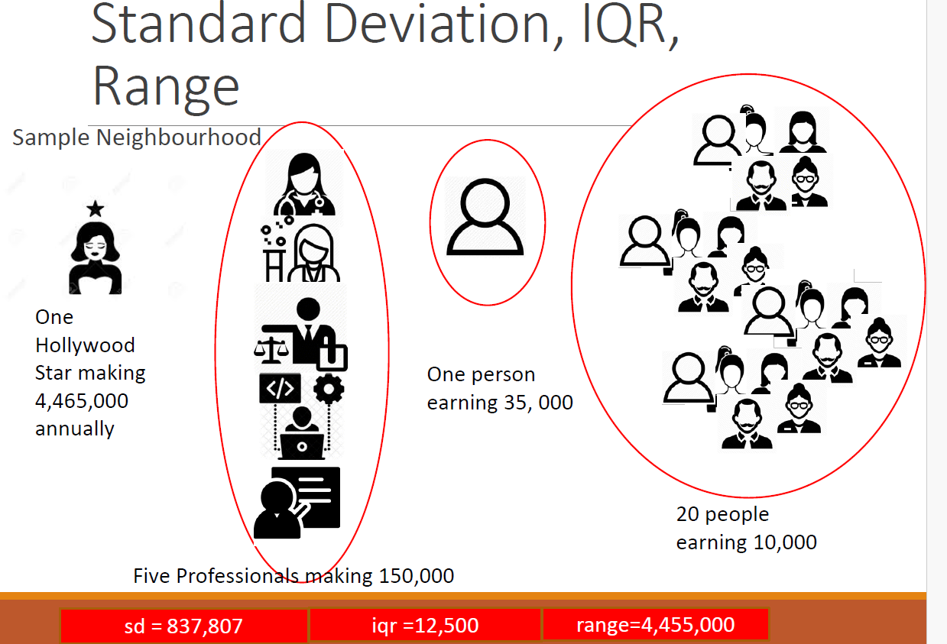

- Sample Neighbourhood
- One Hollywood Star making 4,465,000 annually
- Five Professionals making 150,000
- One person earning 35, 000
- 20 people earning 10,000

- MEAN = 201,852
- SD = 837,807

- MEDIAN =10,000
- IQR =12,500

- MODE=10,000
- RANGE=4,455,000

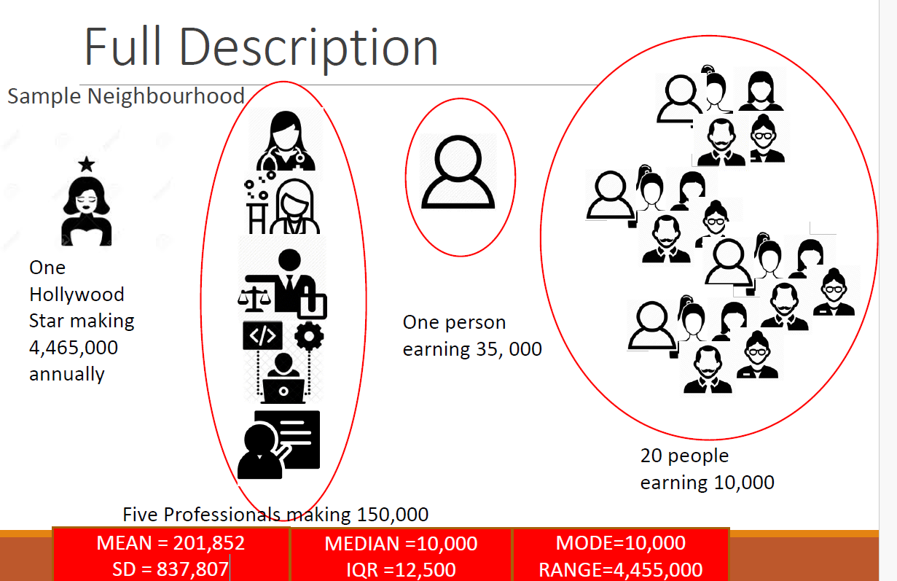

Getting Stared

- Open MATH9102W1.R
- SECTION FOUR: MEASURES OF CENTRAL TENDENCY
- SECTION FIVE: MEASURES OF DISPERSION

Lab - Exerises
- Instructions available in the file MATH9102-Lab-Instructions-W1.docx
- Solution - MATH9102W1.Soln.R

‘’’{r}
---
title: "R Notebook"
output: html_notebook
---

This is an [R Markdown](http://rmarkdown.rstudio.com) Notebook. When you execute code within the notebook, the results appear beneath the code.

Try executing this chunk by clicking the *Run* button within the chunk or by placing your cursor inside it and pressing *Ctrl+Shift+Enter*.

```{r}
plot(cars)
```

Add a new chunk by clicking the *Insert Chunk* button on the toolbar or by pressing *Ctrl+Alt+I*.

When you save the notebook, an HTML file containing the code and output will be saved alongside it (click the *Preview* button or press *Ctrl+Shift+K* to preview the HTML file).

The preview shows you a rendered HTML copy of the contents of the editor. Consequently, unlike *Knit*, *Preview* does not run any R code chunks. Instead, the output of the chunk when it was last run in the editor is displayed.

```{r}
#SECTION ONE: INSTALL AND LOAD packages

# Define a helper function `quiet_library`:
# - Takes a package name as input
# - Installs the package if it is not already installed
# - Loads the package while suppressing warnings and messages
quiet_library <- function(pkg) {
suppressMessages(suppressWarnings({
if (!requireNamespace(pkg, quietly = TRUE)) {
install.packages(pkg, quiet = TRUE) # Install without messages
}
library(pkg, character.only = TRUE) # Load silently
}))
}

# Load required packages (install if missing)
quiet_library("tidyverse") # for data wrangling and visualization
quiet_library("carData") # companion datasets for the 'car' package
quiet_library("gtsummary") # for creating publication-ready summary tables
quiet_library("flextable") # for customizable tables in reports
quiet_library("officer") # needed for flextable advanced customization

```

```{r}
#Load it into a dataframe
msleepdata<-ggplot2::msleep

# Get the names of the variables in the dataset
names(msleepdata)
```
```{r}
#b. Try out exploring the data using some of the functions covered in SECTION THREE in MATH9102W1.R (names, str, summary)
summary(msleepdata)
str(msleepdata)
spec(msleepdata)
head(msleepdata)
tail(msleepdata)
nrow(msleepdata)
ncol(msleepdata)

```

#-----------------------------------------------------------------------------------------------

```{r}

#=-=============SECTION THREE: LOOK AT THE DATA=================

#Get a list of all variables in the dataset using colnames
names(msleepdata)

#You can look at the data in a variable by entering its name at the command prompt
msleepdata$sleep_total #total amount of sleep in hours

#You can use the str function to get an overview of the variable
str(msleepdata$brainwt) #brain weight
str(msleepdata$bodywt) #body weight

#Use summary to get a relevant statistical summary for a variable
summary(msleepdata$vore) #carnivore,herbivore etc

#For numerical data - this will give use median, mean, IQR, max and min for the salary as it is a scale
summary (msleepdata$brainwt)

#Or get a summary of all the variables in the dataset
summary(msleepdata)

#The distribution of observations across mammalian foraging types
table(msleepdata$vore)

#To see investigate the conservation status by vore type

#We start by creating a table
table(msleepdata$conservation, msleepdata$vore)

#Then we can look at the proportions
proportions(table(msleepdata$conservation, msleepdata$vore))

# Show the proportion of each conservation status for each vore type (Row wise proportions)
# e.g. Critically Endagered Carnivore: 50%, Domesticated Herbivore: 70%
proportions(table(msleepdata$conservation, msleepdata$vore),margin = 1)

# Columnwise proportions
proportions(table(msleepdata$vore, msleepdata$conservation),margin = 1)

#Using the gtsummary package using pipes to create a prettier version of the table
msleepdata |>
select(conservation, vore) |>
gtsummary::tbl_summary()

#Showing proportions
msleepdata |>
select(conservation, vore) |>
gtsummary::tbl_summary(
statistic = list(all_categorical() ~ "{n} ({p}%)") # Show counts and proportions
)

#Using flextable to create a version that can be saved to a file
msleepdata |>
select(conservation, vore) |>
gtsummary::tbl_summary(
by = conservation, # Group by conservation
statistic = list(all_categorical() ~ "{n} ({p}%)")) |> # Show counts and proportions
gtsummary::as_flex_table() |> # Convert the table to a format that can be exported
flextable::save_as_docx(path = "my_table.docx") # Save the file
#By default this will be saved in your default working directory
#To check where this is in the Console pane enter the command getwd()

# Create styled flextable
msleepdata |>
select(conservation, vore) |>
tbl_summary(
by = vore, # group by vore type
statistic = list(all_categorical() ~ "{n} ({p}%)")
) |>
as_flex_table() |>
theme_vanilla() |> # start with a clean theme
border_outer(part = "all", border = fp_border(color = "black", width = 2)) |> # thick outer border
border_inner_h(part = "all", border = fp_border(color = "darkblue", width = 1)) |> # horizontal lines
border_inner_v(part = "all", border = fp_border(color = "darkblue", width = 1)) |> # vertical lines
color(color = "white", part = "header") |> # white text in header
bg(bg = "darkblue", part = "header") |> # dark blue header background
bold(part = "header") |> # bold header text
autofit() |>
save_as_docx(path = "my_fancy_table.docx")
#By default this will be saved in your default working directory
#To check where this is in the Console pane enter the command getwd()

#------------
```

```{r}
# --categorical summaries and table creation--
#c. Try out creating tables using some of the functions covered in SECTION THREE in MATH9102W1.R (table, proportions, gtsummary::tblsummary, flextable)
# i. Potential variables to use genus and vore, vore and conservation e.g. conservation and vore, sleep_total

# Frequency table of vore (diet type)
table(msleepdata$vore)

# Cross-tabulation of vore and conservation
table(msleepdata$vore, msleepdata$conservation)

```{r}
# 📊 2. Using prop.table()
# prop.table() converts a frequency table into proportions (i.e., percentages).

# Overall proportions
prop.table(table(msleepdata$vore))

# Proportion by row or column
prop.table(table(msleepdata$vore, msleepdata$conservation), margin = 1) # by vore
prop.table(table(msleepdata$vore, msleepdata$conservation), margin = 2) # by conservation
```

```{r}
# 📋 3. Using gtsummary::tbl_summary()
#
# This produces publication-quality summary tables — especially great for reports.
# Install if needed
# install.packages("gtsummary")
library(gtsummary)

# Summary of categorical variables
msleepdata %>%
select(vore, conservation) %>%
tbl_summary()

# you cna add continuous variables too
# This gives you mean, median, and IQR of sleep_total grouped by diet type (vore).
msleepdata %>%
select(vore, sleep_total) %>%
tbl_summary(by = vore)

```

```{r}
#🪶 4. Using flextable
#To turn a simple table into a nicely formatted one for Word, PowerPoint, or HTML reports:

# install.packages("flextable")
library(flextable)

# Create a table of vore vs conservation
tab <- table(msleepdata$vore, msleepdata$conservation)

# Convert it to a flextable
ft <- flextable::qflextable(as.data.frame(tab))
ft

#or directly
ft <- flextable(as.data.frame(tab))
ft <- autofit(ft)
ft

```

```{r}
<!-- 🧠 Summary of Each Approach -->

| Function | Purpose | Output Type |
| -------------------------- | ------------------- | ------------------------------------- |
| `table()` | Counts | Basic R table |
| `prop.table()` | Percentages | Numeric matrix |
| `gtsummary::tbl_summary()` | Descriptive summary | Publication-style table |
| `flextable()` | Nicely formatted | Report-ready table (Word, HTML, etc.) |

```

```{R}
-------------------------------------------------------------------------------
# =========SECTION FOUR: MEASURES OF CENTRAL TENDENCY==========
#Median

median(msleepdata$sleep_total) #total hours sleep

#Mean
mean(msleepdata$sleep_total)

#You can assign the outcome to a variable
meansal <- mean(msleepdata$sleep_total)

#and then display it on screen
meansal

#Mode
#R doesn't have a built in function to compute the mode but there is a simple function which you can write and include in your code that will do it for you")

getmode <- function(v)
{
uniqv <- unique(v)
uniqv[which.max(tabulate(match(v,uniqv)))]
}

#Use the function to get the mode of total sleep hours
getmode(msleepdata$sleep_total)

#---------------------------------
```

```{r}

# >>>>>> Central Tendency functions- <<<< below -- next 5 below
# 1️⃣ Mean
#
# The mean (average) is calculated using mean().
# Mean total sleep (in hours)
mean(msleepdata$sleep_total, na.rm = TRUE)
```

```{r}
# 2️⃣ Median
#
# The median is the middle value when data are sorted.

median(msleepdata$sleep_total, na.rm = TRUE)
```

```{r}
# 3️⃣ Mode
#
# R doesn’t have a built-in mode function, but you can find the most frequent value using:

# Simple custom mode function
mode_func <- function(x) {
ux <- na.omit(unique(x))
ux[which.max(tabulate(match(x, ux)))]
}

# Example: mode of vore (diet type)
mode_func(msleepdata$vore)
```
```{r}
# 4️⃣ Summary of a Variable
#
# You can quickly view several central tendency stats at once with:

summary(msleepdata$sleep_total)
```
```{r}
# 5️⃣ Grouped Central Tendency (using tidyverse)
#
# You can calculate central tendency by category — e.g., average sleep by diet type (vore):

library(dplyr)

msleepdata %>%
group_by(vore) %>%
summarise(
mean_sleep = mean(sleep_total, na.rm = TRUE),
median_sleep = median(sleep_total, na.rm = TRUE),
count = n()
)
```

```{r}
#========== Solution============================
# ----- SECTION FOUR: MEASURES OF DISPERSION----
#Range
range(msleepdata$sleep_total)

#Quantiles
quantile(msleepdata$sleep_total)

#to get 1st quantile
x=quantile(msleepdata$sleep_total); x[1]

#Interquartile Range
IQR(msleepdata$sleep_total)

#Variance
var(msleepdata$sleep_total)

#Standard deviation
sd(msleepdata$sleep_total)
#Rounded
round(sd(msleepdata$sleep_total,2)) #rounded to 2 decimal places
```

```{r}
# 📊 Dispersion Functions in R
#
# Dispersion (or variability) measures how consistent or variable your data values are.
#
# Common dispersion measures:
#
# Range
#
# Variance
#
# Standard deviation
#
# Interquartile range (IQR)
#
# Minimum / Maximum

```

```{r}
1️⃣ Range

The range is the difference between the maximum and minimum values.

# Range of total sleep
range(msleepdata$sleep_total, na.rm = TRUE)

# Difference between max and min
diff(range(msleepdata$sleep_total, na.rm = TRUE))
```

```{r}
2️⃣ Variance

Variance measures the average squared deviation from the mean.

var(msleepdata$sleep_total, na.rm = TRUE)
```

```{r}
3️⃣ Standard Deviation

Standard deviation is the square root of variance, measuring spread in the same units as your data.

sd(msleepdata$sleep_total, na.rm = TRUE)
```

```
4️⃣ Interquartile Range (IQR)

IQR = difference between the 75th percentile (Q3) and 25th percentile (Q1).
It’s a measure of the middle 50% of your data

IQR(msleepdata$sleep_total, na.rm = TRUE)
```

```{r}
5️⃣ Five-Number Summary

You can get a quick summary of spread with summary():

summary(msleepdata$sleep_total)
```

```{r}

6️⃣ Grouped Dispersion (using tidyverse)

You can calculate measures of spread by group (e.g., by diet type):

library(dplyr)

msleepdata %>%
group_by(vore) %>%
summarise(
mean_sleep = mean(sleep_total, na.rm = TRUE),
sd_sleep = sd(sleep_total, na.rm = TRUE),
var_sleep = var(sleep_total, na.rm = TRUE),
iqr_sleep = IQR(sleep_total, na.rm = TRUE),
range_sleep = diff(range(sleep_total, na.rm = TRUE))
)
```

```{r}

| Function | Measure | Description |
| --------------- | ----------------------- | ------------------------------ |
| `range()` | Range | Min and max values |
| `diff(range())` | Range width | Max − Min |
| `var()` | Variance | Average squared deviation |
| `sd()` | Standard deviation | Square root of variance |
| `IQR()` | Interquartile range | Q3 − Q1 |
| `summary()` | Quick descriptive stats | Min, Q1, Median, Mean, Q3, Max |

```

Here Endeth the First Lesson…
SEE YOU NEXT WEEK!

Week 2 – Describing and Visualizing Data

The Process

- Comment
  - Last week did you process
    - Starts with a question
      - Comes from
        - observation of data
        - research
        - somethg fro our own experience
      - Everything gets driven from this
  - Suitable to use data analysis to provide an answer to that question
  - Type of question we’re interested in is >>> something we can derive theory
  - A theory in this context is something that will be testable using evidence
  - We would Need data to build that evidence from
  - Rather than providing a proof or evidence that would support an entire theory
    - We Break it into smaller subsets called hypothesise
      - We examine each of those hypothesise separately
      - And test to see have we got evidence to see if we can support each of those hypothesise
    - Once we have that clarified and done we will have clear picture of concepts involved in this theory
    - Will work then from those concepts to find data
    - That we can actually fins to test our theory
      - What variables we need
      - What Measurements we need
      - Once we have those
        - Describe it
        - Analysie it
        - Ultimately Fit a model that demonstrates our theory in action
    - So remember we always start with a question
      - The Question gives us our conceptual framewoek
      - Once we understand the concepts
      - We can start thinking how we represent them in terms of data
      - And whaty we need to do to actually get data into our dataset to do it
      - We can make lots of different choices but choices must be driven by our research question

Data Analysis Pipeline

- Plan >>
  - Whats our question?
  - Whats our Theory?
  - Whats our hypothesis?
  - What are our concepts ?
  - What do we need to collect?

- Collect >>>
  - What are our concepts and what do we need to collect
  - Might just involve finding secondary data that fits our purpose
- Explore >>
  - First f all to understand whats going on
  - May have to clean
  - Once have ful understanding
- (Clean) >>
- Describe and Visualize >>
  - As exporing build
  - St descriptinos
  - Build visualizations
- Model >>
  - Has to be interepreted
- Interpret >>
  - Has to be expressed in how it relates t the question
- Communicate
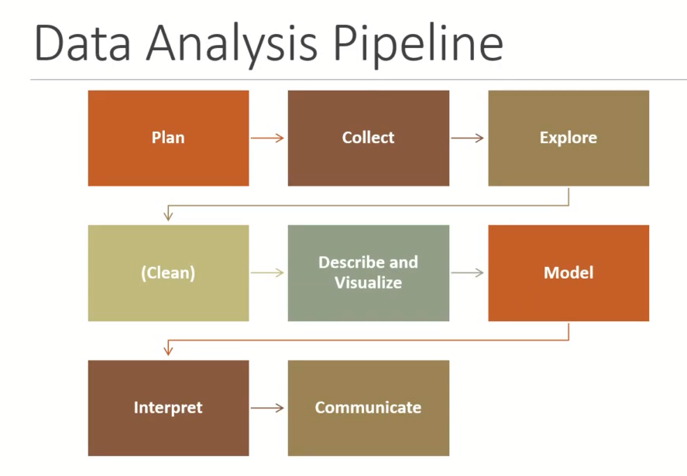

Getting Started With Statistical Study Conceptual Framework

Before you start
  - You need to decide your research question and the nature of the study
  - Then decide what individuals or objects are of interest
  - Conceptual Framework
  - You need a detailed understanding of the data needed to conduct the analysis
  - Create a careful advance plan of data collection/manipulation
  - Choose the correct analytic approach is needed to answer the question under investigation in a scientific way

Start with understanding the Population

- All possible cases that meet certain criteria.
- The total collection of cases that you are interested in studying
- Usually constantly changing, difficult to collect

Work with a sample (set of samples)
- Subset or portion of the population
- Substitute for the population
- Representativeness and size are key

A statistical experiment or observation
- is any process through which measurements are obtained.
- We conduct the experiment and generate data about the person, place, thing, situation or idea which is the subject of our theory

Experiments

- An experiment is a procedure we conduct working with an appropriate sample sample with the intention of conducting an analysis of that sample to make some decisions about our question(s) of interest for our population of interest.

- Experiments can be:
  - Observational studies (observing and recording data about concepts of interest)
    - Example: A researcher records the number of hours university students spend in the library each week and compares it with their GPA.
    - Key point: No intervention, just observing naturally occurring behaviour.

  - Surveys (using questions to elicit data about concepts of interest)
    - Example: Participants complete a wellbeing questionnaire (like survey.dat) where they report on stress levels, optimism, and smoking habits.
    - Key point: Data is elicited directly through structured questions.
  - Scientific experiments (under controlled conditions may involve manipulation of some concepts)
    - Example: Researchers randomly assign participants to two groups.
      - Group A listens to relaxing music for 20 minutes.
      - Group B sits in silence for 20 minutes.
    - After the session, both groups complete a validated stress scale questionnaire (empirical measurement of perceived stress), and their heart rate variability is recorded using a monitor (physiological empirical measurement).
    - The goal is to test whether music reduces stress compared to silence.
    - Key point: Researcher manipulates a condition and controls the environment.
  - Meta-analytical studies (combining findings of other statistical experiments)
    - Example: A systematic review collects results from 50 published studies examining whether smoking is linked to life satisfaction, then applies statistical methods to combine the findings into one overall effect size.
    - Key point: Integrates and re-analyses data/results from multiple independent studies.

- For an experiment we identify concepts/criteria of interest.
- These need to be represented these in our sample
- Data must be collected to represent these concepts
- A

variable/feature
- Represents a concept of interest in an experiment
  - Describes or quantifies an aspect of a person, place, thing, situation, or idea.
- Takes on a statistical type appropriate for that concept of interest?
  - Why do we care about the type?
    - Different statistical procedures/techniques suit different types of variables
- The value of a variable can "vary" from one entity to another.
- A variable is random if the value it takes on in an experiment or observation is determined by chance.
- Your job is to ensure your design is sufficiently robust that this is what happens when we create our sample.

Selecting Variables for your study
- Looking for indicators that represent your
- concepts of interest.
- You need to ensure the indicators chosen
- demonstrate:
- ◦

Reliability
- Degree to which an indicator is a consistent measuring device
  - E.g.
    - Is asking a student how well they did in school a reliable indicator of their ability to learn?

Validity
- Extent to which an indicator measures what it is intended to measure
  - E.g.
    - Is a student’s IQ value a valid indicator of their educational achievement?

Variables

Some we measure indirectly
- Sometimes it is not possible to measure something directly, so we work with approximations
  - E.g. psychological tests are approximate measures
- Sometimes there will be a difference between values we use to represent a thing we are measuring and the actual value of the thing
- We must always be aware of Measurement error

Some we control for

- Recognising that some measurements are influenced by other factors which we may also have measured
  - Confounding variables
  - Attributing too muich to a variable as ignoring a confounding variable

May also be:
- Things we can manipulate to derive a measure for other concepts
  - E.g. Dimension Reduction
- Things we can compute from measures of other concepts
  - E.g. Using a set of variables as a scale or index

Variable Types

  - Determine the types of measurement that each variable can hold

Qualitative (Attribute or Cetegorical )
- Variable categorizes or describes an element of a population.
- Take on values that are names or labels
  - ◦E.g.
  - ◦Hair Colour (Black, Light-Brown, Dark-Brown, Gray, Red, Blonde)
  - ◦Creativity (Very Creative, Somewhat Creative, Not Creative)
  - ◦Grade (A, B, C, D, E, F)
  - ◦Grade Point (1, 2, 3, 4)

Qualitative, or Attribute, or Categorical, Variable
- Can be coded numerically but the numbers are meaningless
  - E.g.
  - •EU Citizenship (1, 2) where 1 = EU, 2 =Non-EU
- But numbers are acting solely as labels
- Therefore, arithmetic operations, such as addition and averaging, are not meaningful for data resulting from a qualitative variable.
  - E.g., Person 1 (EU Citizenship value1) + Person 2 (EU Citizenship value 1)
  - This does not mean we can add the values for EU Citizenship for Person 1 and Person 2

Nominal
- Data can be assigned to a category
  - Country of Origin: 1=Ireland, 2=India, 3=…….
  - Mode of travel to work: 1=Car, 2=Cycle, 3=Walk, 4=Bus
- Arithmetic does not make sense on numeric labels

Ordinal
- There is a ranking associated with the variable. Data can be ordered from smallest to largest, best to worst etc.

- Arithmetic does not make sense on numerical labels
  - Examples
  - Ranking: 1st, 2nd, 3rd
  - Likert Scale: psychometric scale commonly involved in research that employs questionnaires. 1=Strongly Disagree, 2=Disagree, 3=Neither Agree or Disagree,4=Agree, 5=Strongly Agree

Quantitative (Numerical Variable)
- A variable that quantifies an element/characteristic of a population.
- Observations or measurements take on numerical values
  - Note:
    - ◦Arithmetic operations such as addition and averaging, are meaningful for data resulting from a quantitative variable.

Quantitative, or Numerical, Variable (Broad Types)

Discrete
- Variable can assume only a finite number of real values within a given interval
- •Usually counted
- •Can only take certain values
  - E.g., Score given by a judge to a gymnast in competition.
- •Range is 0 to 10 and the score is always given to one decimal (e.g. a score of 9.5)
  - E.g. #students attending class.
- •This is count data. The number of possible values is the #num of students enrolled.
  - •e.g. if this is 20, implies that there are 20 possible values

Continuous
- Variable that can be any value in a given range
- Usually measured
- E.g. , Heights of students attending class
- •Can’t be any values, can’t be negative, can’t be higher than three metres. BUT on the scale between 0 and 3, the number of possible values is theoretically infinite;
- E.g., Time spent concentrating in class
- •Can’t be any values, can’t be negative, can’t be higher than 180mins. BUT on the scale between 0 and 180, the number of possible values is
- •Theoretically infinite.

Interval

- Data is ordered but there is meaning between the values of order
- •The distance between two points on the scale is standardised and equal
- •Allows comparison between the data values
  - •Can be added and subtracted. (not multiplied or divided)

  - E.g., Temperature (Farenheit), temperature (Celcius).
    - •The difference between 10° and 20° is quantitatively the same as the difference between 20° and 30°
  - E.g., IQ Test. No one can have an IQ of zero (according to studies so it is not ratio).
- Therefore, the difference between an IQ of 110 and 115 is quantitatively the same as the difference between an IQ of 115 and 120.

Ratio
Has all the properties of interval data
- •Has an absolute 0
- •It makes sense to say for example one value is twice as large as another
- •Can be added and subtracted, multiplied and divided.
- PLUS
- •4 is also twice as much as 2.
  - E.g., The difference between 1 and 2 is the same as the difference between 3 and 4

- Is A persons age is ratio!!!
  - Technically YES.
  - ◦Does have a zero and
  - ◦(if measured with the required accuracy) is continuous
  - Practically, IT DEPENDS
  - ◦Need to consider the measurement
  - ◦Culture?
  - ◦Age categories?
  - ◦Age as a discrete count (e.g. number of years)?

Variables and Data

- Statistical analysis revolves around the “collection, organization, and interpretation of data according to well-defined procedures.”
- ◦Kachigan, S. K. (1991). Multivariate statistical analysis: A conceptual introduction (2nd ed.),New York: Radius.
  - Data
    - : information about different variables.
  - Data point
    - : individual piece of information related to one variable.
  - Dataset
    - : collection and organisation of information relative to specific variables
  - Data distribution
    - : a listing of the values or responses associated with a particular variable in a data set.
- Frequency distribution:
    - a table or graph that indicates how many times a value appears in a dataset of values.
- We must be able to describe our sample
  - Be able to describe it simply
    - Using the appropriate summary statistics for the variables of interest
- Be able to represent it visually
  - Using the appropriate type of graph/plot for variables of interest
- Then we will be able to analyse it appropriately
  - Using the appropriate statistical tests to draw inference

Important Step – describing your data
- Must describe before analyzing
- Need to include sufficient detail that your consumer can
  - See what you are basing your analysis/conclusions on
  - Understand anything that may constrain those analysis/conclusions
- You are trying to present information about a large body of data so that your consumer/reader can understand it without having to view every individual case you have collected

Reporting your data
- Put yourself in the readers shoes
- Are you providing enough information to make the experiment/analysis reproducible?
- Have you made clear any assumptions, sources of potential bias, mechanisms used to overcome flaws in the sample?
- Have your provide references to any sources used?

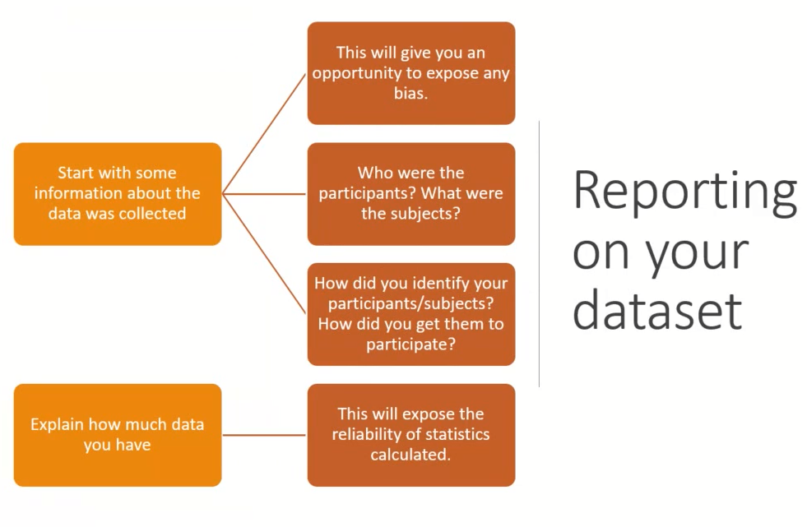

Start with some information about the data was collected
- This will give you an opportunity to expose any bias.
  - Who were the participants? What were the subjects?
  - How did you identify your participants/subjects? How did you get them to participate?
  - Explain how much data you have
- This will expose the reliability of statistics calculated.
  - Example. The participants in this study included 134 cisgender men between 18 and 25 years old attending electronic engineering undergraduate degree programmes in a university in Dublin. All participants were fluent in English, and first-generation college students.

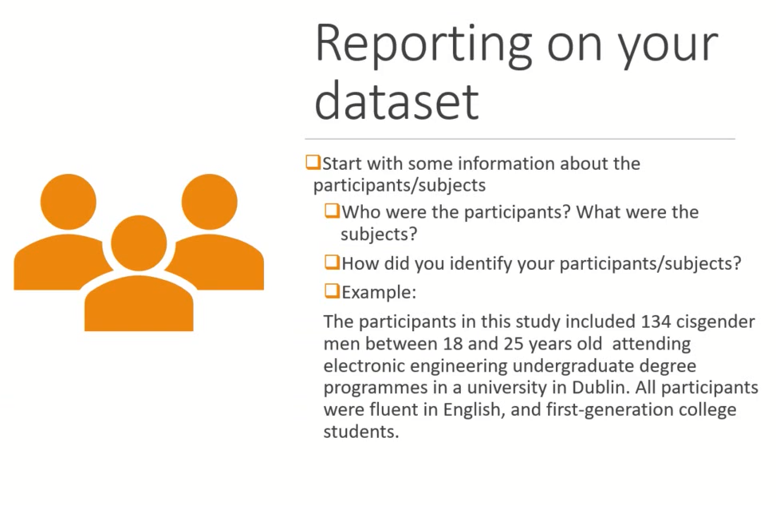

- >>

Explain your sampling procedure. How did you decide what to include/exclude?
- Did you invite participants? Were incentives provided? Did you need permission to conduct the study?
-  Is it a secondary data source? If so what do you know about how it was collected.
  - Example:
  - Ethics approval was obtained from the University Ethics committee before any participants were recruited. Current first-generation college students were invited to participate. The study was advertised through general emails sent to university-wide mailing lists, social media posts, and flyers across campus. Participants were self-selected and compensated with a voucher for their participation in the hour-long study.

Explain any procedures used in the data collection.
- The design of the instruments/mechanisms used
- Measures of reliability and validity
- All participants were informed that the survey concerned students’ general knowledge and would take a maximum of thirty minutes. After arriving at the laboratory individually, they were assured confidentiality, and they provided informed consent.
- Participants were randomly assigned to a control or experimental condition. To begin, all participants were given the AAI and a demographics questionnaire to complete, followed by an unrelated filler task. In the control condition, participants completed a short general knowledge test immediately after the filler task. In the experimental condition, participants were asked to visualize themselves taking the test for 3 minutes before they actually did. For more details on the exact instructions and tasks given, see supplementary materials.

State the variables and their statistical type.

  - You only need to describe the variables for the concepts of interest
  - We are nto talig about variables >>> we are talking about concepts of interest
    - explain them
            - > what they are, statistical type
            - > how mcuh data we have
            - > driving the measure
            - > how much we have in the dataset and what values it could take
  - For each variable
      - State how much of it you have
      - You will be missing some data, and you need to acknowledge that (we will learn how to address this later)
      - State how you derived the measure (and if necessary, provide measures of validity and reliability)
  - You need to provide some information on the potential values that variables can take.

Case Studies

CS 1 : Psychological Adjustment and well being of respondents in Melbourne Australia

- Dataset: survey.dat
- This is a real data set condensed for use by Julie Pallant to accompany her book Surviving Statistics.
- This dataset contains data collected from respondents who completed a survey as part of a study to explore the factors that impact on respondents' psychological adjustment and wellbeing.
- This dataset contains data collected from 439 respondents who completed a survey as part of a study to explore the factors that impact on respondents' psychological adjustment and wellbeing.

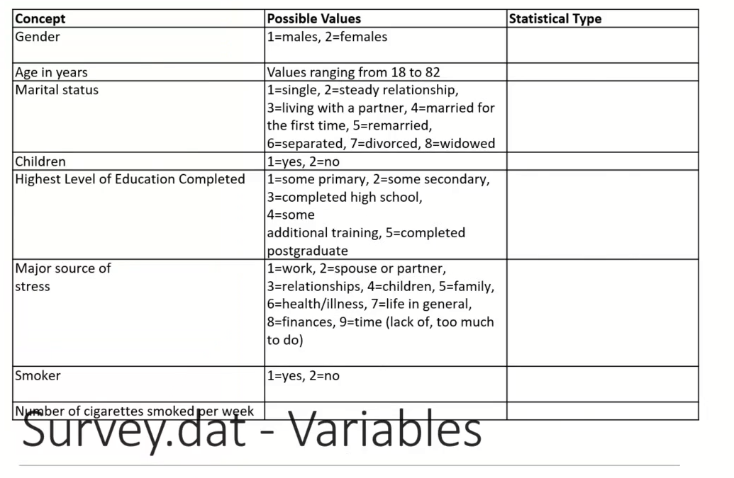

Label Variable Types
- Comment
  - Question 1 - is gender > as represented in this dataset
    - Is it
    - nominal
    - Ordinal
    - Interval
    - Ratio
  - Answer >>> gender = nominal!!
    - Question
  - Question 2 - What statistical type is age? Values aneg frpo 18 to 82
    - Nominal
    - Ratio
    - Answer – age is technically = ratio or interval for this
    - If it was nominal the only 2 valeus you could have chosen from were 18 and 82
    - If ordinal then needs to eb some order to categpriatio then have all values from 18 to 82 represented.
    - If vategorical would need to have full range from 0 to 82
  - Question 3 – highest level of education
    - Nominal
    - Ordinal
    - Answer = highest level of education = ordinal (as some degree of organization or ordering)
  - Remainder of variable types
    - Marital Status = Nominal
    - Children = Nominal (as can only be yes or no)
    - Major levels of stress = nominal
    - Smoker = nominal
    - Number of cigarettes smoked per week = Scale variable = ratio
    - Have age group categories (1=18-29yrs, 2-30-44 yrs, 3=45+ = nominal
      - In one or another category can’t be in more than 1 at any one time.

Concept
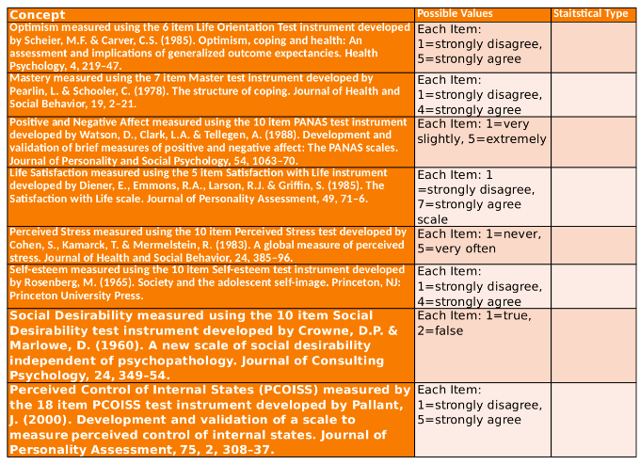
Ratings in data above

Questionaire Types - Likert and MCSDS

- How do we measure aspects of pyscholopgical well being
  - Measure using psychological instrument
  - Optimism – using
    - 6 Item Life Orientation test
    - Each item could strogly kdisagree upt to 1
    - 1 strongly disagree
    - Etc
    - All Likert style….

======================================================================
From chatgpt…
A Likert-style question asks respondents to indicate their level of agreement, frequency, importance, or satisfaction with a statement.
It typically uses a scale with ordered response options, such as:
“I find it easy to concentrate at work.”
- 1 = Strongly disagree
- 2 = Disagree
- 3 = Neutral
- 4 = Agree
- 5 = Strongly agree
Likert style questions >>>> Always Ordinal!
Only one not ordinal is social desirability below MCSDS
==========================================================================

🧠 What Is the Marlowe–Crowne Social Desirability Scale (MCSDS)?
The Marlowe–Crowne Social Desirability Scale is a psychological questionnaire designed to measure social desirability bias — that is, the tendency for people to respond to questions in a way that makes them look good according to social norms, rather than answering honestly.
- 📅 Developed: 1960
- 👨‍🔬 By: Douglas P. Crowne & David Marlowe
- 🧩 Purpose: To assess whether respondents are likely to give socially acceptable answers instead of truthful ones.

MCSDS >> is always scale measure with each item given true or false => = nominal variable

==============================================================================

- Now have all the data and classified - how do we use it?
- We have
  - 6 variables for optimism
  - 10 variables for perceived stress
- => Very awkward if doing analysis
- => Use statistics to distill them down into single variable….
  - So single measure for each one of those items

Dimension reduction

- How would we work with all these Ordinal variables?
- We have lots of different items for all the psychometric scales
- Conducting individual analyses would be very time -consuming and may not be the focus of the study.
- We need a way to establish a single measure for each of the major concepts.
- This is where dimension reduction comes in (we will work on that later in the module).
- In the dataset survey.dat measures have already been calculated for each one of these (as scale variables):

“
tposaff" "tnegaff" "tlifesat" "tpstress" "tslfest" "tmarlow"
"
tpcoiss" “toptim” “tmast”
- And All of these are Ratio variables

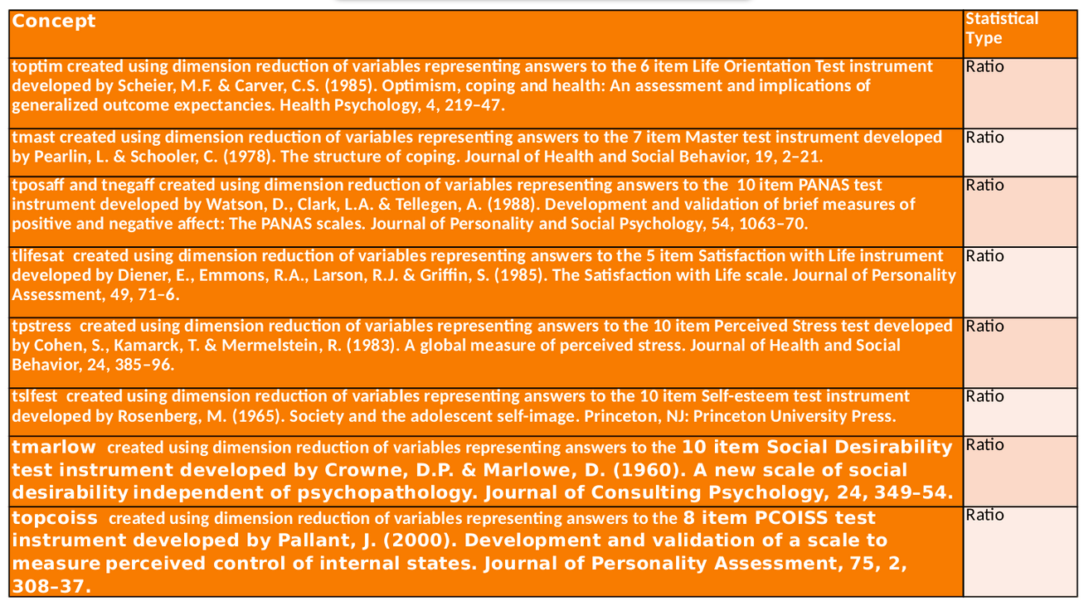

What Questions do we ask?

- Does optimism predict life satisfaction, controlling for stress and self-esteem?
- Do age, gender, optimism, and life satisfaction predict whether someone is a smoker (yes/no)?
  - AGE
  - GENDER
  - TOPTIM
  - TLIFSAT
  - SMOKE

What Variables do we choose to answer the questions?
- What variables do we need from our survey dataset?

- Question 1: Does optimism predict life satisfaction, controlling for stress and self-esteem?
  - Variables
  - TOPTIM – total optimism
  - TLIFESAT – life satisfaction
  - TPSTRESS – life stress
  - TSLFEST – self esteem
- Question 2 : Do age, gender, optimism, and life satisfaction predict whether someone is a smoker (yes/no)?
  - Variables
    - AGE
    - GENDER
    - TOPTIM - optimism
    - TLIFSAT – life satisfaction
    - SMOKE

Describe each Variable
- Quantitive
  - Measure of Centre = mean, median, mode
  - Measure of Spread = range , SD, IQR,
  - Shape = distribution, - normal /skewed, outliers, multimodality
- Quantitive
  - Distribution across categories for qualitative data

Samples and Population- Again

CS 2: Mean Length of Fish in Lough Mask

- Comment
  - Parameter – is a fixed value abuot a population that we don’t know
  - Poll - mean length of fish in lough mask…
  - Answer = 1
  - We just don’t know it…
  - Can we find it out?
    - Measure all the fish
    - Can’t some will die / born etc
    - So calaulate a statistic form a sample and use as an estimate for a population mean
    - Calculate mean of each sample
    - then
    - get mean of the mean

Going beyond on the Data

- We ideally want to collect data from all members of the population
- ◦But can’t
- We usually collect a number of samples
- ◦Each sample could have a different mean

Sampling variation
  - Variation in the observed values of the sampling statistic
  - We can plot the sample means into a frequency distribution
    - Sample distribution

The Sampling Distribution
- Any statistic, being calculated from a sample, will vary between samples and consequently will have a distribution
- Consider the mean
  - If it is calculated repeatedly for different samples drawn from a population, these values of the mean will vary and will be distributed in some way
  - ◦The distribution of a statistic is called a sampling distribution
  - ◦This has a standard error (corresponding to the standard deviation of a value distribution)
  - ◦And has an expected value (corresponding to the mean of a value distribution)
  - Ie.. getting mean of height of students in a class
    - We’d calculate the std deviation of the height aswell as the mean

- So what?
  - If we have enough samples, we can get a better estimate the population mean
  - But how well does it fit ?
- Need to calculate the standard deviation of the sample means
  - Have to quantify how far away it could be and that is
    - Standard error of the mean (SE)
    - tells you how spread out the sample means are around the true population mean.
    - I.e. every sample distribution needs to have a standard error of mean (SE)

From chatgpt
📊 Interpretation
Concept | Meaning
Standard deviation (SD) | Spread of individual data points around the sample mean
Standard error (SE) | Spread of sample means around the population mean

Standard Error of the mean (SE)
  - Taking a set of samples from the population
  - We can calculate the standard error of the mean:

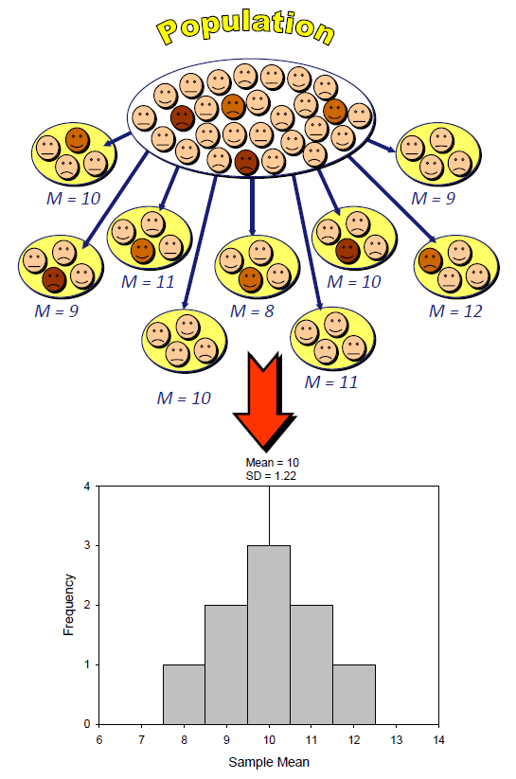
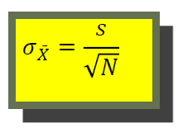
S = sample standard deviation

- >> Why use square root of N rather than N?
- Sample size influences variability and the distribution of sample means.
- If you used n directly, the SE of the Mean (SEM) would decrease too quickly as the sample size increases.
- In reality, the relationship between sample size and the reduction in variability is not linear, but rather proportional to the square root of the sample size.

- >>> The reduction follows the square root law, which reflects the way randomness averages out as you take larger samples.
- Using square root of n instead adjusts the SEM to reflect the fact that each additional data point provides diminishing returns in terms of reducing the variability of the sample mean.

Central Limit Theorem - Cant’ Collect Enough samples

- In reality, we can’t collect enough samples

- Instead, we rely on an approximation of the sample mean and sample error
- Based on the Central Limit Theorem
  - Concerned with drawing finite samples of size n from a population with a known mean μ, and a known standard deviation,σ.

- Two alternative forms
- If we collect samples of size n with a “large enough n,” calculate each sample’s mean, and create a histogram of those means, then the resulting histogram will tend to have an approximate normal bell shape.
  - # of samples up => get
- If we again collect samples of size n that are “large enough,” calculate the sum of each sample and create a histogram, then the resulting histogram will again tend to have a normal bell-shape.

Central Limit Theorem
  - As samples get large, the sampling distribution has a normal distribution with
    - a sample mean equal to the population mean μ,
    - and a standard deviation σ of :
- 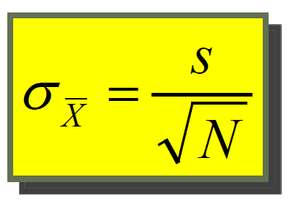

Normal Distribution

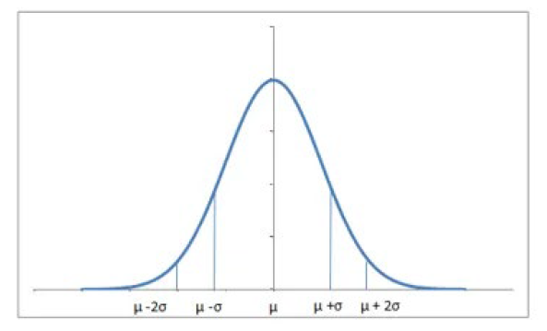
- The normal distribution is perfectly symmetrical about the mean.
- The probabilities move similarly in both directions around the mean.
- The total area under the curve is 1, since summing up all the possible probabilities would give 1.

Q: So what does it mean?

A: Can use the standard deviation of the sampling distribution as the approximation of the sample error

- If our distribution follows the normal distribution
- We can use the standard deviation of the sampling distribution as the approximation of the sample error
- For other shapes of distribution, we have other ways of approximating the population mean and standard error.

Probability Frequency Distribution

Shows how often an event will happen Sample question
:
- In a sample of 43 students:
  - 15 had brown hair.
  - 10 had black hair.
  - 16 had blond hair.
  - 2 had red hair.
  - find the probability a person has neither red nor blond hair.

Frequency distribution table:
- Brown = 15/43 (15 out of 43 students have brown hair).
- Black = 10/43 (10 out of 43 students have black hair).
  - Add these together to get the total number of students who have either brown or black hair
    - 15/43 + 10/43 = 25/43
      - (25 out of 43 students have either brown or black hair).

Frequency Distribution to Probability

- Frequency distribution can be displayed as a histogram
  - gives us an idea about how frequently a given data point occurs
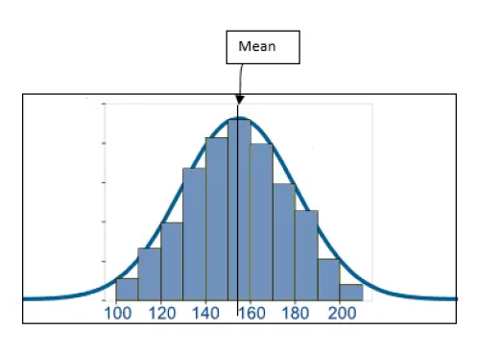

From this, probability can be calculated and using probability density function (equation/function)
- Using this you can plot the probability distribution

Sampling
- When you have huge amount of data, it is difficult to make sense of it (or even collect it).
- To tackle this problem, what we do is take a small chunk of data and look at it.
- But we won’t be satisfied with just a single chunk.
- We’d try to look at multiple chunks to be sure of results.

- Let’s say we have the cholesterol levels of all the people in a country
- We can look at the mean, median and mode of the data.
- Suppose we plot the data, and it looks like this.

- We calculate the mean is 153.2

>> But it is difficult to process this large amount of data.
- We can take the data of some 50 people and calculate their mean.
- We then take a new sample of 50 people and calculate the mean.
- We then take another new sample of 50 people and calculate the mean
- We keep doing that to collect a quantity of samples….

- We can then plot the means (or any other statistic) of these samples.
- We get a symmetrical frequency distribution.
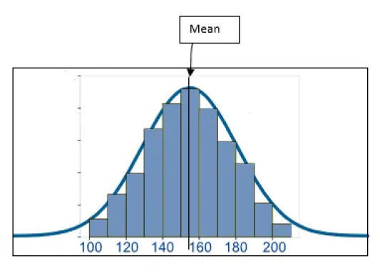
When we take means of cholesterol levels of 50 people, again and again, we observe the mean values are around 150-160.
- Only a few mean values are more than 170 and less than 140.
- There are very, very few over 190 or less than 110.

Sampling Frequency to Probability
We can easily convert these frequencies to see probabilities.
- If we divide the frequency of a bin (range like 110 to 120) by the total number of data points, we get the probabilities of each bin.
- This converts the frequency distribution to a probability distribution of the same shape.
- The probability distribution becomes more and more symmetrical when the sample size that we use to create those means is very large.
- As the sample size approaches infinity, the probability distribution becomes a perfectly symmetrical where the center of the curve is the mean of the population – the central limit theorem.
- The curve is known as normal distribution.
- We can treat it as such and use thay knowledge in testing building etc

Normal Distribution
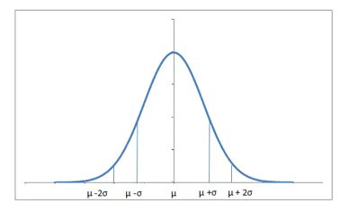
- The normal distribution is perfectly symmetrical about the mean.
- The probabilities move similarly in both directions around the mean.
- The total area under the curve is 1, since summing up all the possible probabilities would give 1.

3 normal curves, same SD different mean

3 normal curves, same mean, different SDs

- The distribution might vary a bit depending upon how spread the data is.

- If the data has a very large standard deviation, the curve would be spread out and flatter since more of the values would be away from the mean.

Probability Distribution

If a lot of values are away from the mean, the probability for data being around the population mean also drops.

- Similarly, if the standard deviation is low, which means most of the values are near around the mean
- Using the laws of probability, there is high probability of the sample mean being around the population mean and the distribution is a lot thinner.

The Standard Normal
- mean equal to zero and standard deviation equal to 1 looks identical to that of the normal but uses a different measurement scale.

- A normal distribution with a
  - mean of 0 and
  - a standard deviation of 1
  - is called a standard normal distribution.
- Any normal distribution in any scale can be converted to the standard normal by transforming the scale to be in units of standard deviation.
  - We change the units of measurement

Benefits
- Allows us to quantitatively compare concepts which were measured using different scales
- Allows us to use pre-calculated statistical tables to draw conclusions about statistics calculated from a sample that conforms to the normal distribution

So what?
- If we have data shaped like the normal distribution
- The mean can be mapped to 0 and the standard deviation to 1
- We can then use the tables of probability created by these statisticians to work out the probability of particular scores occurring within that distribution

- How do we map our scores to fit the standard normal?

>>> later slides after z scores….

>> from later slide>>

Standard Normal
= The distribution of a normal variable with mean =0 + standard deviation = 1 looks identical to that of the normal but uses a different measurement scale.

So what? – related to z scores…
It is the fact that we can now have access to a table showing, for each point in [−∞, +∞], the probability that we have a realization of a variable to the left and to the right of that point.

Z scores and Raw Scores
- We need a way to standardise the distributions so we can use one table for all normal distributions

- We can use the standard deviation as the measurement scale
  - We consider how many standard deviations a measure is from the mean
  - This allows comparison between a value in one normal distribution with a value in another

Z-scores

- Expresses a score in terms of how many standard deviations it is away from the mean.
- Standardising a score with respect to the other scores in the group.
- The distribution of z-scores has a mean of 0 and SD = 1.

- Transform an original IQ scores into scores with a mean of 0 and an SD of 1.
- Raw IQ scores (mean = 100, SD = 15)
- z for 100 = (100-100) / 15 = 0,
- z for 115 = (115-100) / 15 = 1, ( 1 std dev away from the mean)
- z for 70 = (70-100) / -2, etc. (2 std devs away from the mean)

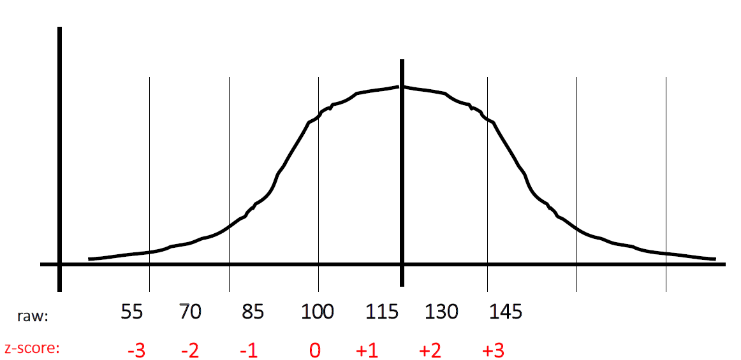

A score, X, is expressed in the original units of measurement:

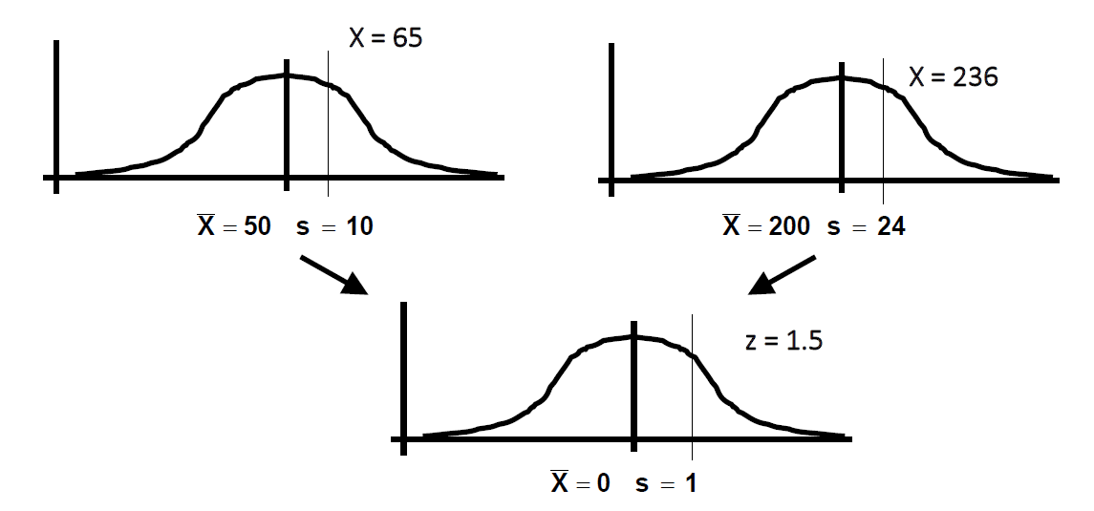

It can also be expressed in terms of its deviation from the mean (in SDs) as part of a z-score distribution

chatgpt

🧩 What is a Z-Score?
A z-score tells you how many standard deviations a value is above or below the mean of a distribution.
It’s basically a way of standardizing scores — turning any normal distribution into a standard normal distribution with:
- Mean (μ) = 0
- Standard deviation (σ) = 1

Stem and Leaf
This is a stem and leaf table

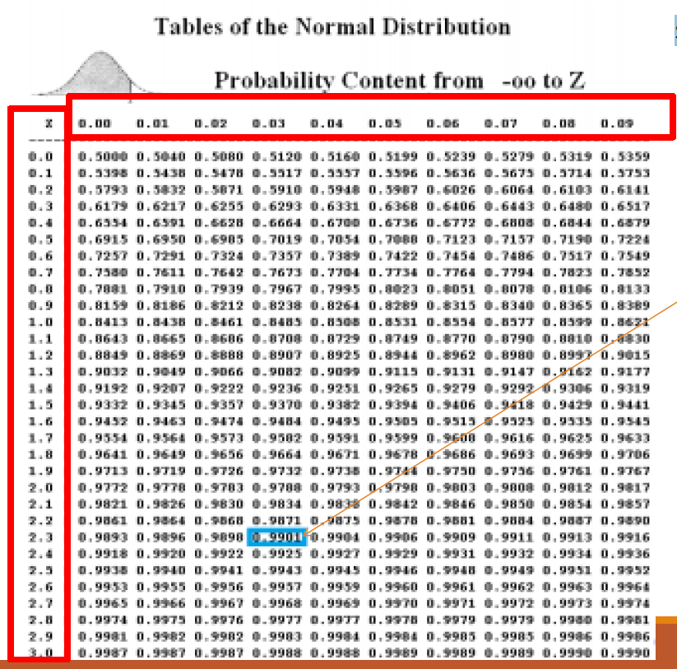
- The probability that a realization is lower than point 2.33 = 0.99 (line above was to here in slide)
- Then the probability that the realization is above 2.33 (1-0.99) = 0.01

- Comment
  - We will not be looking up these scores
  - We will use functions to do the calculations for us

Why use Z-scores
- z-scores make it easier to compare scores from distributions using different scales.

Example -1 Compare two test scores:
  - Test A: Fred scores 78. Mean score = 70, SD = 8.
  - Test B: Fred scores 78. Mean score = 66, SD = 6.

Did Fred do better or worse in comparison to the rest of the class on the second test?

- Test A: as a z-score, z = (78-70) / 8 = 1.00
- Test B: as a z-score , z = (78 - 66) / 6 = 2.00

Conclusion: Fred comparatively did much better on Test B.

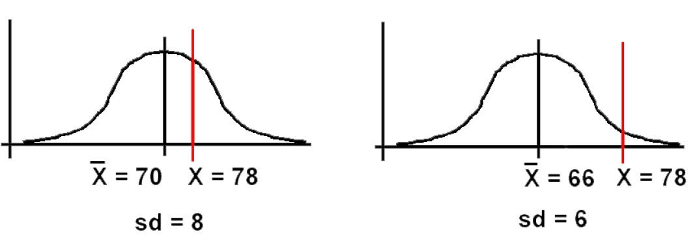

- z-scores enable us to determine the relationship between one score and the rest of the scores, using just one table for all normal distributions.

- If we have 480 scores, normally distributed with a mean of 60 and an SD of 8, how many would be 76 or above?

Graph the problem:

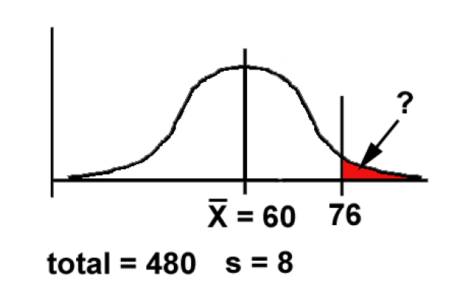

Work out the z-score for 76:

z = (X – X̄) / s = (76 - 60) / 8 = 16 / 8 = 2.00

X̄ = (x bar= mean of X )
We need to know the size of the area beyond z (remember - the area under the Normal curve corresponds directly to the proportion of scores).

Z Score Tables
Many statistics books have z-score tables, giving us this information:

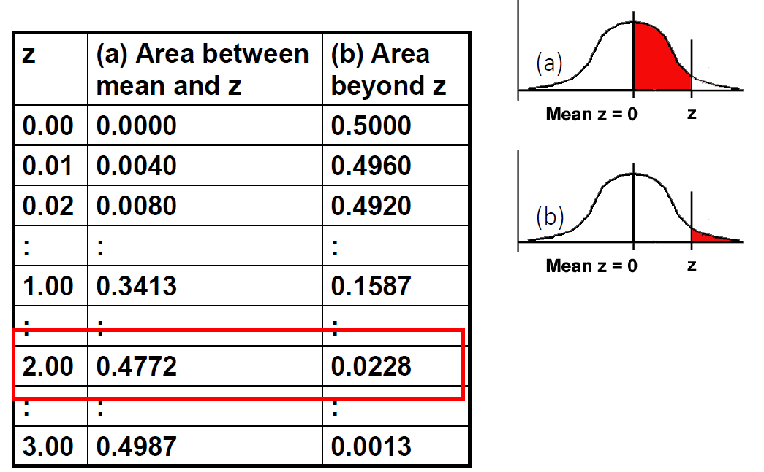

- So:
  - as a proportion of 1, 0.0228 of scores are likely to be 76 or more.
  - As a percentage = 2.28%
  - As a number= 0.0228 * 480 = 10.94 scores.

Example – 2 – Head Injury Impact

Conducting a word comprehension test to investigate the impact a head injury has on a person’s word comprehension.

Have created a dataset of scores from people with NO head injury
No. correct: mean = 92, SD = 6 out of 100

Have conducted the test with a person WITH a head injury:
No. correct: 89 out of 100.
Is this person's comprehension significantly impaired?

Step 1: Graph the problem:

Step 2: Convert 89 into a z-score:

z = (89 - 92) / 6 = - 3 / 6 = - 0.5

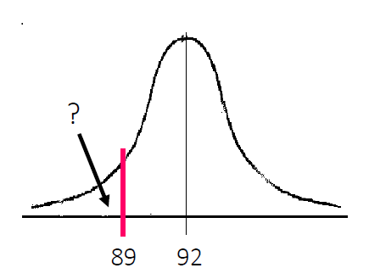

Step 3: use the table to find the "area beyond z" for our z of - 0.5:

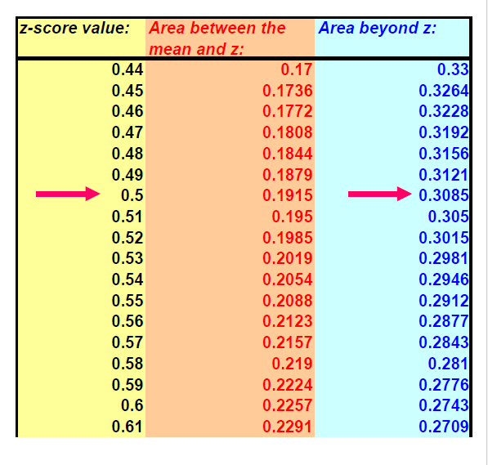

Area beyond z = 0.3085
Conclusion: .31 (31%) of people without a head injury are likely to have a comprehension score this low or lower.

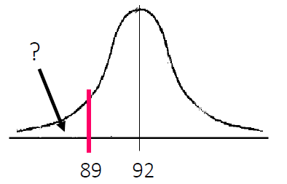

Normal Distribution – density curve

- A density curve describes the overall pattern of a distribution.

- Formula used to generate the shape of the curve is the normal density function

- A distribution is normal if its density curve is symmetric, single-peaked and bell-shaped.
  - Mean, Median, and mode are same for a normal distribution.

Recap - Overview
- A Normal Curve or Bell-shaped Curve
  - Key players: Abraham DeMoivre (1667-1754) and Carl Frederick Gauss (1777-1855)
  - Sometimes normal distribution is referred to as a Gaussian distribution
- Smooth, symmetrical curve about the mean which is the highest point of the curve
- Approaches the horizontal axis but never touches it (asymptotic)
- The spread of the curve is determined by the standard deviation
  - Larger this value the more spread out the curve is,
  - The large the peak the smaller the std deviation
- The inflection points where it starts to transition are determined by the mean +/- one standard deviation
- The area under the curve is 1.

If we know μ (mean) and σ (standard deviation), we derive a lot of additional information about the data with a normal distribution.

Mean dn std dev relation to Norm Distri
- Empirical Rule (also known as 68-95-99.7 rule) states - If a variable is normally distributed, then:
  - within one standard deviation of the mean there will be approximately 68% of the data
  - within two standard deviations of the mean there will be approximately 95% of the data
  - within three standard deviations of the mean there will be approximately 99.7% of the data
- This is really helpful as we can now translate this to z -scores.

Empirical Rule describes how data is distributed in a normal distribution
Telles us what % of data lies within 1, 2, or 3 Std devs from the mean.

Properties of z-scores
- Using our empirical rule we know that:
  - 95% of z-scores lie between −1.96 and 1.96.
  - 1.96 cuts off the top 2.5% of the distribution.
  - −1.96 cuts off the bottom 2.5% of the distribution.
- 99% of z-scores lie between −2.58 and 2.58,
- 99.9% of them lie between −3.29 and 3.2

- Comment - Important
  - If 95% of z-scores lie between -1.96 and 1.96 => we can treat it as if its normal
  - Are approximating the normal distribution and can treat it as such
  - If we go beyond that and have a large enough sample
    - Then we can treat it as normal
    - The more data we have the more variation we have and the easier to get accurate result

Chatgpt
🧮 Uses of the Empirical Rule
- Quick estimation of probabilities without needing a z-table
- Detecting outliers — values beyond ±3 SD are very rare
- Checking normality — if your data roughly follow these percentages, they may be normally distributed
- Understanding variability — it links SD directly to data spread

🧩 In Summary
SD Range | Percent of Data | Z-Score Range | Meaning
±1σ | 68% | -1 to +1 | Typical/average range
±2σ | 95% | -2 to +2 | Most of the data
±3σ | 99.7% | -3 to +3 | Nearly all data

Summary - Normal Distribution

- Many psychological/biological properties are normally distributed.

- This is very important for statistical inference (extrapolating from samples to populations)

- Z -scores provide a way of
  - comparing scores on different raw-score scales;
  - showing how a given score stands in relation to the overall set of scores.
  - using probability tables to calculate likelihood of particular scores.9.

- The logic of z-scores underlies many statistical tests:
  - Scores are normally distributed around their mean.
  - Sample means are normally distributed around the population mean.
  - Differences between sample means are normally distributed around zero ("no difference").

- We can exploit these phenomena in devising tests to help us decide
- whether or not an observed difference between sample means is due to chance.

Idealised shape

- The curve shows the idealized shape.
- It is important that our data is close to this shape if we wish to use Parametric tests.

Distribution Central to chosing correct test

- Parametric Tests
  - Normal distribution
- Non-parametric Tests
  - Non normal distribution
  - Some sort of a ranking which will be slightly less accurate
- Always start by looking at the data!

From chatgpt >>

A parametric test is a statistical test that:
- Assumes your data come from a population that follows a specific distribution (usually normal),
- Uses parameters (like μ and σ) of that distribution to make inferences.
- In short >> Parametric tests are statistical methods that assume a known distribution (usually normal) and use population parameters (like μ and σ) to test hypotheses.

Feature | Parametric | Nonparametric
Assumes normal distribution | ✅ Yes | ❌ No
Uses parameters (μ, σ) | ✅ Yes | ❌ No
Data type | Interval/Ratio | Ordinal or Non-normal
Examples | t-test, ANOVA | Mann–Whitney U, Kruskal–Wallis, Spearman’s rho

Descriptive Statistics

Purpose: Describe and Summarize Data

Describing Data > key ideas
- Provide the maximum description with the minimum statistics
- Generally, you need to provide relevant statistics and visualization for key concepts.

Qualitative

- Summarize the distribution of categories: How the data is distributed across categories.

- Provide insight into trends or patterns
- Compare different categories
- Use:
  - Frequencies: How often each category or value appears.
  - Percentages/Proportions: Relative frequency of each category to the total.
  - Mode: Most frequently occurring category.

Quantitative

- Give a sense of the "average" value or typical case.
  - Mean: Arithmetic average of the data.
  - Median: Middle value, especially useful when data is skewed (more of a particular type of data).
  - Mode: Most frequently occurring value (if any).

- Summarize the Variability (Spread): Spread or variability of the data.
  - Variance: How much the data varies from the mean.
  - Standard Deviation: A measure of how spread out the values are around the mean.
  - Interquartile Range (IQR): Spread of the middle 50% of the data, useful for skewed distributions.
  - Range: The difference between the largest and smallest values

- Shape of the Data Distribution: : Describe the shape of the data distribution (e.g., symmetric, skewed, bell-shaped).
  - Bell Shaped: Indicates that the data is equally distributed either side of the mean (aligns with the normal distribution).
  - Skewness: Indicates if the data is more spread out on one side of the mean.
  - Kurtosis: Describes whether the distribution has heavy tails or is more peaked than a normal distribution.
  - Identify Outliers: Values that are significantly higher or lower than the rest of the data.

Central tendency

- A descriptive statistic for numerical data – a single variable.
- A single number to serve as a representative value around which all the numbers in the set tend to cluster.

Measure of Central tendency – Mode/Median/Mean

- Mode
  - The value that occurs most frequently for a variable in a set of data.
  - Undefined for sequences in which no observation is repeated.

- Median
  - The value in the middle; half of the values for a variable are larger than the median and half of the values are smaller than the median
  - he middle value of a sequence of all the values in a distribution arranged from lowest to highest.
  - In case of an even number of observations the average of the two middle most values is the median.

- Mean:
  - The arithmetic average of a group of values;
  - the sum of the values divided by the number of values.

Mean - Calculating the mean

- Calculate the mean of the following
  - data: 1 5 4 3 2
  - Sum the scores (ΣX): 1 + 5 + 4 + 3 + 2 = 15
- Divide the sum (ΣX = 15) by the number of scores (N = 5): 15 / 5 = 3
- Mean = X = 3
- The mean is sensitive to extreme values

The Median

- Just another name for the 50th percentile
  - It is the score in the middle; half of the scores are larger than the median and half of the scores are smaller than the median
  - The middle score of a sequence of all the scores in a distribution arranged from lowest to highest.
- Sort the data from highest to lowest
- Find the score in the middle
  - middle = (N + 1) / 2
  - If N, the number of scores, is even the median is the average of the middle two scores
  - X tilda
    - $\tilde{x}$→ sample median
    - $\tilde{X}$→ population median (sometimes used)

Example 1 - what is the median
- What is the median of the following
- scores:10 8 14 15 7 3 3 8 12 10 9
- Sort the scores:15 14 12 10 10 9 8 8 7 3 3
- Determine the middle score:middle = (N + 1) / 2 = (11 + 1) / 2 = 6
- Middle score (6th score)
- Median = 9

Example 2 - what is the median

- What is the median of the following
- scores:24 18 19 42 16 12
- Sort the scores:42 24 19 18 16 12
- Determine the middle score:middle = (N + 1) / 2 = (6 + 1) / 2 = 3.5
- Median = average of 3rd and 4th scores:(19 + 18) / 2 = 18.5

Mode
- The mode is the score that occurs most frequently in a set of data
- The value with the greatest frequency on the distribution.
- The mode is the most frequent value in a dataset — the one that occurs most often.

Bimodial Distributions

- When a distribution has two “modes,” it is called bimodal
- If a distribution has more than 2 “modes,” it is called multimodal

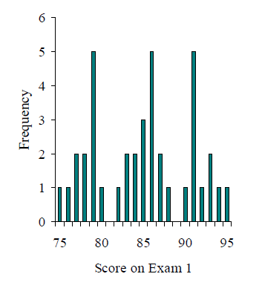

When to use the Mode

- The mode is not a very useful measure of central tendency for numerical/quantitative variables
- It is insensitive to large changes in the data set
  - That is, two data sets that are very different from each other can have the same mode

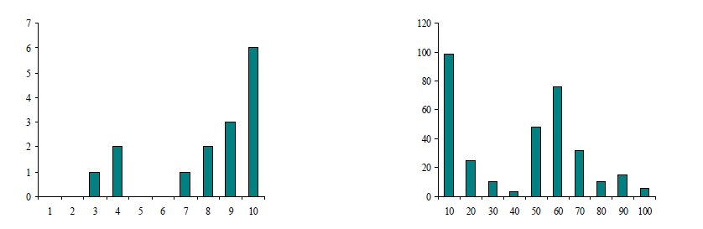

The mode is primarily used with nominal variables that use numerical values as labels
- Example:
  - 3, 7, 5, 13, 20, 23, 39, 23, 40, 23, 14, 12, 56, 23, 29
- In order these numbers are:
  - 3, 5, 7, 12, 13, 14, 20, 23, 23, 23, 23, 29, 39, 40, 56

In this case the mode is 23.

⚖️ When not to use the Mode
- If data are continuous and all values are unique (no repeats), the mode isn’t meaningful.
- If the dataset has many modes, it might be better to use the median or mean to describe the center.

Mean or Median
- The median is less sensitive to outliers (extreme scores) than the mean
- Therefore, it is a better measure than the mean for data that is strongly influenced by outliers
- ◦
- E.g. family income.

Example
- Sample: 20, 30, 40, and 990
- Mean is (20+30+40+990)/4 =270.
- Median (990, 40, 30, 20)
  - (30+40)/2 =35.
- 3 observations out of 4 lie between 20-40.
  - Mean of 270 really fails to give a realistic picture of the major part of the data.
    - It is influenced by extreme value 990.
  - Median is more reflective of the data.

🧠 Summary
Measure | Use it when...
Mean (x̄) | Data are numeric and normally distributed
Median (x̃) | Data are skewed or have outliers
Mode | Data are categorical or you want the most frequent value

Measures of Dispersion/Variability

- Variability/Dispersion = How spread out are values of a variable ?

- Reported with a measure of central tendency

Why is it important to know about variability?

- All of the values for a variable are clustered close together
- Any individual value or sample will necessarily provide a good representation of the entire set.

- When the population variability is small
- It is easy for one or two extreme values to give a distorted picture of the general population.

Why is the study of variability important?

- Variability (or dispersion) measures the amount of scatter in a dataset.
- There is variability in virtually everything
- Allows us to distinguish between usual and unusual values
- Reporting only a measure of centrality doesn’t provide a complete picture of the distribution.
  - Eg. Disappointed Dad finds single Wotsit in his packet of crisps
  - Source: https://metro.co.uk/2019/09/10/disappointed-dad-finds-single-wotsit-packet-crisps-10715789/

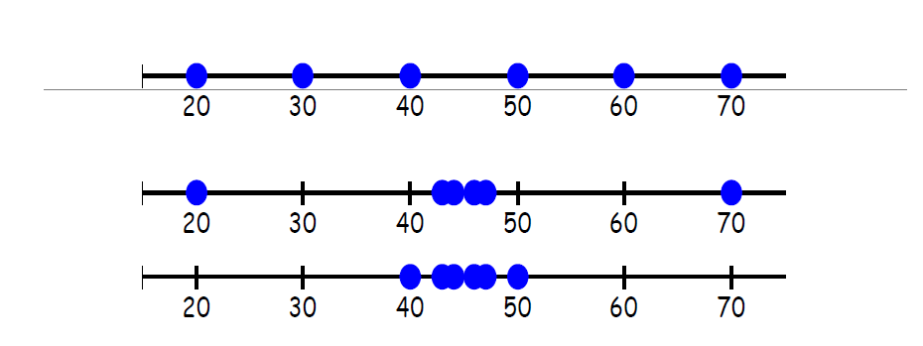

Notice that these three data sets all have the same mean and median (at 45), but they have very different amounts of variability.

Measures of Variability/Dispersion

- The simplest numeric measure of variability is range.
  - Its a crude measure of variability.

Range = largest observation - smallest observation

- The first two data sets have a range of 50 (70-20) but the third data set has a much smaller range of 10.

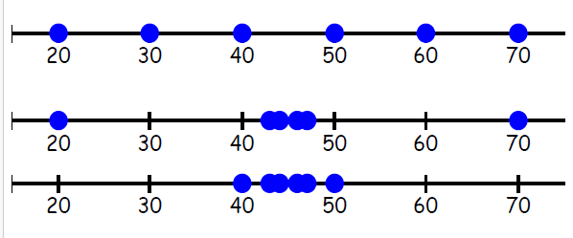

A common measure of the variability in a data set uses the deviations from the mean (x – x).
- If we have a sample of 6 fish that we caught from the lake . . .
- Suppose they were the following lengths:
3”, 4”, 5”, 6”, 8”, 10”
- And that the mean length was 6 inches.
- We can calculate the deviations from the mean.
- What was the sum of these deviations?
$$\frac{∑\left(x-x\right)}{}$$
(3-6)+(4-6)+(5-6)+(8-6)+(10-6)=-3-2-1+2+4=0
Is this helpful?

Variance

- A sample of 6 fish that we caught from the lake . . .
- They were the following lengths:
3”, 4”, 5”, 6”, 8”, 10”
- The mean length was 6 inches. We can calculate the deviations from the mean.
- What was the sum of these deviations?
- Can we find an average deviation?
$$\frac{∑\left(x-x\right)}{}$$

- (3-6)+(4-6)+(5-6)+(8-6)+(10-6)=-3-2-1+2+4=0

Uses the square of deviations from the mean (x – x).

- A sample of 6 fish that we caught from the lake . . .
- They were the following lengths:
3”, 4”, 5”, 6”, 8”, 10”
- The mean length was 6 inches. We can calculate the deviations from the mean.
- We can then calculate the sum of these deviations.
- What can we do to the deviations so that we could find an average?

$$s^{2}=\frac{∑{\left(x-\overline{x}\right)}^{2}}{n_{-}^{-1}}$$

Example - Variance of length of Fish

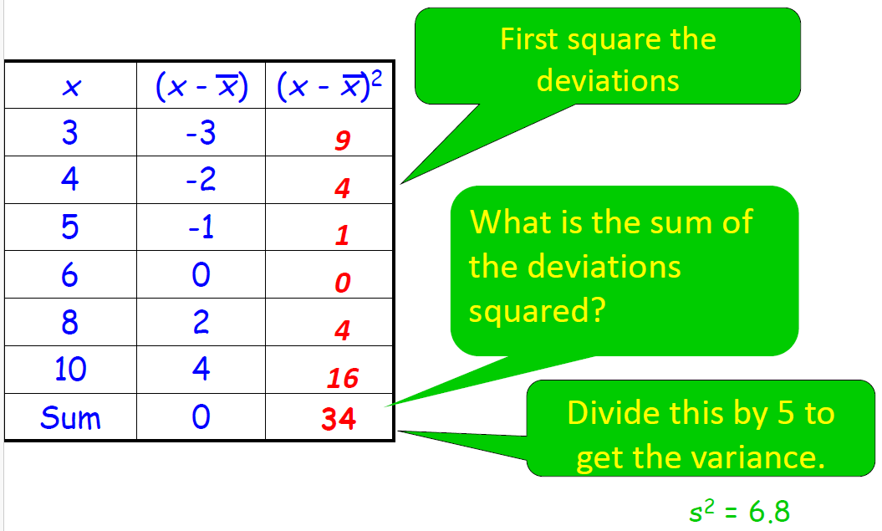

Varience - 2
- Variance: concerned with deviations from the mean (X-μ)
  - First subtract the mean from each of the values gives use a deviate or a deviation value - how far a given value is from the typical, or average, value
  - Then square the result
    - If we just added up the differences from the mean the negatives would cancel the positives
    - If we used absolute values we wouldn’t get an accurate measure of spread
    - Squaring is the best option
    - Variance is defined as the average of the deviations from the mean squared:

$$s_{0}^{2}rσ^{2}=\frac{∑{\left(x-μ\right)}^{2}}{N-1}$$

- N-1 here is the degrees of freedom =the number of independent pieces of information on which the estimate is based

- When calculating sample variance, we use degrees of freedom (n – 1) in the denominator instead of n because this tends to produce better estimates.

$$s^{2}=\frac{∑{\left(x\overline{-x}\right)}^{2}}{n-1}$$

- Population variance is denoted by s2.
- Degree of freedom?

Measure of Variability - Standard Deviation

- The square root of variance is called standard deviation.
- A typical deviation from the mean is the standard deviation.

- This is the more common measure since it makes it will be in the units of measurement rather than squared units of measurement – so is more intuitive

- Our fish example: s^2 = 6.8 inches^2 so standard deviation = 2.608 inches
- The fish in our sample deviate from the mean of 6 by an average of 2.608 inches.

Degrees of freedom

- Degrees of freedom of an estimate is the number of independent pieces of information that went into calculating the estimate.
  - It’s not quite the same as the number of items in the sample.

- In order to get the df for the estimate, you have to subtract 1 from the number of items.

>>> Chatgpt >>>
💡 5. Intuitive Way to Think About It
Degrees of freedom tell you how much independent information you have left to estimate something.
- More df → more data, more confidence
- Fewer df → more uncertainty, less reliable estimates

DoF - 2
- Fundamentally it gives you a better estimate

- We are working with a sample to make a statement about the population

- It is unlikely that the standard deviation of a sample will give us the exact population standard deviation (or even be very close to it).

- The standard deviation is affected by the number of cases used to calculate it.

DoF – 3 – Why n-1?

- Imagine a population that has substantial variability in it e.g. the distribution of 23,000 students’ ages at a large university.

- There will be some unusually young students in the population and there will be some unusually old students in the population.

- If you selected a sample of students, it would be hard to ensure you collect all the variability that actually exists in the population.

- Most of your sample cases would likely come from the portion of the population that has most of the cases to begin with (say 20 to 25)
- Your sample probably wouldn’t reflect all of the variability that really exists in the population.
- So your sample standard deviation would likely be slightly less than the true standard deviation of the population.

DoF -4 – Why n-1?
- We need to make some adjustment

- Statisticians deal with this situation by using a small correction factor.

- When calculating the standard deviation of a sample (or the variance of a sample, for that matter), they change the n in the denominator to n – 1.

- This slight reduction in the denominator results in a larger standard deviation—one that better reflects the true standard deviation of the population.

- When you use n-1 in the denominator of the formula for the standard deviation of a sample, you not only slightly increase the final answer (or value of the standard deviation), you do so in a way that is sensitive to sample size.

- The smaller the size of the sample, the more of an impact the adjustment will make.

Measures of Dispersion
- Standard Deviation: the most useful and the most popular measure of dispersion.
  - Concept was first introduced by Karl Pearson in 1893.
  - Standard deviation = the square root of the Variance
  - Use Greek symbol sigma σ
  - The larger the value the more spread out around the mean the data is, smaller means less spread.
  - The Empirical Rule:
    - The 68-95-99.7 Rule
    - In the normal distribution with mean μ and standard deviation σ:
    - 68% of the observations fall within σ of the mean μ.
    - 95% of the observations fall within 2σ of the mean μ.
    - 9.7% of the observations fall within 3σ of the mean μ.
- Allows us to see how spread out on average individual cases are from the mean

Measures of Variability – Interquartile Range

- Interquartile range (IQR) is the range of the middle half of the data.
- Lower quartile (Q1) is the median of the lower half of the data
- Upper quartile (Q3) is the median of the upper half of the data

iqr = Q3 – Q1

- Q: What advantage does the interquartile range have over the standard deviation?
- A: The IQR is resistant to extreme values

IQR – Example
- The Chronicle of Higher Education (2009-2010 issue) published the accompanying data on the percentage of the population with a bachelor’s or higher degree in 2007 for each of the 50 states and the District of Columbia.

21 27 26 19 30 35 35 26 47 26 27 30 24 29 22 24 29 20 20 27 35 38 25 31 19 24 27 27 23 34 25 32 26 24 22 28 26 30 23 25 22 25 29 33 34 30 17 25 23 34 26

- Q: Find the interquartile range for this set of data.

Step 1: First put the data in order & find the median.

17 19 19 20 20 21 22 22 22 23 23 23 24 24 24 24 25 25 25 25 25 26 26 26 26 26 26 27 27 27 27 27 28 29 29 29 30 30 30 30 31 32 33 34 34 34 35 35 35 38 47

Step 1: Answer : 52 values Median is the 26th value = 26

- Step 2: Find the lower quartile (Q1) by finding the median of the lower half.
  - 13th value =24

- Step 3: Find the upper quartile (Q3) by finding the median of the upper half.
  - 39th value =30

- Step 4:
  - iqr = IQ3 –IQ1
  - =30 – 24 = 6

Measures of Dispersion

- Measures of Dispersion are descriptive statistics that describe how similar a set of values are to each other (or the range of values)

- The more similar the values are to each other, the lower the measure of dispersion will be

- The less similar the values are to each other, the higher the measure of dispersion will be

- In general, the more spread out a distribution is, the larger the measure of dispersion will be

- Needs to be considered in relation to the measure of central tendency

Summary – Key Slides – what do I need to do!!

Samples vs Populations

Sample
  - Mean and SD describe only the sample from which they were calculated.

Population
  - Mean and SD are intended to describe the entire population (very rare in most studies).

Sample to Population:
  - Mean and SD are obtained from a sample, but are used to estimate the mean and SD of the population (very common).
  - Thid s what we want

What do I need to describe for interval/ratio data?

Centre
  - Discuss where the middle of the data falls
  - Measures of central tendency
    - mean, median and mode

Spread/Dispersion
  - Discuss how spread out the data is
  - Refers to the variability in the data
    - Range, standard deviation, IQR

Shape/Pattern
  - Refers to the overall shape of the distribution
  - Symmetrical, uniform, skewed, or bimodal
  - We will talk about shape next

Unusual Occurrences
  - Outliers (value that lies away from the rest of the data)
  - Gaps
  - Clusters

Context
  - You must write your answer in reference to the context in the problem, using correct statistical vocabulary and using complete sentences.

Visualization
- Sources used in creation of this lecture:
- Discovering Statistics Using R Field, Miles and Field;
- Understanding Basic Statistics, Brase and Brase;
- Statistics and Data Analysis, Peck, Olsen and Devore

Plots and Graphs

The Art of Presenting Data
- Graphs should (Tufte, 2001):
  - Show the data.
  - Induce the reader to think about the data being presented (rather than some other aspect of the graph).
  - Avoid distorting the data.
  - Present many numbers with minimum ink.
  - Make large data sets (assuming you have one) coherent.
  - Encourage the reader to compare different pieces of data.
  - Reveal data.

- Ef: Tufte(2001) Edward Tufte, The Visual Display of Quantitative Information, Graphics Press, 2nd edition,2001

Examples

Missing bars for years from a timeline

KEY SLIDE - Graphical Presentation – Choose the correct type for each variable
- Interval or Ratio numerical data
  - Histogram – most logical usually as looking at normal distributins)
  - Stem and Leaf diagrams (rarely used – wills ee them in some literature)
  - Box-plot
    - Depending on dispersion
KEY SLIDE STAR – 1

Stem-and-Leaf plot
- Shows data arranged by place value.
- You can use a stem-and-leaf plot when you want to display data in an organized way that allows you to see each value.

- Use for small to moderate sized data sets.
  - Doesn’t work well for large data sets.
- Accompany with a comment on the centre, spread, and shape of the distribution and if there are any unusual features.

Creating Stem-and-Leaf Plots
Use the data in the table to make a stem-and-leaf plot.

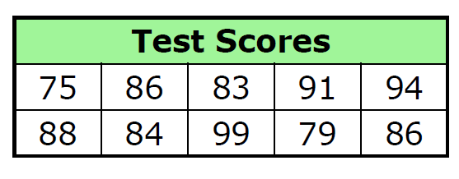

Step 1: Group the data by tens digits.
Step 2: Order the data from least to greatest.

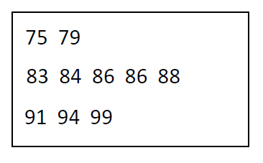

Step 3: List the tens digits of the data in order from least to greatest. Write these in the “stems” column.
Step 4: For each tens digit, record the ones digits of each data value in order from least to greatest. Write these in the “leaves” column.
Step 5: Title the graph and add a key.
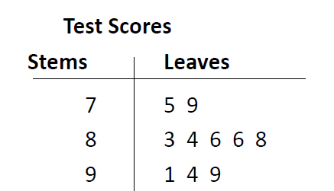

Key: 7 5 means 75


Reading Stem-and-Leaf Plots

Find the least value, greatest value, mean, median, mode, and range of the data.

- The least stem and least leaf give the least value, 40.
- The greatest stem and greatest leaf give the greatest value, 94.
- Use the data values to find the mean (40 + … + 94) ÷ 23 = 64.

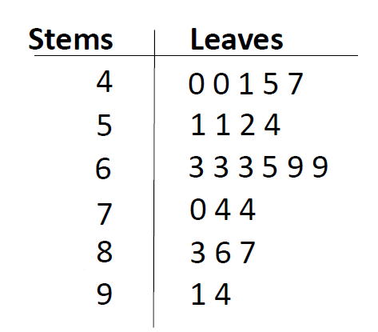

Key: 4 0 means 40

Reading Stem-and-Leaf Plots - Ctd

- The median is the middle value in the table, 63.
- To find the mode, look for the number that occurs most often in a row of leaves. Then identify its stem. The mode is 63.
- The range is the difference between the greatest and the least value. 94 – 40 = 54.

- Key: 4 0 means 40


Analysing Data
- First step: Graph the data

- Frequency Distributions (aka Histograms)
  - A graph plotting values of observations on the horizontal axis, with a bar showing how many times each value occurred in the data set.

- Ideal: The ‘Normal’ Distribution
  - Bell-shaped
  - Symmetrical around the centre

Histograms – discrete data?
**(Constructed differently for discrete versus continuous data)**
- When to Use
  - Univariate (single variable) numerical data

- Discrete data
  - May only take on a finite number of values or countable number of values
  - Draw a horizontal scale and mark it with the possible values for the variable
  - Draw a vertical scale and mark it with frequency or relative frequency
  - Above each possible value, draw a rectangle centred at that value with a height corresponding to its frequency or relative frequency

- To describe
  - Comment on the centre, spread, and shape of the distribution and if there are any unusual features
- Constructed differently for discrete versus continuous data

Example
- Queen honey bees mate shortly after they become adults.
- During a mating flight, the queen usually takes several partners.
- A study on honey bees provided the following data on the number of partners for 30 queen bees.
- 12 2 4 6 6 7 8 7 8 11 8 3 5 6 7 10 1 9 7 6 9 7 5 4 7 4 6 7 8 10
- Create a histogram for the number of partners of the queen bees.

    - Next draw a vertical axis, scaled with frequency or relative frequency.

    - Next draw a vertical axis, scaled with frequency or relative frequency.

    - Next draw a vertical axis, scaled with frequency or relative frequency.

- Suppose we use relative frequency instead of frequency on the vertical axis.

- Suppose we use relative frequency instead of frequency on the vertical axis.

Histogram – Contunous Data
** This is the type of histogram that most people are familiar with.**
- When to Use
  - Univariate numerical data (one variable)

- Continuous data
  - ◦Mark the boundaries of the class intervals on the horizontal axis
  - Draw a vertical scale and mark it with frequency or relative frequency
  - Draw a rectangle directly above each class interval with a height corresponding to its frequency or relative frequency

- To describe
  - Comment on the centre spread, and shape of the distribution and if there are any unusual features

Example

A study examined the length of hours spent watching TV per day for a sample of children age 1 and for a sample of children age 3. Below are comparative histograms

Client age 1 Client Age 3

Frequency Distribution
- Graphs are useful in assisting us in assessing the distribution in a set of data for a particular variable

- Frequency distribution shows the relative frequencies of values for variables of interest in a dataset
  - Where values have been binned into groups (e.g. 10 to 20, 21 to 30 etc.)
  - The height of each bar is proportional to the relative frequency in the data set of the group it represents.

- Normal distribution
  - Bell-shaped, scores equally distributed around a central value (mean)

- Skewed
  - Lack of symmetry
  - Data pulled towards one end of the graph

- Kurtosis
  - Pointyness

The Normal Distribution

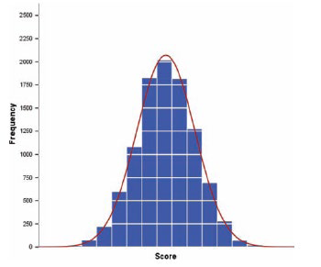

Skew

Properties of Frequency Distributions

Skew
  - The symmetry of the distribution.
  - Positive skew (scores bunched at low values with the tail pointing to high values).
  - Negative skew (scores bunched at high values with the tail pointing to low values).

Kurtosis
  - The ‘heaviness’ of the tails.
  - Leptokurtic = heavy tails (more scores in the tails).
  - Platykurtic = light tails (more scores in the middle).
  - Positive Kurtosis = pointy – diagram below
  - Negative Kurtosis = flatter - diagram below

Comparing Groups

- It is almost always more interesting to compare groups.
- With histograms, note the shapes, centers, and spreads of the two distributions.

- What does this graphical display tell you?

Example

A study examined the length of hours spent watching TV per day for a sample of children age 1 and for a sample of children age 3. Below are comparative histograms.

Client Age 1 Client Age 3

Q: ***Write a few sentences comparing the distributions.***

A: The median number of hours spent watching TV per day was greater for the 1-year-olds than for the 3-year-olds. The distribution for the 3-year-olds was more strongly skewed right than the distribution for the 1-year-olds, but the two distributions had similar ranges.

Jitter
- Jitter adds a small amount of random variation to the location of each point
- This spreads the data out
‘’’{r}
graph + geom_point(aes(colour = Rating_Type), position = "jitter") + ggtitle ("geom_point(aes(colour = Rating_Type), position = jitter)")
```

The Normal Distribution

- The curve shows the idealized shape.
- It is important that our data is close to this shape if we wish to use Parametric tests.

The Normal Distribution

- Normal Curve or Bell-shaped Curve
  - Key players: Abraham DeMoivre (1667-1754) and Carl Frederick Gauss (1777-1855)
  - Sometimes normal distribution is referred to as a Gaussian distribution

- Smooth, symmetrical curve about the mean which is the highest point of the curve

- Approaches the horizontal axis but never touches it (asymptotic)

- The spread of the curve is determined by the standard deviation
  - Larger this value the more spread out the curve is, smaller the more peaked it is

- The inflection points where it starts to transition are determined by the mean +/- one standard deviation

- The area under the curve is 1

Density Curve/Density Plot
- A density curve describes the overall pattern of a distribution.
- A density curve is a graphical representation of a numerical distribution where the outcomes are continuous.
  - Density plot is A smoothed version of a histogram
  - Aims to (smoothly) show how data is spread out

- The Kernel Density Estimation (KDE) function chosen provides a way to estimate the probability distribution of your data
  - Gives you a smooth curve that represents where data points are likely to be found.

- The area under a density curve represents probability.

- The area under a density curve = 1

** from chatgpt ***
A density curve is a smooth, continuous curve that represents the overall shape of a distribution of data. It is used in statistics to model the distribution of a quantitative variable.

Key Features of a Density Curve:
- Total area under the curve is exactly 1 (or 100%), representing the entire population or data set.
- The area under the curve over a particular interval represents the proportion or probability of observations within that interval.
- A density curve can be symmetrical (like a normal distribution) or skewed (left or right).
- The height of the curve shows how dense (frequent) data points are around certain values, but the height is not a probability—only the area under the curve has that meaning.
Example:
- For a normal distribution, the density curve is the familiar bell-shaped curve.
- For right-skewed data, the curve has a peak on the left and a long tail to the right.
Why Use It?
- To model real-world data and understand patterns.
- To calculate probabilities for continuous variables.
- To approximate distributions when exact data is not available.
****************************

Density Curve/Plot

- Example:
  - Suppose we have a crowded room full of people standing at different heights.
  - We can create a density plot is like a smooth map that shows where most people are standing and where fewer people are.

- Data Points
  - Individual heights (people in the room).
- Kernel
  - The shape of each person’s light (e.g., bell-shaped).
- KDE Function
  - The process of adding up all the individual lights.

- Density Plot
  - The final brightness map showing height distribution.

- 1. Collect Data: Imagine you have the heights of 100 people.
- 2. Choose a Kernel: Let’s say you choose a Gaussian (bell-shaped) kernel.
- 3. Apply KDE: For each person’s height, place a small bell-shaped curve centred at their height.
- 4. Combine Curves: Add up all these small curves to create one smooth hill.
- 5. Create Density Plot: The resulting hill shows where most people’s heights are concentrated and where there are fewer.

Normal/Gaussian Density Curve
Formula used to generate the shape of the curve is the normal density function

A Gaussian kernel will tend to produce density estimates that look Gaussian-like (normal curve), with smooth features and tails.

By contrast, a rectangular kernel can generate the appearance of steps in the density curve

Kernel density estimates depend on the chosen kernel and bandwidth. Here, the same age distribution of Titanic passengers is shown for four different combinations of these parameters: (a) Gaussian kernel, bandwidth = 0.5; (b) Gaussian kernel, bandwidth = 2; (c) Gaussian kernel, bandwidth = 5; (d) Rectangular kernel, bandwidth = 2.

Ref >> https://clauswilke.com/dataviz/histograms-density-plots.html

NOTE from Link >> Always verify that your density estimate does not predict the existence of nonsensical data values.

Density Curve
- Curves are "uniform" when the probabilities for all outcomes are the same.

- In a uniform distribution each outcome has the same frequency. Because of this, the height at each point on the x-axis is identical and the shape of a uniform density curve becomes a rectangle.

- In a uniform distribution the probability of x=a is zero and probability that x < a is equal to the probability that x ≤ a.

- Probability is equal to the area.

- For P(x < a), one shades to the left of the point and thus creates a rectangle of area.

- For a single point x = a, there would be nothing to shade left causing the rectangle of area to have no width and thus no probability.

- Therefore, the probability that x = a is zero, and the probability that x < a must be the same as the probability that x ≤ a.

Example: Given a uniform density curve with a length of 50.

- We can calculate the height of density curve. The area must equal 1, and uniform density curves are rectangular.

- Thus, we can set up the equation basexheight = 1→ (50)(h) = 1→ height = 0.02

- Calculate probability P(x < 40):

- Step 1) Shade in the area.

- Step 2) Find the area of the shaded rectangle using the height you calculated.→ area = (40)(0.02) = 0.8

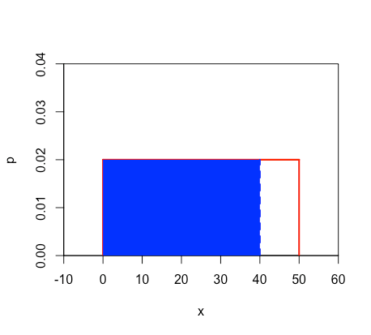

Calculate P(x = 40)

If you attempt to follow the steps from the previous slide you will see that there is no area that can be shaded in since this rectangle of area would have no width. Thus, the probability is equal to zero.

Normal Distribution
A distribution is normal if its density curve is symmetric, single-peaked and bell-shaped.

Normal Distribution: - Properties

Normal Distribution properties
  - It is bell-shaped and asymptotic at the extremes.
  - It's symmetrical around the mean.
  - The mean, median and mode all have same value.
  - It can be specified completely, once mean and SD are known.
  - The area under the curve is directly proportional to the relative frequency of observations.

Thus we can calculate the probability of observations occurring in a population

AUC – 50%
e.g. here, 50% of scores fall below the mean, as does 50% of the area under the curve.

AUC – 85%

e.g. here, 85% of scores fall below score X, corresponding to 85% of the area under the curve.

Normal Distri - Inflection Point

- If we know μ and σ, we derive a lot of additional information about the data with a normal distribution.

Standard deviations percentages

Empirical Rule
- - The 68-95-99.7 Rule
  - In the normal distribution with mean mew, and standard deviation σ:
    - 68% of the observations fall within σ of the mean μ.
    - 95% of the observations fall within 2σ of the mean μ.
    - 99.7% of the observations fall within 3σ of the mean μ.

- If a variable is normally distributed, then:
  - within one standard deviation of the mean there will be approximately 68% of the data
  - within two standard deviations of the mean there will be approximately 95% of the data
  - within three standard deviations of the mean there will be approximately 99.7% of the datan.

Summary

- Many psychological/biological properties are normally distributed.
- This is very important for statistical inference (extrapolating from samples to populations)
  - Rely on this to extrapolta eou distributions

Statistical Tests
- Normal distribution is central to choosing the correct statistical test
  - Parametric Tests
    - Assume a normal distribution
  - Non- parametric Tests
    - Non normal distribution
  - Always start by looking at the data!

BoxPlots

- Take a boxplot and turn it 90 degrees…
- Particularly good if looking at a number of groups….

Constructing Boxplots
- Draw a single vertical axis spanning the range of the data.
- Draw short horizontal lines at the lower and upper quartiles and at the median.
- Then connect them with vertical lines to form a box.

Fence Lines

- Draw “fences” around the main part of the data.
  - The upper fence is 1.5*(IQR) above the upper quartile.
  - The lower fence is 1.5*(IQR) below the lower quartile.
- Note: the fences only help with constructing the boxplot and should not appear in the final display.

Whiskers
- Use the fences to grow “whiskers.”
- Draw lines from the ends of the box up and down to the most extreme data values found within the fences.
- If a data value falls outside one of the fences, we do not connect it with a whisker.

Outliers

- Add the outliers by displaying any data values beyond the fences with special symbols.
- We often use a different symbol for “far outliers” that are farther than 3 IQRs from the quartiles.

Boxplots v Histograms

- Compare this histogram and boxplot for daily wind speeds:

- How does each display represent the distribution?

What Do Boxplots Tell Us?
- The center of the boxplot shows us the middle half of the data between the quartiles.

- The height of the box is equal to the IQR.

- If the median is roughly centered between the quartiles, then the middle half of the data is roughly symmetric. Thus, if the median is not centered, the distribution is skewed.

- The whiskers also show the skewness if they are not the same length.

- Outliers are out of the way to keep you from judging skewness, but give them special attention.

Ouotlier

Whisker

Comparing Groups
- Boxplots offer an ideal balance of information and simplicity, hiding the details while displaying the overall summary information.

- We often plot them side by side for groups or categories we wish to compare.

What do these boxplots tell you?

Dot Plot
- Comment
- We do not use dot plots in this module at all!

- A data display in which each data item is shown as a dot above a number line
- In a dot plot a cluster shows where a group of data points fall.
- A gap is an interval where there are no data items.

KEY SLIDE - Which Descriptive Statistic to use?
Depends on measurement type and data dispersion

- Interval or Ratio (Scale)
  - Normally distributed
    - Mean and Standard Deviation

  - Skewed/Kurtotic
    - Median and Interquartile Range

KEY SLIDE STAR – 2

KEY SLIDE - Which Visualisation to use?
- Depends on measurement type and data dispersion

- Interval or Ratio (Scale)
  - Normally distributed
    - Histogram
  - Skewed/Kurtotic
    - Histogram/BoxPlot (boxplot might be better)

KEY SLIDE STAR –3

DESCRIBING AND VISUALISING QUALITATIVE DATA
Sources used in creation of this lecture:
Discovering Statistics Using R Field, Miles and Field;
Understanding Basic Statistics, Brase and Brase;
Statistics and Data Analysis, Peck, Olsen and Devore

What do I need to describe for categorical data? – Qualitative Data

- Set of all possible values
- Frequency
  - The number of occurrences of each possible value
  - Maybe a graph or a table
  - The most commonly occurring value
- Unusual Occurrences
  - Gaps
  - Clusters

KEY SLIDE - Graphical Presentation – Choose the correct type for each variable
- Nominal or Ordinal data
  - Bar charts
  - Pie charts
  - Frequency Tables

Key Slide STAR- 4

KEY SLIDE - Which Descriptive Statistic to use?
- Ordinal or nominal
  - Mode and/or simple frequencies

Key Slide STAR - 5

Lab - Survey.dat

Concept | Possible Values |  | Statistical Type |  | Summary Statistics
Gender | 1=males, 2=females |  | Nominal |  | Males 42%  Female 58%
Age in years | Values ranging from 18 to 82 |  | Ratio |  | M=37.4, Sd=13.20
Marital status | 1=single, 2=steady relationship,  3=living with a partner, 4=married for  the first time, 5=remarried,  6=separated, 7=divorced, 8=widowed |  | Nominal |  | Single 24%  Steady Relationship 8%  Living With Partner 8%  Married First Time 43%  Remarried 7%  Separated 2%  Divorced 5%  Widowed 2%
Children | 1=yes, 2=no |  | Nominal |  | Yes 42%  No 58%
Highest Level of Education Completed | 1=some primary, 2=some secondary,  3=completed high school,  4=some  additional training, 5=completed postgraduate |  | Ordinal |  | Primary Some 0%  Some Secondary 12%  Completed Highschool 19%  Completed Undergraduate 28%  Additional Training 27%  Postgraduate Completed 13%
Major source of  stress | 1=work, 2=spouse or partner,  3=relationships, 4=children, 5=family,  6=health/illness, 7=life in general,  8=finances, 9=time (lack of, too much  to do) |  | Nominal |  | Work 53%  Spouse Or Partner 3%  Relationships 3%  Children 6%  Family 6%  Health/Illness 5%  Life In General 8%  Money/Finances 13%  Time (Lack Of Time, Too Much To Do)4%
Smoker | 1=yes, 2=no |  | Nominal |  | No 81%  Yes 19%
Number of cigarettes smoked per week |  | Ratio |  | m= 16.59, sd= 44.90

Quarto - Getting Started with Quarto

- Quarto is an open-source publishing system for creating documents, presentations, blogs, and dashboards.
- It is the next-generation version of R Markdown, supporting multiple languages, including R, Python, and Julia.

- Why Use Quarto with R?
  - Seamless integration with R for data analysis and visualization.
  - Create reproducible reports and dynamic documents.
  - Publish results in various formats (HTML, PDF, Word, slides).

Key Features
- Multi-Format Output:
  - Export to HTML, PDF, Word, and more.

- Code and Output Integration:
  - Run R code directly in the document with output inline.

- Interactive Visualizations:
  - Use ggplot2, plotly, and leaflet within reports.

- Cross-Referencing and Citations:
  - Add figures, tables, and references easily.

- Version Control:
  - Work with Git for collaborative projects.

Some Basics

- File extension
  - .qmd
- Use the Render button in the RStudio IDE to render the file:

- Keyboard shortcuts:
  - Windows: Ctrl + Shift + K
  - Mac: ⇧⌘K

Visual (YSIWYM)

Os Source Editor

Yaml Header

Code Chunks

Running Chunks

Markdown Syntax

- https://www.markdownguide.org/basic-syntax/
- Lightweight markdown language
- –very similar to HTML

Lab

- MATH9102-W2-basics of plots.qmd
- MATH9102-W2-bar charts.qmd
- MATH9102-W2-histograms.qmd

‘’’{r}

# = MATH9102-W2-basics of plots.qmd

---
title: "TU059/TU060/TU256/PhD PSI — Week 2: Creating Basic Plots in R"
author: "Deirdre Lawless"
date: 2025-08-22
format: html
---

# 1. Install and load packages

This first bit of code installs all the packages needed to run the various functions within this file.
We define a helper `quiet_library()` that installs (if needed) and loads a package quietly.

```{r}
# label: install-and-load — assigns a label to the code chunk so it can be referenced later.
# message: false — suppresses messages that might appear (e.g., package startup messages).
# warning: false — suppresses warnings from appearing in the rendered document.

#| label: install-and-load
#| message: false
#| warning: false

quiet_library <- function(pkg) {
suppressMessages(suppressWarnings({
if (!requireNamespace(pkg, quietly = TRUE)) {
install.packages(pkg, quiet = TRUE)
}
library(pkg, character.only = TRUE)
}))
}

quiet_library("tidyverse") # includes ggplot2, readr, dplyr, etc.
quiet_library("readr") # explicit (for read_delim), though also in tidyverse

#Amend this to reflect your folder structure
datalocation <- file.path("./")
#On Mac this would be datalocation <- file.path("/Users", "deirdre.lawless", "datafiles")

```

# 2. Reminder of some basics
A **dataframe** is a structure into which we load data from a file. It is a collection of rows and columns.
We refer to the columns as **variables**. We can find out the names of all variables in the data frame using the **names** command.
We can reference a particular variable using the **$** symbol.
R is case sensitive so it will consider the variable salary to be different to a variable Salary or SALARY.

# 3. Some Basics with ggplot
Using the data file facebookNarcissim that contains data from a study that looked at ratings of Facebook profile pictures which were rated (on coolness, fashion, attractiveness and glamour, each of which is assigned a number). The intent was to try to predict (by building a statistical model) how high the person in the profile picture rated on a narcissism scale.

```{r loaddata}
datapath <- file.path(datalocation,'FacebookNarcissism.dat')

facebookData <- read.delim(datapath, header=TRUE)

#| label: load-data
#| message: false
#| warning: false

# Peek at columns available (uncomment if needed)
names(facebookData)

```

```{r}
# Peek at columns available (uncomment if needed)
library(tibble)

# facebookData <- as_tibble(facebookData)
# spec(facebookData)

facebookData <- as.data.frame(facebookData)
#spec(facebookData)

#wine_tbl <- as.data.frame(wine_tbl)
head(facebookData)

# spec(facebookData)

```

## 3.1 Creating a basic ggplot
We are now going to step through a series of ggplot commands to create some basic plots.

First create the graph (pass the dataset to ggplot and we map the aesthetics (aes(x,y)) to use the variables for the narcissim scale total value (NPQC_R_Total) and the rating variable).
Then setup to use points and a title.
You can find more about aes at https://ggplot2.tidyverse.org/articles/ggplot2-specs.html

```{r}
#For each rating, show the values of NPQC_R_Total appearing in the dataset
graph <- ggplot(facebookData, aes(NPQC_R_Total, Rating))
graph + geom_point() + ggtitle("geompoint")
```

## 3.2 Changing the shape used
Changes the graph to use triangles
You can find the numbers to use for different shapes at this link http://www.sthda.com/english/wiki/ggplot2-point-shapes#point-shapes-in-r

```{r}
graph + geom_point(shape = 2)

```

## 3.3 Change plot to use a theme and change the title to reflect that
```{r}
#using a theme theme, using Triangles
#you find more themes at https://ggplot2.tidyverse.org/reference/ggtheme.html

graph + theme_dark() + geom_point(shape = 2) + ggtitle ("theme_dark")

```

## 3.4. Change plot to us different colours for each rating type and change the title to reflect this
```{r}
graph + geom_point(aes(colour = Rating_Type)) + ggtitle("geom_point(aes(colour = Rating_Type))")
```

## 3.5 Change plot to add Jitter
Jitter adds a small amount of random variation to the location of each point
This spreads the data out
```{r}
graph + geom_point(aes(colour = Rating_Type), position = "jitter") + ggtitle ("geom_point(aes(colour = Rating_Type), position = jitter)")
```

## 3.6 Save a plot as an image
```{r}
ggsave("Week2 Example jitter.png", plot=last_plot())
```

## +-------------------------------END OF FILE ---------------------+

‘’’
============================================================

‘’’{r}
# file 2 = MATH9102-W2-bar charts.qmd
---
title: "Bar Charts"
author: "Deirdre Lawless"
format: html
editor: visual
---

# 1. Install and load packages

This first bit of code installs all the packages needed to run the various functions within this file. We define a helper `quiet_library()` that installs (if needed) and loads a package quietly.

```{r}
#| label: install-and-load
#| message: false
#| warning: false

quiet_library <- function(pkg) {
suppressMessages(suppressWarnings({
if (!requireNamespace(pkg, quietly = TRUE)) {
install.packages(pkg, quiet = TRUE)
}
library(pkg, character.only = TRUE)
}))
}

quiet_library("tidyverse") # includes ggplot2, readr, dplyr, etc.
quiet_library("readr") # explicit (for read_delim), though also in tidyverse

#Amend this to reflect your folder structure
datalocation <- file.path("./")
#On Mac this would be datalocation <- file.path("/Users", "deirdre.lawless", "datafiles")

```

# 2. Bar Charts

Using the dataset RomCom.dat. This contains data from a study of 20 students living in the city and 20 living in a rural area who watched two movies. Half the sample watched Bridget Jones Diary, half watched Memento. Their interest in the movie was measured.

```{r}

datapath <- file.path(datalocation,'RomCom-UrbanRural.dat')

RomCom <- read.delim(datapath, header=TRUE)

#| label: load-data
#| message: false
#| warning: false

# Peek at columns available (uncomment if needed)
# names(RomCom)

```

## 2.1 Create a basic bar chart of levels of interest in each film

This is simply showing a frequency count

```{r}
#Load the ggplot into a variable bar, and display it by echoing it to the screen
bar<-ggplot(RomCom, aes(x=interest)) + geom_bar()
bar
```

## 2.2 Create a bar chart of the mean level of interest for each film

```{r}
#We use the mean level of interest in each film
#We are using the stat_summary function to calculate and then plot the mean values for each film
bar <- ggplot(RomCom, aes(film, interest))
bar + stat_summary(fun.y=mean, geom="bar")

```

## 2.3 Adding location where student lives to the mix

```{r}
bar <- ggplot(RomCom, aes(film, interest, fill = location ))
bar + stat_summary(fun.y = mean, geom = "bar", position="dodge") + labs(x="Film") + labs(y="Mean interest") + scale_fill_manual("Living Location", values=c("Rural" = "#008000", "City" = "#0000FF"))

#We use the labs command to set the labels for the x and y axes
#The scale_fill_manual function is used to change the colours
#position="dodge" adjusts horizontal positioning while maintaining vertical positions - to handle overlaps

```

## +--------------- END OF FILE -------------+

============================================================================

```{r}
File 3 = MATH9102-W2-histograms.qmd

---
title: "Histograms"
author: "Deirdre Lawless"
format: html
editor: visual
---

# 1. Install and load packages

This first bit of code installs all the packages needed to run the various functions within this file. We define a helper `quiet_library()` that installs (if needed) and loads a package quietly.

```{r}
#| label: install-and-load
#| message: false
#| warning: false

quiet_library <- function(pkg) {
suppressMessages(suppressWarnings({
if (!requireNamespace(pkg, quietly = TRUE)) {
install.packages(pkg, quiet = TRUE)
}
library(pkg, character.only = TRUE)
}))
}

quiet_library("tidyverse") # includes ggplot2, readr, dplyr, etc.
quiet_library("readr") # explicit (for read_delim), though also in tidyverse

#Amend this to reflect your folder structure
datalocation <- file.path("./")
#On Mac this would be datalocation <- file.path("/Users", "deirdre.lawless", "datafiles")

```

# 2. Stem and Leaf

Using the dataset RomCom.dat. This contains data from a study of 20 students living in the city and 20 living in a rural area who watched two movies. Half the sample watched Bridget Jones Diary, half watched Memento. Their interest in the movie was measured.

```{r}

datapath <- file.path(datalocation,'Festival-UrbanRural.dat')
festivalData <- read.delim(datapath, header = TRUE)

#| label: load-data
#| message: false
#| warning: false

# Peek at columns available (uncomment if needed)
# names(festivalData)

```

## 2.1 Example of a Stem and Leaf

```{r}
#Stem and leaf of Hygiene Day 1
stem(festivalData$day1)
```

# 3. HISTOGRAMS

## 3.1 Histogram of hygiene day

```{r}
#Using a theme and set the bin width
festivalHistogram <- ggplot(festivalData, aes(day1)) + theme(legend.position="none")
festivalHistogram + geom_histogram(binwidth = 0.4) + labs(x = "Hygiene (Day 1 of Festival)", y = "Frequency")
```

## 3.2. Using differnt colours for location (but on a single histogram)

```{r}
#Next set up the aesthetics and the labels differentiating by location
festivalHistogram <- ggplot(festivalData, aes(x=day1, color=location))

festivalHistogram + geom_histogram(fill="white",binwidth = 0.4) + labs(x = "Hygiene (Day 1 of Festival)", y = "Frequency")
```

## 3.3 Creating separate histograms one for each living location

```{r}
#Use facets to create sub-plots for each location
festivalHistogram <- ggplot(festivalData, aes(x=day1, fill=location)) + geom_histogram(binwidth = 0.4) + facet_grid(vars(location))
festivalHistogram

```

# 4. BOXPLOTS

## 4.1 Boxplot of hygiene day 1 by living location

```{r}
festivalBoxplot <- ggplot(festivalData, aes(location, day1))
festivalBoxplot + geom_boxplot() + labs(x = "Living Location", y = "Hygiene (Day 1 of Festival)")
#You should see an outlier for Rural Day 1 (around 20 on the y axis)

```

## 4.2 Boxplot with outlier removed

#We create a new dataframe from the dataset with the outlier removed

```{r}
festivalData2 = read.delim("Festival-UrbanRural-NoOutlier.dat", header = TRUE)
festivalBoxplot2 <- ggplot(festivalData2, aes(location, day1))
festivalBoxplot2 + geom_boxplot() + labs(x = "Location", y = "Hygiene (Day 1 of Festival)")
#Spot the differences....
```

## 4.3 Boxplot for hygiene day 2 and day 3

Using the original data

```{r}
#Boxplot for day 2
festivalBoxplot <- ggplot(festivalData, aes(location, day2))
festivalBoxplot + geom_boxplot() + labs(x = "Location", y = "Hygiene (Day 2 of Festival)")

#Boxplot for day 3
festivalBoxplot <- ggplot(festivalData, aes(location, day3))
festivalBoxplot + geom_boxplot() + labs(x = "Location", y = "Hygiene (Day 3 of Festival)")

```

# 5. Density Plots

A density plot is a representation of the distribution of a numeric variable. It is a smoothed version of the histogram and is used in the same concept.

## 5.1 Density plot of hygiene day 1

```{r}
festivalDensity <- ggplot(festivalData, aes(day1))
festivalDensity + geom_density() + labs(x = "Hygiene (Day 1 of Festival)", y = "Density Estimate")
```

If we look at a summary of the data we find there is one outlier in the festival data with a score of 20.020

```{r}
summary(festivalData$day1)
```

If we use a dataset with it removed - notice the change in the max in the summary and in the density plot

```{r}

summary(festivalData2$day1)

festivalDensity <- ggplot(festivalData2, aes(day1))
festivalDensity + geom_density() + labs(x = "Hygiene (Day 1 of Festival)-no outlier", y = "Density Estimate")

# Create a histogram showing hygiene levels day 1 for city and urban students separately
# Impose a denisty curve on each histogram
ggplot(festivalData2, aes(x = day1, fill = location)) +
geom_histogram(aes(y = ..density..), alpha = 0.5, position = "identity", bins = 30) +
geom_density(aes(color = location), size = 1) +
labs(title = "Hygiene Distribution for City and Rural Students",
x = "Hygiene Score",
y = "Density") +
theme_minimal() +
scale_fill_manual(values = c("lightblue", "lightpink")) +
scale_color_manual(values = c("blue", "red"))
```

## +-------------------- END OF FILE ---------------------+

```
======================================================================

Week 3 – Hypothesis testing, inspecting data and correlation

Hypothesis Testing
(page 432 – chapter 9 – costrucing a statistical test)
Sources used in creation of this lecture:
Statistics and Data Analysis, Peck, Olsen and Devore; Discovering Statistics Using R, Field, Miles and Field; Understanding Basic Statistics, Brase and Brase;SPSS Survival Manual, Julie Pallant

The general Linear statistical Model
- Concepts of interest (measured by their variables) are hypothesised to be related to each other in some way
- The goal is to summarize or describe accurately what is happening in the data.

- Easiest way to think about it is for bivariate data
  - Looking to model the pattern in ordered pairs where each member of the pair is the value of one of the variables of interest
- Our statistical model takes the form of a mathematical equation
  - Outcome i = model + errori (i = ith case)
  - Outcome in the data we observed = model we built + an error

- In the linear model
  - Trying to fit a line to it to model the pattern
  - Using the equation of a line y = b0 + b1x + e
    - Where y is our dependent (or outcome) variable and x is the independent (or predictor)
    - b0 is the intercept (value of y when x is 0)
    - e is the error term - the degree to which the line is in error in describing each data point

- comment
  - use a line to model the pattern
  - equation of the line

Before Building Predictive Models
- We need to establish evidence to support going ahead with building a predictive model

- 1) f we are asserting a relationship between concepts
  - E.g. as the value of x increases there is an equivalent, consistent pattern of increase/decrease in the value of y
  - We need to investigate if there is any evidence of a relationship using the appropriate test and make a decision based on the results (strength, direction etc.)

- 2) If we are asserting a differential effect for different groups
  - E.g. group a and group b experience x differently e.g. the mean of x for group a is significantly different to the mean of y for group b
  - We need to investigate if there is any difference using the appropriate test and make a decision based on the result
- We do this using hypothesis testing.

What is a test of hypotheses?

- A test of hypotheses is a method that uses sample data to decide between two competing claims (hypotheses) about the population characteristic.
- We use statistical tests to generate the evidence to make the decision.

Revisiting Distributions

Frequency Distribution
- A frequency distribution shows how often values occur in a dataset (e.g., how many students scored between 50–60, 60–70, etc.).
- If have interval or ratio data >>
    - 1) >> can get frequency distri (histogram)
    - 2) >> can get probability distri
      - (take # if students achieving a particular grade
      - Divide by total number of student who took the exam
      - 5 students got between 70-80
      - 20 in total
      - Prob someone gettgin between 70 and 80 = 5 / 20 = .25 (prob distri associated with our range of avlues)
    - Z score also us get next step
      - Take raw scores down into standardised scores
        - Score are 1 and 100
        - Commuting 0 and 50 kms , someon else does it in miles
        - Etc
      - Transform them to a common scale and use standardised normal to do that (standardised normal => mean = 0 / sd = 1)
      - Calculate z score
        - Raw form value - mean / Std Dev
      - In this way can tansform are form into units of SD
        - i.e. could eb 1.5 SDs above the mean

Probability Distribution
- To turn this into a probability distribution, you divide each frequency by the total number of observations.
  - Example:
  - If 20 students took an exam and 5 scored between 70–80, then the probability of a randomly chosen student being in that range is:
    - P(70 ≤ X <80) = 5/20 =0.25
  - ◦This gives us a probability distribution: values (or ranges) with their associated probabilities.

Z Scores (standardised scores)
- A z-score tells us how far (and in what direction) a value is from the mean, in units of standard deviation.

- Formula:

z-score = $\frac{x-u}{σ}$

  - Where:
    - x = raw score
    - μ= mean
    - σ = standard deviation

- If exam scores have
  - mean μ=65
  - standard deviation σ= 10
  - a student with x=80
  - =>
    - z=80−65/1.5
- This means the student is 1.5 standard deviations above the mean.

The normal distribution
- Many natural and social phenomena (heights, IQ scores, measurement errors) follow a normal distribution — a symmetric, bell-shaped curve.

- Properties of normal distri:
- Mean = Median = Mode at the centre.

- Spread is controlled by standard deviation
  - 68% of values lie within 1 standard deviation
  - 95% within 2
  - 99.7% within 3 (

  - ( this is the 68–95–99.7 empirical rule).

The standard normal distribution

Z-scores
- By converting data to z-scores, we can use the standard normal distribution (mean = 0, standard deviation = 1).

- Then we can look up probabilities (areas under the curve) using z-tables or software.

  - Is it happening randomly
  - Or
  - It is actually happening and we have evidence in data to show it is happening

- Example:
  - For the exam scores above, if we want the probability of scoring above 80:
  - Convert to z: 𝑧𝑧=1.5z=1.5
  - Look up 𝑃𝑃(𝑍𝑍>1.5) in the standard normal table → about 0.067 (6.7%).
  - So about 7% of students are expected to score higher than 80.
  - Z score table tells us if its ramdon / probability of this event happening / reall or random…

Central Limit Theorem (CLT)
- When we take a random sample from a population and compute a statistic
  - (e.g., the sample mean),
- => the Central Limit Theorem (CLT) tells us that this statistic will have an approximately normal distribution, even if the population itself is not perfectly normal
  - (as long as the sample size is reasonably large).
  - Sample size is key

How large is large enough?
- Statistically the “n ≈ 30” rule is the bare minimum that makes the Central Limit Theorem work in theory.

- In practice, researchers usually prefer much larger samples, because:
  - They give better normal approximation (even if the population is skewed).
  - They reduce sampling variability (your estimate gets more precise).
  - They increase power for hypothesis tests.

- Rules of thumb for practice
  - n = 100 → Usually good enough if the population isn’t extremely skewed.
  - n = 200–300 → Gives a very solid normal approximation in most cases.
  - n ≥ 500 → The Central Limit Theorem is essentially guaranteed to “kick in” even with strongly non-normal populations.
  - n ≥ 1000s → Common in modern data analysis (e.g., survey research, machine learning), sampling error becomes very small.

- In summary:
  - Theory > a sample size of around 30 is often cited as sufficient for the CLT,
  - Practice researchers typically aim for much larger samples (100–200 or more), particularly when dealing with skewed or heavy-tailed populations.

- Each panel shows the sampling distribution of the sample mean based on 5,000 repeated samples of the same size n.
  - If n = 30 → Still skewed, not perfectly normal.
  - If n = 100 → Much closer to a bell shape.
  - If n = 500 → Very close to normal.

What is a test of hypotheses?

- A test of hypotheses is a method that uses sample data to decide between two competing claims (hypotheses) about the population characteristic.
  - Is the value of the computed sample statistic a random occurrence due to natural variation?

- Is it one of the values of the sample statistic that are likely to occur?

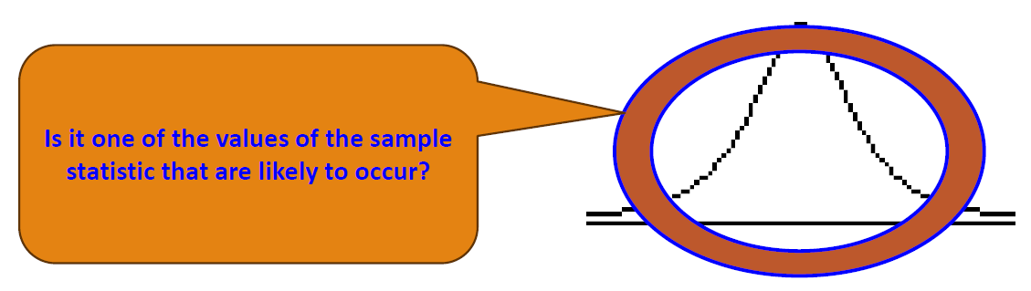

- A test of hypotheses is a method that uses sample data to decide between
  - two competing claims (hypotheses) about the population characteristic.

- Or is the value of the sample statistic a value that would be considered surprising
  - One that isn’t likely to occur due to natural variation? (in middle of curve) >> accept null Hypothesis
  - Or is the value of the sample statistic a value that would be considered surprising ie.. falls within the tail (left or right) >>> reject null Hypothesis

Is it one of the values of the sample
statistic that are likely to occur
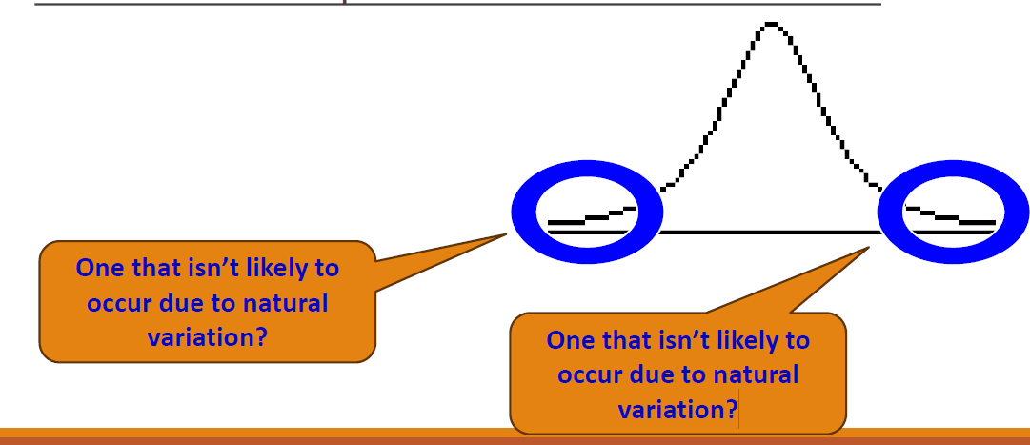

What is a test of hypotheses? - 2
- A test of hypotheses is a method that uses sample data to decide between two competing claims (hypotheses) about the population characteristic.

- How do we make that decision?
  - Based on our distribution, the statistic we generate and the number of pieces of information used to calculate it
  - We can compare our statistic to the critical values for an idealised distribution
  - We look it up in a table for the standardised version of this statistic that shows how extreme a statistic needs to be for a given number of degrees of freedom to be considered statistically significant.

Hypothesis Testing
- Hypotheses may concern a relationship (effect) in the population or a difference between groups in a population.

- The general goal of a hypotheses test is to rule out chance (sampling error) as a plausible explanation for the results from a research study.
  - All hypothesis testing starts with the assumption that the null hypothesis holds:
    - that there is no effect or difference in the population.
    - All tests are conducted on that what should be the likely outcome and we are looking of unusual outcomes to support our Hypothesis
    - Ho = True => no effect

Goal
- Make statement(s) regarding unknown population parameter values based on sample data

- Elements of a hypothesis test:
  - Null hypothesis (H0)
    - Statement regarding the value(s) of unknown parameter(s).
    - Typically, this will imply no association between independent and dependent variables in our theory (will always contain an equality)

  - Alternative hypothesis (Ha)
    - Statement contradictory to the null hypothesis (will always contain an inequality)
    - Collect data and seek evidence against H0 as a way of bolstering Ha (deduction

  - Test statistic
    - Quantity based on sample data and null hypothesis which allows you to determine between null and alternative hypotheses.

Process
- You start with the assumption (the 'null hypothesis' Ho) that there are no differences or relationships in the population as a whole.

- You then state an alternative hypothesis (Ha) that there is a difference or a relationship.

- You select a sample and find a difference/relationship in it.

- You can then use a variety of tests for statistical significance to work out the probability of the difference/relationship you have found in your sample simply occurring by chance.

Hypothesis Statements
- Hypothesis statements: The null hypothesis, denoted by H0
  - A claim about a population characteristic that is initially assumed to be hold.
  - Null – nothing.
  - Presumption of status quo or no change.

- The alternative hypothesis, denoted by Ha
  - The competing claim.
  - You are usually trying to determine if this claim is believable.
  - Should state what you expect the data to show, based on your theory.
  - You need to keep your research objectives in mind when stating this.

p-Value (sometimes called - probability of chance)

- Hypothesis testing depends on calculating a p-value:

  - P-value = The probability of observing a test statistic as extreme as the one we obtained, assuming the null hypothesis is true.

- These probabilities are computed using the normal distribution (or distributions derived from it: t, F, χ²).
- Without the normal distribution framework, we couldn’t assign these probabilities reliably.

- Comment
  - Probability of achieveing a test statistic as extreme as the one we have obtained, assuming that Ho is true = p – value
  - How statistically significant our result is
- Midle of Bell = >>> p-value = high
- Tails =>> p-value = 0.025
  - If value falls into this area > we know we have a very unusual result and statistically significant
- Computed using Norm Distri form the normal /

One v Two Tailed Hypotheses
- Can be directional > > or <
- One -tailed tests:
  - Allow for the possibility of an effect or difference in one direction.
  - checks for an effect or difference in one specific direction (either greater than or less than a certain value)

- Two-tailed tests: look at both sides…
  - Allow for the possibility of an effect or difference in two directions—positive and negative.

One Tailed Hypotheses
- Suppose you run a factory that produces light bulbs.
- You want to test if the average lifetime of the bulbs is greater than 1,000 hours (your null hypothesis is that it's 1,000 hours).

- You're not concerned if the lifetime is shorter, only if it's longer.
  - Null Hypothesis (H₀): The average lifetime is ≤ 1,000 hours.
  - Alternative Hypothesis (HA): The average lifetime is > 1,000 hours.
- This is a one-tailed test, because you're only testing if the lifetime is greater than 1,000 hours

Two Tailed Hypotheses
- Suppose you run a factory that produces light bulbs.

- You want to test whether the average lifetime of your bulbs is different from 1,000 hours.

- You're interested in finding out if it's either greater than or less than 1,000 hours.
  - Null Hypothesis (H₀): The average lifetime is = 1,000 hours.
  - Alternative Hypothesis (HA): The average lifetime is ≠ 1,000 hours.
- This is a two-tailed test, because you're testing for any difference, in either direction (both higher and lower).

Derive Hypothesis Pairs - 1

Question:
- The mean number of years Americans work before retiring is 34.
- Is this a null hypothesis/alternate hypothesis?
- Complete the hypothesis pair

Answer:
- Mean number of years Americans work before retiring is34.
  - Null hypothesis
  - Alternate: The mean number of years Americans work before retiring≠34 (not equal)

Derive Hypothesis Pairs - 2

Question:
- The average high temperature in July in Dublin historically has been 19C.
  - Perhaps it is higher now.
  - State the hypothesis pair.

Answer:
- The average high temperature in July in Dublin historically has been 19C. Perhaps it is higher now.
  - Null hypothesis: The average high temperature in July in Dublin is 19C.
  - Alternate: The average high temperature in July in Dublin is > 19C.

Question:
- Is this one-tailed or two-tailed?

Derive Hypothesis Pairs – 3 - Exercise

- Express H0 and HA for each of the following:
  - The mean annual starting salary for computer science majors is greater than £40,000
  - The proportion of people that suffer from diabetes in Ireland is less than 9%

- Identify whether they are one or two tailed hypotheses.

Answer
- answer
  - Ho = null hypothesis - mean starting salary for CS grad = 40K
  - HA = greater than – mean is > 40K
  - One tailed
- Answer
  - Ho = prop of people that suffer from diabetes in Ireland = 9%
  - Ha = prop of people ….. < 9%
  - One tailed

P-Value
- The threshold of probability or level of significance (denoted as α - alpha) is the level of significance is the threshold at which you decide whether to reject the null hypothesis.

- It represents the probability of making the error of incorrectly rejecting a null hypothesis.

- Common levels of significance are:
  - 5% (0.05):
    - This means that you are willing to accept a 5% chance of incorrectly rejecting the null hypothesis.
  - 1% (0.01):
    - This means you are willing to accept only a 1% chance of making that error.
  - 0.1% (0.001):
    - This means you are willing to accept only a 0.1% chance of making that error.
    - Comment > Probability of us making a mistake here is very low….

P-value and Confidence Interval

- A confidence interval is a range of values that is likely to contain the true population parameter (e.g., a mean or proportion) with a certain degree of confidence.

- The level of confidence is typically 1−𝛼:
  - If α = 0.05 (5%), the confidence interval would be 95%.
    - A 95% confidence interval means that if you were to repeat the experiment 100 times, in 95 of those experiments, the calculated interval would contain the true population parameter.
  - For α=0.01, the confidence interval would be 99%.

P-Value – cut off value
- Decide in advance your cut-off value (0.05, 0.01)

- If find P-value >= cut-off
  - No evidence to reject null hypothesis
  - Report decision and report the actual p-value

- If find P-value < cut-off
  - Need to also consider the strength of your statistic
  - Have evidence to reject null hypothesis in favour of the alternate
  - Report p < your cut-off
    - Note: convention is if p value is < .000 then report it as < 0.001 even if working at a level of 0.05

Hypothesis test - Decision

- Decision:
  - reject H0

- OR
  - fail to reject H0

- Each could possibly be a wrong decision:
  - Therefore, there are two types of errors:
  - Type I
  - Type II

KEY SLIDE – Type 1 Error
- The error of rejecting H0 when H0 actually holds
- The probability of making a Type I error is denoted by α.
- α is called the significance level of the test

KEY SLIDE STAR - 6

KEY SLIDE – Type 2 Error

- The error of failing to reject H0 when H0 is does not hold
- We don’t find it but it does exist….
- => we dont have enough variation in our sample
- The probability of making a Type II error is denoted by β
  - This is the lower-case Greek letter “beta”.

KEY SLIDE STAR - 7

KEY SLIDE - Power if s Statistical test

- The power of a statistical test is the probability that it correctly rejects the null hypothesis when the alternative hypothesis holds.

- In other words, it’s the test's ability to detect a true effect.

- The power of a test is calculated as:

  - Power=1−𝛽

KEY SLIDE STAR - 8

P-value, α – statistical significance

- A probability measure of evidence about H0.

- H0 : the assumption that null hypothesis holds.
  - There is no effect or no difference.
  - It represents the default state or a baseline assumption about the population

- Statistical significance in simple terms:
  - Given our presumption that the null hypothesis holds
  - α is the probability that the results could have been obtained purely because of chance alone.

- The probability (under presumption that H0 holds) the test statistic equals observed value or value even more extreme predicted by Ha

- The P-value allows us to answer the question:
  - Do our sample results allow us to reject H0 in favour of Ha?
  - If that probability (p-value) is small, it suggests the observed result cannot be easily explained by chance.

KEY SLIDE STAR - 9

Statistical Significance
- Working with random samples can never have 100% certainty that findings we derive from the sample will reflect real differences in the population as a whole.

- Convention is that (for your field of study) there is an accepted level of probability such that it is considered so small that the finding from your sample is unlikely to have occurred by chance or sampling error.
  - Normally, that line is drawn at p=0.05 or p=0.01.
    - In other words, when a statistical test tells us that the finding has less than a 5% or 1% chance of occurring due to sampling error then we tend to conclude that we can be sufficiently confident that the finding is therefore likely to reflect a ‘real’ characteristic of the population as a whole.
  - When this occurs, you can say that your finding is statistically significant.

Hypothesis Testing – Process recap

- You start with the assumption (the 'null hypothesis' H0 ) that there are no differences or relationships in the population as a whole.

- You then state an alternative hypothesis (Ha) that there is a difference or a relationship.

- You select a sample and find a difference/relationship in it.

- You can then use a variety of tests for statistical significance to work out the probability of the difference/relationship you have found in your sample simply occurring by chance.

- Using the standard level accepted by your domain (e.g. p ≤0.05 or p ≤0.01)

- If the probability less than this value then you reject the null hypothesis and thus accept the alternative hypothesis and you can state that your findings are 'statistically significant'.

- If the probability is greater this value then you conclude that there is no evidence to reject the null hypothesis and your findings are not ‘statistically significant’.
  - N.B. This is different from concluding that you have evidence to accept the null hypothesis.
  - In these cases, your findings are said to be ‘not significant’.

Caveat
- Is not black and white….
  - If we get a p-value of 0.051 should we accept the null hypothesis?

  - Should we reject the null hypothesis if we get a p-value of 0.049?

  - Need to allow for some flexibility in interpretation… would say this is what I found… “…while its less than cut off.. we do have to treat it with care..”

KEY SLIDES - Accepting and Rejecting Hypotheses

KEY SLIDE - Non-statistically significant result
- A non-statistically significant test result does not mean that the null hypothesis is true or that you have proved the null hypothesis
  - We do not use terms “TRUE” or “PROOF”
  - Use terms like “… have evidence to support..”
  - It means you do not have sufficient statistically significant evidence to reject the null in favour of the alternate

KEY SLIDE STAR - 10

KEY SLIDE - A significant result

- A significant result does not mean that the null hypothesis is false or that you have proved the alternate hypothesis
  - It means you have sufficient statistically significant evidence to reject the null in favour of the alternate

KEY SLIDE STAR - 11

Inspecting and Preparing Data
- Comment >>>> completed after lab step through
- Order was hypothesis > lab with corr / p value testing >> descrbing data

What do I need to describe for numerical data?
- Centre
  - Discuss where the middle of the data falls
  - Measures of central tendency
    - mean, median and mode
- Spread
  - Discuss how spread out the data is
  - Refers to the variability in the data
    - Range, standard deviation, IQR
- Shape
  - Refers to the overall shape of the distribution
  - Symmetrical, uniform, skewed, or bimodal

- Unusual Occurrences
  - Outliers (value that lies away from the rest of the data)
  - Gaps
  - Clusters
- Context
  - You must write your answer
  - With reference to the context in the problem you are investigating,
  - Using correct statistical vocabulary adhering to referencing scheme guidelines
  - Using complete sentences.

Parametric v Non-parametric

- Parametric
  - Make assumptions about the population from which the sample is taken
  - Shape of the population (normally distributed)

- Non-parametric
  - Do not make assumptions about the population and its distribution
  - Tolerant set of tests which don’t expect your data to anything fancy
    - Not high-powered and don’t promise more than they can deliver
    - May fail to detect differences that exist
- Use for nominal or ordinal data
- Use for small samples
- Use for skewed data

The normal distribution
- When we take a random sample from a population and compute a statistic (e.g., the sample mean), the Central Limit Theorem (CLT) tells us that this statistic will have an approximately normal distribution, even if the population itself is not perfectly normal (as long as the sample size is reasonably large).

- Parametric tests assume normality.
  - The test statistics (like the t-statistic or F-statistic) are derived under the assumption that data, or at least the sampling distribution of the mean, follows a normal distribution.

- If the assumption of normality is badly violated (especially in small samples), the test statistics may not follow their theoretical distributions, making p-values invalid.

- For large samples, the Central Limit Theorem helps:
  - A normal approximation works even when data are not strictly normal, which is why parametric tests are often considered “robust” to moderate deviations from normality.

Hypothesis Testing
- Hypothesis testing depends on calculating a p-value:
  - The probability of observing a test statistic as extreme as the one we obtained, assuming the null hypothesis is true.
- These probabilities are computed using the normal distribution (or distributions derived from it: t, F, χ²).
- Without the normal distribution framework, we couldn’t assign these probabilities reliably.

Choices to be made before conducting a hypothesis test/building a model
- Before go to Hypothesis test need to decide if have enough data
  - Deciding if you have sufficient data and sufficient variability within that data

- Correcting for non-response, design effect
  - Weighting variable
  - Be careful of scale up weighting
  - Did they add this in data set that you need to look at? Maybe they added it?

- Missing data
  - Decide what level of data is missing
  - Decide what the pattern is
  - Decide why it is missing
  - Correct accordingly or ignore

- Normality
  - Inspect and test for normality
  - Be aware of allowable limits
- If not normal
  - Could use non-parametric tests
  - OR
  - Apply a transformation to see if that results in a normal distribution

- Linearity and homoscedasticity (scale variables)
  - Inspect your scatterplot
  - If assumptions are not addressed could consider transformation but also non-parametric test

Preparing your data
- You may need to consider doing the following:
- Making a decision about missing data
- Making a decision about outliers
- Recoding your variables
  - E.g. to reduce the number of categories
  - Doing so will not be objective but working with categorization at all is highly contested and highly political
- Weighting your data to correct for bias, address design effects, make sample more representative of the population

- Selecting cases
  - To work only with particular sub-groups of data
- Splitting your file
  - Allows you to organise your output by category of variable you are interested in

Why Prepare Data?..
- Its all about Bias…. Want to minimise bias….

Bias
- We want our sample to be representative of the population from which it is taken.

- A sample is biased if it is systematically different from the population
  - Under representation
  - Over representation

Bias – 2 - Types
- Selection Bias
  - Choosing only to use certain cases or groups of cases in your analysis
  - Randomness is not achieved
- Sampling Bias
  - Caused by non-random sampling
  - Is a fact of life in most cases as you mainly use convenience samples
  - Need to recognise and try to minimise the impact
- Time interval Bias
  - By specifying a time bounded interval for collecting data
- Confirmation Bias
  - Choosing data which is more likely to support your belief which is determined in advance of analysis
- Omitted Variable Bias
  - Choosing not to collect data about certain concepts or not to include variables which represent certain concepts in predictive models

Missing Data
- Is a form of Bias!!
- Missing data affects the validity of statistical analysis and can lead to invalid conclusions
  - Reduces statistical power
    - the probability that the test will reject the null hypothesis when it is does not hold.
- Can reduce the representativeness of the samples.
  - Can cause bias in the estimation of parameters.

- May complicate the analysis of the study.

Missing Data - 2
- What is certain in quantitative research?
  - Measurement error
  - Missing data

- Missing data can be:
  - Due to preventable errors, mistakes, or lack of foresight by the researcher
  - Due to problems outside the control of the researcher
  - Deliberate, intended, or planned by the researcher to reduce cost or respondent burden
  - Due to differential applicability of some items to subsets of respondents
  - Etc.

Why are the values missing

Automated Data Collection (e.g., web scraping, monitoring, sensors)
- Doesn’t mater that tis missing but you need to determine why its missing….

- Non -response analogue:
  - Some sources may be systematically missing. For example, scraping social media may exclude private accounts, deleted posts, or platforms that block crawlers.
- Unobserved factors
  - Technical constraints (e.g., only collecting during certain times of day, only capturing certain device types) can bias the dataset.
- Example
  - Traffic monitoring systems may miss cyclists or pedestrians if only cars are recorded.

Experimental Studies
  - Attrition (dropout bias)
    - Participants may leave an experiment early, and dropout is often non-random (e.g., those not experiencing a treatment benefit may withdraw).
  - Non-compliance:
    - Some participants may not follow protocols (e.g., skipping medication, ignoring instructions). If this is not random, it biases results.
  - Unobserved factors
    - Conditions like lab environment, researcher effects, or hidden participant traits may affect outcomes but aren’t measured.

Observational / Administrative Data
  - Coverage bias
    - Administrative records (e.g., hospital data, school registers) only capture people who interact with those systems, missing those outside.
  - Systematic exclusions
    - Some groups may be underrepresented (e.g., undocumented migrants missing from government datasets).
  - Mechanism knowledge
    - Sometimes we know who is excluded (e.g., lack of insurance → not in claims data), which allows adjustment with auxiliary variables.

Survey-Specific Issues (with generalisable analogues)
    - Survey refusals
      - Equivalent in non-survey contexts to “opt-out” of participation (e.g., patients refusing to be part of a clinical registry).
    - “Don’t know” responses
      - Analogous to uncertain or incomplete data logs (e.g., IoT devices transmitting null values).
    - Differential applicability
      - Just as some survey items apply only to subsets of respondents, certain measurements in experiments may apply only to subsets (e.g., biomarkers only measurable in those with sufficient sample material).

Data Errors

- Data Entry Errors
  - Human Error: Mistakes made during data entry can lead to missing values, such as typing errors or omitting values accidentally.
  - System Limitations: Certain data management systems may not enforce mandatory fields, leading to incomplete records.

- Data Integration Issues
  - Mismatched Sources: When merging data from different sources, discrepancies in data formats or schemas can lead to missing values for some records.
  - Duplicate Entries: During data consolidation, duplicate records may be eliminated, which could inadvertently remove data fields from some records.

- Data Corruption
  - File Corruption: Data files can become corrupted due to system crashes, hardware failures, or software bugs, resulting in missing or unusable data.
  - Incompatible Formats: Data transferred between incompatible systems may result in loss or corruption of certain fields.

- Incomplete Data Collection
  - Limited Data Collection Period: Data may be collected over a limited time, leaving gaps for periods not covered by the data collection process.
  - Insufficient Coverage: If the sample or data collection process does not encompass all relevant categories or time frames, some data points will be missing.
- Data Privacy and Security
  - Anonymization: In some cases, data may be intentionally withheld or anonymized to protect individuals' privacy, leading to missing values for certain sensitive fields.
  - Compliance Regulations: Data retention policies driven by privacy regulations (like GDPR) may lead to the deletion of certain records.
- Data Filtering or Preprocessing
  - Outlier Removal: During data cleaning, outliers may be removed, leading to missing data for certain records.
  - Thresholds: Data might be filtered out based on specific thresholds (e.g., only including records with a certain level of detail), resulting in missing entries for others.

- Missing by researcher error
  - May be missing completely at random
  - May reflect researcher bias
  - Due to preventable errors, mistakes, or lack of foresight by the researcher
  - Due to problems outside the control of the researcher
    - E.g.
    - Perceived risk to researcher
  - Deliberate, intended, or planned by the researcher to reduce cost or respondent burden

- Code reason value is missing
  - Depends on your domain but standards will apply
    - e.g. -99 social sciences data
    - NA by default in R – how to treat them? / delete / impute…
  - Treat each reason differently
- Can we impute a better value?
  - Should we?

KEY SLIDE – last two bullets - Why do we need to care about missing data?

- Source of bias
  - Introduces the possibility of making inferences on the basis of sample data that are inadvertently biased in unknown directions

- Choice of treatment (e.g. deletion) can lead to loss of information and loss of statistical power through reduced sample size

- Makes some common tests inappropriate or difficult to use

- The mechanism and the pattern of missing data have greater impact on results than does the amount of data missing

- The logic of statistical inference presumes that the sample is randomly drawn from the population.
  - Thus whether the missing data within a sample are random is important.

- Comment
  - Why data is missing is more important than the amount missing

- When data are missing in a random fashion, there is no systematic difference between the available data and the missing data;
  - That’s OK!
- They are both random subsets of the data composing the entire sample.

KEY SLIDE STAR - 12

The reason instructs the Solution

Data missing at random (MAR). – May be possible to ignore need to ID reason and decide if ignore or not

- The distribution of the missing data is related to the distribution of the observed data but not to the values in the variable which has missing values.

- Here the missing values for IQ score are related to the value of the Age variable.

2. Data missing completely at random (MCAR). – Can ignore
◦
- This is what we want!! – not related to anything else
- When the probability of missing data on a variable is unrelated to any other measured variable and is unrelated to the variable with missing values itself.
- ◦i.e. the missingness on the variable is completely unsystematic.

- Here there does not appear to be a pattern to the missingness of IQ Score.

3. Data that are not missing at random (MNAR) – Cannot Ignore

- Worst case… no values lower than 110…have to deal with it
- When the missing values on a variable are related to the values of that variable itself, even after controlling for other variables.

- Data are missing on IQ but only the people with low IQ values have missing observations for this variable.

Missing Data Mechanisms
- The appropriateness of different missing data treatments depends (among other things) on the underlying missing data mechanism

- “Real” missing data can seldom be classified into just one of the three (MCAR, MAR, MNAR)

- Because we don’t have access to the missing data (Ymiss), we can not empirically test whether or not the data is MNAR

- If we know (or can convincingly argue) that the data is not MNAR, a test of whether the data is MCAR is available (in various packages in R).

What should you do?

Case = row
Variable = column

- Consider the amount of missing data
  - Percent of cases with missing data
  - Percent of variables having missing data
  - Percent of data values that are missing
- Consider the pattern of missing data
  - Missing by design
  - Missing data patterns

- Understand why each value is missing

- Delete observations or variables where you do not intend to impute a value

  - Drop variable
  - Drop observation
- Must report that you have done this and why.

Chatgpt >> get % of missing data in cases/variables and overall
‘’’{r}
mean(is.na(df)) * 100
# [1] 16.66667 → 16.7% of all data values missing

mean(colSums(is.na(df)) > 0) * 100
# [1] 66.66667 → 2 of 3 variables (columns) have missing values

mean(rowSums(is.na(df)) > 0) * 100
# [1] 50 → 2 of 4 cases (rows) have missing values
‘’’
>> % missing - using naniar package (mice is another package)
‘’’{r}
install.packages("naniar")
library(naniar)

miss_var_summary(df) # Missingness by variable
miss_case_summary(df) # Missingness by case
pct_miss(df) # Overall % missing values

library(mice)
md.pattern(df)
‘’’{
>> % missing - using VIM package -visualise missing data
‘’’{r}
library(VIM)
aggr(df)
‘’’

Missing Data – reference paper

- Anesthesiol. 2013 May;64(5):402-6. doi: 10.4097/kjae.2013.64.5.402. Epub 2013 May 24. PMID: 23741561; PMCID: PMC3668100.
- https://www.ncbi.nlm.nih.gov/pmc/articles/PMC3668100/#:~:text=Missing%20data%20can%20reduce%20the,estimates%2C%20leading%20to%20invalid%20conclusions.&text=Missing%20data%20(or%20missing%20values,in%20the%20observation%20of%20interest

What usually happens?
- Sample = large > we may be able to allow cases to be excluded.

- Sample = small > try a substitution method so that we can retain enough cases to have sufficient power to detect effects.

- In either case, we need to make certain that we understand the potential impact that missing data may have on our analysis.

KEY SLIDE – last 2 bullets - Goals of missing data treatment

- Preserve the essential characteristics of the data
  - Distributions of the variables
  - Relationships among the variables
- Maintain the representativeness of the analyzed data
- Provide valid statistical inference (control Type I error)
- Maximize the statistical power of the study and its statistical analyses (minimize Type II error)
- Avoid bias and instability in the parameter estimates and standard errors for statistical models

- If missing data represent less than 5% of the total and is missing in a random pattern from a large data set, almost any procedure for handling missing values yields similar results

- Ref> - Tabachnik and Fidell, Using Multivariate Statistics, 6th Edition, Pearson

KEY SLIDE STAR - 13

KEY SLIDE - R test for missing data - naniar

‘’’R
# install.packages(“naniar“) # if not already installed
library( naniar)

# Example: running Little's MCAR test on a dataset
called ‘survey'
result <- mcar_test(survey)
print(result)

‘’’
- This test evaluates whether the missing data pattern is consistent with MCAR.
- A non-significant p-value (p > 0.05) suggests that the data could plausibly be MCAR.
- A significant p-value (p < 0.05) suggests the data is not MCAR (likely MAR or MNAR).

KEY SLIDE STAR – 14

- Comment –
  - Question Adem Cayir
    - should we use missing data (by filling with mean values) or not use. or how can we make this decision?
  - Answer :
    - It depends how much you have got
    - If have < 5% of total data missing and is random pattern and nto concerned about patter in which they are missing
      - Doesn’t mater what you do
        - Delete / impute /put in mean etc
        - Will nto make that much difference
    - Need to look at pattern –
      - if missing group of pop
      - missing data
      - include that section if you ned ti >> impute it
      - if don’t need it delete it as long as < than 5%
      - Tabachnik and Fidell – Using Multivariate Statistics, 6th Ed

Delete Data

Deletion Methods – Listwise

- Listwise deletion (complete case analysis)
  - Deletes the case if any variable is missing data
  - All cases with missing scores on one or more variables are excluded from the analysis.
  - The advantage of this method is that the remaining dataset is complete.
    - But this complete dataset has a reduced sample size and power, caused by the loss of the incomplete cases.
  - The chance of having a biased dataset is substantial if data is not MCAR.
  - In most situations, the disadvantages of listwise deletion far outweigh its advantages

Deletion Methods – Pairwise

- Pairwise deletion (available case analysis)
  - Deletes case only when considering the variable for which data is missing, can still use it for other variables.
  - Any given case may contribute to some analyses but not to others.
    - So the sample size varies from test to test/model to model - the sample size will be the same for some analyses but will be reduced for others.
  - Using this method the assumption of the MCAR mechanism can produce unbiased estimates
  - But also the inconsistency of the sample size can lead to problems in computing standard errors.

Replace Data

Replace - Imputation
- Replace missing values with a substitution (uses historical data)
- Cold deck (uses data from previous study or historical study)
- Hot deck (donor case) imputation
  - Various forms : mean, nearest neighbor, random

- Mean substitution
  - (Variable) mean substitution
  - Mean substitution with added random error
- Regression imputation
  - Regression predicted value imputation
  - Regression imputation with added random errors.

Replace - Maximum Likelihood

  - Estimates summary statistics or statistical models using all available data
  - Uses each cases available data to compute maximum likelihood estimates.
  - The maximum likelihood estimate of a parameter is the value of the parameter that is most likely to have resulted in the observed data.
  - The likelihood is computed separately for those cases with complete data on some variables and those with complete data on all variables.
  - These two likelihoods are then maximized together to find the estimates.
  - Gives unbiased parameter estimates and standard errors.
  - Limited to linear models.

Replace – Multiple Imputation
- Imputes individual data values in multiple complete datasets, averaging the results of the statistical analyses across these datasets
- Because it uses an imputation method with error built in, the multiple estimates should be similar, but not identical.
- The result is multiple data sets with identical values for all of the non-missing values and slightly different values for the imputed values in each data set.
- The statistical analysis of interest, such as ANOVA or logistic regression, is performed separately on each data set, and the results are then combined.
- Because of the variation in the imputed values, there should also be variation in the parameter estimates, leading to appropriate estimates of standard errors and appropriate p-values.

Statistical Analysis with Missing Data

- What do you get when you don’t specify what you want?
- What choices do you have within a given analysis procedure?
  - Listwise
    - Complete-case analysis removes all data for a case that has one or more missing values for variables of interest
  - Pairwise
    - Attempts to minimize the loss that occurs in listwise deletion.
    - Will conduct relevant analysis for variables if data exists in one or more of them and it makes sense to do so.

- Missing data treatments carried out prior to analysis
  - Ad hoc methods (Listwise, pairwise, single imputation, etc.)
  - Modern methods(Maximum Likelihood, Multiple Imputation)

Missing Data Approach Summary

- If you find a variable with a large amount of missing data you need to find out why it is missing

- If it is not missing at random you need to deal with it in your tests
  - In R most functions have a series of na parameters you can set to indicate what you want to do e.g. na.omit=true

Key SLIDE - General Steps - Dealing with Missing data

- Identify patterns/reasons for missing and recode correctly

- Understand distribution of missing data
  - Consider the probability of missingness
  - Are certain groups more likely to have missing values?
  - Example: Respondents in service occupations less likely to report income
  - Are certain responses more likely to be missing?
  - Example: Respondents with high income less likely to report income

- Decide on best method of analysis
  - Use what you know about
  - Why data is missing
    - Distribution of missing data

- Decide on the best analysis strategy to yield the least biased estimates
  - Deletion Methods
    - Listwise deletion, pairwise deletion
  - Single Imputation Methods
    - Mean/mode substitution, dummy variable method, single regression
  - Model-Based Methods
    - Maximum Likelihood, Multiple imputation

Handling Missing Data in R –

Lab reference - 1
- See the Quarto notebook accompanying the lecture
- Calculate the % for the variables of interest
- Visualise the patterns
- Make a judgement on whether it is MAR, MCAR or MNAR and what you will do about it

Lab reference - 2
- You can choose to eliminate all the data
‘’’R
ydata <- na.omit(survey)

‘’’
- You can filter those that are na for all relevant variables
- Most modelling functions offer you an option for handling missing data
◦

‘’’R
na.rm=True
‘’’
- Imputing missing data
  - Simputation package
- Hmisc package contains several functions that are helpful for missing value imputation (agreImpute(),impute()andtranscan())
- https://cran.r-roject.org/web/packages/Hmisc/index.html#:~:text=Contains%20many%20functions%20useful%20for,of%20R%20objects%20to%20LaTeX
- mitools package
  - https://cran.r-project.org/web/packages/mitools/index.html

Survey Data – Sources of Bias
- Oversampling
  - Some groups are purposefully sampled more frequently than others to produce a large enough sample size for analysis.
- Undersampling
  - Sample size is intentionally reduced to ensure equal representation of different groups.
- Non-response
  - When individuals who choose not to participate in a survey have different characteristics or opinions than those who participate
  - This can result in under- or overestimating certain aspects of a population, leading to a skewed representation of the data.

Weighting

- Use to
  - Correct for any known bias that may exist in the final sample
  - Scale-up frequencies so that frequencies calculated from the sample represent estimates for the population as a whole
  - To address ‘design effects’ arising from the sampling methods used.

Example

- Suppose we undertake a survey
- We have selected a random sample for this purpose
- Suppose we collect data on gender and marital status.

Example – Ctd
Work out your actual proportions surveyed:
Demographic group Percentage
Unmarried male 18.5%
Unmarried female 18.7%
Married male 21.2%
Married female 20.9%
Widowed man 2.3%
Widowed woman 3.1%
Divorced man 4.7%
Divorced woman 6.6%

Work out your expected proportions based on population
Demographic group Percentage
Unmarried male 20%
Unmarried female 16.9%
Married male 23.8%
Married female 23.7%
Widowed man 1.4%
Widowed woman 4.7%
Divorced man 4.1%
Divorced woman 5.4%

Weighting – Correcting for Non-Response

- We could conduct our analysis doing nothing to correct for this disparity, but we would be running the risk of creating biased estimates (perhaps males and females prefer different facilities)
- By not correcting for bias in our sample we are giving more weight to some categories than others.

Weighting Factor

- Calculate the weights for each demographic group by dividing the expected percentage by the actual percentage

Weighting – Correcting for Non-Response -1

- How do we use the weighting factor?
- We multiply all responses for that category by the corresponding weighting factor
- We apply the weight in the calculation of all relevant statistics (e.g. weighted mean).
- In R: simple multiplier applied to all variables of interest, can include in your dataset

Weighting – Correcting for Non-Response - 2

- Weighting variables are normally used to correct for known biases in several factors.

- In the youthcohort.sav (Paul Connolly) the weighting variable is used to correct for four factors related to non-response (gender, qualifications achieved, region in which they live and type of school)

- Principle for calculating weighting variable remains the same.

Weighting – Correcting for design effects

- Due to cluster sampling
- Used in large-scale surveys where it would be too costly to select a simple random sample

- Suppose we need to conduct a survey of 10-11 yr. old pupils in school

- Assuming it is possible to create a full -list of all eligible pupils in the country, then the selection of a simple random sample of 2000 pupils could mean having to interview children scattered across 800 schools throughout the country
  - Lots of cost in doing interviews
  - Huge amount of time in negotiating access, seeking permission etc.

Weighting – Correcting for design effects - 2

- An alternative is to use some form of cluster sampling
- Select 100 schools at random
- Survey all children in those schools
- If on average 20 pupils per school takes part this gives us our sample of 2000 pupils

- But this may underestimate the amount of variation within the population as a whole
  - Pupils within each cluster (each school) are likely to be more like each other than to those outside the school
  - Thus, we are likely to underestimate variation unless we correct for this ‘design effect’
  - Consequence: increased risk of Type I error

Weighting – Correcting for design effects - 3

- Correct Approach: Use multi-level modelling (examine each cluster)
  - Beyond the scope of this module

- Compromise Approach: Employ a weighting variable that attempts to reduce the overall size of the sample so that standard errors are increased to account for this

- In earlychildhood.sav and afterschools.sav WTCORRCT corrects for known biases by non-response and provides a correction due to sampling.

What do I need to do?
- Check if a weighting variable is included in your dataset.

- If yes
  - Find out what type of weighting variable it is
  - Design effect – apply for all analysis
  - Non-response – apply for all analysis – but check the sampling method and use caution in reporting as above

Outliers

- CASES THAT HAVE DATA VALUES THAT ARE VERY DIFFERENT FROM THE DATA VALUES FOR THE MAJORITY OF CASES IN THE DATA SET.

- IMPORTANT BECAUSE THEY CAN CHANGE THE RESULTS OF OUR DATA ANALYSIS.

- WHETHER WE INCLUDE OR EXCLUDE OUTLIERS FROM A DATA ANALYSIS DEPENDS ON THE REASON WHY THE CASE IS AN OUTLIER AND THE PURPOSE OF THE ANALYSIS.

Univariate and Multivariate Outliers

- Univariate outliers
  - Cases that have an unusual value for a single variable

- Multivariate outliers
  - Cases that have an unusual combination of values for several of the variables.
  - The value for any of the individual variables may not be a univariate outlier, but, in combination with other variables, is a case that occurs very rarely

Reasons for Outliers

Reasons
- Data entry error
- Failure to specify a particular value for missing data
- Outlier not a true member of population of interest
- Outlier is a true member of population of interest with an extreme score

What to do?

- Transform to standardized variables
  - Look at histogram
  - Sometimes transforming data can “pull in” the outlier
- Censoring outliers
  - May need to delete case/s and run with and without outlier

Standard Scores Detect Univariate Outliers
- One way to identify univariate outliers is to convert all values for a variable to standard scores.

- sample size= small i.e. < or = 80 cases
  - a case is an outlier if its standard score is ±2.5 or beyond.

- sample size > 80 cases
  - a case is an outlier if its standard score is ±3.29 or beyond

- This method applies to interval/ratio level variables, and to ordinal level variables that are treated as metric.
- It does not apply to nominal level variables.

Correlation

Correlation - what are we interested in?
- We are interested in two concepts in the real world.
- We hypothesize that they vary in common (change at a constant rate)
- We are interested in calculating a statistical measure that expresses the extent to which two variables are linearly related.

- Linear: A change in one variable is reflected by a consistent change in the other.

- We are interested in:
  - the strength of the relationship
AND
  - the direction

Covriance

- Covariance is a measure of how two variables change together. “Co..”
- It tells us whether two variables tend to increase or decrease together, or if one increases while the other decreases

Covariance – 2

- Variance tells us by how much scores deviate from the mean for a single variable.

- Covariance = Scaled version of variance
  - Calculate the error between the mean and each observations score for the first variable (x).
  - Calculate the error between the mean and their score for the second variable (y).
  - Multiply these error values.
  - Add these values and you get the cross-product deviations.
  - The covariance is the average cross-product deviations.

Positive and Negative

- Positive covariance:
  - If two variables have a positive covariance, it means that as one variable increases, the other tends to increase as well (they move in the same direction).

- Negative covariance:
  - If two variables have a negative covariance, it means that as one variable increases, the other tends to decrease (they move in opposite directions).

- Comment
  - We don’t use Covariance as it is not a standardised statistical measurement
  - Btu we want a number we can use

Sense, measure and magnitude
- Covariance does not provide a standardized measure
- Only gives
  - Sense of the direction of the relationship (positive or negative)
  - Sense of magnitude of their joint variability,
    - but the magnitude can be hard to interpret since it's not scaled.

Correlation

- Correlation is a standardized version of covariance, meaning it's scaled to always fall between -1 and 1.
- Correlation coefficient (r) ranges from:
  - +1: Perfect positive relationship (as one variable increases, the other increases in a perfectly linear fashion).
  - -1: Perfect negative relationship (as one variable increases, the other decreases in a perfectly linear fashion).
  - 0: No relationship (the variables are not related).

Correlation - What are we interested in?

- Modelling this in the linear model
  - We are using a line as the model
- Direction of the relationship
  - Positive or negative
  - Slope of the line
- Strength of the relationship
  - How close are the data points to the line
    - Very close = strong
    - Very dispersed = weak

Visualize Using a Scatterplot

- When to Use:
  - Bivariate numerical data (two variables)
  - Plot the relationship between two variables
    - One independent, one dependent
  - Collection of ordered pairs

- How to construct:
  - Draw a horizontal scale and mark it with appropriate values of the independent variable
  - Draw a vertical scale and mark it appropriate values of the dependent variable
  - Plot each point corresponding to the observations

- To describe
  - Comment the relationship between the variables

What are we Interested in ? - Again

- Direction
  - Positive or negative
  - Slope of the line
- Strength
  - How close are the data points to the line
  - Very close = strong
  - Very dispersed = weak

Positive Correlation
- If the x -coordinates and the y-coordinates both increase, then it is POSITIVE CORRELATION.

- This means that both are going up, and they are related.

- X > going up
- Y > going up

Positive Correlation - 2

Age | 1 | 2 | 3 | 4 | 5 | 6 | 7 | 8
Height | 25 | 31 | 34 | 36 | 40 | 41 | 47 | 55

- If you look at the age of a child and the child’s height, you will find that as the child gets older, the child gets taller.
- Because both are going up, it is positive correlation.

Negative Corelation
- If the x-coordinates and the y-coordinates have one increasing and one decreasing, then it is NEGATIVE CORRELATION.

- This means that 1 is going up and 1 is going down, making a downhill graph.

- This means the two are related as opposites.

- Y > Up
- X > down

Negative Correlctaion - 2
Age of car | 1 | 2 | 3 | 4 | 5
Value | € 30,000 | € 27,000 | € 23,500 | € 18,700 | € 15,350

- If you look at the age of a car and its value, you will find as the car gets older, the car is worth less.
- This is negative correlation

No Correlation

- If there seems to be no pattern, and the points looked scattered, then it is no correlation.
- This means the two are not related.

Strength of the relationship
- Consider how close the Data Points are to the line:
  - If the points are widely spread from the trend line, it indicates more variability in the data and thus a weaker relationship.
  - If the points are tightly packed along the line, it indicates less variability and a stronger relationship.

- Strong Relationship:
  - If the points are closely clustered around a straight line (for a linear relationship) or a curve (for a nonlinear relationship), it indicates a strong correlation. The points follow a clear pattern.

- Weak Relationship:
  - If the points are more scattered and don't form a clear pattern, the relationship between the variables is weak or even nonexistent.

Outliers

- Presence of outliers (points far away from the general trend) can weaken the strength of the relationship, especially if the rest of the points follow a pattern.
- You need to investigate these outliers in your initial data inspection to ensure they could not unduly influence your analysis.

- Comment
  - It is our responsibility o inspect and figure out whay it is an outlier
  - Maybe an error?
  - Maybe can get rid of it?

Relationship – what does it mean?

- The relationship between bivariate numerical variables
  - May be positive or negative
  - May be weak or strong
- What does it mean if the relationship is positive? negative?

- Positive or Negative
  - A positive relationship is one where as x increases, y increases.
  - A negative relationship is one where as x increases, y decreases.

- Strong or Weak
  - What feature(s) of the graph would indicate a weak or strong relationship?
    - Closeness of Data Points to a Line
    - Spread of the Data
    - Outliers

Example Questions to complete

Set A = stront positive linear relationship Set B = little or no relationship
Set C = Weak (Moderate) Negative Liner relationship
Set D = Strong positive Curved relationship (Monotonic – starts oen way then changes….) maybe nw grouping need ot think about)

Scatterplots
Which Scatterplots below show a linear tend?

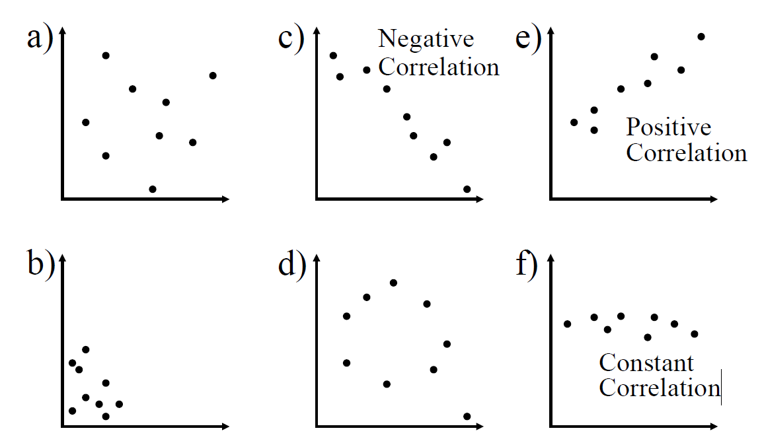

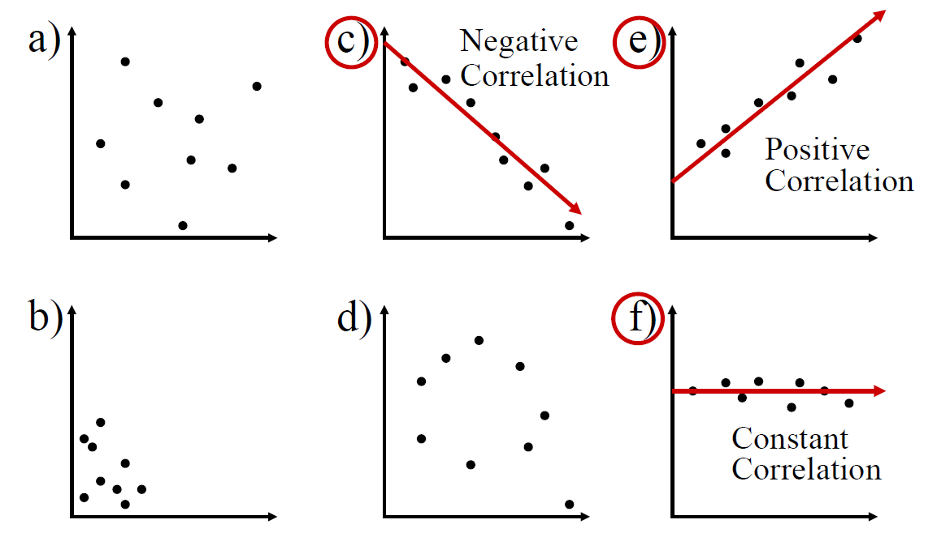

Statistical model

NOTE (I here is lower case and bottom left of text, just can’t get it like that in word)
- Equation for any model:
  - Outcome i = (model) + error i

- For a Linear model:
  - Outcome i =Σ(β × predictor variable i )+error i
  - Dependent i =Σ(β × independent variablei )+error i
  - β = weight that describes the relationship between the dependent and independent variable
  - Represents the amount that the outcome variable changes for one unit change in the independent variable

- For a linear relationship:
  - y(dependent/outcome variable) =Σ(b0 + b (slope of line)× x(predictor/independent variable )

Example
- Suppose we want to look at children’s maths scores at age 16 and their achievement of a standard maths test at aged 7 (key stage 1).

- We are interested to see if the score a child achieves at age 7 is related to the score that they achieve at age 16.
  - And if they are related, what is the direction and strength of the relationship

- Example - Relationship between Maths score age 7 with score at age 16 (for 25 students)
y = b0 + bx + e

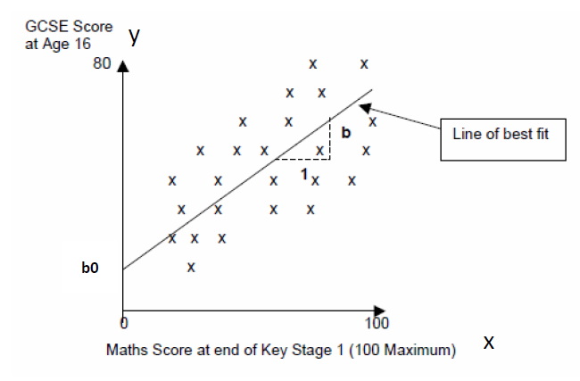
- ‘y’ is the outcome variable (in this case maths score age 16) – the dependent variable
- ‘x’ is the predictor variable (in this case score age 7) – the independent variable
- ‘b0’ is the intercept or the point where the line crosses the y-axis (y value when x =0 i.e. value of maths score at age 16 if score at age 7 is 0)
- ‘b’ is the gradient of the line
  - Represents the amount that the outcome variable changes for one unit change in the independent variable
  - i.e. for every one percentage point increase in a child’s Maths Test score, the line suggests that the child’s maths score age 16 increases by ‘b’ points

y = b0 + bx + e
- If the line did completely model the data, then all of the points would rest exactly on the line.

- But they don’t - e is the vertical distance between each point and the line itself. E is the error
  - The model is a best fit: ‘e’ obviously varies for each data point.
    - Without any further information about confounding variables, we cannot explain this variation – so we include it as an error.
- However, if we are dealing with a normal distribution then expect equal numbers above and below the line, and these error terms will cancel each other out and we do not need to include it in the equation.
y = b0 + bx

We are Really Looking at Covariance

- World is full of co-variation
  - Nutrition and growth
  - Pollen and bees
  - Violence on TV and violence in Society ?

What is a Correlation?

- It is a way of measuring the extent to which two variables are related.
- It measures the pattern of values across variables.
- It is used to describe the strength and direction of the linear relationship between two variables.
  - Parametric Test (normal distribution): Pearson Correlation (statistic is r)
    - Eman is aprametric
  - Non-parametric Test (non-normal distribution): Spearman Rank Order Correlation (statistic is rho) or Kendall’s Tau (statistic is tau)
    - Median is non-parametric

Measuring Relationships
- We are investigating whether as one variable increases, the other increases, decreases or stays the same.

- We assess the relationship via the correlation coefficient.
  - The sign of it will give us the direction (positive or negative)
  - The magnitude will give us the strength

- We can look at a bi-variate correlation or a partial correlation
  - Bi-variate – two variables
  - Partial – two variables while controlling for another

Calculating Covariance
- By calculating the Covariance.
  - We look at how much each score deviates from the mean.
  - If both variables deviate from the mean by the same amount, they are likely to be related.

Linear Correlation
- The extent to which two variables have a straight-line (linear)relationship

- We are interested in
  - Direction (+/-)
  - Strength (Weak/Moderate/Strong)
    - Values closer to +1 or -1 indicate stronger relationship
- Statistical Significance
  - Likelihood the relationship we observe is occurring due to chance

Pearson Correlation Co-efficient

- We have a number (n) of data pairs (x,y)
- We calculate the mean of x and the mean of y
- We calculate the std. deviation of x and y (Sx and Sy)

Pearson Correlation Values - Strength of relationships

How do we calculate the strength and direction?
- Determined by testing the null hypothesis
  - Usually states that there is no correlation between the two variables
  - i.e. the population correlation coefficient =0

- 1. Calculate the Correlation Coefficient
  - Computed from the sample data.
  - Summarizes the strength and direction of the linear relationship between the two variables.
  - Pearson’s r, Spearman rho, Kendall tau

- 2. A test statistic is calculated to assess how likely it is that the observed sample correlation occurred by chance, under the assumption that the null hypothesis holds
  - For Pearson the statistic used to determine this is t, calculated as t=r√(1−r2)/(N−2)
  - The degrees of freedom for this test are n - 2
  - This is because there are two variables involved.

- 3. Compute a p-value for the test statistic
  - P value is determined using the Student's t-distribution with n - 2 degrees of freedom.
  - The t statistic is looked up in the associated table to identify the probability.
  - We can compare our statistic to the critical values for an idealised distribution
  - We look it up in a table that shows how extreme a statistic needs to be for a given number of degrees of freedom to be considered statistically significant.
  - Indicates the probability of obtaining a correlation at least as extreme as the one observed, assuming the null hypothesis holds.
  - A low p-value (less than the cut-off level for your field of work) suggests that the correlation is statistically significant, meaning it is unlikely that the observed correlation happened by chance.

P-Value

- The p-value is the central concept in statistical hypothesis testing.

- A p-value of a statistic with respect to a distribution is the probability of more extreme values for the statistic being drawn from the distribution
  - The extreme values are in the tails of the distribution
  - Depending on how the variable is expected to behave or its meaning in the context of the analysis, its p-value may be defined as one-tailed or two-tailed

- >> p-value for a statistic is the probability of it having a more extreme value in a given distribution<<
- Is a quantification of how unusual our result is
- We want to be in the tails

Two tailed hypothesis
- If we are looking at a two tailed hypothesis (at cut -off level of 0.05) we look at both extremes of the distribution:

One tailed hypothesis

If we are looking at a one tailed hypothesis (at a cut-off of 0.05) we look at only one side of the distribution:

OR

Threshold of Probability/Level of significane α
- The threshold of probability or level of significance (denoted as α) is the level of significance is the threshold at which you decide whether to reject the null hypothesis.

- It represents the probability of making the error of incorrectly rejecting a null hypothesis.

- Common levels of significance are:
  - 5% (0.05):
    - This means that you are willing to accept a 5% chance of incorrectly rejecting the null hypothesis.
  - 1% (0.01):
    - This means you are willing to accept only a 1% chance of making that error.
  - 0.1% (0.001):
    - This means you are willing to accept only a 0.1% chance of making that error.

Confidence Interval and p-value

- A confidence interval is a range of values that is likely to contain the true population parameter (e.g., a mean or proportion) with a certain degree of confidence.

- The level of confidence is typically 1−𝛼:
- If α is 0.05 (5%), the confidence interval would be 95%.
  - A 95% confidence interval means that if you were to repeat the experiment 100 times, in 95 of those experiments, the calculated interval would contain the true population parameter.
- For α=0.01, the confidence interval would be 99%.

Cut-off

- Decide in advance your cut-off value (0.05, 0.01)

- P-value >= cut-off
  - No evidence to reject null hypothesis
  - Report decision and report the actual p-value

- P-value < cut-off
  - Need to also consider the strength of your statistic
  - Have evidence to reject null hypothesis in favour of the alternate
  - Report p < your cut-off
    - Note: convention is if p value is < .000 then report it as < 0.001 even if working at a level of 0.05.

Parametric vs Non-Parametric

- Parametric
  - Make assumptions about the population from which the sample is taken
  - Shape of the population (normally distributed)

- Non-parametric
  - Do not make assumptions about the population and its distribution
  - Tolerant set of tests which don’t expect your data to anything fancy
    - Not high-powered and don’t promise more than they can deliver
    - May fail to detect differences that exist
  - Use for nominal or ordinal data
  - Use for small samples
  - Use for skewed data

Pearsons Correlation Assumptions

- Level of measurement
  - Two Interval or ratio (scale) variables
  - Exception:
    - You can have one independent variable with two categories (e.g. gender) and one continuous dependent.
    - Caveat: you must have approximately the same numbers of cases for each category of the categorical variable

Pearsons Correlation Assumptions - 2

- Related Pairs
  - Each case must provide a score on the two independent variables

- Independence of observations
  - Each measurement must not be influenced by any other
  - E.g. if studying TV habits on children and all children are from same family then behaviours of one child are likely to affect all so observation is unlikely to be independent

KEY SLIDE - Pearsons Correlation Assumptions - 3

- Normality
  - Scores should be normally distributed
  - Inspect histograms for each variable
- Linearity
  - Then show there is a linear relationship between the two variables
  - Inspect a scatterplot and you should see a straight line not a curve
- Homoscedasticity
  - Variability of variable 1 should be similar to variable 2
  - Check scatterplot
    - Looking at distance between the points to that straight line.
    - The shape of the scatterplot should be tube-like or rectangular in shape.
    - If the shape is cone-like, then homoscedasticity would not be met.
      - If a cone like hape we don’t have homoscedasticity
  - It is a matter of degree
KEY SLIDE STAR - 15

Homoscedasticity
- Suppose that we are interested in the relationship between income levels and spending on gadgets.
  - We want to investigate if income level could be considered to predict the level of spending on gadgets.
  - We find a strong, positive association between income and spending.
    - So far so good.
  - But when we look at our pattern graphically, we find the levels of spend are low for low incomes
    - This makes sense people with low incomes don’t spend lots of money on luxury items
  - And we find the level of spend varies for those with high incomes
    - Again, this makes sense, some people are more moderate in their spending than others
  - We therefore have heteroscedasticity which means that it doesn’t make sense to base any prediction based on this relationship

Graphic Rep of it

KEY SLIDE - Getting Started With Analysis – Lab Files and steps?
- Inspect your data
- Generate your descriptive statistics
- Generate your visuals (graphs)
- Make decisions about normality
  - Choose the correct tests

KEY SLIDE STAR - 16

Conducting Correlation Anaylsis

- Check assumption/Bias

(Ref Andy Field , Discovering statistics)

Example Pearson Correlation
- For the dataset survey.dat
  - SPSS Survival Manual 6th Edition Julie Pallant
  - http://spss.allenandunwin.com.s3-website-ap-southeast-2.amazonaws.com/data-files.html#.Wb0vvnWP-po
  - Dataset created from a designed to explore the factors that impact on respondents’ psychological adjustment and wellbeing.

Note - PSIWeek3.rmd R notebook which contains all the commands used in this lecture.

Hypotheses
Can use Hypothesese testing on numerical or categorical data
- H0:
  - There is no relationship between a respondent’s perception of their ability to regulate and manage their internal state (i.e. emotions, thoughts, and physiological states) and their level of perceived stress.

- Ha:
  - There is a relationship between a respondent’s perception of their ability to regulate and manage their internal state (i.e. emotions, thoughts, and physiological states) and their level of perceived stress.

  - Two-tailed hypothesis

Data inspection
- We need to:
  - inspect to decide which type of test to use
  - report this inspection and the conclusions we have drawn
  - provide the appropriate descriptive statistics and visualisations

inspect interval/ratio data?
- Generate plots
  - Generate a histogram with a normal curve showing
  - Generate a Q-Q plot

- Generate summary statistics
  - Central tendency and dispersion plus measures of skewness and kurtosis and assessing the percentage of standardised scores falling within acceptable limits.

- Review your statistics and plots to see how far away from normal your data is

- Report the correct statistics based on your assessment of whether your data can be considered to follow the normal distribution

Histogram

Normal Quantile Plot (Q-Q Plot)
- Quantile-Quantile Plot (Q-Q Plot)

  - Compares the quantiles of your data to the quantiles of a theoretical distribution (often the normal).

  - Helps us to assess whether our data can be considered to plausibly came from some theoretical distribution such as a Normal distribution

  - A scatterplot created by plotting two sets of quantiles against one another.

  - If both sets of quantiles came from the same distribution, we should see the points forming a line that’s roughly straight.

What are “quantiles”?
- These are often referred to as “percentiles”.

- These are points in your data below which a certain proportion of your data fall.

- For example:
  - ◦For a standard Normal distribution with a mean of 0 (the peak of the bell curve)
  - ◦The 0.5 quantile, or 50th percentile, is 0.
  - ◦Half the data lies below 0.
  - ◦The 0.95 quantile, or 95th percentile, is about 1.64.
    - ◦ 95 percent of the data lies below 1.64.

- Quantiles are basically just your data sorted in ascending order, with various data points labelled as being the point below which a certain proportion of the data fall

Normal Quantile Plot (Q-Q Plot) expectations
- Compares the spacing of our data to what we would expect to see in terms of spacing if our data were approximately normal.

- If our data is approximately normally distributed, we should see spacing that is similar that on the normal curve on the right.

- Very few observations in both tails and increasingly more observations as we move towards the mean from either side.

- Also remember the spacing must be symmetric about the mean.

The Ideal Q-Q Plot (Normal Quantile Plot)
- The plot below is a Q-Q plot with the data on the vertical axis (observed) and the expected z-scores if our data was normal on the horizontal axis.
- When our data is approximately normal the spacing of the two will agree resulting in a plot with observations lying on the reference line in the normal quantile plot.
- When looking at a Q-Q plot, you should look for points that stray far from the line of expected values, as well as trends in the observed values.

Inspect by Eye

Step 1: Generate Plots for Perception of Control

Step 2: Generate Summary Statistics for Perception of Control
- Generate Descriptive Statistics
- Before we do that, we need to see how far away from normal our data is:
  - 1st - Calculate standardised scores for skew and kurtosis
    - Check if these are within acceptable limits.
  - 2nd - Calculate the percentage of standardised scores for the concept itself are outside the acceptable range
    - 95% within +/- 1.96 >>> can trest as normal
    - 99.7% within +- 3.29 for larger distributions >> can se that measure?

Check Standardized Skew and Kurtosis Accepted Heuristics ONE

- Calculate a value for skew and divide that by the standard error (same for kurtosis)
  - If the score is between +/-2 (1.96 rounded) >> is acceptable to treat your data as approximating a normal distribution

- Cite:
  - Curran, Patrick J., Stephen G. West, and John F. Finch. "The robustness of test statistics to nonnormality and specification error in confirmatory factor analysis." Psychological methods 1.1 (1996): 16.

Our Example

Tpcoiss:
Standardised Skew = -0.4
Standardised Kurtosis=.24

Acceptaable

Need to look at the outliers, how many of them there.

Check the standardized scores for the variable Accepted Heuristic TWO

- Convert the raw score for TPCOISS to a standardised score
- If 95% of our data falls within +/
  - 1.96 then we can treat the data as normal (using the empirical rule):

- Ztpcoiss <- abs(scale(survey$tpcoiss))
  - will convert of raw scores to absolute value of z scores

- FSA::perc(as.numeric(ztpcoiss), 1.96, "gt")
  - Will calculate the percentage that are greater than 1.96

  - Cite: Field, A., Field Z. and Miles J. (2012). Discovering Statistics Using R.

- If more than 5% of our data falls outside of +/- 1.96
  - The size of the dataset has an impact
  - If the sample size is larger than 80 cases, a case is an outlier if its standard score is ±3.29 or beyond
  - Therefore if 99% of our data falls between +/- 3.29 we can treat our data as approximately normal

- Cite: Field, A., Field Z. and Miles J. (2012). Discovering Statistics Using R.

What does this mean for our data?

- For TPCOISS
  - 18 values fall outside +/- 1.96 (ignoring missing data)
  - 18/431=4.18% of our data
  - Since the data is larger than 80 cases we can use +/- 3.29 as our measure
    - 0.46% of our data falls outside of thos ranges
  - It is therefore acceptable to treat as approximately normal
  - We will report mean and standard deviation as well as describing our decision making

From chatgpt >>>> tpcoiss refers to “Total Perceived Causes of Occupational Illness and Stress.”

Reporting

Total Perception of Control on Internal States scores were assessed for normality. Visual inspection of the histogram and QQ-Plot (seeFigure1andFigure2) identified some issues with skewness and kurtosis. While the standardized score for kurtosis (1.09) could be considered acceptable using the criteria proposed by Curran, West and Finch (1996), but the standardized score for skewness (-3.4) was outside the acceptable range. However as over 99% of standardized scores fall within the bounds of +/-3.29, using the guidance of Field , Miles and Field (2013), the data can be considered to approximate a normal distribution (m=60.63, sd=11.99, n=430).

Repeat for TPStress
- Standardised score for skew : -3.396456
- Standardised score for kurtosis: 1.088118
- 6% outside +/- 1.96
- 0.23% outside +/- 3.29

Reporting

Visual inspection of the histogram and QQ-Plot (see Figure 3 and Figure 4) identified some issues with skewness and kurtosis. While the standardized score for kurtosis (0.77) could be considered acceptable using the criteria proposed by Curran, West and Finch (1996), but the standardized score for skewness (2.08) was outside the acceptable range. However as over 99% of standardized scores fall within the bounds of +/-3.29, using the guidance of Field, Miles and Field(2012), the data can be considered to approximate a normal distribution (m=26.73, sd=5.85, n=433).

Comment - report full thinking and decision making….

Correlation Example

Scatterplot Total PCOISS and Total Perceived Stress

Total PCOISS and Total Perceived Stress

- comment
  - Warnings above are fine…..This is fine.
  - There is no point including rows where you have a value for only one variable or are missing values for both.
  - Note: You need to find out why these are missing.

Total PCOISS and Total Perceived Stress
As perceived control increases, stress decreases

- Stress decreases as control increases

Doing a Correlation test - in R - Total PCOISS, Total Perceived Stress

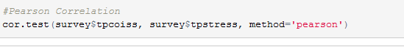
- To quantify what we have got we do a correlation test
  - Cor.etxt form baseline r package
- We do ‘pearson’ as both are normal

Doing a Correlation in RTotal PCOISS, Total Perceived Stress

- Comment
- 1st > Degrees of freedom – result value
  - df – number of independent pieces of information used to calculate our statistic
  - d in calculating r (report as n)
- 2nd - our statistic = - 0.5805759
  - This is ‘pearsons correlation co-efficient’ – so we call it ‘r’ in our reporting
- 3rd – p -value > 2.2e – 16
  - Very small so report which is why make more sens to report as p < 0.01
  - Generally round co-eff to 2 or 3 decimal places
- 4th - t – value =
  - In order for test to decide whether our correlation is statistical significant it looks at a similar distribution, comparing it to a distribution with same DoF s
  - With a zero corelation co-eff.
  - And Looks to see whether its significantly different, so look sup statistial tables for t, to see whether this value is > critical value for that distri to decide whether yes, this is actually a difference, not just random chance..

- To decide if the correlation is statistically significantly different from zero a t-test is conducted to compare with a group with a zero correlation

KEY SLIDE - Correlation Co-efficient values – Cohen effect sizee
- It varies between -1 and +1
  - 0 = no relationship

- It is an effect size - how strong is the correlation
  - (ignore sign for magnitude of effect)
  - ±.1 = small/weak
  - ±.3 = medium/moderate
  - ±.5 = large/strong
  - Cohen’s effect size heuristic is standard

- Find a book that is respected in your field that discusses this and cite it when stating you used Cohen’s convention
  - Cohen’s effect size - we use it to comment on level of correlation
Key SLide - 17

Eg ctd – Correlation – P value meaning

- P – value = significance value tells us that the probability of this correlation being due to random chance is very low (close to zero in fact).
- Hence, we can have confidence that this relationship is genuine and not a chance result (if we have done everything else correctly e.g. representative sample, eliminating bias etc.)

Reporting a Pearson Correlation in words
The relationship between perceived sense of being in control (Total PCOISS derived from the PCOISS questionnaire) and perceived stress(Total PerceivedS tress derived from the perceived stress questionnaire) was investigated using a Pearson correlation.
A strong, statistically significant, negative correlation was found (r=-0.58,n=424,p<.001).
This result suggests that individuals with higher levels perceived sense of control report lower levels perceived stress.

- NOTE1: Because the significance is < .000 in test results, the convention is to report it as <.001
- NOTE2: N=424 because it does not include missing values
- NOTE3: In some cases where you are doing multiple correlation tests, you may report a set of coefficients in a table and discuss the implications in the text.

Reporting p values

Statistically Significant
- If statistically significant (e.g., p<0.05)
  - report as:“𝑝𝑝<.05” or “𝑝𝑝p<.001”
  - Without the exact value.
  - Common thresholds: 0.05, 0.01, 0.001

- If not significant, report the exact value:“ 𝑝𝑝=.27p=.27”.
- The logic:
  - When significant, the exact decimal (like 𝑝𝑝=.0000123p=.0000123) isn’t very informative — we just need to know it’s below the threshold.
  - When not significant, the exact value is useful to show how close it was (e.g., 𝑝𝑝=.06 is more informative than just “not significant”).

KEY SLIDE - No statistically significant correlation was found
If you wish to report in text– this is not based on our dataset
“The relationship between perceived tension (derived from the PTT questionnaire) and perceived stress (derived from the perceived stress questionnaire) was investigated using a Pearson correlation. No statistically significant correlation was found (r =-.08, n=424, p=.10). This results provides no evidence against the null hypothesis of no relationship between perceived tension and perceived stress.
- NOTE1: Because the test is not statistically significant we report the actual p value.

KEY SLIDE - 18

Things to know about the Correlation Co-efficient
Significance of all co-efficients and covariance depends on the p-value (significance value of the test)

Covariance
- Variance tells us by how much scores deviate from the mean for a single variable.

- Covariance = Scaled version of variance
  - Calculate the error between the mean and each observations score for the first variable (x).
  - the error between the mean and their score for the second variable (y).
  - Multiply these error values.
  - Add these values and you get the cross product deviations.
  - The covariance is the average cross-product deviations

R2 Shared variance

- Coefficient of determination, r2
  - By squaring the value of r you get the proportion of variance in one variable shared by the other.

- For our example > r2 for -.580*-.580=.3364

- This means that time Total PCOISS and Total Perceived stress share 33.64% of their variance
  - Always round up to 2 decimal places

- You can report the variance if it is relevant to your domain.
- In some cases, you may report a set of coefficients in a table and discuss the variance in the text.

From chatgpt >> .

📈 Why It’s Important
- R² gives you a sense of how well one variable explains another.
- It’s a measure of effect size — how strong the relationship really is in practical terms.

Covariance
- It depends upon the units of measurement.
  - E.g. The Covariance of two variables measured in Miles might be 4.25, but if the same scores are converted to Km, the Covariance is 11.

- One solution: standardise it!
  - Divide by the standard deviations of both variables.
  - Create standardised scores
  - Analyse -> Descriptive Statistics -> Frequencies (check Save as Standardised Scores)
- The standardised version of Covariance is known as the Correlation coefficient.

Things to know about the Correlation Co-efficient
- Coefficient of determination, r2
  - By squaring the value of r you get the proportion of variance in one variable shared by the other.
  - You can report this if it is relevant to your research.
  - In some cases you may report a set of coefficients in a table and discuss the variance in the text.

- What does this mean?
  - In our example r= r =-.58 so r2=0.3364=33.64%
  - What does this mean?
  - Our concepts have 33.64% of their variation in common

Statistical v Practical Significance
- A small correlation co-efficient can reach statistical significance.

- This doesn’t mean anything practically.

- Need to consider both the co-efficient and the amount of shared variance (squaring the co-efficient) .

  - E.g. a coefficient of 0.2 explains 4% of the shared variance

- Need also to consider other research into the area and compare your findings with those
  - Even though your research explains only a small amount of the variance it may be more than others have found (or less).

Sample size and correlation – important -reporting Corr and variance
- In small samples (e.g. n=30) you may have moderate correlation that does not reach statistical significance
- In larger samples (n=100+) small correlations may reach statistical significance
- You need to report statistical significance but also the strength of the relationship and the amount of shared variance.

Non-parametric Tests: Spearman or Kendall
- If Data cannto be treated as Normal >>>>>
- Doesn’t require normality
- Requires independent observations
- Use when assumptions of Pearson are violated or when data is not scale
  - Spearman - Requires a monotonic relationship – as one variable increases, so does the other or as one increases the other decreases

Spearman Correlation in R

- All we do is change the method in our corelation test
  - Spearman = rho
  - Spearman is more widely used

- Spearman’s Rho is the statistic

Kendal Correlation

- Change the method > kendall
  - Kendall’s Tau is the statistic
  - Used in more scientific dataa

Reporting Spearman and Kendall in words
- As you would for Pearson except make sure you cite the correct test and give the correct statistic
  - Spearman
    - Spearman’s rho
    - or rs
    - or the Greek letter ρ
  - Kendall
    - Kendall’s tau
    - Kendall's tau-b
    - τb

Spearman V Kendall
- Spearman
  - More widely reported – check which your discipline prefers
  - Based on ranked data
  - More sensitive to error and discrepancies in data
  - Easier to calculate by hand

- Kendall
  - More robust
  - Based on concordant and discordant pairs (consistent and inconsistent)

- Generally, both lead to same inferences

Hypothesis Testing - Making a decision

Inspecting Ratio/Interval Data
- Generate plots
  - Generate a histogram with a normal curve showing
  - Generate a Q-Q plot
- Generate summary statistics
  - Central tendency and dispersion plus measures of skewness and kurtosis and assessing the percentage of standardised scores falling within acceptable limits.
- Review your statistics and plots to see how far away from normal your data is
- Report the correct statistics based on your assessment of whether your data can be considered to follow the normal distribution

When you perform a hypothesis test you make a decision:

- Decision: reject H0 OR fail to reject H0

- Each could possibly be a wrong decision
  - Therefore, there are two types of errors:
    - Type I
    - Type II

KEY SLIDE - Type I error
The error of rejecting H0 when H0 actually holds
The probability of making a Type I error is denoted by α.
α is called the significance level of the test
Key SLIDE - 19

KEY SLIDE - Type II error
The error of failing to reject H0 when H0 is does not hold
The probability of making a Type II error is denoted by β (This is the lower-case Greek letter “beta”.)

Key SLIDE - 20

KEY SLIDE - Power of a statistical test
The power of a statistical test is the probability that it correctly rejects the null hypothesis when the alternative hypothesis holds.
In other words, it’s the test's ability to detect a true effect.
The power of a test is calculated as:
Power=1−𝛽

Key SLIDE - 21

KEY SLIDE - P-value, α – statistical significance
- A probability measure of evidence about H0.
- H0 : the assumption that null hypothesis holds.
  - There is no effect or no difference.
  - It represents the default state or a baseline assumption about the population

- Statistical significance in simple terms:
  - Given our presumption that the null hypothesis holds
    - α is the probability that the results could have been obtained purely because of chance alone.

- The probability (under presumption that H0 holds) the test statistic equals observed value or value even more extreme predicted by Ha
- The P-value allows us to answer the question:
  - Do our sample results allow us to reject H0 in favour of Ha?
  - If that probability (p-value) is small, it suggests the observed result cannot be easily explained by chance.

Key SLIDE - 22

KEY SLIDE - Statistical Significance
- Working with random samples can never have 100% certainty that findings we derive from the sample will reflect real differences in the population as a whole.

- Convention is that (for your field of study) there is an accepted level of probability such that it is considered so small that the finding from your sample is unlikely to have occurred by chance or sampling error.
  - Normally, that line is drawn at p=0.05 or p=0.01.
  - In other words, when a statistical test tells us that the finding has less than a 5% or 1% chance of occurring due to sampling error then we tend to conclude that we can be sufficiently confident that the finding is therefore likely to reflect a ‘real’ characteristic of the population as a whole.
- When this occurs, you can say that your finding is statistically significant.

Key SLIDE - 23

Hypothesis Testing
- You start with the assumption (the 'null hypothesis' H0 that there are no differences or relationships in the population as a whole.

- You then state an alternative hypothesis (Ha that there is a difference or a relationship.

- You select a sample and find a difference/relationship in it.

- You can then use a variety of tests for statistical significance to work out the probability of the difference/relationship you have found in your sample simply occurring by chance.

Next slide –
- Using the standard level accepted by your domain (e.g. p ≤0.05 or p ≤0.01)

- If the probability less than this value then you reject the null hypothesis and thus accept the alternative hypothesis and you can state that your findings are 'statistically significant'.

- If the probability is greater this value then you conclude that there is no evidence to reject the null hypothesis and your findings are not ‘statistically significant’.
  - N.B. This is different from concluding that you have evidence to accept the null hypothesis.
  - In these cases, your findings are said to be ‘not significant’.

Next slide –
- Caveat
  - If we get a p-value of 0.051 should we accept the null hypothesis?
  - Should we reject the null hypothesis if we get a p-value of 0.049?
  - Need to allow for some flexibility in interpretation

KEY SLIDE - Accepting and Rejecting Hypotheses
- A non-statistically significant test result
  - does not mean that the null hypothesis is true
  - It means you do not have sufficient statistically significant evidence to reject the null in favour of the alternate

- A significant result
  - does not mean that the null hypothesis is false
  - It means you have sufficient statistically significant evidence to reject the null in favour of the alternate

Key SLIDE – 24

What do I do if my data is far away from normal?

Transformations to Improve Normality

- Many statistical methods require that the numeric variables you are working with have an approximately normal distribution.
- Reality is that this is often not the case.
- One of the most common departures from normality is skewness.
- There are many different types of transformation available.

Assessing Normality Heuristic approach
- According to some researchers, sometimes violations of normality are not problematic for running parametric tests.
- Our Heuristic Approach is:
      - Inspect Histogram and Boxplot
      - Inspect Normal Quantile Plot (also called Normal Probability Plot)
      - Generate and Inspect Recognized heuristics
        - Standardized skewness and kurtosis
        - Percentage of standardized scores falling within ranges (see previous slides and previous lectures for bounds)

3a)
Step 3: Generate and Inspect Quantitative Heuristics
This means using numerical indicators that summarize how close the data are to normal.
a) Standardized Skewness and Kurtosis
Measure | What It Tells You | Heuristic Rule
Skewness | Asymmetry (left or right tail) | Between –2 and +2 ≈ acceptable
Kurtosis | “Peakedness” or tail heaviness | Between –2 and +2 ≈ acceptable

‘’’{r}
library(moments)
skewness(data)
kurtosis(data)

‘’’

3b)
b) Percentage of Standardized Scores within Expected Ranges
For a normal distribution:
Range (z-scores) | Expected %
±1 SD | 68.27%
±2 SD | 95.45%
±3 SD | 99.73%

Tools for Assessing Normality Goodness of Fit Tests

- These will detect whether your dataset deviates from normality

- You need to make a decision about whether your data can be treated as approximately normal or not

  - Shapiro-Wilk Test (small dataset)
  - Kolmogorov-Smirnov Test (larger dataset)
  - ***These are unreliable if your dataset is large
  - Anderson-Darling Test: extension of the Kolmogorov-Smirnov test and gives more weight to the tails of the distribution
  - D’Agostino-Pearson Test: combines skewness and kurtosis to assess normality. It’s more suitable for larger datasets, typically above 50 observations, and provides a good balance of sensitivity and specificity.

Transforming Data

- When a variable is not normally distribute (a distributional requirement for many different analyses), we can create a transformed variable and test it for normality.

- Transformation:
  - Perform a mathematical operation on each of the scores in a set of data, and thereby converting the data into a new set of scores which are then employed to analyze the results of an experiment.
  - If the transformed variable is normally distributed, we can substitute it in our analysis.

Transforming Data
- Transformations are obtained by computing a new variable.
  - R, either transform and save variable to dataset or apply transformation within whatever statistical formula

- There may be data values which are not mathematically permissible.
  - For example, the log of zero is not defined mathematically, division by zero is not permitted, and the square root of a negative number results in an “imaginary” value.
  - You need to decide what to do about this.

Transformations
- Logarithmic Transforms ◦
  - “Pull in" distribution toward a more normal curve.
  - Can be used for right (positive) skew, positive kurtosis, unequal variance, lack of linearity (log10).
  - Reduces skewness by compressing high values more than low values.

- Square root transformation
  - Will bring larger scores closer to the centre
  - Can be used for positive skew, positive kurtosis, unequal variance, lack of linearity.
  - Especially for count data or when values are close to zero.
  - Reduces the impact of extreme values while still preserving the data's original scale.

- Reciprocal transformation (1/x)
  - Reduces impact of large scores
  - Can be used for positive skew, positive kurtosis, unequal variance, lack of linearity
  - Often used when there are large outliers.

- Combination
  - Reverse score transformation and then apply one of the above transformations
  - For negatively skewed/kurtotic data

- Box-cox transformation
  - Flexible family of power transformations that can accommodate various types of skewness by adjusting the power parameter λ lambda.
  - λ =1: No transformation is applied; the data remains unchanged.
  - λ=0: The transformation becomes a natural log, ln(𝑦𝑦)ln(y), which is effective for reducing right skewness in positively skewed data.
  - 0<𝜆<1: A power transformation that can moderately reduce right skewness while still compressing larger values
  - 𝜆<0: Negative values of 𝜆𝜆λ apply reciprocal transformations that can be effective for highly skewed data with large outliers
  - 𝜆>1: A stronger power transformation that might be useful for left-skewed data

Transformations – Video references
- Two quick videos
  - Short and to the point:
  - https://www.youtube.com/watch?v=5571wc0iWCI&ab_channel=Udacity
- More involved:
  - https://www.youtube.com/watch?v=kV9_qFR3ORg&ab_channel=PatrickManapat

Transforming Data
- If transformation does not bring data to a normal distribution, the investigators might well choose a nonparametric procedure that does not make any assumptions about the shape of the distribution.

Refernce

Good Information Source - Andy Field’s The Beast of Bias
https://www.discoveringstatistics.com/repository/exploringdata.pdf

Lab and Exercises

MATH9102-W3-Correlation.qmd

Version 1 - I edited this during class
‘’’{r}
# #### version 1 #####
I edited this during class – demo by deirdre… all done except for last section
---
title: "MATH9102-W3-Correlation"
author: "Deirdre Lawless"
format:
html:
self-contained: true
code-fold: true
editor: visual
---

# 1. Install and Load Packages

```{r}
#| label: install-and-load
#| message: false
#| warning: false

quiet_library <- function(pkg) {
suppressMessages(suppressWarnings({
if (!requireNamespace(pkg, quietly = TRUE)) {
install.packages(pkg, quiet = TRUE)
}
library(pkg, character.only = TRUE)
}))
}

quiet_library("tidyverse") # Collection of R packages (dplyr, ggplot2, tidyr, etc.) for data wrangling, visualization, and analysis
quiet_library("pastecs") # Tools for descriptive statistics, time series analysis, and data exploration (e.g., stat.desc)
quiet_library("FSA") # Includes general tools for data analysis (e.g., nonparametric tests, bootstrapping)
quiet_library("semTools") # Supplementary functions for Structural Equation Modeling (SEM), including model fit, reliability, and measurement invariance tests

#Amend this to reflect your folder structure
datalocation <- file.path("./")
datapath <- file.path(datalocation,'experim.dat')

#Read in the dataset
experim <- read.table(datapath)

#Setting the column names to be that used in the dataset but in lowercase to make life a bit easier
colnames(experim) <- tolower(colnames(experim))

```

# 1. Introduction

This statistical analysis was designed to investigate students fear of statistics as part of an experimental stud involving interventions to help students decrease their fear and incldued additional measures which might impact this fear such as confidence in coping and depression.

| Concept | Measurement Instrument Used | Variable Type |
|---------------------|---------------------------------|------------------|
| Fear of Statistics at Time 1 | Derived from a questionnaire at the start of the module) | Continuous |

.....

<p align="center">

**Table 1: Concepts of Interest**

<p>

#2. Hypotheses \## Hypotheses 1: H0: There is no relationship between a students fear of statistics at the start of the module and their confidence in coping measured at the start of the module..\

Ha: There is a relationship between a students fear of statistics at the start of the module and their confidence in coping measured at the start of the module\

```{r assess-fost1}
#Create a histogram
gg <- ggplot(experim, aes(x=fost1)) + labs(caption="Figure 1: Histogram - Fear of Statisics at the start of the module.")
#Change the label of the x axis
gg <- gg + labs(x="Fear of Statistics")
#manage binwidth and colours
gg <- gg + geom_histogram(binwidth=2, colour="black", aes(y=..density.., fill=..count..))
gg <- gg + scale_fill_gradient("Count", low="#DCDCDC", high="#7C7C7C")
#A a density curve using a normal denisty function
#Use stat_function to compute a normalised score for each value of fost1
#Pass the mean and standard deviation to this as parameters
#use the na.rm parameter to say how missing values are handled
gg <- gg + stat_function(fun=dnorm, color="red",args=list(mean=mean(experim$fost1, na.rm=TRUE), sd=sd(experim$fost1, na.rm=TRUE)))
#to display the graph request the contents of the variable be shown
gg

#Create a qqplot
qqnorm(experim$fost1, main="Figure 2: QQ Plot for Fear of Statistics")
qqline(experim$fost1, col=2) #show a line on the plot

#Generate summary statistics
#stat.desc is a function from pastecs - make sure you include the basic switch=F to ensure you don't get scientific notation
pastecs::stat.desc(experim$fost1, basic=F)

#We can make our decision based on the value of the standardised score for skew and kurtosis
#We divide the skew statistic by the standard error to get the standardised score
#This will indicate if we have a problem
tpskew<-semTools::skew(experim$fost1)
tpkurt<-semTools::kurtosis(experim$fost1)
# 1st item is measure of skewness
# second item is standard error
# skew statistics divided by standardised error = standardised scores
tpskew[1]/tpskew[2]
tpkurt[1]/tpkurt[2]

#And also by calculating the percentage of standardised scores for the variable itself that are outside our acceptable range
#This will tell us how big a problem we have
# Calculate the percentage of standardised scores that are greated than 1.96
# the perc function which is part of the FSA package which calculate the percentage that are within a range - you can look for greater than "gt", greater than or equal "geq", "gt", less than or equal "leq", or less than "lt"),
# scale is a function that creates z scores, abs gets absolute value

# have absolute values of fear statstic
zfost1<- abs(scale(experim$fost1))

# decide how many of them are ourside of range
FSA::perc(as.numeric(zfost1), 1.96, "gt")
FSA::perc(as.numeric(zfost1), 3.29, "gt")
# Below we are reporting the normality assessment - embedding code within a paragraph to get the statistics generated ( you can just write it out)

# can see from pastec stats we have a problem -
# histogram is missing data for two columns
# QQ-plot - problem - not filly linear at start and end

# run
# get standarised score = -.0424 --- within + or - 2
# kurtosis = -0.643 >> so thats OK

# so lets have a look now at % of standardised score that fall in between + or - 1.96
# = 3% outside of the range
# use bigger statistics - as have a full data set >> get 0 =>> 100% within 3.29...

# NOTE - even tho histogram and QQ plot looks like they have problems
# we are looking to see if population they come from can be considered approx normal
```

<p style="text-align:justify">

Fear of Statistics at time one scores were assessed for normality. Visual inspection of the histogram and QQ-Plot (see Figure 1 and Figure 2) identified some issues with skewness and kurtosis. The standardized score for kurtosis (`r round(tpkurt[1]/tpkurt[2],2)`) and skewness (`r round(tpskew[1]/tpskew[2],2)`) could be considered acceptable according to the advie of Curran , west and Finch. using the criteria proposed by Curran, West and Finch (CITE....). As 100% of the standardised scores fall within the bounds of +/- 3.29, using the guidance of Field, Miles and Field (2013), the data can be considered to approximate a normal distribution (m=`r round(mean(experim$fost1, na.rm=TRUE),2)`, sd=`r round(sd(experim$fost1, na.rm=TRUE),2)`, n=`r length(experim$fost1)-sum(is.na(experim$fost1))`).

</p>

```{r stats-confid1}
#Create histogram
gs <- ggplot(experim, aes(x=confid1)) + labs(caption="Figure 3: Histogram for Confidence in coping at the start of the module")
gs <- gs + labs(x="Confidence in coping at te start of the module")
gs <- gs + geom_histogram(binwidth=2, colour="black", aes(y=..density.., fill=..count..))
gs <- gs + scale_fill_gradient("Count", low="#DCDCDC", high="#7C7C7C")
gs <- gs + stat_function(fun=dnorm, color="red",args=list(mean=mean(experim$confid1, na.rm=TRUE), sd=sd(experim$confid1, na.rm=TRUE)))
gs

#Create a qqplot
qqnorm(experim$confid1, main="Figure 4: QQPlot for Confidence in coping at the start of the module")
qqline(experim$confid1, col=2) #show a line on theplot

#Generate regular summary statistics
pastecs::stat.desc(experim$confid1, basic=F)

#Generate standardized scores for skewness and kurtosis
tpskew<-semTools::skew(experim$confid1)
tpkurt<-semTools::kurtosis(experim$confid1)
tpskew[1]/tpskew[2]
tpkurt[1]/tpkurt[2]

#Calculate the percentage of standardized scores outside acceptable limits
zconfid1<- abs(scale(experim$confid1))

FSA::perc(as.numeric(zconfid1), 1.96, "gt")
FSA::perc(as.numeric(zconfid1), 3.29, "gt")
# Below we are reporting the normality assessment - embedding code within a paragraph to get the statistics generated ( you can just write it out)

# as with earlier boock - look at skew and kurtosis - run just seleted lines
# standardised skewness = 0.8166
# standardised kurtosis = - 0.91
# both within range...

# look at % scores, ahgai as with previus chunk....between 1.96 and 3.29
# + or - 1.96 = 0
# + or - 3.29 = 0
# 100% fall within the ranges above
# can treat it as population being approximately normal

```

<p style="text-align:justify">

Total Perceived Stress were assessed for normality. Visual inspection of the histogram and QQ-Plot (see Figure 3 and Figure 4) identified some issues with skewness and kurtosis. While the standardized score for kurtosis (`r round(tpkurt[1]/tpkurt[2],2)`) could be considered acceptable using the criteria proposed by Curran, West and Finch (1996), but the standardized score for skewness (`r round(tpskew[1]/tpskew[2],2)`) was outside the acceptable range. However as over 99% of standardized scores fall within the bounds of +/- 3.29, using the guidance of Field, Miles and Field (2012), the data can be considered to approximate a normal distribution (m=`r round(mean(experim$confid1, na.rm=TRUE),2)`, sd=`r round(sd(experim$confid1, na.rm=TRUE),2)`, n=`r length(experim$confid1)-sum(is.na(experim$confid1))`).

</p>

```{r corr-fostconfid}

#Create a Simple scatterplot of fear of statistics abd confidence
#aes(x,y)
scatter <- ggplot(experim, aes(fost1, confid1))
scatter + geom_point() + labs(x = "fear of Statistics", y = "Confidence in coping")

#Add a regression line
scatter + geom_point() + geom_smooth(method = "lm", colour = "Red", se = F) + labs(x = experim$confid1)

#Pearson Correlation - this is the correct test for this data
stats::cor.test(experim$fost1, experim$confid1, method='pearson')
corstat=stats::cor.test(experim$fost1, experim$confid1, method='pearson')

# when run this correlation test get the below...
# correlation is in moderate range
# p-value is 0.016 which is less than 0.05 (working at that level) => and it is statistically significant!

```

<p style="text-align:justify">

The relationship between perceived sense of being in control (Total PCOISS derived from the PCOISS questionnaire) and perceived stress (Total Perceived Stress derived from the perceived stress questionnaire) was investigated using a Pearson correlation. A strong, statistically significant, negative correlation was found (r =`r round(as.numeric(corstat[4]),2)`, n=`r as.numeric(corstat[2])`, p\<.001). There is therefore evidence to reject the null hypothesis in favour of the alternate that there is a relationship between perceived sense of being in control and perceived stress.

</p>

# Appendix: How to conduct other types of correlation test

Note: These are included for illustration only. If your data cannot be treated as approximately normal then you need to use a non-parametric test. You should choose either Spearman or Kendall. Either is fine. Some sources consider Kendall to be more robust than Spearman.

```{r other-tests}
#Spearman Correlation for illustration only - you SHOULD NOT do multiple tests
#This test will give an error for our datasince this method uses ranking but cannot handle ties but that is ok with us - we consider this to be missing data
cor.test(experim$fost1, experim$confid1, method = "spearman")
#We can also use kendall's tau which does handle ties
cor.test(experim$fost1, experim$confid1, method = "kendall")
```

# References

Cohen, S., Kamarck, T. & Mermelstein, R. (1983). A global measure of perceived stress. Journal of Health and Social Behavior, 24, 385–96.\
Cohen, J. (1988). Statistical power analysis for the behavioral sciences (2nd ed.). Hillside, NJ: Lawrence Erlbaum Associates.\
Crowne, D.P. & Marlowe, D. (1960). A new scale of social desirability independent of psychopathology. Journal of Consulting Psychology, 24, 349–54.\
Curran, Patrick J., Stephen G. West, and John F. Finch. (1996). "The robustness of test statistics to nonnormality and specification error in confirmatory factor analysis." Psychological methods 1.1 (1996): 16.\Diener, E., Emmons, R.A., Larson, R.J. & Griffin, S. (1985). The Satisfaction with Life scale. Journal of Personality Assessment, 49, 71–6.\
Field, A., Field Z. & Miles J.(2012). Discovering statistics using IBM SPSS statistics. Sage publications limited,\
Pallant, J. (2000). Development and validation of a scale to measure perceived control of internal states. Journal of Personality Assessment, 75, 2, 308–37. Pearlin, L. & Schooler, C. (1978). The structure of coping. Journal of Health and Social Behavior, 19, 2–21.\
Rosenberg, M. (1965). Society and the adolescent self-image. Princeton, NJ: Princeton University Press.\
Scheier, M.F. & Carver, C.S. (1985). Optimism, coping and health: An assessment and implications of generalized outcome expectancies. Health Psychology, 4, 219–47.\
Watson, D., Clark, L.A. & Tellegen, A. (1988). Development and validation of brief measures of positive and negative affect: The PANAS scales. Journal of Personality and Social Psychology, 54, 1063–70.\

‘’’

version 2 – solution file provided
‘’’{r}
# version 2 – solution file provided

---
title: "MATH9102-W3-Correlation - Lab"
author: "Deirdre Lawless"
format:
html:
self-contained: true
code-fold: true
editor: visual
---

```{=html}
<style>
/* Center figure captions in Quarto HTML, make them black and bold */
.quarto-figure .figure-caption,
figure > figcaption {
text-align: center;
color: black;
font-weight: bold;
}
</style>
```

# 1. Install and Load Packages

```{r}
#| label: install-and-load
#| message: false
#| warning: false

quiet_library <- function(pkg) {
suppressMessages(suppressWarnings({
if (!requireNamespace(pkg, quietly = TRUE)) {
install.packages(pkg, quiet = TRUE)
}
library(pkg, character.only = TRUE)
}))
}

quiet_library("tidyverse") # Collection of R packages (dplyr, ggplot2, tidyr, etc.) for data wrangling, visualization, and analysis
quiet_library("pastecs") # Tools for descriptive statistics, time series analysis, and data exploration (e.g., stat.desc)
quiet_library("FSA") # Includes general tools for data analysis (e.g., nonparametric tests, bootstrapping)
quiet_library("semTools") # Supplementary functions for Structural Equation Modeling (SEM), including model fit, reliability, and measurement invariance tests
quiet_library("VIM") # Visualization and Imputation of Missing Values
quiet_library("naniar") #(naniar short for NA + naniar) - Missing data wrangling plus Little's test
quiet_library("simputation") # For imputing variables

#Amend this to reflect your folder structure
datalocation <- file.path("C:","Users", "deirdre.lawless", "datafiles")
datapath <- file.path(datalocation,'experim.dat')

#Read in the dataset
experim <- read.table(datapath)

#Setting the column names to be that used in the dataset but in lowercase to make life a bit easier
colnames(experim) <- tolower(colnames(experim))

```

# 1. Introduction

This statistical analysis was designed to investigate students fear of statistics based on responses to a psychological questionnaire designed to measure extroversion and primacy of traits in individuals. The dataset used was constructed for use by Julie Pallant and contains scores on personality-related scales, as well as demographic information such as age and gender. The concepts of interest to this data analysis include repeated measures of three psychological constructs: Fear of Statistics, Coping with Confidence, and Depression. Each construct was assessed at two time points (Time 1 and Time 2), allowing for the examination of changes over time. These are identified in Table 1.

| Concept | Measurement Instrument Used | Variable Type |
|------------------------|------------------------|------------------------|
| Fear of Statistics at Time 1 and Time 2 | Scores reflect levels of anxiety and apprehension associated with learning or applying statistics. Measured using the Statistics Anxiety Rating Scale (STARS) or an adapted sub-scale. | Continuous |
| Confidence in Coping at Time 1 and Time 2 | Scores represent self-perceived confidence in coping with challenges, particularly within an academic context. Assessed with items drawn from a coping/self-efficacy scale. Derived from a questionnaire taken at the start of the module | Continuous |
| Fear of Statistics at Time 1 and Time 2 | Scores indicate the presence and severity of depressive symptoms. Measured with a short-form depression inventory (such as items adapted from the DASS – Depression Anxiety Stress Scales. Derived from a questionnaire taken at the start of the module | Continuous |

::: {style="text-align: center;"}
**Table 1: Concepts of Interest**
:::

The data for the concepts of interest were inspected to assess the level and pattern of missing data. No missing data was found, see Figure 1.

All analysis was conducted using a significance level of p \< .05 as the cut-off for statistical significance. Effect sizes are reported in accordance with Cohen’s (1988) conventions, with values of correlation ≈ 0.1, 0.3, and 0.5 interpreted as weak, moderate, and strong effects respectively (or equivalent thresholds for other effect size measures).

```{r}
#We create a subset with just these variables
varsint<-c("fost1", "fost2", "confid1", "depress2")

# create a subset with only variables of interest
esub <- experim[varsint]

# rename columns to human-friendly labels - we are restricted with the length we can use
colnames(esub) <- c("FearTime1", "FearTime2", "ConfidTime1", "DepressTime1")

```

```{r}
#| fig-cap: "Figure 1: Missing data patterns for the concepts of interest"
#| fig-align: center
#Adjust the margins so that we can display the labels
par(mar = c(10, 4, 4, 2)) # more space at bottom

VIM::aggr(esub, sortVar = TRUE, combined = FALSE)
```

# 2. Hypotheses

## 2.1 Confidence in Coping and Fear of Statistics

H0: There is no relationship between a student's confidence in coping and their fear of statistics at the start of the module measured at the start of the module.

Ha: There is a relationship between a student's confidence in coping and their fear of statistics at the start of the module measured at the start of the module..

```{r histconfid1}
#| fig-cap: "Figure 2: Histogram for Confidence in Coping at Time 1"
#| fig-align: center
#Create histogram
gs <- ggplot(experim, aes(x=confid1))
gs <- gs + labs(x="Confidence in Coping at the Start of the module")
gs <- gs + geom_histogram(binwidth=2, colour="black", aes(y=..density.., fill=..count..))
gs <- gs + scale_fill_gradient("Count", low="#DCDCDC", high="#7C7C7C")
gs <- gs + stat_function(fun=dnorm, color="red",args=list(mean=mean(experim$confid1, na.rm=TRUE), sd=sd(experim$confid1, na.rm=TRUE)))
gs
```

```{r qqconfid1}
#| fig-cap: "Figure 3: QQPlot for Confidence in Coping at Time 1"
#| fig-align: center
#Create a qqplot
qqnorm(experim$confid1)
qqline(experim$confid1, col=2) #show a line on the plot
```

```{r assessconfid1}
#Generate regular summary statistics
pastecs::stat.desc(experim$confid1, basic=F)

#Generate standardized scores for skewness and kurtosis
tpskew<-semTools::skew(experim$confid1)
tpkurt<-semTools::kurtosis(experim$confid1)
tpskew[1]/tpskew[2]
tpkurt[1]/tpkurt[2]

#Calculate the percentage of standardized scores outside acceptable limits
zconfid1<- abs(scale(experim$confid1))

FSA::perc(as.numeric(zconfid1), 1.96, "gt")
FSA::perc(as.numeric(zconfid1), 3.29, "gt")
# Below we are reporting the normality assessment - embedding code within a paragraph to get the statistics generated ( you can just write it out)

```

Confidence in coping skills at time 1 were assessed for normality. Visual inspection of the histogram and QQ-Plot (see Figure 2 and Figure 3) identified some issues with skewness and kurtosis. The standardized score for kurtosis (`r round(tpkurt[1]/tpkurt[2],2)`) and the standardized score for skewness (`r round(tpskew[1]/tpskew[2],2)`) could be considered acceptable using the criteria proposed by Curran, West and Finch (1996). As 100% of standardized scores fall within the bounds of +/- 3.29, using the guidance of Field, Miles and Field (2012), the data can be considered to approximate a normal distribution (m=`r round(mean(experim$confid1, na.rm=TRUE),2)`, sd=`r round(sd(experim$confid1, na.rm=TRUE),2)`, n=`r length(experim$confid1)-sum(is.na(experim$confid1))`).

```{r histfost1}
#| fig-cap: "Figure 4: Histogram Fear of Statistics at Time 1"
#| fig-align: center
#| #Create a histogram
gg <- ggplot(experim, aes(x=fost1))
#Change the label of the x axis
gg <- gg + labs(x="Fear of Statistics")
#manage binwidth and colours
gg <- gg + geom_histogram(binwidth=2, colour="black", aes(y=..density.., fill=..count..))
gg <- gg + scale_fill_gradient("Count", low="#DCDCDC", high="#7C7C7C")
#A a density curve using a normal density function
#Use stat_function to compute a normalised score for each value of fost1
#Pass the mean and standard deviation to this as parameters
#use the na.rm parameter to say how missing values are handled
gg <- gg + stat_function(fun=dnorm, color="red",args=list(mean=mean(experim$fost1, na.rm=TRUE), sd=sd(experim$fost1, na.rm=TRUE)))
#to display the graph request the contents of the variable be shown
gg
```

```{r qplotfost1}
#| fig-cap: "Figure 5: QQ Plot for Fear of Statistics at Time 1"
#| fig-align: center
#Create a qqplot
qqnorm(experim$fost1)
qqline(experim$fost1, col=2) #show a line on the plot
```

```{r assessfost1}
#Generate summary statistics
#stat.desc is a function from pastecs - make sure you include the basic switch=F to ensure you don't get scientific notation
pastecs::stat.desc(experim$fost1, basic=F)

#We can make our decision based on the value of the standardised score for skew and kurtosis
#We divide the skew statistic by the standard error to get the standardised score
#This will indicate if we have a problem
tpskew<-semTools::skew(experim$fost1)
tpkurt<-semTools::kurtosis(experim$fost1)
tpskew[1]/tpskew[2]
tpkurt[1]/tpkurt[2]

#And also by calculating the percentage of standardised scores for the variable itself that are outside our acceptable range
#This will tell us how big a problem we have
# Calculate the percentage of standardised scores that are greater than 1.96
# the perc function which is part of the FSA package which calculate the percentage that are within a range - you can look for greater than "gt", greater than or equal "geq", "gt", less than or equal "leq", or less than "lt"),
# scale is a function that creates z scores, abs gets absolute value

zfost1<- abs(scale(experim$fost1))

FSA::perc(as.numeric(zfost1), 1.96, "gt")
FSA::perc(as.numeric(zfost1), 3.29, "gt")
# Below we are reporting the normality assessment - embedding code within a paragraph to get the statistics generated ( you can just write it out)
```

Fear of Statistics at time 1 scores were assessed for normality. Visual inspection of the histogram and QQ-Plot (see Figure 4 and Figure 5) identified some issues with skewness and kurtosis. The standardized score for kurtosis (`r round(tpkurt[1]/tpkurt[2],2)`) and skewness (`r round(tpskew[1]/tpskew[2],2)`) could be considered accepted according to the advice of Curran, West and Finch (1996). As 100% of standardized scores fall within the bounds of +/- 3.29, using the guidance of Field, Miles and Field (2013), the data can be considered to approximate a normal distribution (m=`r round(mean(experim$fost1, na.rm=TRUE),2)`, sd=`r round(sd(experim$fost1, na.rm=TRUE),2)`, n=`r length(experim$fost1)-sum(is.na(experim$fost1))`).

```{r corr-fostconfid}
#| fig-cap: "Figure 6: Scatterplot Confidence in Coping and Fear of Statistics Time 1"
#| fig-align: center

ggplot(experim, aes(x = confid1, y = fost1)) +
geom_point() +
geom_smooth(method = "lm", colour = "red", se = FALSE) +
labs(
x = "Confidence in Coping",
y = "Fear of Statistics"
)

#Pearson Correlation
stats::cor.test(experim$confid1, experim$fost1, method='pearson')
corstat=stats::cor.test(experim$confid1,experim$fost1, method='pearson')

```

The relationship between fear of statistics and confidence in coping at time 1 was investigated using a Pearson correlation. A moderate, statistically significant, negative correlation was found (r =`r round(as.numeric(corstat[4]),2)`, n=`r as.numeric(corstat[2])`, p\<.05). There is therefore evidence to reject the null hypothesis in favour of the alternate that there is a relationship between perceived sense of being in control and perceived stress.

## 2.2 Depression and Fear of Statistics

H0: There is no relationship between a student's fear of statistics at the start of the module and their level of depression measured mid-way through the module.

Ha: There is a relationship between a student's fear of statistics at the start of the module and their level of depression measured mid-way through the module.

```{r histdepress2}
#| fig-cap: "Figure 7: Histogram of Depression at Time 2"
#| fig-align: center
#| #Create histogram
gs <- ggplot(experim, aes(x=depress2))
gs <- gs + labs(x="Depression at Time 2")
gs <- gs + geom_histogram(binwidth=2, colour="black", aes(y=..density.., fill=..count..))
gs <- gs + scale_fill_gradient("Count", low="#DCDCDC", high="#7C7C7C")
gs <- gs + stat_function(fun=dnorm, color="red",args=list(mean=mean(experim$depress2, na.rm=TRUE), sd=sd(experim$depress2, na.rm=TRUE)))
gs
```

```{r qqplotdepress2}
#| fig-cap: "Figure 8: QQ Plot for Depression at Time 2"
#| fig-align: center
#Create a qqplot
qqnorm(experim$depress2)
qqline(experim$depress2, col=2) #show a line on the plot
```

```{r stats-depress2}
#Generate regular summary statistics
pastecs::stat.desc(experim$depress2, basic=F)

#Generate standardized scores for skewness and kurtosis
tpskew<-semTools::skew(experim$depress2)
tpkurt<-semTools::kurtosis(experim$depress2)
tpskew[1]/tpskew[2]
tpkurt[1]/tpkurt[2]

#Calculate the percentage of standardized scores outside acceptable limits
zdepress2<- abs(scale(experim$depress2))

FSA::perc(as.numeric(zdepress2), 1.96, "gt")
FSA::perc(as.numeric(zdepress2), 3.29, "gt")
# Below we are reporting the normality assessment - embedding code within a paragraph to get the statistics generated ( you can just write it out)

```

Depression levels at time 2 were assessed for normality. Visual inspection of the histogram and QQ-Plot (see Figure 7 and Figure 8) identified some issues with skewness and kurtosis. The standardized score for kurtosis (`r round(tpkurt[1]/tpkurt[2],2)`) and the standardized score for skewness (`r round(tpskew[1]/tpskew[2],2)`) could be considered acceptable using the criteria proposed by Curran, West and Finch (1996). As 100% of standardized scores fall within the bounds of +/- 3.29, using the guidance of Field, Miles and Field (2012), the data can be considered to approximate a normal distribution (m=`r round(mean(experim$depress2, na.rm=TRUE),2)`, sd=`r round(sd(experim$depress2, na.rm=TRUE),2)`, n=`r length(experim$depress2)-sum(is.na(experim$depress2))`).

```{r histfost2}
#| fig-cap: "Figure 9: Histogram of Fear of Statistics at Time 2"
#| fig-align: center
#Create a histogram
gg <- ggplot(experim, aes(x=fost2))
#Change the label of the x axis
gg <- gg + labs(x="Fear of Statistics")
#manage binwidth and colours
gg <- gg + geom_histogram(binwidth=2, colour="black", aes(y=..density.., fill=..count..))
gg <- gg + scale_fill_gradient("Count", low="#DCDCDC", high="#7C7C7C")
#A a density curve using a normal density function
#Use stat_function to compute a normalised score for each value of fost2
#Pass the mean and standard deviation to this as parameters
#use the na.rm parameter to say how missing values are handled
gg <- gg + stat_function(fun=dnorm, color="red",args=list(mean=mean(experim$fost2, na.rm=TRUE), sd=sd(experim$fost2, na.rm=TRUE)))
#to display the graph request the contents of the variable be shown
gg
```

```{r qqfost2}
#| fig-cap: "Figure 10: QQPlot for Fear of Statistics at Time 2"
#| fig-align: center
#Create a qqplot
qqnorm(experim$fost2)
qqline(experim$fost2, col=2) #show a line on the plot
```

```{r assessfost2}
#Generate summary statistics
#stat.desc is a function from pastecs - make sure you include the basic switch=F to ensure you don't get scientific notation
pastecs::stat.desc(experim$fost2, basic=F)

#We can make our decision based on the value of the standardised score for skew and kurtosis
#We divide the skew statistic by the standard error to get the standardised score
#This will indicate if we have a problem
tpskew<-semTools::skew(experim$fost2)
tpkurt<-semTools::kurtosis(experim$fost2)
tpskew[1]/tpskew[2]
tpkurt[1]/tpkurt[2]

#And also by calculating the percentage of standardised scores for the variable itself that are outside our acceptable range
#This will tell us how big a problem we have
# Calculate the percentage of standardised scores that are greater than 1.96
# the perc function which is part of the FSA package which calculate the percentage that are within a range - you can look for greater than "gt", greater than or equal "geq", "gt", less than or equal "leq", or less than "lt"),
# scale is a function that creates z scores, abs gets absolute value

zfost2<- abs(scale(experim$fost2))

FSA::perc(as.numeric(zfost2), 1.96, "gt")
FSA::perc(as.numeric(zfost2), 3.29, "gt")
# Below we are reporting the normality assessment - embedding code within a paragraph to get the statistics generated ( you can just write it out)
```

Fear of Statistics at time 2 scores were assessed for normality. Visual inspection of the histogram and QQ-Plot (see Figure 9 and Figure 10) identified some issues with skewness and kurtosis. The standardized score for kurtosis (`r round(tpkurt[1]/tpkurt[2],2)`) and skewness (`r round(tpskew[1]/tpskew[2],2)`) could be considered accepted according to the advice of Curran, West and Finch (1996). As 100% of standardized scores fall within the bounds of +/- 3.29, using the guidance of Field, Miles and Field (2013), the data can be considered to approximate a normal distribution (m=`r round(mean(experim$fost2, na.rm=TRUE),2)`, sd=`r round(sd(experim$fost2, na.rm=TRUE),2)`, n=`r length(experim$fost2)-sum(is.na(experim$fost2))`).

```{r corr-fostdepress}
#| fig-cap: "Figure 11: Scatterplot for Depression and Fear of Statistics at Time 2"
#| fig-align: center
ggplot(experim, aes(x = depress2, y = fost2)) +
geom_point() +
geom_smooth(method = "lm", colour = "red", se = FALSE) +
labs(
x = "Depression",
y = "Fear of Statistics"
)

#Pearson Correlation
stats::cor.test( experim$depress2, experim$fost2, method='pearson')
corstat=stats::cor.test( experim$depress2, experim$fost2, method='pearson')

```

The relationship between fear of statistics and depression at time 2 was investigated using a Pearson correlation. No statistically, significant correlation was found (r =`r round(as.numeric(corstat[4]),2)`, n=`r as.numeric(corstat[2])`, p\<.05). There is therefore evidence no evidence reject the null hypothesis that there is no relationship between fear of statistics and depression at time 2.

# 3. Conclusion

These results suggest that students who reported lower confidence in coping also tended to report greater fear of statistics at Time 1. The moderate negative correlation indicates that as coping confidence increases, fear of statistics decreases. In contrast, there was no evidence of a meaningful relationship between depression and fear of statistics at Time 2. Overall, these findings support the theoretical expectation that confidence in coping is closely related to anxiety about academic tasks, whereas depression appears to be less strongly associated in this context.

# References

Cohen, J. (1988). Statistical power analysis for the behavioral sciences (2nd ed.). Lawrence Erlbaum Associates. Curran, Patrick J., West, Stephen G., and Finch., John F. (1996). "The robustness of test statistics to nonnormality and specification error in confirmatory factor analysis. Field, A., Field Z. & Miles J.(2012). Discovering statistics using IBM SPSS statistics. Sage publications limited.

‘’’

MATH9102-W3-Missing Data.qmd

‘’’{r}
---
title: "MATH9102 Missing Data"
author: "Deirdre Lawless"
format:
html:
self-contained: true
editor: source
---

# 1. Install and Load Packages
```{r}
#| label: install-and-load
#| message: false
#| warning: false

quiet_library <- function(pkg) {
suppressMessages(suppressWarnings({
if (!requireNamespace(pkg, quietly = TRUE)) {
install.packages(pkg, quiet = TRUE)
}
library(pkg, character.only = TRUE)
}))
}

quiet_library("tidyverse")
quiet_library("VIM") # Visualization and Imputation of Missing Values
quiet_library("naniar") #(naniar short for NA + naniar) - Missing data wrangling plus Little's test
quiet_library("simputation") # For imputing variables

#Amend this to reflect your folder structure
datalocation <- file.path("./")
datapath <- file.path(datalocation,'survey.dat')

#Read in the dataset
sdata <- read.table(datapath)

#Setting the column names to be that used in the dataset but in lowercase to make life a bit easier
colnames(sdata) <- tolower(colnames(sdata))

#Our variables of interest are the nine continuous variables reflecting the total
#for each of our pschological factors measured

#We create a subset with just these variables
varsint<-c("toptim", "tmast", "tposaff", "tnegaff", "tlifesat", "tpstress","tslfest", "tmarlow" , "tpcoiss" )

# create a subset with only variables of interest
sdatasubset <- sdata[varsint]

# rename columns to human-friendly labels - we are restricted with the length we can use
# ask 'vim' to get missingnes and percenatage of missing ness per variable
# just get human friendly labels
colnames(sdatasubset) <- c("Optimism", "Mastery", "Pos.Affect", "Neg.Affect", "LifeSat", "Stress", "SelfEst", "Soc.Des", "Perc.Ctrl")

#Adjust the margins so that we can display the labels
par(mar = c(10, 4, 4, 2)) # more space at bottom

# run VIM::aggr
res <- summary(VIM::aggr(sdatasubset, sortVar = TRUE, combined = FALSE))$combinations

#Get our summary statistics - these are just for us not for publication
summary(sdatasubset)
```

# 2. Visualise the missing data level and pattern
## 2.1 Using functions from VIM

Show number of rows of missing values for each and combinations across variables using VIM::aggr.
Get levels of missingness using the aggr function from the VIM package.
We summarise and store the results in a variable called res.
```{r}
#| label: visualise-missing

res<-summary(VIM::aggr(sdatasubset, sortVar=TRUE, combined=FALSE))$combinations

# Show the number of rows missing values for each variable and combinations of variables
#Red is missing, blue is not missing
aggr(sdatasubset, combined = FALSE, numbers = TRUE, prop = c(TRUE, FALSE))
```

Blue means the variable has a value. In this case 421 rows are complete - no missing data.
Red means a variable has missing data.
In this case there is 1 row missing values for all variables, 1 missing values for tslfest and tlifesat, 1 missing tslifesat, tslfest and tpcoiss, 5 missing values for just tpcoiss etc.

Output of the most common combinations using the head function:
```{r}
head(res[rev(order(res[,2])),])
```

## 2.2 Summary of whether data is missing or not
Use naniar::vis_miss to create a plot showing whether a variable is missing data and showing the percentage missing:

```{r}
#| label: vis_miss

naniar::vis_miss(sdatasubset)

```
This identifies key variables that are missing, but we need to explore the relationship between these variables and others.

Look at the number of cases and the combinations of missingness using naniar::gg_miss_upset:
```{r}
#| label: miss_upset

naniar::gg_miss_upset(sdatasubset)
```

tpcoiss alone is missing - 5 cases/rows
tpstress is missing - 3 cases/rows
tmarlow is missing - 2 cases/rows
There is 1 case/row where all variables are missing
There are 2 cases/row where tnegaff, tpstress and toptim are missing
etc.
** There is no real pattern to this missing data **

We can use ggplot to generate a point plot showing how many missing combinations we have per pair of variables:

```{r}
#| label: ggplot-missing

ggplot(sdata,
aes(x = tpstress,
y = toptim)) +
geom_miss_point()
```

## 2.3 Look at patterns by group
We need to include the grouping value as part of the sub-set dataframe we are using
We can then look at the pattern using gg_mis_fct from naniar package.

Explore missingness across a factor. In this case by whether respondents have children or not:
```{r}
#| label: grouping-missing

varsintgrp<-c("toptim", "tmast", "tposaff", "tnegaff", "tlifesat", "tpstress","tslfest", "tmarlow" , "tpcoiss","child" )
# Create a new subset
sdatasubgroup<-sdata[varsintgrp]#create a subset of data with just the variables of interest

naniar::gg_miss_fct(x = sdatasubgroup, fct = child)
```

We can look at a plot by group also for a pair of variables using ggplot:

We can use ggplot to generate a point plot showing how many missing combinations we have per pair of variables for a factor by using facets:

```{r}
#| label: ggplot-bygroup

ggplot(sdatasubgroup,
aes(x = tpstress,
y = toptim)) +
geom_miss_point() +
facet_wrap(~child)
```
You can create tables to look at patterns of missing data in continuous for nominal
Or use some of the packages available in https://www.tidyverse.org/

# 3. Mean Substitution Example
You can substitute na values for the variable tpcoiss with the mean of tpcoiss:
```{r}
#| label: mean-subexample

sdatasubgroup$tpcoiss[is.na(sdatasubgroup$tpcoiss)] <- mean(sdatasubgroup$tpcoiss, na.rm = TRUE)
```

To look at the number of cases and the combinations of missingness repeat the missingness assessment.

# 4. Imputation Example
You can impute a value for na values for the variable tpstress with the impute_lm function tpstress, the variables used need to make sense. Here we impute tpstress from the values of perception of control and positive affect (we would need to be sure this is sensible for our conceptual framework):

```{r}
#| label: impute-example

summary(sdatasubgroup$tpstress)
sdatasubgroup <- simputation:: impute_lm(sdatasubgroup,tpstress ~ tpcoiss + tposaff)
summary(sdatasubgroup$tpstress)
```

Note: We can see this has resolved only 3 na values - this is because tposaff has na's so we would need to address that before doing the imputation.

# 5. Test for MCAR
You can use Little's MCAR test. If the p value is > 0.05 then you fail to reject the null hypothesis that the data are MCAR → consistent with MCAR.
If p < 0.05, the data are unlikely to be MCAR (they may be MAR or MNAR).
Note: you must have inspect your variables and eliminate MNAR yourself before using this test.
```{r}

result <- naniar::mcar_test(sdatasubset)

print(result)

```

week 4 – Difference 2 groups-continuous variable-Nominal

Recap
So far we’ve talked abuot doing analuysis to understdna f a relationship is evident in a population and we’re suing a sample data collected which we want to be as representative as possible to condict that analysis and support any conclusion about the relationship or not.

So we’re dping H testing where Ho is the most likely conclusion , ther is no relationship, therefor any evidence we find in our data would eb just down to random chance.

So we model our data and compare it to statistical distributions , for which there is a lot of stat theory about, and identify the level of relationship that we find in our population and compare it to a pop where Ho would hold and comapre it to what we found in terms of quantifying the level of relatinoship is so different to what you would find in 95% of the cases that we can conclude that we have some evidence that this is actually hapoenign and our sample id representative happuign in theb population

Compare it usu ND, not all sampel will follwop ND exactly, so use set fo heuristics to see how far away from ND our data is,

- Start>>
- Look at our continuous data..
- 1st plot it
  - Create histo
  - Create Q-Q plot
- Identify if any very large problems with it
  - Cause working with large datasets unlikely we’ll see a lot just by looking at it
  - What we’re interested in is how far away are the tails, so either side of the distri, from being considered normal
  - And Is there any issue with Kurtosis i.e. flat or peaked
  - We want to quantify how far away from ND it is..
    - So we work out
      - Std scores for skewness + Kurtosis
      - Using the heuristic from Curran, West and Finch
      - We can say if those standardised scores fall within + or – 2 (which are + or – 1.96 rounded up)
        - We can say it is approx. Normal
        - Thas ok
- We now need to look at standardised scores for entire variable, so need to create z-cores for entire variable
  - See how many fall outside our boundaries of + or – 1.96 if we’re looking at a sample fo 80 or less
  - Or + or – 3.29 if we’re looing at a sample > than 80.
  - So its not that we can’ conclude thas it approc Normal form our standard sied skewness and kurtosis scopre
    - What we’re interested here is how many outliers we’ve got and we need to investigate those outliers
      - Lok at values
      - See where those valuess have come from
      - Are they reasonable for variable
      - Due to error from inputs/mistakes
      - Is there some signal/flag to a design defect / design affect they way we collected our sample
        - Age groups =-- data mostly form one category for example
  - Relationships are one thing… that we were just looking at /talking about

- Other types of evidence we want to deal with before start building predictive models is whether there is a difference with experience of a concept with different groups
  - i.e. eg a new phone – enhance some element of it
    - execute some experiments with phone as is now + same experiment with new phone
    - is there a SS outcome in whatever it is we’re trying to measure
  - eg People – control group i.e. placebo and 2nd group get new drug…
    - Do some medical test and see if SS difference in glucose levels / cholesterol levels
    - See if there is a differential effect between these two groupings….

Before Inferential Statistics…
- We need to establish evidence to support going ahead with building a predictive model

- If we are asserting a relationship
  - We need to investigate if there is any evidence of a relationship using the appropriate test and make a decision based on the results (strength, direction etc.) covered in previous modules…

- If we are asserting a differential effect for different groups
  - We need to investigate if there is any difference using the appropriate test and make a decision based on the result

Comparison between Samples

- Sometimes we want to investigate if different groups within our population
  - experience a certain concept differently,
  - or
  - if a specific effect varies across these group
- There are a range of statistical tests we can use. The choice depends on:
  - The measurement of the variable
  - The shape of the data

Are these groups different?

"Is there a significant difference in the average amount of time spent on family activities per episode between the Griffin family and the Simpsons family?

- Start with what we need!

Tests for Group Comparison

 | Independent Samples (sometimes 2 entirely different groups) | Related Samples (also called dependent means test) (same group tested at different times)
Continuous data at Interval (or ratio) measures + parametric | Independent samples t-test* | Paired samples t-test**
Ordinal/ or Interval or Ratio and doesn’t approximate to ND) non-parametric | Mann-Whitney U-Test* | Wilcoxon test **

* 2 different groups of participants
** 2 same participants measured at two different points

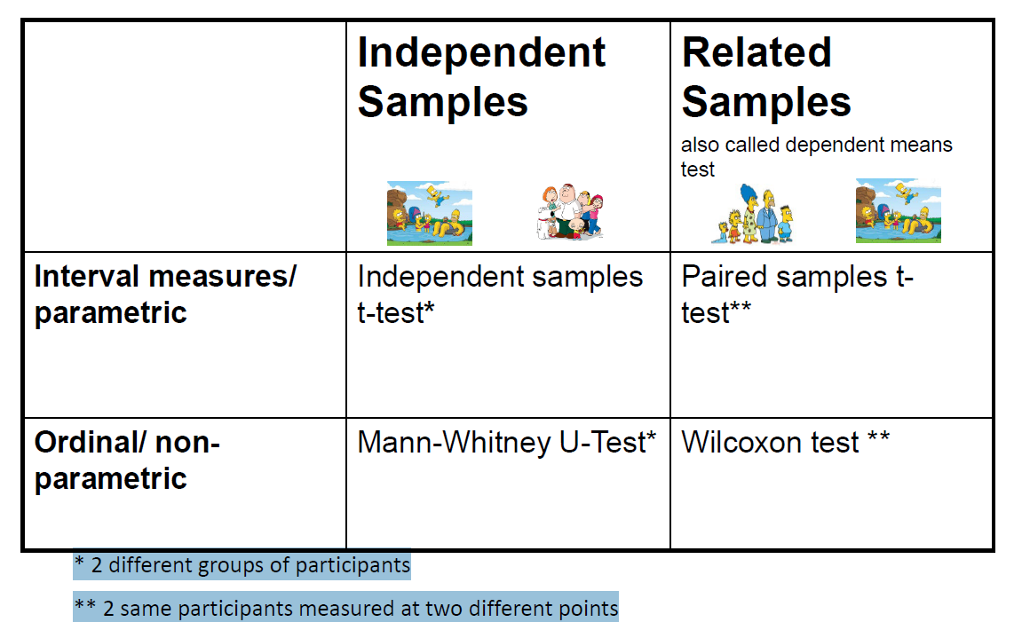

Parametric - MATH9102-W4-TTEST.QMD

Parametric: t-tests

- We’ll start with t-test….
- How do we determine if 2 groups at statistically different
  - Theory is we compare the means –
    - Take means fo both grousp
    - If from same population shodula hev same mean
    - If very different when lok up critical avlues table we find that it would eb very unsual to get this level fo difference => we have a SS difference => higher likely they are drawn from 2 different populations
      - i.e. spending power / IQ test can be treated as 2 separate populations
  - Implications for inferential statistics – where we make predictions
    - We’re going to have to make the model work so it reflects the difference and give a different prediction for each different group….a different prediction

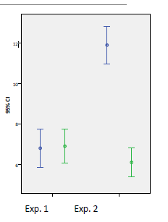

- Compare the mean between 2 samples/groups/conditions

- If 2 samples are taken from the same population
  - Then they should have similar means
- If 2 means are statistically different
  - Then the samples are likely to be drawn from 2 different populations,
    - i.e. they really are different

t Distribution

- t distribution = very similar to the Z distribution by assuming normality.
- As n goes up>> t becomes normal and
- Normality is obtained after about 120 data observations.
  - In which case t = z
- Basic rule of parameter estimation:
  - The higher the observations (N) of sample the more reflective of overall population.
- This is CLT(central limit theorem in operation)

The t Distribution

- The shape of t depends on its degrees of freedom (number of observations used to calculate the statistic).
- As df becomes infinitely large, t becomes normal and becomes z
  - => need to know DoF
  - Alpha level – you’re cut off
  - That gives critical value of t
    - And if you find a t value – the absolute value is > than t value in critical tables
      - => you’re test is SS

t critical values table
- Statistics - T-distribution table
  - https://www.tutorialspoint.com/statistics/t_distribution_table.htm
- Your statistical tool will do this look up for you and calculate whether your test is statistically significant or not.

Formula for test statistic
Difference between the means divided by the pooled standard error of the mean

SE variability between sample means If large, then may be a problem with representativeness of the sample

Formula for test statistic

- Very useful – all the formulas for different types of t-test with explanation
  - https://www.peggykern.org/uploads/5/6/6/7/56678211/ttestformulas.pdf
  - Dr. Peggy (Margaret) L. Kern, University of Melbourne

Types of t-tests

2 -tailed tests
  - H0 (Null): There is no difference in perceived stress for respondents who have children and those respondents who do not
  - Ha (Alternate): There is a difference in perceived stress for respondents who have children and those respondents who do not
  - What does this mean:
    - H0 :μ parents=μ non-parents
    - Ha :μ parents ≠ μ non-parents

2.5 % 2.5%

1-tailed tests
- E.g.
  - H0 (Null): Parents do not have higher perceived stress levels than non-parents.
  - Ha (Alternate): Parents have higher perceived stress levels than non-parents.
  - What does this mean:
    - H0 :μ parents ≤μ non-parents
    - Ha :μ parents > μ non-parents

5.0%

5.0%

Types of t-tests
- 2 sample (groups) t-tests
  - Takes your sample data from two groups
  - Comparing mean to mean across two sample groups



Mean Mean

- 1 sample (group) t-tests
  - Compare to a historical value to see if we have a difference

A Known Value

Mean

Assumptions of the t-test

- Both the independent t-test and the dependent t-test are parametric tests based on the normal distribution.

- Therefore, they assume:
  - Data are measured at least at the interval level (interval or ratio data is acceptable).
    - comment
    - At least interval but can be ration - -- most likely is going to be ratio
  - The sampling distribution is normally distributed.

- And because it is used to test different groups, also assumes:
  - Variances in these populations are roughly equal (homogeneity of variance).
    - comment
      - Similar scatter
      - Don’t want 1 having oval / square and other aveing cone shape…
  - Scores in different treatment conditions are independent (because they come from different people).

Independent t-test process

Explore Data >>>>> Run the t-test >>>> Calculate an effect size
- comment
  - (We always calculate an effect size)

Andy Field, Discovering Statistics

Independent t-test Example

- Dataset:
  - Survey.dat (Julie Pallant)

- Question:
  - Is there a significant difference in the mean perceived stress scores for respondents who have children and respondents who do not have children?

- Hypothesis (Two-tailed):
  - H0: There is no difference in perceived stress scores for respondents who have children and respondents who do not have children
  - HA: There is a difference in perceived stress scores for respondents who have children and respondents who do not have children
- Cut-off or α level:
  - 0.05
- T-test:
  - Will tell you whether there is a statistically significant difference between the mean scores of the groups

Independent t-test in R

Step 1: Assess and Describe the scale variable first
- As per previous examples
  - Histogram with density curve (or boxplot)
  - Q-QPlot
  - Standardised skew and kurtosis
  - Percentage of absolute scores falling within bounds
  - Appropriate central tendency and dispersion statistics
    - Chosoe CT and Disp Stst – for approx. ND = mean and SD

- Look at each group
  - Histogram with density curve (or boxplot)
  - We only need to do the skewed and kurtosis check on the variable as a whole

Chatgpt
Scale variable =
- A scale variable is a quantitative variable — that is, a variable that represents numerical values where you can meaningfully measure differences, averages, and ratios.
- In other words:
- A scale variable is one that is measured on a continuous numerical scale — like height, weight, temperature, or test scores.
- 🧩 2. The Four Levels of Measurement (Context)
- Every variable belongs to one of four “measurement scales” (developed by Stevens, 1946):
Level | Type | Example | What You Can Do With It
Nominal | Categorical (names) | Gender (male/female), Eye color | Count, Mode
Ordinal | Ordered categories | Satisfaction: 1 = Low, 2 = Medium, 3 = High | Order, Median
Interval | Continuous, equal intervals but no true zero | Temperature in °C, IQ score | Add/Subtract, Mean
Ratio | Continuous, equal intervals, has a true zero | Weight, height, income, time | All arithmetic opera

Step 2: Assess the groups and describe the scale variable per group

- We need to know how many are in each group.
  - Percentages or contingency table
  - Bar chart or pie chart

- We know from last week that we can treat the data for these two variables as a normal distribution
- We need to look at the descriptive statistics for the variable by group
  - Mean=27.04, SD= 6.133 for respondents who have children
  - Mean= 26.34, SD= 5.43 those for who don’t
  - Differences not huge so wouldn’t necessarily expect t-test to give us a SS result

Step 3: Test for Homogeneity of Variance - are variances equal -Levenes Test

- We now need to Test for homogeneity of variance in your groups

- In R you need to choose whether to run a t-test with modification.

- This requires you to test homogeneity of variance in advance of running other tests
  - Levene’s test is best – this is the most robust test for normally distributed data. Null hypothesis is that the variance is equal.
- To run in R
  - Levene’s is in the library car

‘’’R
library(car)
leveneTest(continuousvariable ~ categoricalvariable, data=dataframename)
‘’’
- Gives as output an F statistic and an estimate of significance
- Don’t worry about F for now we will talk next week

Step 3: Test for Homogeneity of Variance - result

- We need to know the homogeneity of variance (if variances in 2 groups are equal) in advance so we can set the parameter on the t-test so we conduct the Levene’s test first

- The null hypothesis for Levene’s test is that variances are equal.
- P value = 0.07 which is > 0.07 >>>
  - Have not found SS result
  - Ho holds and => can treat variance as normal….
- If the resulting p-value is under 0.05 it means that variances are not equal, we need to employ a correction.
- Note: this test is meant to be used with normally distributed data but can tolerate relatively low deviation from normality.
- This is why parametric test are seen as robust as, as there are corections we can put n them to take account of minor difference in variation for example in groups, and it means we can still get the benefit of all our values being considered and get a more accuarate estimates than if we had not -parametric tests….

Step 4 – Conduct the t-test

- Now ready to conduct the t-test

- t.test( ) function produces a variety of t-tests.
  - Standard independent samples t-test
    - Variance of group is not equal
  - Or
  - Independent samples t-test with Welch’s correction

  - Unlike most statistical packages, the default assumes unequal variance and applies the Welsh df modification.
  - variance NOT = (no change to code -is default comamnd)
  - Variance IS = add switch as below
    - You can use the var.equal = TRUE option to specify equal variances and a pooled variance estimate.

‘’’R
t.test(y~x) # where y is numeric and x is a binary factor
t.test (tslfest~child)
‘’’

Step 5: Interpret the findings

- t.test( ) function produces a variety of t-tests.

‘’’R
t.test(y~x) # where y is numeric and x is a binary factor
‘’’

- output
  - t-value = 1.2254
  - DoF = 430 (430 rows of data)
  - P-value = 0.22
  - statistic =27.03 and 26.33
- Here >> p value is > 0.05
  - P-value is not less than our cut-off so it is not statistically significant.
- ◦Look also at the mean difference
  - Here we can see there is very little difference between the two groups –
    - mean difference = 0.697
    - quite small – but want and effect size (how much)

Ste p 5 a – calculate how much effect a size…

- Calculate an effect size
  - Like last week interpreting the correlation co-efficient we
- Looking to quantify the difference between the two groups
  - Cohen’s d
  - Calculated from t-statistic and the DoF
  - Guidelines on effect suze:
    - 0.2=small effect
    - 0.5=moderate
    - 0.8 = large

- OR

  - Eta Squared (calculated from our means)
    - How much variance in the outcome is explained by group membership.
    - Magnitude of the difference between the means of your groups
    - Guidelines on effect size:
      - = small
      - 0.06 = moderate
      - 0.14 =large
- NOTE: Choice of using eta squared or Cohen’s d depends on your field of study

From chatgopt >>>
Cohen’s d is a widely used measure of effect size, telling us how big the difference between two means is, in standardized units

Step 5 A – Cohen D – effect size

- Calculate an effect size

- Cohen’s d
  - Value for a between subjects t test and the degrees of freedom.

- Cohen's d= 2t/√(df)
  - In our case t=1,2254., df = # children(183) + # no children (249) -2 = 430
  - 2*1.2254/ sqrt(430)=0.059 – rounds to d= 0.06
  - Reporting Cohen’s d = convention:
    - 0.2=small effect
    - 0.5=moderate
    - 0.8 = large

Step 5B – Eta Squared – effect size

- Calculate an effect size

- Eta squared
  - Magnitude of the difference between the means of your groups
  - Eta squared ranges from 0 to 1
    - 0.01 indicates a small effect
    - 0.06 indicates a medium effect
    - 0.14 indicates a large effect

- For our example this is 0.003
  - => is a very small effect

Chatgpt>>>
⚖️ 3. How They Relate
They both describe effect size, but from different perspectives:
Concept | Cohen’s d | Eta squared (η²)
Focus | Difference between means | Variance explained by the group
Scale | Standard deviation units | Proportion (0–1 or 0–100%)
Typical use | t-test | ANOVA
Tells you | How big the mean difference is | How much of the outcome’s variation is due to the group factor
Unit-free? | Yes | Yes
Derived from t? | Yes — $d=\frac{2t}{\sqrt{df}}$

Feature | Cohen’s d | Eta squared (η²)
Definition | Standardized mean difference | Proportion of variance explained
Typical test | t-test | ANOVA
Range | -∞ to +∞ | 0 to 1
Interpretation | Small = .2, Med = .5, Large = .8 | Small = .01, Med = .06, Large = .14
Mathematical base | Mean difference / SD | SS between / SS total
Relationship | ( η² = \frac{d^2}{d^2 + 4} ) (approx.) | ( d = 2\sqrt{\frac{η²}{1 - η²}} )

Step 6: Report your findings

- Reporting convention:
  - Report
    - the statistic – t
    - Degrees of freedom (df) – number of pieces information used to calculate the statistic (put in brackets after t)
    - Probability of getting this statistic (p)
      - Non statistical significance result
        - Report the actual p value
    - Statistically significant result
      - Report p < 0.05
      - Unless it is extremely significant
        - p < 0.001
    - The effect size (even if not statistically significant)
      - Cohens d or eta squared
      - Comment on the effect size.
      - Report Cohens d or eta squared, one or the other but not both….

Text Report

Non-statistically significant result:
An independent-samples t-test was conducted to compare perceived stress scores for respondents who have children and those who do not have children. Levene’s test for equality of variances was not statistically significant, indicating that the assumption of homogeneity of variance was met (p > .05). No significant difference in the scores for perceived stress was found (M=27.04, SD= 6.13, n=183 for respondents who have children, M= 26.64, SD= 5.43, n=249 for respondents who do not have children), (t(430)= 1.23, p = 0.22). Cohen's d also indicated a very small effect size (0.06).

Note: This does not reflect our example – it is for illustration only

Statistically significant result (not our example):
An independent-samples t-test was conducted to compare perceived stress scores for respondents who have children and those who do not have children. Levene’s test for equality of variances was not statistically significant, indicating that the assumption of homogeneity of variance was met (p > .05). A statistically significant difference in the scores for perceived stress was found (M=31.20, SD= 5.79, n=183 for respondents who do not, M= 33.64, SD= 5.30, n=249 for respondents who do not have children), (t(431)= 0.692, p < 0.05). A very small effect size was also indicted by the eta squared value (0.001).

Note: This does not reflect our example – it is for illustration only

Statistically significant result (with unequal variances): i.e. call ut Welch’s test was run at the start…
A Welch’s independent-samples t-test was conducted to compare perceived stress scores for respondents who have children and those who do not have children as Levene’s test for equality of variances was statistically significant, indicating that the assumption of homogeneity of variance was not met (p < .05). A statistically significant difference in the scores for perceived stress was found (M=31.20, SD= 5.79, n=183 for respondents who do not, M= 33.64, SD= 5.30, n=249 for respondents who do not have children), (t(431)= 0.692, p < 0.05). A very small effect size was also indicted by the eta squared value (0.001).

t-test Usage Assumptions
- The t-test is based on assumptions of
  - Normality
    - The continuous variable of interest should follow a normal distribution
  - Homogeneity of variance
    - The scatter for values of the variable for each of the groups should be similar
- You can test for both these
- BUT…
  - As long as the samples in each group are large and nearly equal, the t-test is robust
  - That is, still good, even though assumptions are not met.

Lab walkthrough of Group Diff - parametric example - MATH9102-W4-ttest.qmd

‘’’{r}
---
title: "MATH9102-W4-ttest"
author: "Deirdre Lawless"
format:
html:
self-contained: true
code-fold: true
editor: visual
---

```{=html}
<style>
/* Center figure captions in Quarto HTML, make them black and bold */
.quarto-figure .figure-caption,
figure > figcaption {
text-align: center;
color: black;
font-weight: bold;
}
</style>
```

```{r}
#| label: install-and-load
#| message: false
#| warning: false

quiet_library <- function(pkg) {
suppressMessages(suppressWarnings({
if (!requireNamespace(pkg, quietly = TRUE)) {
install.packages(pkg, quiet = TRUE)
}
library(pkg, character.only = TRUE)
}))
}
quiet_library("tidyverse") # Collection of R packages (dplyr, ggplot2, tidyr, etc.) for data wrangling, visualization, and analysis
quiet_library("psych") # Descriptive statistics by group
quiet_library("car") # Includes Levene's test for homogeneity
quiet_library("effectsize") # Includes calculations for effectsize quiet_library("pastecs") # Tools for descriptive statistics, time series analysis, and data exploration (e.g., stat.desc)
quiet_library("FSA") # Includes general tools for data analysis (e.g., nonparametric tests, bootstrapping)
quiet_library("semTools") # Supplementary functions for Structural Equation Modeling (SEM), including model fit, reliability, and measurement invariance test

#Amend this to reflect your folder structure
datalocation <- file.path("./")
datapath <- file.path(datalocation,'survey.dat')

#Read in the dataset
survey <- read.table(datapath)

#Setting the column names to be that used in the dataset but in lowercase to make life a bit easier
colnames(survey) <- tolower(colnames(survey))
```

# Investigate Difference in Perceived Stress Levels for Those With or Without Children

This analysis investigate the following hypothesis:

H0: There is no difference in perceived stress scores for respondents who have children and respondents who do not have children HA: There is a difference in perceived stress scores for respondents who have children and respondents who do not have children

The sample consisted of respondents who either had children or did not. Out of the total sample, 42.24% reported having children, while 57.76% did not have children, see Table 1 and Figure 1.

```{r}
# Create a frequency table for the numbers in each group
# create table from child alue - just inlcude frequencies
child_freq <- table(survey$child)

# Percentage table
# her calculating the proportions - workign ut the %s
child_perc <- prop.table(child_freq) * 100

# Combine ing both - joining frequencies and percentages from above
child_summary <- cbind(Frequency = child_freq, Percentage = round(child_perc, 2))
```

```{r}
#| fig.cap: "Table 1: Contingency Table Respondents Children Status"
# Print the combined table with frequencies and percentages
print(child_summary)

```

```{r}
# Filter out NA values from the 'child' variable only
# get rid of NAs
# already doen missing values analysis - ctaete a bar chart to show that
cleaned_survey <- survey %>%
filter(!is.na(child))
```

```{r}
#| fig.cap: "Figure 1: Bar Chart Showing Number of Respondents By Children Status"
# Base R bar chart
barplot(table(survey$child),
main = "Distribution Children Status",
xlab = "Children (YES/NO)",
ylab = "Count",
col = c("skyblue", "orange"))
```

```{r}
#| fig-cap: "Figure 2: Histogram of Total Perceived Stress"
#Create histogram
gs <- ggplot(survey, aes(x=tpstress))
gs <- gs + labs(x="Total Perceived Stress")
gs <- gs + geom_histogram(binwidth=2, colour="black", aes(y=..density.., fill=..count..))
gs <- gs + scale_fill_gradient("Count", low="#DCDCDC", high="#7C7C7C")
gs <- gs + stat_function(fun=dnorm, color="red",args=list(mean=mean(survey$tpstress, na.rm=TRUE), sd=sd(survey$tpstress, na.rm=TRUE)))
gs
```

```{r}
#| fig.cap: "Figure 3: QQPlot for Total Perceived Strees"
#Create a qqplot
qqnorm(survey$tpstress)
qqline(survey$tpstress, col=2) #show a line on theplot
```

```{r}
#Generate regular summary statistics
pastecs::stat.desc(survey$tpstress, basic=F)

#Generate standardized scores for skewness and kurtosis
tpskew<-semTools::skew(survey$tpstress)
tpkurt<-semTools::kurtosis(survey$tpstress)
tpskew[1]/tpskew[2]
tpkurt[1]/tpkurt[2]

#Calculate the percentage of standardized scores outside acceptable limits
ztpstress<- abs(scale(survey$tpstress))

FSA::perc(as.numeric(ztpstress), 1.96, "gt")
FSA::perc(as.numeric(ztpstress), 3.29, "gt")
# Below we are reporting the normality assessment - embedding code within a paragraph to get the statistics generated ( you can just write it out)

```

Total Perceived Stress scrires were assessed for normality. Visual inspection of the histogram and QQ-Plot (see Figure 2 and Figure 3) identified some issues with skewness and kurtosis. While the standardized score for kurtosis (`r round(tpkurt[1]/tpkurt[2],2)`) could be considered acceptable using the criteria proposed by Curran, West and Finch (1996), but the standardized score for skewness (`r round(tpskew[1]/tpskew[2],2)`) was outside the acceptable range. However as over 99% of standardized scores fall within the bounds of +/- 3.29, using the guidance of Field, Miles and Field (2012), the data can be considered to approximate a normal distribution (m=`r round(mean(survey$tpstress, na.rm=TRUE),2)`, sd=`r round(sd(survey$tpstress, na.rm=TRUE),2)`, n=`r length(survey$tpstress)-sum(is.na(survey$tpstress))`).

```{r}
#| fig.cap: "Figure 5: Histogram of Total Perceivced Stress Grouped by Repondent's Children Status"

# Create a separate histogram showing the distribution for the two (potentially) separate populations (the groups)
# Create the plot with both histogram and density plot
ggplot(cleaned_survey, aes(x=tpstress, color=child, fill=child)) +
labs(x="Total Perceived Stress") +
# Histogram with alpha for transparency
geom_histogram(aes(y = ..density..), position="identity", alpha=0.5, binwidth=1, color="black") +
# Density plot with transparency for overlapping curves
geom_density(alpha=0.4) +
# Customize the color and fill scales
scale_color_manual(values=c("blue", "red"), labels=c("No Children", "Children")) +
scale_fill_manual(values=c("lightblue", "lightcoral"), labels=c("No Children", "Children"))

```

```{r}
#| fig.cap: "Table 2: Descriptive Statistics of Total Perceived Stress Grouped by Respndent's Children Status"
#Get descriptive stastitics by group - output as a matrix
psych::describeBy(survey$tpstress, survey$child, mat=TRUE)

```

## Differences - Parametric Tests

## Independent t-test

```{r}
#Conduct Levene's test for homogeneity of variance in library car - the null hypothesis is that variances in groups are equal so to assume homogeneity we would expect probability to not be statistically significant.
car::leveneTest(tpstress ~ child, data=survey)
#Pr(>F) is your probability - in this case it is not statistically significant so we can assume homogeneity

#Conduct the t-test from package stats - basic r package. Prefixing it to make sure that is the one used rather than t-test from another package.

#In this case we can use the var.equal = TRUE option to specify equal variances and a pooled variance estimate
stats::t.test(tpstress~child,var.equal=TRUE,data=survey)
#No statistically significant difference was found

res <- stats::t.test(tpstress~child,var.equal=TRUE,data=survey)
#Calculate Cohen's d
#artithmetically
effcd=round((2*res$statistic)/sqrt(res$parameter),2)

#Alternate approach -Using function from effectsize package to convert t to Cohen's d
effectsize::t_to_d(t = res$statistic, res$parameter)

#Calculate eta squared
effes=round((res$statistic*res$statistic)/((res$statistic*res$statistic)+(res$parameter)),3)
effes

```

### Reporting the results with Cohen's d effect

An independent-samples t-test was conducted to compare perceived stress scores for respondents who have children and those who do not. Levene’s test for equality of variances was not statistically significant, indicating that the assumption of homogeneity of variance was met (p \> .05). No significant difference in the scores for self-esteem was found (M=33.20, SD= 5.79, n=183 for respondents who have children, M= 33.64, SD= 5.30, n=249 for respondents who do not), (t(`r res$parameter`)= `r round(res$statistic,3)`, p = `r round(res$p.value,2)`. Cohen's d also indicated a very small effect size (`r effcd`).

### Reporting the results with eta squared effect

An independent-samples t-test was conducted to compare perceived stress scores for respondents who had children and those who do not. Levene’s test for equality of variances was not statistically significant, indicating that the assumption of homogeneity of variance was met (p \> .05). No significant difference in the scores for self-esteem was found (M=33.20, SD= 5.79 for respondents who have children, M= 33.64, SD= 5.30 for respondents who do not), (t(`r res$parameter`)= `r round(res$statistic,3)`, p = `r round(res$p.value,2)`. A very small effect size was also indicted by the eta squared value (`r effes`).

‘’’

Non-Parametric - MATH9102-W4-NONPARAM.QMD

- What do we do if our data is ordinal and we’re looking at differences
- Or if data is ration or interval or not sufficiently close to ND
- In that case ==>> use non-parametric test….

- Has less assumptions
  - Requires randome samples
  - Requires each row comes from separate independent observation or test
    - Unless repeated measure

Assumptions for Non-Parametric Tests

- Random samples
  - Independent observations
    - Each case is counted only once
    - Unless it is a repeated measure where the same participants are retested on different occasions or under different conditions

Non-Parametric Example from Andy Field

- Our neurologist investigating the depressant effects of certain alcoholic drinks:
  - Tested 20 students who went to a social event on Saturday night
    - 10 were allowed to drink only DrinkX
    - 10 were allowed to drink only DrinkY
  - Levels of depression were measured using the Beck Depression Inventory (BDI) the day after and midweek.

- Lab file >> Field-BDI-NonParametric.csv

Hypothesis

- We are hypothesising that two groups of different entities will differ on the result of a test for depression.
  - As using no-parametric tests > using ranking of data not the data itself…

- A similar number of high and low ranks in each group would suggest depression levels do not differ between the groups.
- How will we work it out?
  - A greater number of high ranks in the DrinkX group than the DrinkY group would suggest the DrinkX group is more depressed than the DrinkY group.

Non-Parametric: Comparing two independent conditions

- This requires us to fit a model that compares the distribution of this variable for those in the DrinkY group and the DrinkX group.
  - Requires us to test differences between two conditions in which different participants have been used.

- To compare the distribution of two conditions and these conditions then you can use:
  - The Mann-Whitney test and
  - Wilcoxon’s Rank-sum test
- These both work on ranking data.

Ranking Data

- The tests work on the principle of ranking the data for each group:
  - Lowest score = a rank of 1,
  - Next highest score = a rank of 2, and so on.
  - Tied ranks are given the same rank: the average of the potential ranks.

- For an unequal group size the test statistic (Ws) = sum of ranks in the group that contains the least people.

- For an equal group size the test statistic (Ws) = the value of the smaller summed rank.

- Add up the ranks for the two groups and take the lowest of these sums to be our test statistic.

- The analysis is carried out on the ranks rather than the actual data.

Ranking the Depression scores for Wednesday and Sunday

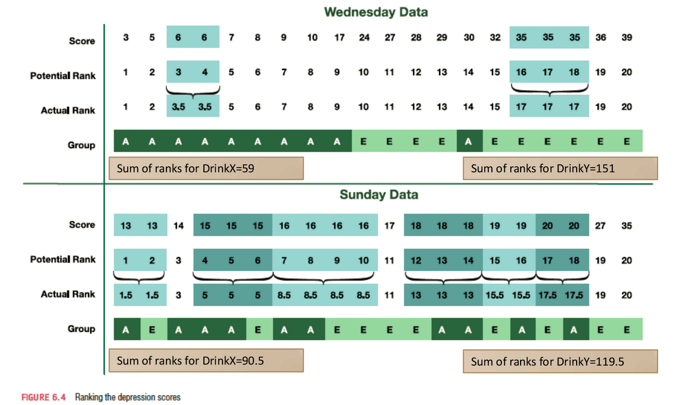

- explanation
  - In bottom have sunday data
  - Lowest score was 13
  - Highest score was 35
  - But 2 got 13 , 1 from group A and 1 from group B, that’s X and y
  - We take the average of them 2 Ranked at 1.5
  - Rank them all up
  - Know groups they come from
  - Get sum of ranks drink X
  - Get sum of ranks drink Y
  - Repeat for wed….
  - Wed

Provisional analysis using R

- We want to load up the csv file
- Need descriptive stats for sun….
- Load the data

‘’’R
drinkset<- read.csv("Field-BDI-Non-parametric.csv“, header=TRUE)
‘’’

- Get your descriptive statistics
- We know it is non-parametric so we want median and IQR

‘’’R
by(drinkset$bdisun,drinkset$drink, median)
by(drinkset$bdisun,drinkset$drink, IQR)
‘’’

- Create your plots using ggplot

Mann-Whitney test
- It is used to test the null hypothesis that two samples come from the same population (i.e. have the same median)

- OR alternatively, whether observations in one sample tend to be larger than observations in the other.

- Compares the medians from two populations and works when the Y variable is continuous, and the Xvariable is discrete with two attributes.
  - Of course, the Mann-Whitney test can also be used for normally distributed data
    - But in that case, it is less powerful than the 2-samplet-test.
- Comment
  - If they come from the same population the median would be the same
  - Ho = they come from same population (median is =)
  - Ha = Alternate = one sample has larger ranks than the other.
  - So comparing medians and working out which is > than the other

The U Value
- The U value for each group is calculated by
  - subtracting the possible minimum rank which the group can take from the sum of the ranks,
    - sum of ranks – possible min value group can take
      - the smallest U value is used for the test.

- For the test of significance of the Mann-Whitney U-test it is assumed that with n > 80 or each of the two samples at least > 30 the distribution of the U-value from the sample approximates normal distribution.

- U value is compared to table of critical values depending on the size of each sample

  - U value must be equal to or less than critical value
  - Want
    - U value <= critical value…

In R – Mann Whitney U (Wilcoxon Test)

- Usin wilcox test (even though using man-whitney_
- Saying in code
  - Pass thru continuous or interval variable we want to work with or ordinal variable
    - It is Depression levels on sun
  - We pass in categorical variable we want to sue ton credate the drinks
  - Look at this variable BDI sun / and divide into drink types, tilda means group)
  - Data we read it into is drink set
    - Get warnings about ties as can’t compute an exact p, but that’s ok
From stats package
‘’’R

wilcox.test(y~A)#where y is your continuous variable and A
is your categorical

# tilda means group
‘’’

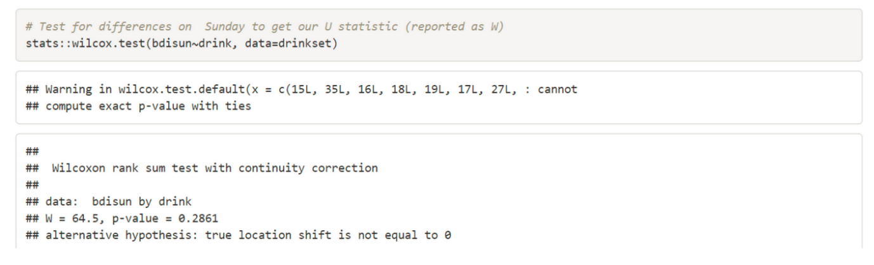
- What we have then is
- Wilcoxon value = 64.5 (our Man -whitney U value)
- Here on Sun - we have p-value = 0.28 (which is greater than 0.5 which is not SS

Do the same on Wed
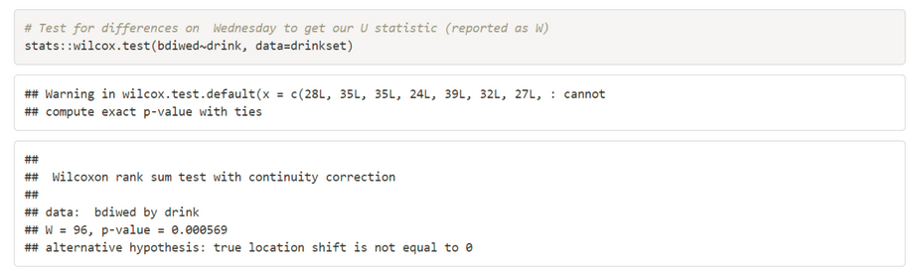

- What we have then is
- Wilcoxon value = 64.5 (our Man -whitney U value)
- Here on Wed - we have p-value = 0.000569 (which is greater than 0.5 which is is SS

Calculating an Effect Size
- Always have to calculate an effect size…
- The equation to convert a z-score into the effect size estimate, r, is as follows (from Rosenthal, 1991: 19):
- Rosenthal’s r

$$r=\frac{z}{\sqrt{N}}$$

- z is something we need to calculate if we use the stats package
- We can use qnorm() of the pvalue to get it or use the wilcox_test from the coin package

Ref source - Rosenthal 1991 Meta-analytic procedures for social research, SAGE

In R – Calculate effect size

- We can calculate our Z statistic by using the wilcox_test from the coin package

‘’’R
#To calculate Z we can use the Wilcox test from the coin package
coin::wilcox_test(bdiwed~as.factor(drink), data=drinkset)
‘’’

- And calculate the effect size r by using the wilcox_effsize from the rstatix package

‘’’R
#Calculate the effect size R
reff=rstatix::wilcox_effsize(bdiwed~drink, data=drinkset)
‘’’

Reporting the Results
A Mann–Whitney test was used to test whether depression levels differed between those who drank DrinkX (Mdn = 17.50, IQR = 3.75) and those who drank DrinkY (Mdn = 16.00, IQR = 3.00) the day after the drinks were taken (Sunday). The results showed no significant difference (U = 64.5, z = 1.11, p = .29, r = .25).
However, a Mann–Whitney test used to compare depression levels three days after the drinks were taken (Wednesday) indicated that those who drank DrinkX (Mdn = 33.50, IQR = 6.75) were significantly more depressed than those who drank DrinkY (Mdn = 7.50, IQR = 3.75) (U = 96.00, z = 3.48, p < .001, r = .78).

- NOTE
  - Our W statistic is what we use for U
  - We report the median values because the data is not normally distributed.
  - Statistic we report is Median and IQR
  - Statistic we report is the U value

Lab Walkthrough – file MATH9102-W4-nonParam.qmd

‘’’{r}
---
title: "MATH9102-W4-NonParam"
author: "Deirdre Lawless"
format:
html:
self-contained: true
code-fold: true
editor: visual
---

```{=html}
<style>
/* Center captions for figures and tables in Quarto HTML, make them black and bold */
.quarto-figure .figure-caption,
figure > figcaption,
.table-caption,
table > caption {
text-align: center;
color: black;
font-weight: bold;
}
</style>
```

```{r}
#| label: install-and-load
#| message: false
#| warning: false

quiet_library <- function(pkg) {
suppressMessages(suppressWarnings({
if (!requireNamespace(pkg, quietly = TRUE)) {
install.packages(pkg, quiet = TRUE)
}
library(pkg, character.only = TRUE)
}))
}
quiet_library("tidyverse") # Collection of R packages (dplyr, ggplot2, tidyr, etc.) for data wrangling, visualization, and analysis
quiet_library("psych") # Descriptive statistics by group
quiet_library("car") # Includes Levene's test for homogeneity
quiet_library("effectsize") # Includes calculations for effectsize quiet_library("pastecs") # Tools for descriptive statistics, time series analysis, and data exploration (e.g., stat.desc)
quiet_library("FSA") # Includes general tools for data analysis (e.g., nonparametric tests, bootstrapping)
quiet_library("semTools") # Supplementary functions for Structural Equation Modeling (SEM), including model fit, reliability, and measurement invariance test

#Amend this to reflect your folder structure
datalocation <- file.path("C:","Users", "deirdre.lawless", "datafiles")
datapath <- file.path(datalocation,'Field-BDI-Non-parametric.csv')

#Load the data into a dataframe - it is a .csv file, we indicate that the first row is a header with colnames
drinkset<- read.csv(datapath, header=TRUE)
#Create data subsets for each drink
drinkxdata <- subset(drinkset, drink=='DrinkX')
drinkydata <-subset(drinkset, drink=='DrinkY')
```

# Differences in Depression Levels - Sunday

```{r}
#Note: I am not doing the inspection of the variables here as I know they are not normal since this data has been designed to illustrate non-parametric difference

#Get your descriptive statistics - we are using the by function to handle the need to group
by(drinkset$bdisun,drinkset$drink, median)
by(drinkset$bdisun,drinkset$drink, IQR)

#Create plots of these
gs <- ggplot(drinkxdata, aes(x=bdisun))
gs <- gs + labs(x="Drink X")
gs <- gs + geom_histogram(binwidth=2, colour="black")
gs <- gs + scale_fill_gradient("Count", low="#DCDCDC", high="#7C7C7C")
gs <- gs + stat_function(fun=dnorm, color="red",args=list(mean=mean(drinkxdata$bdisun, na.rm=TRUE), sd=sd(drinkxdata$bdisun, na.rm=TRUE)))
```

```{r}
#| fig.cap: "Figure 1: Histogram of Depression Levels for Drink X on Sunday"
gs
```

```{r}
gs <- ggplot(drinkydata, aes(x=bdisun))
gs <- gs + ggtitle ("Depression Levels Sunday")
gs <- gs + labs(x="Drink Y")
gs <- gs + geom_histogram(binwidth=2, colour="black")
gs <- gs + scale_fill_gradient("Count", low="#DCDCDC", high="#7C7C7C")
gs <- gs + stat_function(fun=dnorm, color="red",args=list(mean=mean(drinkydata$bdisun, na.rm=TRUE), sd=sd(drinkydata$bdisun, na.rm=TRUE)))
```

```{r}
#| fig.cap: "Figure 2: Histogram of Depression Levels for Drink Y on Sunday"
gs
```

```{r}

# Test for differences on Sunday to get our U statistic (reported as W)
stats::wilcox.test(bdisun~drink, data=drinkset)
#by default wilcox.test() calculates an exact p-value if the samples contain less than 50 finite values and there are no ties. Otherwise, a normal approximation is used. In our example, the sample contains less than 50 finite values but there are ties. That’s why the warning message “cannot compute exact p-value with ties” is appearing.

#To calculate Z we can use the Wilcox test from the coin package
coin::wilcox_test(bdisun~as.factor(drink), data=drinkset)

#Calculate the effect size R
reff=rstatix::wilcox_effsize(bdisun~drink, data=drinkset)

#Calculate the effect r
reff$effsize

```

## Reporting the results of the Sunday Finding

A Mann–Whitney test was used to test whether depression levels differed between those who drank DrinkX (Mdn = 17.50, IQR = 3.75) and those who drank DrinkY (Mdn = 16.00, IQR = 3.00) the day after the drinks were taken (Sunday). The results showed no significant difference (U = 64.5, z = 1.11, p = .29, r = .25).

#Note: We are reporting the W statistic output by the stats::wilcox_test as U here.

# Differences in Depression Levels - Wednesday

```{r}
#Note I am not doing the inspection of the variables here as I know they are not normal since this data has been designed to illustrate non-parametric difference

#Get your descriptive statistcs
by(drinkset$bdiwed,drinkset$drink, median)
by(drinkset$bdiwed,drinkset$drink, IQR)
```

```{r}
#Create plots of these
gs <- ggplot(drinkxdata, aes(x=bdiwed))
gs <- gs + ggtitle ("Depression Levels Wednesday")
gs <- gs + labs(x="Drink X")
gs <- gs + geom_histogram(binwidth=2, colour="black")
gs <- gs + scale_fill_gradient("Count", low="#DCDCDC", high="#7C7C7C")
gs <- gs + stat_function(fun=dnorm, color="red",args=list(mean=mean(drinkxdata$bdiwed, na.rm=TRUE), sd=sd(drinkxdata$bdiwed, na.rm=TRUE)))
```

```{r}
#| fig.cap: "Figure 3: Histogram of Depression Levels for Drink X on Wednesday"
gs
```

```{r}

gs <- ggplot(drinkydata, aes(x=bdiwed))
gs <- gs + ggtitle ("Depression Levels Wednesday")
gs <- gs + labs(x="Drink Y")
gs <- gs + geom_histogram(binwidth=2, colour="black")
gs <- gs + scale_fill_gradient("Count", low="#DCDCDC", high="#7C7C7C")
gs <- gs + stat_function(fun=dnorm, color="red",args=list(mean=mean(drinkydata$bdiwed, na.rm=TRUE), sd=sd(drinkydata$bdiwed, na.rm=TRUE)))
```

```{r}
#| fig.cap: "Figure 4: Histogram of Depression Levels for Drink Y on Wednesday"
gs
```

```{r}
# Test for differences on Wednesday to get our U statistic (reported as W)
stats::wilcox.test(bdiwed~drink, data=drinkset)
#by default wilcox.test() calculates an exact p-value if the samples contain less than 50 finite values and there are no ties. Otherwise, a normal approximation is used. In our example, the sample contains less than 50 finite values but there are ties. That’s why the warning message “cannot compute exact p-value with ties” is appearing.

#To calculate Z we can use the Wilcox test from the coin package
coin::wilcox_test(bdiwed~as.factor(drink), data=drinkset)

#Calculate the effect size R
reff=rstatix::wilcox_effsize(bdiwed~drink, data=drinkset)

#Calculate the effect r
reff$effsize

```

## Reporting the comparison

However, a Mann–Whitney test used to compare depression levels three days after the drinks were taken (Wednesday) indicated that those who drank DrinkX (Mdn = 33.50, IQR = 6.75) were significantly more depressed than those who drank DrinkY (Mdn = 7.50, IQR = 3.75) (U = 96.00, z = 3.48, p \< .001, r = .78).

‘’’

Comparing Nominal Variables - MATH9102-W4-nominal.qmd

Sources used in creation of this lecture:
Statistics and Data Analysis, Peck, Olsen and Devore; Discovering Statistics Using IBM SPSS, Andy Field; Understanding Basic Statistics, Brase and Brase;SPSS Survival Manual, Julie Pallant

- Comment – overview intro talk
- We have talked about relationships between data that can be considered continuous, interval, ratio and talked about differences in the experience of a concept represented by a continuous variable and two groups created by a categorical variable.

- But what if there are categorical variables in our data that represent concepts where we’re interested to see if theres a relationship or a difference.

- So we know that these can have numerical values, but that doing maths with them makes absolutely no sense…

- So what we’re basically saying is that if theres no relationship between 2 categorical variables,

  - > then being assigned to a category of one of them has absolutely no influence on being assign ed to a category of another
  - EG .. You live in a rural or urban area and whether that influences whether your child attends private or non private school
  - So Ho = is no influence
  - HA there is an influence
  - We need to quantify the level fo relationship between them….

- To describe them
  - can’t use CT and we
  - can’t use Disp(SD/IQR)
  - can use mode and range, but they don’t really help us very much.

- What we really need to look at is
  - the frequency of occurrence of all the values
  - combination of values across these variables….

Comparing Nominal Variables

- When two nominal variables are independent, there is no relationship between them.
  - This means that
    - For all cases
      - The classification of a case into a particular category of one variable (the group variable) has no effect on the probability that the case will fall into any particular category of the second variable (the test variable).

- Lab file >> MATH9102-W4-Nominal.qmd

Analyzing categorical variables
- Central Tendency (mean/median) of a categorical variable is meaningless
  - The numeric values you attach to different categories are arbitrary
  - The mean of those numeric values will depend on how many members each category has.
- Therefore, we analyze frequencies.

New slide – 1

- Using the bullying.dat dataset (Paul Connolly)
  - Dataset Descriptor:
  - https://www.routledge.com/Quantitative-Data-Analysis-in-Education-A-Critical-Introduction-Using-SPSS/Connolly/p/book/9780415372985
- Contains the results of national school level survey, subset of this survey which deals with bullying.

- Question:
  - “Is there a relationship between being bullied in school and participating in bullying of others in school?”
  - H0: There is no relationship between being a victim of bullying in school and participating in bullying others in school.
  - HA: There is a relationship between being a victim of bullying in school and participating in bullying others in school.

- Variables:
  - ‘ubullsch’ – Q26. Have you yourself ever been bullied in school? {1- Yes, 2 –No, 99-not answered}
  - ‘ubulloth’ - Q28 - Have you yourself ever taken part in bullying other students? {1- Yes, 2 –No, 99-not answered}

Compraing Nominal Variables – create contingency table

- We could create a contingency table/
- A → Students who were bullied and bullied others
- B → Students who were bullied but did not bully others
- C → Students who were not bullied but bullied others
- D → Students who were not bullied and did not bully others
- N → Total number of students
- We’re interetsed in the row totals
  - A +B
  - C + D
  - column totals
  - and overall numbers we have
- A Chi square test will compare the observed frequencies (A, B, C, D) with the expected frequencies under the assumption being bullied and bullying others are independent.

- The chi-square statistic will be calculated, and its significance will be determined based on the p-value and the degrees of freedom (df = 1 in this case).

Chi-squared test

- We are comparing observed values to expected values according to a specific hypothesis (null hypothesis)

- The null hypothesis for this test states that the proportions (the distribution across categories) are the same for all of the populations

- Views the data as two (or more) separate samples representing the different populations being compared

  - The same variable is measured for each sample by classifying individual subjects into categories of the variable.
  - The data are presented in a matrix with the different samples defining the rows and the categories of the variable defining the columns.
  - The data, called observed frequencies, simply show how many individuals from the sample are in each cell of the matrix.

Chi Square Test for Independence

- We are comparing observed values to expected values according to a specific hypothesis (null hypothesis)
  - The null hypothesis for this test states that the proportions (the distribution across categories) are the same for all of the populations
  - The null hypothesis is used to construct an idealized sample distribution of expected frequencies that describes how the sample would look if the data were in perfect agreement with the null hypothesis
  - Calculated from the observed frequencies:

Expected Frequencies
Suppose we had the following observed frequencies:

- Expected frequency of ‘was bullied’ and ‘buillied others’ is below…
  - Have A+B = 244 * 60 (is uor A+ C)
    - Row total + column total / total number we got – 799
    - These are Epected freq if H-0 hold
    - Can compare those to actual observed freq and if we have a diff or not…

 | Formula | Expected Frequency
E(A) = “Was Bullied” & “Bullied Others” | (244 × 60) / 799 | 18.32
E(B) = “Was Bullied” & “Did Not Bully” | (244 × 739) / 799 | 225.68
E(C) = “Not Bullied” & “Bullied Others” | (555 × 60) / 799 | 41.68
E(D) = “Not Bullied” & “Did Not Bully” | (555 × 739) / 799 | 513.32

Comparing
- Comparing these to the observed counts (35 vs. 18.32, 25 vs. 41.68, etc.) shows a clear deviation — especially:
  - ◦More students than expected were both bullied and bullied others (A).
  - ◦Fewer students than expected were not bullied but bullied others (C).
- This is what our chi square test will measure and will test to see if the difference is large enough to be statistically significant.

Chi-Square Test for Independence

- A chi-square statistic is computed to measure the amount of discrepancy between the ideal sample (expected frequencies from H0) and the actual sample data (the observed frequencies).
- The output is a cross-tabulation table
- Easiest way to do this is to use the cross table function from the gmodels package

Chi squared - Fisher test - code in R
‘’’R
#CrossTable(predictor, outcome, fisher = TRUE, chisq = TRUE, expected = TRUE)#Note: for this approach there must be the same number of values for both variables so # missing data is important.

# Remove rows where either variable is NA
bully_clean <- bully %>% filter(!is.na(ubullsch) & !is.na(ubulloth))

# Now run CrossTable requesting both Fisher and Chi Square so we have full information# We request the format in SPSS to make it easier to interpret.

gmodels::CrossTable(
bully_clean$ubullsch,
bully_clean$ubulloth,
fisher = TRUE,
chisq = TRUE,
expected = TRUE #expected to eb created,
sresid = TRUE # residuals to be created,
format = "SPSS" # as gives detailed output all in one go)
‘’’

1st step - chi squared – fisher test - % totals = 100

- Look at total observations
- Look at row totals
- And Make sure your %s add up to 100.
  - It should - if have eliminated all NAs and no missing data

1st step - Make sure your %s add up to 100.

2nd Step – chi squared – fisher test – minimum expected frequency
- expected frequency is > 5.
- if < 5 ---- this test is not appropriate and should use Fisher’s Exact Probability Test

Need to check this – assumption is that lowest expected frequency is 5 or more. If not then this test is not appropriate and should use Fisher’s Exact Probability Test.

3rd Step if 2 x 2 (Yes/No – Yes / N

- If we are looking at 2 x 2 table
- (Yes/No – Yes / No for 2 categorical variables
  - 2 possible variables in category 1
  - 2 possible variables ni category 2
- we have to do a Yates continuity correction

If we are looking at 2x 2 table we look at Yates continuity correction

Yate’s Continuity Correction
- This is to help prevent us making a Type I error

- When we are doing a Chi-square test, we are assuming that the probability distribution of the binomial frequencies observed approximate the Chi-square distribution
  - This is not quite correct
  - Yate’s correction adjusts Pearson’s Chi-square by subtracting 0.5 from each of the differences between the observed values and the expected values, which will reduce the Chi-square statistic and its associated p-value
  - Particularly important for small data (larger datasets this can be overcome)
  - May tend to overcorrect – make sure you reflect your research area’s perspective (some would say Yates is unnecessary even for small data).
  - Be aware of it….

In R – more simplistic option – create table and compare output

‘’’R
#Create your contingency table
mytable<-xtabs(~ubullsch+rsex, data=bully)
ctest<-chisq.test(mytable, correct=TRUE)#chi square test
#correct=TRUE to get Yates correction needed for 2x2 table
ctest#will give you the details of the test statistic and p-value
ctest$expected#expected frequencies
ctest$observed#observed frequencies
ctest$p.value
OUTPUT:
X-squared = 2.3005, df = 1, p-value = 0.1293

‘’’

4th Step - Chi Square – Calculate the Statistic
- Measures the amount of discrepancy between the ideal sample (expected frequencies from H0) and the actual sample data (the observed frequencies = fo).
  - A large discrepancy results in a large value for chi-square which indicates that the data do not fit the null hypothesis and the hypothesis does not hold.
  - We compare our test statistic to the Chi Square distribution (in the form of a table) and we can get the probability that any deviation in the observed from the expected is due to chance only

- For one degree of freedom
  - Need to look at right DoF
  - Anything > critical value = > we have SS result
  - The critical value associated with p = 0.05 for Chi Square is 3.84
  - The critical value associated with p =0.01 it is 6.64
  - Chi-square values higher than this critical value are associated with a statistically low probability that H0 holds.

5th Step – Calc Effect Size 2 x 2
- Number of items in each category determines what effect size we use
- Phi (2 x 2 contingency table)
- Phi is used for 2×2 tables

$$φ=\sqrt{\frac{x^{2}}{n}}$$

  - is considered a small effect
  - a medium effect
  - 0.5 a large effect.

5th Step - Effect Sizes – Cramers V
- If more than 2 values in each category = > Cramers V
- Cramers V depends on the degrees of freedom
- Cramer’s V is suitable for tables larger than 2×2, and
$$v=\sqrt{\frac{x^{2}}{n⋅df}}$$

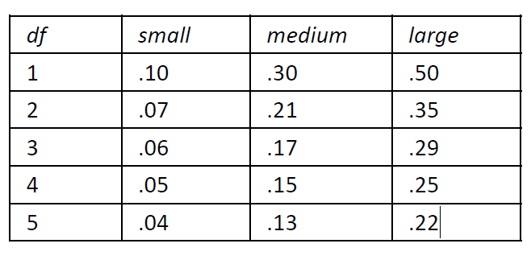

6th Step – Report - Chi-Square Test for Independence – Text report
Reporting the findings

A Chi-square test of independence was conducted to examine the relationship between being bullied in school and bullying others. The association was statistically significant (χ²(1, N = 799) = 22.23, p < .001). Students who reported being bullied were significantly more likely to report bullying others (14.3%) than those who were not bullied (4.5%). The effect size, measured by Phi (φ = 0.17), indicates a small association. There is therefore evidence to support rejecting the null hypothesis in favour of the alternate hypothesis.

Where did the %s come from?

- Bullied students who bullied others:
  - (35/244)×100=14.3%

- Bullied students who did not bully others:
  - (209/244)×100=85.7%

New Slide – 1

- Non-Bullied students who bullied others:
  - (25/555)×100=4.5%

- Non-Bullied students who did not bully others:
  - (530/555)×100=95.5%

Repeated Measures Categorical Variables

- Use McNemar’s test

- Matched Samples or repeated measures (pre-test/post-test)
  - Two variables one recorded at Time 1 and one recorded at Time 2 (after an intervention)

- Use for categorical variables with two response options
  - For 3 or more use Cochran’s Q-test

- In R: mcnemar.test

From chatgpt >> 🧠 What Is McNemar’s Test?
- McNemar’s test is a non-parametric test used to analyze paired nominal (categorical) data — typically from before-and-after or matched pairs designs.
- It tests whether the proportion of “successes” (or responses in a category) has changed significantly between two related conditions.

Week 5 – Difference more than 2 groups + Inspecting an prep data

What we have covered so far…

 | Theme | Located in Lectures | Core Skills
1 | Foundations and Measurement | Weeks 1, 2 | Understanding variables, data types, sampling, measurement, bias
2 | Descriptive Statistics | Weeks 1, 2 | Central tendency, dispersion, visualisation
3 | Data Quality and Preparation | Week 3, Week 5 | Handling missing data, outliers, weighting, normality; Transforming data
4 | Inferential Statistics – Foundations | Week 3 | Hypothesis testing, p-values, assumptions
5 | Relationships | Week 3 | Correlation analysis
6 | Comparing Categorical | Week 4
7 | Comparing Groups | Week 4 | Comparing Groups
8 | Comparing Groups | Week 5 (This week) | Continuous and Binary categorical

Comparison of more than 2 samples



Tell me the difference between these groups…
Thank God I have ANOVA

Tests for Multiple Group Comparison

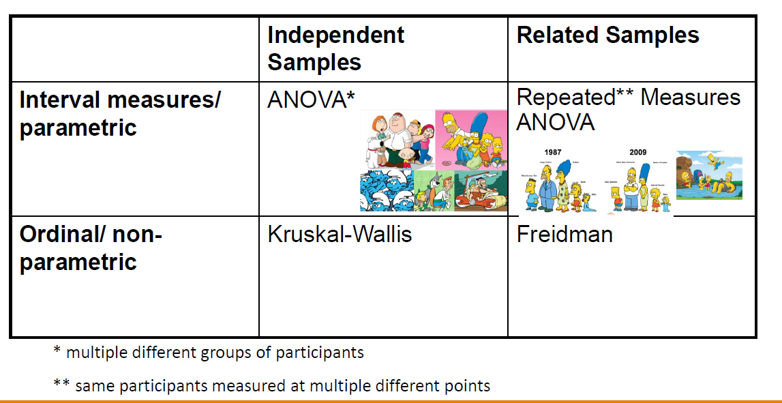

 | Independent Samples | Related Samples (also called dependent means test)
Interval measures/ parametric | ANOVA* | Repeated** Measures ANOVA
Ordinal/ non-parametric | Kruskal-Wallis | Freidman

* multiple different groups of participants
** same participants measured at multiple different points

Parametric
MATH9102-W4-ANOVA.QMD

ANOVA

ANOVA
ANalysis Of VAriance (ANOVA)

- Still compares the differences in means between groups but it uses the variance of data to “decide” if means are different
- Really is ANOVASMD (Analysis of variance to see if means are different)

- Looks to see what the variation (variance) is within the groups, then works out how that variation would translate into variation (i.e. differences) between the groups, taking into account how many subjects there are in the groups.
- If the observed differences are a lot bigger than what you'd expect by chance, you have statistical significance.

From chat gpt >> 🎓 1️⃣ What Is ANOVA?
ANOVA (Analysis of Variance) is a statistical test used to compare the means of three or more groups to see if at least one mean is significantly different from the others.
It’s like a generalization of the t-test (which compares two means).

ANVA – slide -2

- Factors: the overall ‘things’ being compared (e.g. age, task, score)

- Levels: the elements of the factor (young v old and naming v reading aloud)

- F- statistic or F-ratio
  - Magnitude of the difference between the different conditions
    - Similar to z or t-score as it compares the amount of systematic variance in the data to the amount of unsystematic variance.
  - It is the ratio of the experimental effect to the individual differences in performance.
  - Less than 1, it must represent a non-significant event (so you always want a F-ratio greater than 1)
  - Degrees of freedom – depends on the number of factors and the number of levels

ANOVA – Omnibus Test
- ANOVA tests for one overall effect only

- Omnibus test

- There is a need for post-hoc testing
  - ANOVA can tell you if there is an effect but not where
  - Need to perform multiple comparisons to identify level of effect and where effect is evident

- To test for significance
  - obtained F-ratio is compared against maximum value one would expect to get by chance alone in an F-distribution with the same degrees of freedom.
  - p-value associated with F is probability that differences between groups could occur by chance if null-hypothesis is correct

- Reporting convention: F= 65.58, df= 4,45, p< .001

F Distribution

- The curve is not symmetrical but skewed to the right.
- There is a different curve for each set of degrees of freedom (dfs).
- The F statistic is greater than or equal to zero.
- As the degrees of freedom for the numerator and for the denominator get larger, the curve approximates the normal

From Chatgpt >>>> The F-distribution is a probability distribution that arises when you take the ratio of two variances (each divided by their respective degrees of freedom).
- It’s positively skewed (can’t be negative).
- The shape depends on two parameters: the numerator and denominator degrees of freedom.
- Used in ANOVA, regression, and other tests involving variances.
So when you see a result like:
$$F(2,27)=4.56, p=.019$$

What Does ANOVA Tell us?
- Null Hypothesis:
  - Like a t-test, ANOVA tests the null hypothesis that the means of the different groups are the same.

- Alternate Hypothesis:
  - The means differ.

- ANOVA is an Omnibus test
  - it test for an overall difference between groups.
  - It tells us that the group means are different.
  - It doesn’t tell us exactly which means differ.

Example 1

- Sleep.rdata
  - http://spss.allenandunwin.com.s3-website-ap-southeast-2.amazonaws.com/data-files.html#.Wb0vvnWP-po
  - Created from the SPSS file sleep.sav taken from SPSS Survival Manual 6th Edition Julie Pallant
- A real data file condensed from a study conducted to explore the prevalence and impact of sleep problems on various aspects of people’s lives.

- Staff from a university in Melbourne, Australia were invited to complete a questionnaire containing questions about their sleep behavior (e.g. hours slept per night), sleep problems (e.g. difficulty getting to sleep) and the impact that these problems have on aspects of their lives (work, driving, relationships).

- The sample consisted of 271 respondents (55% female, 45% male) ranging in age from 18 to 84 years (mean=44yrs).

Example: One-way Between-Groups ANOVA (sleep.rdata)
- Question
  - Does age impact Total Sleepiness And Associated Sensation scores of participants?

- Need
  - One independent categorical (nominal/ordinal) variable with three or more levels (age category) (agegp3)
    - Group 1=<=37yrs , Group 2=38-50yrs, Group 3=51+yrs (older)
  - One continuous (ratio) variable (Total Sleepiness and associated sensation scale scores) (totsas)

- Hypotheses:
  - H0: There are no differences between Total Sleepiness And Associated Sensation Scale scores for respondents in Group 1, Group2 and Group3.
  - HA: There are differences between Total Sleepiness And Associated Sensation Scale scores for respondents in Group 1, Group2 and Group3.

One-way Between-Groups ANOVA
- One-way ANOVA will tell us
  - whether there are significant differences in Total Sleepiness and associated sensation scale scores (totsas) across the three groups (agegp3)
- BUT
  - Not where the difference is

- We need to conduct post-hoc tests (additional tests after the ANOVA) to find out where the differences lie
  - E.g. Is it between young and older, young and middle-aged, middle-aged and older?

One-way Between-Groups ANOVA - Step 1
- Before we conduct the ANOVA we would first have inspected and described the data for that variable as we would any scale (interval/ratio) variable in advance to see if it can be considered normal.

- Generate and Inspect:
  - Histogram with density curve
  - QQ Plot
  - Standardized scores for skewness and kurtosis
  - Percentage of absolute (z scores) outside acceptable ranges
  - Appropriate descriptive statistics

One-way Between-Groups ANOVA – Text report
Reporting our findings:
“Total Sleepiness and associated sensation scores data was assessed to see if it followed a normal distribution. Visual inspection of the histogram and QQ-Plot (see Figure x) identified some issues with skewness and kurtosis. The standardised score for skewness (-0.37) can be considered acceptable using the criteria proposed by West, Finch and Curran (1996), however the standardised score for kurtosis (-3.65) was outside the acceptable range. However as 100% of standardised scores for total sleepiness and associated sensation fell within the bounds of +/- 3.29, the data can be considered to approximate a normal distribution as outlined in Field, Miles and Field (2013).”
West SG, Finch JF, Curran PJ. Structural equation models with nonnormal variables: problems and remedies. In: Hoyle RH, editor.Structural equation modeling: Concepts, issues and applications.Newbery Park, CA: Sage; 1995. pp. 56–75.

One Way ANOVA - Step 2

- Generate summary statistics for the variable of interest for each group.
- These three approaches will all work:
‘’’R
by(sleep$totsas, survey$agegp3, summary)
psych::describeBy(survey$totsas, survey$agegp3)
tapply(survey$totsas, survey$agegp3, summary)
‘’’

One Way ANOVAStep 2Generate Summary Statistics per Group

Generate summary statistics for the variable of interest for each group.

‘’’R
# item group1 vars n mean sd

median trimmed mad min max
Group 1 <= 37 n=79, m=27.77, sd=10.30
Group 2 38- 50 n= 79, m=26.07, sd= 11.18
Group 3 51+ n=72, m=25.14, sd=9.71

One Way ANOVA - Step 3 > Testing for homogeneity of variance in R

- We need to check for homoscedasticity (homogeneity of variance) for the variable of interest across groups

- In R we use Bartlett’s test from the library stats

‘’’R
stats::bartlett.test(sleep$totsas, sleep$agegp3)
‘’’

- Can be argued that the variances are homogeneous if the p-value > 0.05

Testing for homogeneity of variance in R
- We need to check for homoscedasticity (homogeneity of variance) for the variable of interest across groups

- In R we use Bartlett’s test from the library stats

- Can be argued that the variances are homogeneous if thep-value > 0.05

- HERE: Bartlett's K-squared = 1.49, df = 2, p-value = 0.48

Testing for homogeneity of variance
- We need to know so we can conduct the correct post-hoc test
- Homoscedasticity:
  - Use Tukey’s honestly significant difference (HSD) post hoc test (tukey)
- Heterocedasticity:
  - Use Games-Howell (games-howell)

One Way ANOVA - Step 4 > Conduct the Omnibus test

- Compute the analysis of variance using the

- We can se VAR.equal to be true because we have homogeneity
  - If we don’t we set it to FALSE

In R – One Way ANOVA
‘’’R
# Compute the analysis of variance using the oneway.test from the stats package- we set VAR.equal to be true because we have homogeneity
res <- stats::oneway.test(sleep$totsas ~ as.factor(sleep$agegp3), data = sleep, var.equal = TRUE)
# Summary of the analysis – echo to screen
res
‘’’

In R – One Way ANOVA

- Check this first!
- If this is not significant you do not need to check the post hoc test results.

One Way ANOVA - Step 5 > If omnibus is significant Conduct the Post-hoc test

◦
- Homoscedasticity:
  - Use Tukey’s honestly significant difference (HSD) post hoc test (tukey)
- Heterocedasticity:
  - Use Games-Howell (games-howell)

In R – One Way ANOVA

- Here we see the differences between groups
- We would be looking for p-values < 0.05 – these are where the differences lie
- We only need to worry about this post-hoc test if the omnibus test returned a significant value

One Way ANOVA - Step 6 > Calculating the effect size

- eta squared = sum of squares between groups/total sum of squares (from our ANOVA output (rounded up))

- Guidelines on effect size:
  - 0.01= small
  - 0.06 = moderate
  - 0.14 =large

- For our example it is =.01

Step 7 - Report the result

A one way ANOVA test was conducted to compare Total Sleepiness and associated sensation scale score for respondents who are young (18 to 37), middle-aged (38 to 50) and older (over 50). No statistically significant difference in the scores was found between age groups, (F(2, 2, 227) = 1.24, p=1.245), ((M=27.77, SD=10.3) for respondents who are aged 37 and under, (M=26.08, SD=11.18) for respondents who are aged between 38 and 50, M=25.14, SD=9.71) for respondents who are aged 50+). A small effect size was indicated by the eta squared value (η² = .01). Therefore, there is no evidence to reject the null hypothesis that Total Sleepiness and associated sensation scores differ by age group.

Example 2: One-way Between-Groups ANOVA Survey.dat

- survey.dat (Julie Pallant)

- Question:
  - Does age impact optimism scores?

- H0: There are no differences between
  - Total Optimism scores for respondents in Group 1, Group2 and Group3.
- HA: There are differences between
  - Total Optimism scores for respondents in Group 1, Group2 and Group3.

Assess toptim for normality
Total optimism scores data were assessed for normality. Visual inspection of the histogram and QQ-Plot (see Figure 1 and Figure 2) identified some issues with skewness and kurtosis. The standardized score for kurtosis (0.91) can be considered acceptable using the criteria proposed by West, Finch and Curran (1996), but the standardized score for skewness (-4.21) was outside the acceptable range. However over 99% of standardized scores for total optimism fall within the bounds of +/- 3.29, using the guidance of Field, Miles and Field (2013) the data can be considered to approximate a normal distribution (m=22.12, sd=4.43, n=435).

Central Tendency and Dispersion for each group

 | group n mean sd | n | mean | sd
1 | 18 - 29 | 147 | 21 | 5
2 | 30 - 44 | 153 | 22 | 4
3 | 45+ | 135 | 96 4 | 4

Check for homogeneity of variance in the groups

‘’’R
stats::
bartlett.test(toptim~ agegp3, data=survey)
##
## Bartlett test of homogeneity of variances
##
## data:
toptim by agegp3
## Bartlett's K-squared = 1.4561, df = 2, p-value = 0.4828

- The p value is > 0.05 so the result is not statistically significant so we can assume homogeneity

Conduct the ANOVA omnibus

‘’’R
#Conduct ANOVA using the one
-way ANOVA from the stats package with var.equal=TRUE
stats::
oneway.test(toptim ~ as.factor(agegp3), data = survey, var.equal = TRUE)
##
## One
-way analysis of means
##
## data: toptim and as.factor(agegp3)
## F = 4.6411,
num df = 2, denom df = 432, p-value = 0.01013
‘’’

- P value is < 0.05 so we have a statistically significant result

Conduct post-hoc testing

‘’’R
#Use Tukey
rstatix
::tukey_hsd(survey, toptim ~ agegp3)
‘’’

Calculate the effect size
‘’’R
effectsize::effectsize(res)

Reporting the Result

A one-way between-groups analysis of variance (ANOVA) was conducted to explore the impact of age on levels of optimism, as measured by the Life orientation Test (LOT). Participants were divided into three groups according to their age (Group 1: 29 yrs or less; Group 2: 30 to 44 yrs; Group 3: 45yrs and above). There was a statistically significant difference in LOT scores for the three age groups: (F(2, 432)= 4.641, p<0.05. Despite reaching statistical significance, the actual difference in mean scores between groups was quite small. The effect size, calculated using eta squared was (0.02). Post-hoc comparisons using the Tukey HSD test indicated that the mean score for Group 1 (M=21.36,SD=4.55) was significantly different to that for Group 3 (M=22.96,SD=4.49). Group 2 (M=22.1,SD=4.15) did not differ significantly from Group 1 or Group3. Therefore while there is evidence to reject the null hypothesis in favour of the alternate hypothesis that there are differences in optimism between age groups, this difference was found to exist only between two groups and was quite small.

Types of ANOVAs

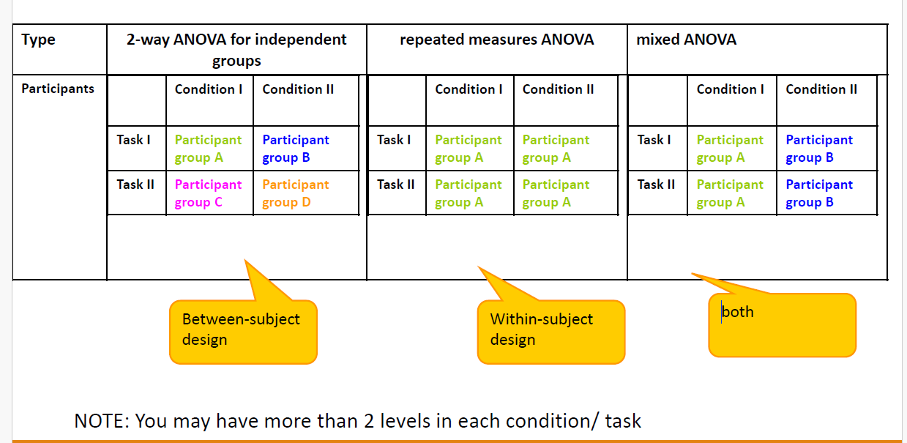

- Type
  - 2-way ANOVA for independent groups
  - Repeated measures ANOVA
  - Mixed ANOVA

NOTE: You may have more than 2 levels in each condition / task

Non-Parametric
MATH9102-W4-KRUSKAL.QMD

Kruskal–Wallis test – Non Parametric
- The Kruskal –Wallis test (Kruskal & Wallis, 1952;) is the non-parametric counterpart of the one-way independent ANOVA (analysis of variance).

- The theory is very similar to that of the Mann–Whitney (and Wilcoxon rank-sum) test:
  - It is based on ranked data.
  - The sum of ranks for each group is denoted by Ri (where i is used to denote the particular group).

Kruskal-Wallis test Theory
- Once the sum of ranks has been calculated for each group.
- The test statistic, H, is calculated as:

- Ri is the sum of ranks for each group.
- N is the total sample size.
- ni is the sample size of a particular group.

Example 1 –
SPSS file taken from Quantitative Data Analysis in Education, Paul Connolly

- Question:
  - “Is there a significant difference in students’ GCSE mathematics grades across different family social class groups ?

- H0: There is no significant difference in the GCSE Maths grades achieved by across different family social class groups.
- HA: There is no significant difference in the GCSE Maths grades achieved by across different family social class groups.

- famsec:

  - A categorical variable representing family social class (grouped by NS-SEC).
    - 1 Large employers and higher professionals, 2 Lower professional and higher technical occupations, 3 Intermediate occupations, 4 Lower supervisory occupations,5 Semi routine and routine occupations, 6 Other
  - gradmath: grade achieved in maths (ordinal)
    - -9 Didn’t take 1 A* 2 A 3 B 4 C 5 D 6 E 7 F 8 G 9 Fail

Provisional Analysis – Statistics for gradmath grouped by socialclass

In R – Do the Omnibus test

‘’’R
Stats::kruskal.test(gradmath~famsec,data=ydata)
‘’’
- The test statistic (Kruskal-Wallis chi-squared) is referred to as H.

Posthoc – Dunn’s Test Approach 1

In R – Posthoc testing

In R – Reporting Posthoc testing Approach 2

What is this Bonferroni Correction?
- When you conduct several statistical tests simultaneously, the chance of finding at least one statistically significant result by random chance increases.
  - This inflates the chance of making a Type I error (incorrectly rejecting the null hypothesis)

- The Bonferroni correction addresses this by making the significance threshold more stringent.
  - Bonferroni corrects/adjusts thepvalue by dividing the original α-value by the number of analyses on the dependent variable.
  - The correction is applied by dividing the original significance level (e.g., 0.05) by the number of comparisons being made.
    - For example, if you are performing 10 tests and the original significance level is 0.05, the adjusted significance level would be 0.05/10=0.0050.05/10=0.005.
    - Each individual p-value must then be less than 0.005 to be considered statistically significant.
  - It is however vulnerable to Type II error

Beware! Multiple Comparison Problem
- When reading a study, you can only account for multiple comparisons when you know about all the comparisons made by the investigators.

- If they report only “significant” differences, without reporting the total number of comparisons, it is not possible to properly evaluate the results.

- Ideally, all analyses should be planned before collecting data, and all should be reported.

Calculate an Effect Size (eta squared)

Can use an effect calculator – in R rstatix package contains a function

‘’’R
rstatix::kruskal_effsize(ydata, gradmath~famsec, ci = FALSE, conf.level = 0.95,
ci.type = "perc", nboot = 1000)#uses bootstrapping
‘’’

Reporting the Results
- You report in the same manner as ANOVA except
  - You report that a Kruskal-Wallis test was conducted
  - The omnibus test statistic is H
  - Report the effect
  - Report the median and IQR of those where differences applied

Reporting the Results - 2
A Kruskal–Wallis test was conducted to examine differences in mathematics grades across family social class groups. The results indicated a statistically significant difference in median maths grades between groups, H(5) = , p < .001, suggesting that family social class is associated with student performance in mathematics.Post hoc pairwise comparisons using Dunn’s test with Bonferroni adjustment revealed that students from higher social class backgrounds (e.g., Large employers and higher professionals) achieved significantly higher maths grades than those from lower social class groups (e.g., Semi-routine and routine occupations, Lower supervisory occupations). Differences between adjacent middle groups (e.g., Intermediate occupations vs.Lower professional and higher technical occupations) were smaller but still significant (p < .001).Overall, the pattern of results suggests a social gradient in mathematics achievement, where students from families with higher occupational status tend to obtain higher grades.The effect size, calculated using eta squared was moderate at 0.12. The median and IQR values for the GCSE Maths grades for all class categories are shown in the following table:

Friedman’s ANOVA

- Non-parametric test for differences between several related groups

- Used for testing differences between conditions when:
  - There are more than two conditions
  - The same participants have been used in all conditions (each case contributes several scores to the data).
- If you have violated some assumption of parametric tests, then this test can be a useful way around the problem.

Inspecting and Preparing Data for predictive Modelling - New Deck

Study Design
- A careful advance plan of data collection and the analytic approach is needed to answer the question under investigation in a scientific way.

- The basic elements of a study design
  - Selecting an appropriate sample size for a specified level of power and level of significance
  - Select appropriate measures
  - Selecting methods of sampling, data collection, and analysis appropriate to the study's objectives

What do I need to describe for numerical data?
- Centre
  - Discuss where the middle of the data falls
  - Measures of central tendency
    - mean, median and mode
- Spread
  - Discuss how spread out the data is
  - Refers to the variability in the data
    - Range, standard deviation, IQR
- Shape
  - Refers to the overall shape of the distribution
  - Symmetrical, uniform, skewed, or bimodal

- Unusual Occurrences
  - Outliers (value that lies away from the rest of the data)
  - Gaps
  - Clusters
- Context
  - You must write your answer
    - With reference to the context in the problem you are investigating,
    - Using correct statistical vocabulary adhering to referencing scheme guidelines
    - Using complete sentences.

Parametric v Non-parametric
- Parametric
  - Make assumptions about the population from which the sample is taken
  - Shape of the population (normally distributed)
- Non-parametric
  - Do not make assumptions about the population and its distribution
  - Tolerant set of tests which don’t expect your data to anything fancy
    - Not high-powered and don’t promise more than they can deliver
    - May fail to detect differences that exist
  - Use for nominal or ordinal data
  - Use for small samples
  - Use for skewed data

Choices to be made before conducting a hypothesis test/building a model
- Deciding if you have sufficient data and sufficient variability within that data

- Correcting for non -response, design effect
  - Weighting variable
  - Be careful of scale up weighting
- Missing data
  - Decide what level of data is missing
  - Decide what the pattern is
  - Decide why it is missing
  - Correct accordingly or ignore
- Normality
  - Inspect and test for normality
  - Be aware of allowable limits
  - If not normal
    - Could use non-parametric tests
    - OR
    - Apply a transformation to see if that results in a normal distribution
- Linearity and homoscedasticity (scale variables)
  - Inspect your scatterplot
  - If assumptions are not addressed could consider transformation but also non-parametric test

Preparing your data
- You may need to consider doing the following:
  - Weighting your data to correct for bias, address design effects, make sample more representative of the population
  - Deciding what to do about missing data
  - Deciding what to do about outliers
  - Recoding your variables
    - E.g. to reduce the number of categories
    - Doing so will not be objective but working with categorization at all is highly contested and highly political
  - Selecting cases
    - To work only with particular sub-groups of data
  - Splitting your file
    - Allows you to organise your output by category of variable you are interested in

Survey Data – Sources of Bias
- Oversampling
  - Some groups are purposefully sampled more frequently than others to produce a large enough sample size for analysis.
- Undersampling
  - Sample size is intentionally reduced to ensure equal representation of different groups.
- Non-response
  - When individuals who choose not to participate in a survey have different characteristics or opinions than those who participate
  - This can result in under- or overestimating certain aspects of a population, leading to a skewed representation of the data.

Weighting
- Use to
  - Correct for any known bias that may exist in the final sample
  - Scale-up frequencies so that frequencies calculated from the sample represent estimates for the population as a whole
  - To address ‘design effects’ arising from the sampling methods used

Example

- Suppose we undertake a survey
- We have selected a random sample for this purpose
- Suppose we collect data on gender and marital status.

Example - 2
Work out your actual proportions surveyed:
Demographic group Percentage
- Unmarried male = 18.5%
- Unmarried female = 18.7%
- Married male = 21.2%
- Married female = 20.9%
- Widowed man = 2.3%
- Widowed woman = 3.1%
- Divorced man = 4.7%
- Divorced woman = 6.6%
Work out your expected proportions based on population
Demographic group Percentage
- Unmarried male = 20%
- Unmarried female = 16.9%
- Married male = 23.8%
- Married female = 23.7%
- Widowed man = 1.4%
- Widowed woman = 4.7%
- Divorced man = 4.1%
- Divorced woman = 5.4%

Weighting – Correcting for Non-Response
- We could conduct our analysis doing nothing to correct for this disparity, but we would be running the risk of creating biased estimates (perhaps males and females prefer different facilities)
- By not correcting for bias in our sample we are giving more weight to some categories than others

Weighting Factor

Calculate the weights for each demographic group by dividing the expected percentage by the actual percentage

Weighting – Correcting for Non-Response
- How do we use the weighting factor?
- We multiply all responses for that category by the corresponding weighting factor.
- We apply the weight in the calculation of all relevant statistics (e.g. weighted mean).

- In R: simple multiplier applied to all variables of interest, can include in your dataset

Weighting – Correcting for Non-Response

- Weighting variables are normally used to correct for known biases in several factors.
- In the youthcohort.sav (Paul Connolly) the weighting variable is used to correct for four factors related to non-response (gender, qualifications achieved, region in which they live and type of school)
- Principle for calculating weighting variable remains the same.

Weighting – Correcting for design effects

- Due to cluster sampling
  - Used in large-scale surveys where it would be too costly to select a simple random sample

- Suppose we need to conduct a survey of 10-11 yr. old pupils in school

- Assuming it is possible to create a full-list of all eligible pupils in the country, then the selection of a simple random sample of 2000 pupils could mean having to interview children scattered across 800 schools throughout the country
  - Lots of cost in doing interviews
  - Huge amount of time in negotiating access, seeking permission etc.

An alternative is to use some form of cluster sampling

- Select 100 schools at random
- Survey all children in those schools
- If on average 20 pupils per school takes part this gives us our sample of 2000 pupils

- But this may underestimate the amount of variation within the population as a whole
  - Pupils within each cluster (each school) are likely to be more like each other than to those outside the school
  - Thus, we are likely to underestimate variation unless we correct for this ‘design effect’
  - Consequence: increased risk of Type I error

Correct Approach = Use multi-level modelling (examine each cluster)

- Beyond the scope of this module

- Compromise Approach: Employ a weighting variable that attempts to reduce the overall size of the sample so that standard errors are increased to account for this

- In earlychildhood.sav and afterschools.sav WTCORRCT corrects for known biases by non-response and provides a correction due to sampling.

What do I need to do?

- Check if a weighting variable is included in your dataset.

- If yes:
  - Find out what type of weighting variable it is
  - Design effect – apply for all analysis
  - Non-response – apply for all analysis – but check the sampling method and use caution in reporting as above

Missing Data
- What is certain in quantitative research?
  - ◦Measurement error
  - ◦Missing data

- Missing data can be:
  - ◦Due to preventable errors, mistakes, or lack of foresight by the researcher
  - ◦Due to problems outside the control of the researcher
  - ◦Deliberate, intended, or planned by the researcher to reduce cost or respondent burden
  - ◦Due to differential applicability of some items to subsets of respondents
  - ◦Etc.

Why do we need to care about missing data?

- Source of bias
- Introduces the possibility of making inferences on the basis of sample data that are inadvertently biased in unknown directions

- Choice of treatment (e.g. deletion) can lead to loss of information and loss of statistical power through reduced sample size
- Makes some common tests inappropriate or difficult to use

Evaluating Missing Data

- Missing data mechanism
  - Missing completely at random (MCAR)—Ignorable
  - Missing at random (MAR)—Conditionally ignorable (need to identify the reason and decide)
  - Missing not at random (MNAR)—Not ignorable

New slide – 1
- Consider the amount of missing data
  - Percent of cases with missing data
  - Percent of variables having missing data
  - Percent of data values that are missing
- Consider the pattern of missing data
  - Missing by design
  - Missing data patterns

Why is it a problem?
- In multivariate data a case will be excluded from the analysis if it is missing data for any variable included in the analysis.

- If our sample is large, we may be able to allow cases to be excluded.

- If our sample is small, we will try to use a substitution method so that we can retain enough cases to have sufficient power to detect effects.

- In either case, we need to make certain that we understand the potential impact that missing data may have on our analysis.

Missing Date

- If missing data represent less than 5% of the total and is missing in a random pattern from a large data set, almost any procedure for handling missing values yields similar results
Source - Tabachnik and Fidell, Using Multivariate Statistics, 6th Edition, Pearson

General Steps for Dealing with Missing Data
- Identify patterns/reasons for missing and recode correctly

- Understand distribution of missing data
  - Consider the probability of missingness
  - Are certain groups more likely to have missing values?
  - Example: Respondents in service occupations less likely to report income
  - Are certain responses more likely to be missing?
  - Example: Respondents with high income less likely to report income

General Steps for Dealing with Missing Data
- Decide on best method of analysis
  - Use what you know about
  - Why data is missing

- Distribution of missing data
  - Decide on the best analysis strategy to yield the least biased estimates
  - Deletion Methods
    - Listwise deletion, pairwise deletion
  - Single Imputation Methods
    - Mean/mode substitution, dummy variable method, single regression
  - Model-Based Methods
    - Maximum Likelihood, Multiple imputation

Outliers
- CASES THAT HAVE DATA VALUES THAT ARE VERY DIFFERENT FROM THE DATA VALUES FOR THE MAJORITY OF CASES IN THE DATA SET.
- IMPORTANT BECAUSE THEY CAN CHANGE THE RESULTS OF OUR DATA ANALYSIS.
- WHETHER WE INCLUDE OR EXCLUDE OUTLIERS FROM A DATA ANALYSIS DEPENDS ON THE REASON WHY THE CASE IS AN OUTLIER AND THE PURPOSE OF THE ANALYSIS.

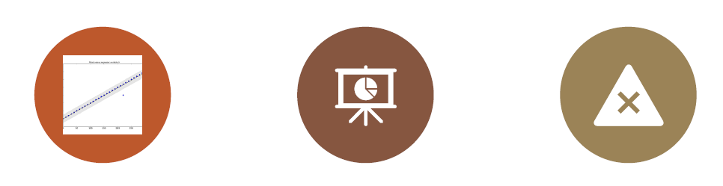

Univariate and Multivariate Outliers
- Univariate outliers
  - Cases that have an unusual value for a single variable
- Multivariate outliers
  - Cases that have an unusual combination of values for several of the variables.
  - The value for any of the individual variables may not be a univariate outlier, but, in combination with other variables, is a case that occurs very rarely.

Reasons for outliers
- Data entry error
- Failure to specify a particular value for missing data
- Outlier not a true member of population of interest
- Outlier is a true member of population of interest with an extreme score

- What to do?
  - Transform to standardized variables
    - Look at histogram
    - Sometimes transforming data can “pull in” the outlier
- Censoring outliers
  - May need to delete case/s and run with and without outlier

Standard Scores Detect Univariate Outliers
- One way to identify univariate outliers is to convert all values for a variable to standard scores.

- If the sample size is small (80 or fewer cases)
  - a case is an outlier if its standard score is ±2.5 or beyond.

- If the sample size is larger than 80 cases
  - a case is an outlier if its standard score is ±3.29 or beyond

- This method applies to interval/ratio level variables, and to ordinal level variables that are treated as metric.

- It does not apply to nominal level variables.

Transformations to Improve Normality

- Many statistical methods require that the numeric variables you are working with have an approximately normal distribution.

- Reality is that this is often not the case.

- One of the most common departures from normality is skewness.

- There are many different types of transformation available.

Tools for Assessing Normality
- According to some researchers, sometimes violations of normality are not problematic for running parametric tests.

- Our Heuristic Approach is based on this premise:
  - Inspect Histogram and Boxplot
  - Inspect Normal Quantile Plot (also called Normal Probability Plot)
  - Generate and Inspect Recognized heuristics
    - Standardized skewness and kurtosis
    - Percentage of standardized scores falling within ranges (see previous slides and previous lectures for bounds)

Tools for Assessing Normality
- Goodness of Fit Tests
  - Shapiro-Wilk Test (small dataset)
  - Kolmogorov-Smirnov Test (larger dataset)
    - These are unreliable if your dataset is large
  - Anderson-Darling Test:extension of the Kolmogorov-Smirnov test and gives more weight to the tails of the distribution
  - D’Agostino-Pearson Test:combines skewness and kurtosis to assess normality. It’s more suitable for larger datasets, typically above 50 observations, and provides a good balance of sensitivity and specificity.

Transforming Data

- When a variable is not normally distributed (a distributional requirement for many different analyses), we can create a transformed variable and test it for normality.

- Transformation:
  - Perform a mathematical operation on each of the scores in a set of data, and thereby converting the data into a new set of scores which are then employed to analyze the results of an experiment.
  - If the transformed variable is normally distributed, we can substitute it in our analysis.

Transforming Data - 2
- Transformations are obtained by computing a new variable.
  - R, either transform and save variable to dataset or apply transformation within whatever statistical formula

- There may be data values which are not mathematically permissible.
  - For example,
    - the log of zero is not defined mathematically,
    - division by zero is not permitted
    - square root of a negative number results in an “imaginary” value.
  - You need to decide what to do about this.

Transformations Types

- Logarithmic transforms
  - “Pull in" distribution toward a more normal curve.
  - Can be used for right (positive) skew, positive kurtosis, unequal variance, lack of linearity (log10).
  - Reduces skewness by compressing high values more than low values.

- Square root transformation
  - Will bring larger scores closer to the centre
  - Can be used for positive skew, positive kurtosis, unequal variance, lack of linearity.
  - Especially for count data or when values are close to zero.
  - Reduces the impact of extreme values while still preserving the data's original scale.
  - Can also use cube root

- Reciprocal transformation (1/x)
  - Reduces impact of large scores
  - Can be used for positive skew, positive kurtosis, unequal variance, lack of linearity
  - Often used when there are large outliers.

- Combination
  - Reverse score transformation and then apply one of the above transformations
  - For negatively skewed/kurtotic data

- Box-cox transformation
  - Flexible family of power transformations that can accommodate various types of skewness by adjusting the power parameter λ lambda.
  - λ =1: No transformation is applied; the data remains unchanged.
  - λ=0: The transformation becomes a natural log, ln(𝑦)ln(y), which is effective for reducing right skewness in positively skewed data.
  - 0<𝜆<1: A power transformation that can moderately reduce right skewness while still compressing larger values
  - 𝜆<0: Negative values of 𝜆𝜆λ apply reciprocal transformations that can be effective for highly skewed data with large outliers
  - 𝜆>1: A stronger power transformation that might be useful for left-skewed data

Transformations -videos
- Two quick videos
  - Short and to the point:
    - https://www.youtube.com/watch?v=5571wc0iWCI&ab_channel=Udacity
  - More involved:
    - https://www.youtube.com/watch?v=kV9_qFR3ORg&ab_channel=PatrickManapat

Transforming Data
- If transformation does not bring data to a normal distribution, the
- investigators might well choose a nonparametric procedure that does not make any assumptions about the shape of the distribution.

Good Information Source
- Andy Field’s The Beast of Bias
  - https://www.discoveringstatistics.com/repository/exploringdata.pdf

week 6 – Worked Example for CA

stepping through CA example

  - Data set / Method
    - If no missing data – say looked at it and couldn’t find any… fine but mention it…
    - Include in appendix the actual branding
      - Litmus … test fi missing data?
      - Missing Data – add to appendix if no missing data aplot of it..?
if less than x

will have to look at outliers anyway…
if don’t meet criteria do transformation -
  - Analysis
    - What test and why

  - Results – explain our exam results…
    - 4.2 Does the type of Support provided Impact examperformance
      - Added a new section above..
      - Data is nominal ? and ?
        - Doing T-test

Week 7 – Review – No Content

Week 8 – Linear Regression

Sources used in creation of this lecture:
Statistics and Data Analysis, Peck, Olsen and Devore; Discovering Statistics Using R, Field, Miles and Field; Understanding Basic Statistics, Brase and Brase;SPSS Survival Manual, Julie Pallant

Predictive Models

Used to explore the relationship between one outcome variable and a set of independent variables (predictors)You should have a sound theoretical or conceptual reason for exploring the relationship and the order of the variables entering the model
For variables that have not been previously shown to contribute to the variation in the outcome variable try to establish evidence (statistical or research) for their inclusion in advance

Predictive Modelling - Linear

Linear models describe relationships between variables that are correlated in a linear way When one variable changes, the other tends to change proportionally (either positively or negatively).

  - (response/dependent) that you want to predict, and one or more independent variables (predictors) that help explain it.

New slide - Predictive Modelling - Linear

- It applies a best-fit line (or plane, if multiple predictors) through the data to minimize the distance between the observed values and the line — this is usually done by ordinary least squares (OLS).
- future values of the dependent variable given new values of the independent variables.

New slide – ctd – Predictive Modelling - Linear
- Equation form:
- 𝑦=𝛽0 + 𝛽1𝑥𝑥1 +𝛽2𝑥𝑥2 +⋯+ 𝛽𝛽𝑛x𝑛 + 𝜀
Where:
- 𝑦 is the output variable
- 𝑥𝑖 are independent variables
- 𝛽𝑖 are coefficients
- and 𝜀 is the error term.

New slide – ctd – Predictive Modelling - Linear

- Linear mdoels don’t just describe relationships — they can also be used to quantify differences between groups or conditions by estimating how much the dependent variable changes when one factor changes.
- investigation of difference by including categorical variables (e.g. gender, region, treatment type) as factors in the model.

New slide – ctd – Predictive Modelling - Linear

Conceptually:
- Prediction focuses on estimating future outcomes.
- Investigation of difference focuses on comparing predictions for groups or conditions
  - e.g. “Is the prediction for Group A significantly different from Group B?”

- Both use the same linear model structure, but the interpretation of coefficients changes:
  - Continuous predictors → rate of change
  - Categorical predictors → group differences

Regression Model

- Explanatory (independent/predictors) variables are used to model the behaviour of a response (outcome/dependent) variable
- Most commonly used class of models in the statistical toolbox
- Different types of regression suit different types of application

Predictive model – what does it allow you do?

- Prediction
  - Really what we are looking at is the variance in the outcome variable and how much of the variance could be considered to be explained by the predictor variables

- Questions it allows you to answer:
  - How well a set of variables can predict an outcome variable
  - Which variable in a set is the best predictor
  - Whether a variable is still able to predict an outcome when controlling for other variables


Predictive model – what does it allow you do? – slide ctd

- The same model structure can be used to explore differences between groups or conditions — this is often called testing for group effects.
- Here, we use categorical predictors (e.g. gender, region, treatment type) to ask whether belonging to one group leads to a statistically significant difference in the outcome variable compared to another group.

- Questions it allows you to answer:
  - Do different groups (e.g. treatment vs. control) show significant differences in the outcome variable?
  - How large is the difference between these groups, after accounting for other predictors?

Before regression

We need to establish evidence to support going ahead with building a predictive model

If we are asserting a relationship
We need to investigate if there is any evidence of a relationship using correlation and make a decision based on the results (strength, direction etc.)
Correlation – Pearson, Spearman, Kendall, Chi, Fisher

If we are asserting a differential effect for different groups
We need to investigate if there is any difference using either the appropriate test and make a decision based on the result
Difference – T-test (independent or paired), Mann-Whitney, Anova (one-way or multiple), Kruskal-Wallis, Friedmann, McNemar, Chi, Fisher

Causal Relationship
- To assert a causal relationship is to claim that changes in the independent variable(s) create changes in the dependent variable

- In practice can only assert that one factor causes change in another when you can satisfy the following criteria:
  - Association
  - Time order
  - Non-spuriousness

Causal Relationship - Association

- Variables correspond to each other in predictable ways
  - ◦Can be either positive (an increase in one causes an increase in the other)
  - Or negative (an increase in one causes a decrease in the other)

- Many associations are not causal
- ◦E.g.
  - ◦Red cars do not cause more accidents
  - ◦Rather aggressive drivers are more likely to buy red cars
  - ◦Aggressive drivers are more likely to be involved in accidents

Causal Relationship – Time Order
- Logically the change in the independent variable precedes the change in the dependent
- Need to be careful
  - ◦Even if time order is satisfied, a causal relationship may not exist

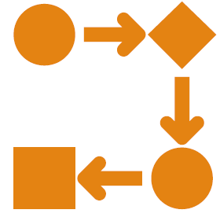

Causal Relationship – Nonspuriousness

- A spurious relationship exists when two variables appear to be causally related but are not
  - ? Any observed dependencies between variables are due to chance or are both related to some unseen confounding factor

- E.g.
  - ? Ice cream consumption causing drowning deaths
  - ? There is an association between ice cream consumption and drowning (more people die during times when a lot of ice cream is being consumed)
  - ? Time order can also be satisfied – increase in ice cream sales precede increase in drowning deaths
  - ? However, the unmeasured factor here is seasonal temperature
    - ? In warm weather more people consume ice cream and swim

Spurious Correlations
https://www.tylervigen.com/spurious-correlations

Relationships and Causality

- Causality
  - ? Determining how particular sets of conditions (represented by variables) lead to outcomes (also represented by variables)
- Seldom are relationships deterministic
  - ? Everyone completing a university degree will have a higher income than those who do not (unlikely to be true)

- Most are probabilistic
  - ? i.e. factors increase or decrease tendency towards particular outcomes
  - ? Those with a university degree tend to earn more than those who do not
  - ? University education is a factor that pushes another factor (income) in a predictable direction

Correlation and Causality

- The third-variable problem:
  - ? Causality between two variables cannot be assumed because there may be other measured or unmeasured variables affecting the results.

- In our example
  - ? Perceived stress does relate significantly to perception of control.
  - ? There may be other factors that are influencing perception of control.
    - ? Some of these variables will have been measured by the researcher.
      - ? Some may not

Correlation and Causality

Direction of causality:
- ? Correlation coefficients say nothing about which variable causes the other to change.
- ? The correlation coefficient doesn’t indicate in which direction causality operates.
- ? So, although it is intuitively appealing to conclude that perceived stress causes perceived control to change, there is no statistical reason why perceived control cannot cause perceived stress.
- ? This is where your knowledge of the constructs and existing theories in your area come in to play
- ? You interpret your statistical findings through the lens of your subject area
- ? Why including relevant background and related research is important in your reporting

Partial Correlations

- Measures the relationship between two variables, controlling for the effect that a third variable
  - ? Usually, a variable you suspect is influencing your two variables of interest
    - ? This can artificially inflate the correlation co-efficient found

Partial Correlation

- Using survey.dat
  - ? Julie Pallant
- Interested in exploring the relationship between scores on the Perceived Control of Internal States Scale (tpcoiss) and scores on the Perceived Stress Scale (tpstress) but controlling for what is known as socially desirable responding bias (tendency to present yourself in a socially desirable way)

  - ? This tendency is measured using Marlowe-Crowne Social Desirability Scale (tmarlow)

Partial Correlation

Zero order correlations

Reporting Results

Partial correlation was used to explore the relationship between perceived control of internal states (as measured by PCOISS) and perceived stress (measured by the Perceived Stress Scale), while controlling for scores on the Marlowe-Crowne Social Desirability Scale. Preliminary analyses were performed to ensure no violation of the assumption of normality, linearity and homoscedasticity. There was a strong, negative partial correlation between perceived control of internal states and perceived stress, controlling for social desirability, (r=-.53, n=422,p<.001). An inspection of the zero-order correlation (r=-.58) suggested that controlling for social desirability had very little effect on the strength of the relationship between these two variables.

Building a Linear Regression Model

MATH9102-W8-REGRESSION.QMD
Sources used in creation of this lecture:
Statistics and Data Analysis, Peck, Olsen and Devore; Discovering Statistics Using R, Field, Miles and Field; Understanding Basic Statistics, Brase and Brase;SPSS Survival Manual, Julie Pallant

Simple Example – Linear Regression

- Suppose we want to look at what variables predict a child’s maths score aged 16 in the UK ( GCSE)
- We have a theory that their achievement on a standard maths test at aged 7 is a good predictor
  - ? (We’ve seen this before in correlation…)

Simple Example - 1
- For a simple one predictor model.
- ‘y’ is the res po nse vari ble to be predic ted (in this case GCSE Score) – the dependent variable
- This is a simple correlation.

Y

X
Relationship between Maths score age 7 with GCSE result at age 16 ( for 25 students)

Simple Example – 2

- ‘x’ is the predictor variable (in this case Maths Score aged 7) – independent variable
X

Relationship between Maths score age 7 with GCSE result at age 16

Simple Example – 2

‘bo’ is the intercept or the point where the line crosses the y-axis – at point a below . it should read ‘bo’ (is changed in graphic in pdf…with red box arund it..

Relationship between Maths score age 7 with GCSE result at age 16

Simple Example
- ‘b’ is the gradient of the line
- Represents the amount that the response variable changes for one unit change in the predictor variable
- (e.g. for every one percentage point increase in a child’s Maths Test score, the line suggests that the child’s predicted GCSE Score will increase by ‘b’ points);

Relationship between Maths score age 7 with GCSE result at age 16

Simple Example
- If the line did completely model the data then all of the points would rest exactly on the line.
- Because there is a difference between what the line predicts (expected values) each student will achieve in their GCSE Score and what they actually achieved (observed values).
- This difference is basically the vertical distance between each point and the line itself and this distance is ‘e’ .
y = b0 + bx + e

Relationship between Maths score age 7 with GCSE result at age 16

Residuals
A scatterplot of some data with a line representing the general trend. The vertical lines(dotted) represent the differences (or residuals) between the line and the actual data.
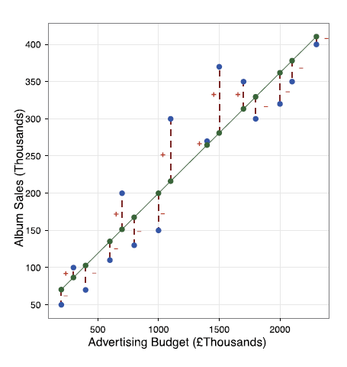

Using our model

- We can re-write the overall model as an equation:

  - GCSE Score = b0 + (b x Maths Score) + error

- To use the model to predict a child’s future GCSE Score we would tend to drop the ‘e’ term and thus use the formula:

  - Predicted GCSE Score = b0 + (b x Maths Score)

- Note: We are now referring to the response variable as the ‘Predicted GCSE Score’ rather than the actual GCSE Score.

Using our model

- Suppose we have plugged our numbers into our statistical tool, and it has given us the following values:
  - b0 = 15 ; b = 0.7

- Our model becomes:
  - Predicted GCSE Score = 15 + 0.7 x Maths Score

- Based on our data this represents our best estimate of what a child’s future GCSE Score is going to be, on average, given their Maths Score at age 7.
  - It is not going to be 100% correct as we know there is an error term.

Using our model

- So suppose a child got just 10% in their maths test aged 7.
  - Predicted GCSE Score = 15 + 0.7 x 10 (maths test aged 7)
  - = 15 + 7 = 22.0

- A child who gets 60% in their maths test aged 7:
  - Predicted GCSE Score = 15 + 0.7 x 60
  - = 15 + 42= 57

- Looking at a student who gets 61% we can see what the gradient b is doing in practice:
  - Predicted GCSE Score = 15 + 0.7 x 61
  - = 15 + 42.7= 57.7
- From our model we can see that on average one unit increase in Maths score aged 7 is predicted to lead to a 0.7 increase in GCSE Maths score aged 16.

Using our model

The gradient therefore represents the average increase in the response variable (GCSE Score) with one unit increase in the predictor variable (Maths Score).

Sample Dataset (Regression.sav)
- The dataset comprises a sample of 4,059 young people (aged 16) selected from 65 difference secondary schools from six inner London Education Authorities.
- This is a sub-sample from a much larger study undertaken by Goldstein, H., Rasbash, J., Yang, M., Woodhouse, G., et al. (1993) A multilevel analysis of school examination results, Oxford Review of Education, 19, pp. 425-433.
- The dataset has been specifically prepared to accompany Rasbash, J. et al. (2005) A User’s Guide to MLwiN 2.0 (Bristol, Centre for Multilevel Modelling).

Simple Linear Regression
- The theory we are exploring is whether the main predictor of ‘normexam’ is a student’s prior performance in a reading test at age 11 (the variable ‘standlrt’)

- The response (outcome or dependent) variable in this case is the student’s exam score at age 16 (‘normexam’) that has been converted into a standardised score (with mean = 0 and standard deviation = 1).
- The predictor (independent) variable in this case is the student's prior performance in a reading test at age 11 (standlrt) which is also a standardised score)

Simple Linear Regression

- It is generally good practice to standardise your response and predictor variables before including them in the model
- It helps in the interpretation of the model.
  - ? For example, if all the predictor variables have been standardised then we know that if they all have the value ‘0’ this would represent the average student.
  - ? As such, the constant in the model comes to represent the mean score on the response variable for the average student in the sample.
  - ? If the response variable has been standardised, we can immediately gain a sense of where the ‘average student’ fits in the distribution of the response variable
    - ? (i.e. if the constant is negative then we know that they have a mean score below the mean for the sample as a whole, and so on).

Simple Linear Regression

- Start by looking at the response variable :
  - ? Create a histogram
  - ? Create a Q-Q Plot
  - ? Examine the skewness and kurtosis and absolute scores
  - ? Create some descriptive statistics

- This example:
  - ? The response variable (normexam) is approximately normally distributed
  - ? And approximately standardised (with mean = -0.0001 and standard deviation = 0.9989).

Normexam

- Mean:0
- SD = 1
- N = 4059

Standlrt

- Mean:0
- SD = 1
- N = 4059

Simple Linear Regression
- Before we create a linear regression model it is worth exploring the nature of the relationship between the response variable and this predictor variable.
- Look at the scatterplot

Simple Linear Regression
- Calculate the correlation for these two variables
- There appears to be a strong statistically significant positive linear relationship. – R2 = 0.35, r=0.592, p<0.01

Simple Linear Regression
- Suppose we have read our data into a dataframe called regression
- To formally model this relationship now we can create a simple linear regression model:

‘’’{r}
#Create the model
model1<-lm(regression$normexam~regression$standlrt)
anova(model1) # Display the output
‘’’

- We now have access to all the elements of the regression output in the variable model which we can unpack and examine.

Simple Linear Regression
- Increases in scores in standlrt appear to associated with increases in scores in normexam.
- There appears to be a moderately strong correlation between the two (r = 0.592, p<0.001).
- Therefore, there is good justification for using regression to look at prediction.
- The constant represents the value at which the regression line crosses the y-axis.

‘’’{r}
stargazer(model1, type="text") #Tidy output of all the required stats
‘’’

Top value= co-efficient
Lower value = p value

How Good is the Model?

- The regression line is only a model based on the data.
- This model might not reflect reality.
  - ? We need some way of testing how well the model fits the observed data.
- How has the model helped improve our understanding in the absence of any model?

How Good is the Model?

- What would we use in the absence of the model?
  - ? The common approach would be to use the mean of the sample
    - ? This would be wrong in the vast majority of the cases
      - ? depending on the variation in the sample i.e. how much each case varies from the mean
    - ? But we can use it as a baseline to see if our model has improved our understanding

How good is the model?

- So how do we go about it?

- Total sum of squares
  - ? Square the differences from each data point to our mean for our outcome variable
  - ? total sum of squares = all variation that exists

- Residual sum of squares
  - ? But we will still experience some error
  - ? This is the variation between our observed data and our regression line
  - ? Squaring these errors gives use the residual sum of squares (unexplained sum of squares) = variation which is left over after the model is fitted to the data
- Difference between the two is the amount of variation accounted for by the model

Sums of Squares

- SSR - Residual/Error variability (variability between the regression model and the actual data).
- SSM - Model variability (difference in variability between the model and the mean).
- SST - Total variability (variability between scores and the mean).

Simple Linear Regression
To get this information in R:
‘’’{r}
anova(model1)
summary(model1)
‘’’

- The F statistic looks at whether the model as whole is statistically significant
- This allows us to answer the question:
- Do the independent variables, taken together, predict the dependent variable better than just predicting the mean for everything?

Simple Linear regression
SSM SSR

- SSR - Residual/Error variability (variability between the regression model and the actual data).
- SSM - Model variability (difference in variability between the model and the mean).
- SST - Total variability (variability between scores and the mean).

Sums of Squares

- SSR - Residual/Error variability (variability between the regression model and the actual data).
- SSM - Model variability (difference in variability between the model and the mean).
- SST - Total variability (variability between scores and the mean).

Testing the Model: ANOVA

- Mean Squared Error
  - ? Sums of Squares are total values.
  - ? They can be expressed as averages.
  - ? These are called Mean Squares, MS

F = MSM / MSR

Simple Linear regression
MSM MSR

- MSM - Mean Square Error of the Model
- MSR - Mean Square Error of the Residuals

Testing the Model: R2
- R2
  - ? The proportion of variance accounted for by the regression model.
  - ? The Pearson Correlation Coefficient Squared

R2 = SSM / SST

Simple Linear Regression

Anova(model)

Simple Linear Regression

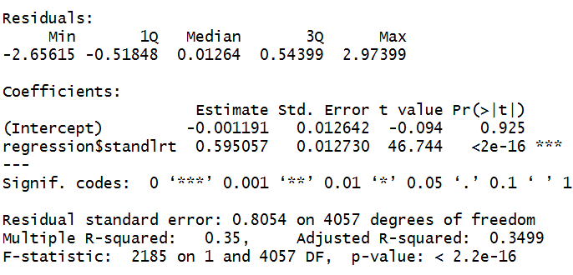
- The R2 is the proportion of variance in the outcome (dependent) variable normexam which can be explained by the predictor (independent) variables. This is the usefulness of the model.
- An R2 of 1 means the independent variable explains 100% of the variance in the dependent variable. Conversely 0 means it explains none.

Multiple R=squared?
- In this case we have a value of 0.350 which means that standlrt explains 35% of the variance in normexam.
- The remaining variance can be explained by variables not currently included in the model.

Adjusted R-squared
- We have only one predictor at the moment so R2 and adjusted R2 are the same.
- ***When we include more predictors, it is the adjusted R2 we need to report..

Note: The intercept is the constant
- The final thing to look at is ‘Coefficients’ gives us all the information we need to construct the actual model using unstandardized co-efficients.

- The significance levels for each of the main terms (in this case the coefficients associated with the constant and ‘standlrt’) also tell us if there is evidence that each of these terms are adding something to the model (they are statistically significant).

- Using the Coefficients from this table we get the following model:
- Predicted ‘normexam’ = -0.001 + 0.595 x ‘standlrt’

What does it mean if the constant (intercept) is negative?
- If constant is negative then when all explanatory variables equal zero, the predicted outcome is below zero. This interpretation is purely mathematical and depends on whether 𝑥𝑥𝑖𝑖=0 is meaningful in the context.
- •If zero is outside the realistic range of the predictors, the intercept itself may not carry practical meaning.
- •The negativity simply ensures that the fitted line or plane best aligns with observed data across the range where predictors are valid.
- •It does not indicate a problem with the model unless it makes the predicted values nonsensical.

Simple Linear regression

‘’’{r}
Call: lm(formula = regression$normexam ~ regression$standlrt) Standardized
Coefficients::
(Intercept) regression$standlrt
- 0.5916496

Function: lm.beta(model1)
‘’’

- Standardised Coefficients
- Not hugely useful for our model since the variables are all standardized but will be useful for models you create.

Reporting

- A simple linear regression model was created to investigate whether a student’s standardized score on the Standard London Reading Test (LRT) at age 11 could be considered to predict a student’s standardized exam result at age 16. A statistically significant regression equation was found (F(1,4057)=2,185.01, p < 0.01) with an adjusted R2of 0.35. The regression equation is therefore:

- Standardized Exam Score at Age16 = -0.001 + 0.595 * Standardized score on Standard LRT at age 11

- This indicates that for each one -unit increase in standardized LRT score at age 11, the standardized exam score at age 16 is expected to increase by approximately 0.595 units, holding other factors constant. This relationship is statistically significant and suggests a meaningful positive association between early reading performance and later academic achievement.

Time for You to Try

- Review the section Regression Model 1 in MATH9102-W8-Linear Regression.qmd and the associated html output
- Your exercise:
  - •Use the template MATH9102-W8-RegressionExercise.qmd
  - •Complete Exercise 1:
    - •Using the Sleep dataset from Pallant (sleep.rdata) build a linear regression model to investigate whether:
    - •Total Sleep and Associated Sensation score (totsas) can be considered to be predicted by a respondent’s level of anxiety (anxiety) (simple linear regression)
  - •You do not need to do the graphs and descriptive statistics –you can assume both can be treated as normal

Multiple Linear regression

Sources used in creation of this lecture:
Statistics and Data Analysis, Peck, Olsen and Devore; Discovering Statistics Using R, Field, Miles and Field; Understanding Basic Statistics, Brase and Brase;SPSS Survival Manual, Julie Pallant

What is Multiple Regression?

- Simple linear Regression is a model to predict the value of one variable from another.
  - ? It is rarely if ever used.
- Multiple Regression is a natural extension of this model:
  - ? This is the most common form of regression model used.
  - ? We use it to predict values of an outcome from several predictors.
  - ? It is a hypothetical model of the relationship between several variables.

Multiple Regression as an Equation

- With multiple regression the relationship is described using a variation of the equation of a straight line.

- y=b0 +b1X1 +b2X2 +….+bnXn +Ɛi

- b0 is the intercept.
  - ? The intercept is the value of the Y variable when all Xs = 0.
  - ? This is the point at which the regression plane crosses the Y-axis (vertical).
- b1 to bn are the regression coefficient for variable 1 to n

Dummy (indicator) variables

- Many variables we are interested in prediction are categorical
  - ? E.g. we are interested in the effect gender or religion, or income category has
- Because they have no scale it makes no sense to think of the effect of a unit of increase in these as it would for a continuous variable
- But we can think in terms of the differential effect for groupings within the category
- We can transform the categorical variable into a series of dummy variables which indicate whether a particular case has that particular characteristic
  - ? Dummy variables may also be referred to as indicator variables

Our regression dataset (Regression.sav)

- Question at end fo the class – about exercises we went thru during the class
- Where are the variables coming from? In the examples? Were they created before hand?
- Generally don’t let model do anythgi you didn’t wantgt do
- Assumgi when r knows its guess shodul eb 1 or zero
- Code I myself

- Says in code book that 1st cat is primary but tis nto its primary
- Its worth having a lok at that
- Doing it in python – 3 category variable as needed to separate them out
- Turngin everythgin into binary codes
- I prefer to do ti by hand
- But someone tells you lm will do ti for you
- But you need to know what its doing

Labs and Exercises
- Week 1
  - Have all files – no soln
- Week 2
  - Have all files + soln
- Week 3
  - Have all files + soln
- Week 4
  - Have all and soln I think
- Week 5
  - Have all files
- Week 6
  - Have all files

Links and References

General course content links
- xls with links to all content – week 1 to week 3 and assessment
  - https://tinyurl.com/FundDA-2025
- XLS - Link to the lecture recordings:
  - https://docs.google.com/spreadsheets/d/1-gUXfyxM-2tX6EIGhE7CoMUMxl7Vf6Pv-b9tbSIaa7Q/edit?usp=drive_link
- Content + links to classrom recordsings >>>
  - https://tinyurl.com/FundDA-2025

week 1 –
- While waiting for Brightspace to be setup, material can be located at this link:
  - https://tinyurl.com/FundDA-2025
- While waiting for Brightspace to be setup, material can be located at this link:
  - https://tinyurl.com/FundDA-2025
- Getting started with R and RStudio >
  - https://education.rstudio.com/learn/beginner
  - Book - R for Data Science – Hadley Wickham and Garret Grolemund
    - https://r4ds.had.co.nz/
  - Book – hands on programming with R - Garrett Grolemund
    - https://rstudio-education.github.io/hopr/
  - Book – Wickham, Hadley. 2019. Tidyverse: Easily Install and Load the ’Tidyverse’
    - https://CRAN.R-project.org/package=tidyverse.
  - Tutorials - Recipes – snippets of topics tp learn from , factors, variables dates * times etc
    - https://posit.cloud/learn/recipes
    - Posit sign up for access to resources

- Book - Peter Bruce,Peter C. Bruce,Andrew Bruce,Peter Gedeck. (2020), Practical Statistics for Data Scientists, 2nd. O'Reilly Media, p.0, [ISBN: 978-1492072942].
  - https://datapot.vn/wp-content/uploads/2023/12/datapot.vn-Practical-Statistics-forData-Scientists.pdf?srsltid=AfmBOopXEOEs6uamO_ogfXsNiiAurw8LY3A_uVTQHVRL4hORSwvVTiC
- Book - Hadley Wickham,Mine Çetinkaya-Rundel,Garrett Grolemund. (2023), R for Data Science, 2nd. O'Reilly Media, p.0, [ISBN: 978-1492097402].
  - https://digitallibrary.tsu.ge/book/2019/september/books/R-for-DataScience.pdf
- Quiz - Types of Data – Quantitive/Qualitiive/Niminal/orinal/Interval/Ratio
  - https://www.med.soton.ac.uk/stats_eLearning/typesofdataquiz/index.html
  - Posit Cloud – online studio and learning resources…. Can tie in github repo
    - Location = https://login.posit.cloud/r
    - Username = D24127620@myTUDublin.ie
    - Pwd = *gE5Z+.H~hHa8Tg
- Let's look at some spurious correlations
  - Article Spurious correlations
    - https://www.tylervigen.com/spurious-correlations
  - Statistical Inference Enables Bad Science; Statistical Thinking Enables Good Science, The AmericanStatistician,73:sup1,246, 261,DOI:10.1080/00031305.2018.1518264 >>
  - Christopher Tong (2019)
    - https://www.tandfonline.com/doi/full/10.1080/00031305.2018.1518264
- Fabricating and falsifying research?
  - A systematic review and meta-analysis of survey data. PLo S One. 2009;4(5):e5738.Published2009May29. doi:10.1371/journal.pone.0005738
    - https://www.ncbi.nlm.nih.gov/pmc/articles/PMC2685008 /
- R
  - I will be using R and R Studio during classes.
  - Getting started with R and RStudio:
    - https://education.rstudio.com/learn/beginner/

week 2 -

- Markdown guide
  - https://www.markdownguide.org/basic-syntax/
- Histogram density plots
  - >> https://clauswilke.com/dataviz/histograms-density-plots.html
  - NOTE from Link >> Always verify that your density estimate does not predict the existence of nonsensical data values.
- From Lab doc
  - Tidyverse cheatsheat - https://www.datacamp.com/cheat-sheet/tidyverse-cheat-sheet-for-beginners
  - R Studio ggplot2 Cheatsheet -https://rstudio.github.io/cheatsheets/html/data-visualization.html
  - The complete ggplot2 Tutorial - http://r-statistics.co/Complete-Ggplot2-Tutorial-Part1-With-R-Code.html

- Lab - You can find more about aes at
  - https://ggplot2.tidyverse.org/articles/ggplot2-specs.html
- Lab plots – aes - You can find the numbers to use for different shapes at this link
  - http://www.sthda.com/english/wiki/ggplot2-point-shapes#point-shapes-in-r

- Article > Disappointed Dad finds single Wotsit in his packet of crisps
  - Source:https://metro.co.uk/2019/09/10/disappointed-dad-finds-single-wotsit-packet-crisps-10715789/

- Missing data – written for non-statisticians
- Anesthesiol. 2013 May;64(5):402-6. doi: 10.4097/kjae.2013.64.5.402. Epub 2013 May 24. PMID: 23741561; PMCID: PMC3668100.
- https://www.ncbi.nlm.nih.gov/pmc/articles/PMC3668100/#:~:text=Missing%20data%20can%20reduce%20the,estimates%2C%20leading%20to%20invalid%20conclusions.&text=Missing%20data%20(or%20missing%20values,in%20the%20observation%20of%20interest

week 3 –
- Midding Data - ref paper
  - Anesthesiol. 2013 May;64(5):402-6. doi: 10.4097/kjae.2013.64.5.402. Epub 2013 May 24. PMID: 23741561; PMCID: PMC3668100.
  - https://www.ncbi.nlm.nih.gov/pmc/articles/PMC3668100/#:~:text=Missing%20data%20can%20reduce%20the,estimates%2C%20leading%20to%20invalid%20conclusions.&text=Missing%20data%20(or%20missing%20values,in%20the%20observation%20of%20interest

- Hmisc package contains several functions that are helpful for missing value imputation (agreImpute(),impute()andtranscan())
- https://cran.r-roject.org/web/packages/Hmisc/index.html#:~:text=Contains%20many%20functions%20useful%20for,of%20R%20objects%20to%20LaTeX
- mitools package
  - https://cran.r-project.org/web/packages/mitools/index.html

- Data Sources
  - For the dataset survey.dat
  - SPSS Survival Manual 6th Edition Julie Pallant
  - http://spss.allenandunwin.com.s3-website-ap-southeast-2.amazonaws.com/data-files.html#.Wb0vvnWP-po

- Transformatinos
  - Two quick videos
  - Short and to the point:
  - https://www.youtube.com/watch?v=5571wc0iWCI&ab_channel=Udacity
  - More involved:
  - https://www.youtube.com/watch?v=kV9_qFR3ORg&ab_channel=PatrickManapat
- Good Information Source - Andy Field’s The Beast of Bias
  - https://www.discoveringstatistics.com/repository/exploringdata.pdf
- Tabachnik and Fidell – Using Multivariate Statistics, 6th Ed
  - Justification about whether to delete/impute missing data or not…
  - Don’t have a link… referenced in slide and comment…
- Deal with Missig Data
  - Imputing missing data
    - Simputation package
  - Hmisc package contains several functions that are helpful for missing value imputation (agreImpute(),impute()andtranscan())
    - https://cran.r-roject.org/web/packages/Hmisc/index.html#:~:text=Contains%20many%20functions%20useful%20for,of%20R%20objects%20to%20LaTeX
  - mitools package
    - https://cran.r-project.org/web/packages/mitools/index.html
- Good Information Source - Andy Field’s The Beast of Bias https://www.discoveringstatistics.com/repository/exploringdata.pdf

week 4 –
- Statistics - T-distribution table
  - https://www.tutorialspoint.com/statistics/t_distribution_table.htm
- T tests explanations - all the formulas for different types of t-test with explanation
  - https://www.peggykern.org/uploads/5/6/6/7/56678211/ttestformulas.pdf
  - Dr. Peggy (Margaret) L. Kern, University of Melbourne
- Using the bullying.dat dataset (Paul Connolly)
  - Dataset Descriptor:
  - https://www.routledge.com/Quantitative-Data-Analysis-in-Education-A-Critical-Introduction-Using-SPSS/Connolly/p/book/9780415372985

week 5 –
- Sleep.rdata
  - http://spss.allenandunwin.com.s3-website-ap-southeast-2.amazonaws.com/data-files.html#.Wb0vvnWP-po
  - Created from the SPSS file sleep.sav taken from SPSS Survival Manual 6th Edition Julie Pallant
- ANOVA - Example 2 > survey.dat (Julie Pallant)

- Transformations - Two quick videos (repeat of earlier)
  - Short and to the point:
    - https://www.youtube.com/watch?v=5571wc0iWCI&ab_channel=Udacity
  - More involved:
    - https://www.youtube.com/watch?v=kV9_qFR3ORg&ab_channel=PatrickManapat
- Andy Field’s The Beast of Bias
  - https://www.discoveringstatistics.com/repository/exploringdata.pdf

Books

Completed –
- Week 1 -
  - Classroom recording
  - Notes - updated
  - Labs and exercises
- Week 2
  - Classroom recording –
    - Video missing middle section – Measures of Dispersion / Variability
  - Notes - updated
  - Labs and exercises
- Week 3
  - Classroom recording
  - Notes updated
  - Labs and exercises
- Week 4
  - Classroom recording
  - Labs and exercises

Symbols
μ = Mew (the mean – average value)
σ = sigma (standard deviation - how spread data is around the mean)
X̄ = (x bar= mean of X )

R – Commands and details

Quarto
- Similar to Latex and Oveleaf
- .qmd file
- Important
  - Use quiet Library
  - Use ===‘’’{r} {loaddata}==== file paths to where data set is located…

Week 1
insatll R – CRAN timing out
🧭 Option 1: Use an alternative CRAN mirror
Try one of these direct links to download Rtools45 (same file, different mirror servers):
- 0-Cloud mirror (fastest and official)
👉 https://cloud.r-project.org
- RStudio CRAN mirror
👉 https://cran.rstudio.com
- R tools >>

    - #####USE this to load packages in assignment files #####
#SECTION ONE: INSTALL AND LOAD packages

# Define a helper function `quiet_library`:
# - Takes a package name as input
# - Installs the package if it is not already installed
# - Loads the package while suppressing warnings and messages
quiet_library <- function(pkg) {
suppressMessages(suppressWarnings({
if (!requireNamespace(pkg, quietly = TRUE)) {
install.packages(pkg, quiet = TRUE) # Install without messages
}
library(pkg, character.only = TRUE) # Load silently
}))
}

# Load required packages (install if missing)
quiet_library("tidyverse") # for data wrangling and visualization
quiet_library("carData") # companion datasets for the 'car' package
quiet_library("gtsummary") # for creating publication-ready summary tables
quiet_library("flextable") # for customizable tables in reports
quiet_library("officer") # needed for flextable advanced customization

  - Packages
    - Week 1 -
    - quiet_library("tidyverse") # for data wrangling and visualization
    - quiet_library("carData") # companion datasets for the 'car' package
    - quiet_library("gtsummary") # for creating publication-ready summary tables
    - quiet_library("flextable") # for customizable tables in reports
    - quiet_library("officer") # needed for flextable advanced customization
    - tidyverse (all below are part of tidyverse?
      - ggplot2
      - dplyr
      - readr
      - tibble
      - tidyr

Week 2
- hello.qmd (quarto file)
  - library(palmerpenguins)

week 3 –
      - FSA::perc(as.numeric(ztpcoiss), 1.96, "gt")
    - quiet_library("tidyverse") # Collection of R packages (dplyr, ggplot2, tidyr, etc.) for data wrangling, visualization, and analysis
    - quiet_library("pastecs") # Tools for descriptive statistics, time series analysis, and data exploration (e.g., stat.desc)
    - quiet_library("FSA") # Includes general tools for data analysis (e.g., nonparametric tests, bootstrapping)
    - quiet_library("semTools") # Supplementary functions for Structural Equation Modeling (SEM), including model fit, reliability, and measurement invariance tests
    - pastecs
      - # Install and load pastecs
      - install.packages("pastecs")
      - library(pastecs)
      - stands for Package for Analysis of Space-Time Ecological Series,
      - ‘’’{r}
      - stat.desc(x)
      - ‘’’
        - where x is a numeric vector, data frame, or matrix.
        - It produces a comprehensive summary that includes:

 | Statistic | Meaning
1 | nbr.val | Number of non-missing (valid) values
2 | nbr.null | Number of zero values
3 | nbr.na | Number of missing (NA) values
4 | min | Minimum value
5 | max | Maximum value
6 | range | Range (max – min)
7 | sum | Sum of all values
8 | median | Median
9 | mean | Arithmetic mean
10 | SE.mean | Standard error of the mean
11 | CI.mean.0.95 | 95% confidence interval for the mean
12 | var | Variance
13 | std.dev | Standard deviation
14 | coef.var | Coefficient of variation (SD / mean)

- quiet_library("VIM") # Visualization and Imputation of Missing Values
- quiet_library("naniar") #(naniar short for NA + naniar) - Missing data wrangling plus Little's test
- quiet_library("simputation") # For imputing variables
- Imputing missing data
  - Simputation package
- Hmisc package contains several functions that are helpful for missing value imputation (agreImpute(),impute()andtranscan())
  - https://cran.r-roject.org/web/packages/Hmisc/index.html#:~:text=Contains%20many%20functions%20useful%20for,of%20R%20objects%20to%20LaTeX
- mitools package
  - https://cran.r-project.org/web/packages/mitools/index.html

- Get list of packages installed
  - installed.packages()[,"Package"]
- package lattice installed
  - "lattice" %in% rownames(installed.packages())
- Clear the console
  - cat("\014")
- Activate an already installed package for the current session
  - library(languageserver)
  - That’s because loading (library()) just activates an installed package for the current session.
- Get a versin of installed package
  - packageVersion("languageserver")
- Databases in R
  - the DBI package provides a consistent interface for connecting to and interacting with databases.

week 4

- “’car” package
🚗 1. The car Package
car stands for Companion to Applied Regression — it’s an R package that provides tools for regression diagnostics, ANOVA, Levene’s test, VIF, etc.
✅ You install it like this:
💡 What You Can Do with car
After loading it, you get access to:
- leveneTest() — for testing equal variances (homogeneity)
- vif() — variance inflation factor (checks multicollinearity)
- Anova() — for Type II or III ANOVA
- scatterplotMatrix() — visual relationships between variables
- recode() — easy variable recoding
  - install.package(‘car’)
  - library(car)

- from week 4 file - MATH9102-W4-ttest.qmd
  - quiet_library("tidyverse") # Collection of R packages (dplyr, ggplot2, tidyr, etc.) for data wrangling, visualization, and analysis
  - quiet_library("psych") # Descriptive statistics by group
  - quiet_library("car") # Includes Levene's test for homogeneity
  - quiet_library("effectsize") # Includes calculations for effect size quiet_library("pastecs") # Tools for descriptive statistics, time series analysis, and data exploration (e.g., stat.desc)
  - quiet_library("FSA") # Includes general tools for data analysis (e.g., nonparametric tests, bootstrapping)
  - quiet_library("semTools") # Supplementary functions for Structural Equation Modeling (SEM), including model fit, reliability, and measurement invariance test
  - quiet_library("coin")
    - was missing in non-param file
    - added it and statement below from text
    - To calculate Z we can use the Wilcox test from the ‘coin ‘package

Datasets used

Week 1
- carData – native in R studio
  - ‘’’{r}
  - acad_salary<-carData::Salaries
  - ‘’’
- ggplot2::msleep
  - accesses the built-in dataset msleep that comes with the ggplot2 package.
  - It contains data on the sleep patterns and traits of different mammals.

Week 2
- From lab doc
  - FacebookNarcissim.dat
  - RomCom-UrbanRural.dat
  - Festival-UrbanRural.dat
  - survey.dat
  - experim.dat
  - SPSS Survival Guide by Julie Pallant
  - http://spss.allenandunwin.com.s3-website-ap-southeast-2.amazonaws.com/data-files.html ) – a manufactured data set

week 3
- In the youthcohort.sav
  - See reference but don’t see file anywhere
  - May jus be an example in the content
- earlychildhood.sav and afterschools.sav WTCORRCT
  - same as youthchort eg
- Lab
  - syrvey.dat
  - experim.dat

week 4 –
- survey.dat
- >> Field-BDI-NonParametric.csv
- Using the bullying.dat dataset (Paul Connolly)
  - Dataset Descriptor:
  - https://www.routledge.com/Quantitative-Data-Analysis-in-Education-A-Critical-Introduction-Using-SPSS/Connolly/p/book/9780415372985

Data Analysis Process – High Level Steps

What we did
Statement of result
Populated with bits of infor to help us understand
Result
What does the mean in real world

Break –
Chats with class
Justify decisions
Comment on decisions
Scatterplots there are some of concern…
Make a decision and justify that decision

Delete the outliers / if keep it in it won’t matter
There may be some areas of concern and it will be part of our investigation

Chat – Q and A
just cofirming we don't need to run the dataset passed you first for approval or anything like that, once we determine it meets the criteria around interval a mix of interval/ratio and categorical variables?
se
Seda Grigoryan
7:19 PM

Should we delete the outliers from the dataset?
de
Deirdre Lawless
7:20 PM

Hi Eamonn - no you don't. As long as it meets the criteria.
ea
Eamonn Kelly
7:21 PM

grand, thanks
de
Deirdre Lawless
7:21 PM

Hi Seda - no you don't need to delete the outliers. You can keep them in as long as they fall within the acceptable limits (95% within +/- 1.96, 99.7% within +/- 3.29)

Seda Grigoryan
7:22 PM
what If they don't fall?
se
Seda Grigoryan
7:23 PM
within the limits
de
Deirdre Lawless(Offline)
7:30 PM
I they don't fall within the limits then you can do non-parametric tests
de
Deirdre Lawless(Offline)
7:30 PM
You could also choose to try a transformation but then you would need to redo the normality assessment and if normal you would use the transformed data
se
Seda Grigoryan
7:31 PM
Thank you!
vi
Victor Hugo Cavichiolli Prado
7:33 PM
Deirdre, my variable avg systolic blood pressure, is calculate using 3 measurements, is that ok?
de
Deirdre Lawless
7:33 PM
not sure I quite understand that

- Check if weighting variable included in your dataset
- Calculate the correlation (relationship between 2 variables)
  - Parametric Test (normal distribution): Pearson Correlation (statistic is r)
    - Check pearson correlation assumptions if they are true?
    - Pearson’s correlation coefficient, often denoted as r, which is the most common measure of linear correlation between two continuous variables.
  - Non-parametric Test (non-normal distribution): Spearman Rank Order Correlation (statistic is rho) or Kendall’s Tau (statistic is tau)
  - Usually done by Test the null hypothesis i.e. population co-eff -=0
  - Compute a p-value
    - Decide in advance your p-value cut off
    - P-value – indicates whether you have a statistically significant result or not
  - To decide if the correlation is statistically significantly different from zero a t-test is conducted to compare with a group with a zero correlation
    - See this in pearson calculation code example
- Calculate covariance
  - deviate from the mean by the same amount, they are likely to be related.

From chatgpt – when t run r, p-value and t test

🧾 4️⃣ When in the Analysis Process?
Stage | Action
After cleaning and preparing data | Check assumptions (normality, linearity, outliers)
During analysis | Run Pearson’s correlation → get r, t, p
In reporting | Report r, p, and sometimes t (if relevant for statistical detail)

🗒️ APA-style Reporting Example
A Pearson correlation revealed a significant negative relationship between perceived stress and job satisfaction, r(98) = –.58, p < .001.
(The t-value is usually not reported unless you need it for a specific statistical comparison.)

✅ In Summary
Statistic | When Calculated | Purpose
r | Always computed first | Measures strength/direction
t | Derived from r | Tests if correlation ≠ 0
p | From t | Tests significance

High Level process
- You start with the assumption (the 'null hypothesis' H0 that there are no differences or relationships in the population as a whole.

- You then state an alternative hypothesis (Ha that there is a difference or a relationship.

- You select a sample and find a difference/relationship in it.

- You can then use a variety of tests for statistical significance to work out the probability of the difference/relationship you have found in your sample simply occurring by chance.

Approach>>>> from week 5 …
- Our Heuristic Approach is based on this premise:
  - Inspect Histogram and Boxplot
  - Inspect Normal Quantile Plot (also called Normal Probability Plot)
  - Generate and Inspect Recognized heuristics
    - Standardized skewness and kurtosis
    - Percentage of standardized scores falling within ranges (see previous slides and previous lectures for bounds)

STEPS – Parametric - MATH9102-W4-ttest.qmd
- Include yaml style guide and tags – code / hyml /visual etc
- Install packages quiet library functions
- Install packages
- Set paths as pe examples
- Import data and put data set into dataframe….
- Introduce what analysis is about
- Create table to show any stats required in intro…. i.e. w4-ttest.qmd >>> frequency + %s(proportions
- Missing Data Analysis –
  - Analyse - see whats missing
  - Create a bar chart to show that – comment in week for test.qmd file..
  - Remove Nas or deal with them as you decide
- Create Histogram – taggig at start a caption - modify as needed / styles com
- Cerate Q-Q plot
- Do normality assessment
  - Create basic descriptive statistics – mean / SD/ median/ IQR > filter out ones I want
- Calculate standardised scores for skewness
- Calculate standardised scores for kurtosis
- Get absolute scores – save to dataset if you want to look at individual rows
- calculate percentages
- Report normality assessment
- Now have normality == >> can do a t-test
- Do a Levene’s test – see if need to turn on welchs correction
  - Looking at homogeneity of variance fom putput so tyrn Var. = REU
- Run t-test
  - Store result in a vairable called ‘res’ as will sue it later to calc eta squared
- Calc effect size
  - Eta squared
    - Can calc eta squared by hand write out formula
  - Cohen’s d
    - Can calc using effectsize::t_to_d equation
- Report findings…. Use either cohens d or eta squared one or other
- Render the file into single html

STEPS – Non-Parametric - MATH9102-W4-nonParam.qmd
- Include yaml style guide and tags – code / hyml /visual etc same as parametric example
- Install and load packages quiet library functions
- Set paths and data set
- We divide it into 2 subsets
  - Drink X
  - Drink Y
  - Juist to make it easy for us when doing histograms
  - Histograms not very clear i9s a problem with bin width, set at 2, try smaller, closer together, as long a portrays right information she doesn’t care, presentational issue…
- Look at our descriptive statistics
  - Create a ggplto using drink X data
  - Putting in density function in ‘red’
  - Removing missing data
  - Wrapping in figure caption and showing it on screen
  - Don’t store it as a gs variable but just easier this way to show how build in layers
- Repeat for dink Y
- Execute actual test for Sun
  - Calculate effect sizes
  - Report our findings
- Report on comparison
- Our W statistic is what we sue for U (Mann Whitney)
- Render the file

List of Tests

Name of test
- Get - mean/median/sd/n (number of cases)
- P-Value = actual probability (calculated from your data) of getting a reslt as extreme or mor extreme that what you observed, assuming Ho is true.
- Alpha = Level of probability / level of significance = alpha >> this is a threshold you set before testing – how much risk are you willing to take of making a Type 1 error
  - 5% (0.05) = 5% chance reject Ho incorrectly
  - 1% (0.01) = 1% chance reject Ho incorrectly
  - 0.1% (0.0010 = 1% chance reject H incorrectly
- Level of Confidence
  - 1 – alpha
  - If alpha = 0.05 (5% => CI – n95%
  - If alpha = 0.01 (1% => CI – 99%
- Beta = Power of a Statistical Test = probability that the test correctly rejects the null hypothesis (H₀) when the alternative hypothesis (H₁) is actually true
  - Power of a Test = 1 – Beta
  - Beta = probability of Type 2 error
  - Helsp you decide sample size before collecting data
  - Usually aim for 80% chance of detecting an effect
    - => 20% chance of missing an effect
- Z-score?
  - Z-score = x – mew / std dev
- Powe of Statistical test
- T-Test
  - Inferential test
  - Tells you if the means differ significantly
    - Output = t-statistic and a p-value
    - A yes no answer – SS or not SS
  - Assessing for normality?
  - Answers the question – is it significant? i.e. a SS result
  - Et squared effect? – done in assignment?
  - Independent samples
  - 3 types
    - One-sample t-test – use when want to compare 1 sample mean to a known or hypothesized pop mean
      - i.e. test if avg IQ in your sample differs from 100
    - Independent samples t-test – compare 2 separate groups
      - Exam score between males and females
    - Dependent samples t-test – paired samples or repeated measures t-test.. i.e. ue when comparing 2 related measurements on the same participants (or matched pairs)
      - i.e. pre-test score vs post test scores for same students..
  - Groups --- parametric
    - When to use
      - Continuous data at Interval (or ratio) measures + parametric
        - Independent Samples (sometimes 2 entirely different groups)
          - Independent samples t-test*
        - Related Samples > Related Samples (also called dependent means test) (same group tested at different times)
          - Paired samples t-test**

- Eta squared (n2)
  - Is an effect size measure – not a hypothesis test
    - Answers = How much? i.e. how string the relationship or group difference is
    - What proportion of the total variance in the dependent variable is explained by the independent variable.
    - Can calculate eta squared from t-test
      - Rules of thumb
        - 0.01 = small effect
        - 0.06 = dmedeffect
        - 0.14 = large effect
- Pearson Correlation
  - Do scatterplot?
  - Run cor.test
    - Get a value for correlation > example.00922138
      - => no correlation
      - If scatterplot all over the place >> no correlation
- Spearman/Kendall correlation
- Mann-Whitney U test
  - Works on ranking data
  - Non-parametric
- Wilcoxon signed rank test
  - When to use
    - Ordinal/ or Interval or Ratio and doesn’t approximate to ND) non-parametric
      - Group Data >>> Related Samples > Related Samples (also called dependent means test) (same group tested at different times)
        - Wilcoxon test **

- Chi-squared test (x2)
  - Good for categorical data
  - Check if theres a SS relationship between Categorical variables
  - Or
  - Whether the observed frequencies differ from what you’d expect by chance.
  - Non-parametric test >> does not require ND
  - 2 main types
    - Goodness of fit
      - Tests whether the distribution of one categorical variable matches an expected pattern
      - i.e. Do people choose the four ice-cream flavors in equal proportions?
    - A test of independence
      - Tests whether two categorical variables are related (associated)
      - Is gender associated with voting preference?
- Fishers exact Test
  - Fisher’s Exact Probability Test
    - Use this test if chi squared minimum frequency value is < 5
- Yates continuity correction
  - Helps us avoid a Type 1 Error
  - Run in chi squared test if have a 2 x 2
- Rho
  - Calculates an Effect size
  - After chi -squared test run
  - Use rho value if 2 x 2 categories i.e. 2 values per category
- Cramers V
  - Effect size from chi-xquared test
  - If more then 2 values in each category use this to calc effect size
- McNemar’s test
  - In week 4 – 2 groups tests –
  - In says > For repeated measures for categorical variables use McNemars test mcnemars.test

  - McNemar’s test is a non-parametric test used to analyze paired nominal (categorical) data — typically from before-and-after or matched pairs designs.
  - It tests whether the proportion of “successes” (or responses in a category) has changed significantly between two related conditions.

- Littles MCAR Test
  - Missing Completely at random
  - P > 0.05 = MCAR
  - P < 0.05 = NOT MCAR >>> must be MAR or MNAR
- Levene’ Test
  - Is T-test?
  - It’s a test for homogeneity of variance *in notes in ca6 qmd file..
  - Levene’s test for equality of variances
  - Are the variances = in 2 groups
    - It decides if use Welchs’ correction or not when we run the t-test
    - Run it before we run the t-test, and include parameter if we have to
  - Note: this test is meant to be used with normally distributed data but can tolerate relatively low deviation from normality.

- Welch’s Independent Sample t-test
  - Welch’s correction –
  - Parameter in t test -
- Bartletts etst >>
  - test of homogeneity of variances
  - ANOVA?
- Tukey’s honestly significant difference (HSD) post hoc test
  - Homoscedasticity:
  - ANOVA?
- Games-Howell
  - Heterocedasciticity
  - ANOVA?
- ANOVA?
- Kruskal – Wallis test

- Mann–Whitney test
  - When to use
    - Ordinal/ or Interval or Ratio and doesn’t approximate to ND) non-parametric
        - Independent Samples (sometimes 2 entirely different groups)
          - Mann-Whitney U-Test*

- Wilcoxon Rank-sum test
  - Works on ranking data
  - Non-parametric test
- Rosenthal’s r
  - To calculate an effect size…
  - Non-parametric ?. used after wilcoxon (mannwhitney) – no parametric example
  - calculate this effect size r by using the wilcox_effsize from the rstatix package
  - we also need Z statistic which is listed below
  - We can use qnorm() of the pvalue to get it or use the wilcox_test from the coin package

- Z statistic
  - calculate by using the wilcox_test from the coin package
  - no parametric – used in example earlier to calculate effect size Rosenthal’s r
  - used to calc effect size in non-parametric example…
- Bonferroni correction
- Friedmans Test
  - ANOVA ?
- Goodness of Fit Test – assessing normality
  - Shapiro-Wilk Test (small dataset)
  - Kolmogorov-Smirnov Test (larger dataset)
    - These are unreliable if your dataset is large
  - Anderson-Darling Test:extension of the Kolmogorov-Smirnov test and gives more weight to the tails of the distribution
  - D’Agostino-Pearson Test:combines skewness and kurtosis to assess normality. It’s more suitable for larger datasets, typically above 50 observations, and provides a good balance of sensitivity and specificity.

Parametric / Non-Parametric
- Parametric
- Parametrc test are dobust as there are correctins we can put on them to address minor for variation in groups for example and still get benefit of all balue being considered
  - Independent samples t-test*
  - Dependent (Paired) samples t-test**
  - Levines test
  - Welch’s correction

- Non-Parametric
  - Wilcoxon test **
  - Mann-Whitney U-Test*

